**DEVELOPMENT OF ONLINE SPORTS REGISTRATION PLATFORM**

**BY**

**EMMANUEL, Simon Maji**

**2017/1/68562CT**

**DEPARTMENT OF COMPUTER SCIENCE**

**FEDERAL UNIVERSITY OF TECHNOLOGY**

**MINNA**

**SEPTEMBER, 2024**

**DEVELOPMENT OF ONLINE SPORTS REGISTRATION PLATFORM**

**BY**

**EMMANUEL, Simon Maji**

**2017/1/68562CT**

**PROJECT SUBMITTED TO THE DEPARTMENT OF COMPUTER SCIENCE, SCHOOL OF INFORMATION AND COMMUNICATION TECHNOLOGY, FEDERAL UNIVERSITY OF TECHNOLOGY, MINNA, NIGERIA IN PARTIAL FULFILLMENT OF THE REQUIREMENT FOR THE AWARD OF THE DEGREE OF BACHELOR OF TECHNOLOGY IN COMPUTER SCIENCE**

**SEPTEMBER, 2024**

# DECLARATION

I hereby declare that the project titled “Development of Online Sports Registration Platform” is a collection of my original project work and it has not been presented for any other qualification anywhere. Information from other sources (published or unpublished) has been duly acknowledged.

**EMMANUEL, Simon Maji**

2017/1/68562CT Signature and Date

Federal University of Technology,

Minna, Nigeria.

# CERTIFICATION

The project titled: “Development of Online Sports Registration Platform” by EMMANUEL, Simon Maji, (2017/1/68562CT), meets the regulations governing the award of the degree of Bachelor of Technology in Computer Science of the Federal University of Technology in Computer Science of the Federal University of Technology, Minna.

Dr. (Mr) Oluwaseun A. Ojerinde

Project Supervisor Signature and Date

Dr. (Mrs) O.A Abisoye

Head of Department Signature and Date

External Examiner Signature and Date

# DEDICATION

This project is dedicated to God Almighhty for His unending and reliable guidance and grace, to my family at large for their endless love and support, to my friends and loved ones for playing a major role in my academic journey and always being there.

# ACKNOWLEDGMENT

I would like to extend my invaluable appreciation and gratitude to my project supervisor (Mr) Oluwaseun A. Ojerinde for his invaluable guidance, effort, patience and encouragement throughout the duration of this project work. I would also like to acknowledge my Head of Department (HOD) Dr. (Mrs) O.A. Abisoye, my lecturers Dr. E.F. Aminu, Prof. J.K. Alhassan, Dr. S.A Bashir, Dr. S.A. Adepoju, Mr. Idris Kolo, Mr. I.S. Shehu, Mr. U.C. Ugwoke, Mr. V.N. Adama, Mr. Y. Lassotte, Mr. A.M. Saliu, Mrs. E Ayobami and all the staff of Computer Science Department and The School of Information and Communication Technology (SICT) at large who has directlty or indirectly contributed to my academic pursuit and success of this work.

Futhermore, I would like to express my deepest gratitude to my parents, Mr and Mrs Simon & Joy Maji, my siblings, Samuel Raphel Maji, Mercy Simon, Hannah Ojo-shegbe Maji, Nelson Moses Maji, Sarah Timothy and others who deserve recognition whose love, endless support, encouragement, individual contribution and generosity brought me this far. To my dear friends, Nasir Rufai (MOA), Tobi Johnson, Rapheal Onyilo Igoche Chache (C-C), Muhammed Mubarak (MOB) Idris Abdullahi Drizzy, Kiforo David Kifs, Mr Gates Emmanuel Ogunleye, Okpeh Dorathy Onyemowo, Nasir Shifawu Camila, Firdausi Alhassan Fido My-G, Sabirah Ejima Isa for your loving, guidance, wisdom, care also for being a source of strength and inspiration throughout this educational pursuit. Finally, I want to acknowledge all my colleagues for their collaboration and support along the way.

# ABSTRACT

**TABLE OF CONTENTS**

**CONTENT PAGE**

Cover Page

Title Page i

Declaration ii

Certification iii

Dedication iv

Acknowledgements v

Abstract vi

Table of Contents vii

List of Table viii

List of Figures xi

**CHAPTER ONE: INTRODUCTION**

1.1 Background to the Study 1

1.2 Motivation of Study 3

1.3 Statement of Problem 4

1.4 Aim and Objectives of Study 5

1.5 Significance of Study 5

1.6 Scope and Limitation of Study 6

1.7 Organisation of Study 7

1.8 Definition of Terms 7

**CHAPTER TWO: LITERATURE REVIEW**

2.1 Introduction 10

2.2 Popular Online Payment Methods 11

2.3 Security Measures and Technologies 12

2.4 Challenges and Issues in Online Payment Systems 13

2.5 Solutions and Best Practices for Overcoming Challenges 13

2.6 Review of the Related Works 14

2.7 Summary of Related Works 20

**CHAPTER THREE: SYSTEM ANALYSIS AND DESIGN**

3.1 Introduction 22

3.2 System Design 22

3.2.1 System Software Requirements Description 23

3.2.2 System Architecture 25

3.3 System Development and Integration 29

3.4 Testing and Evaluation 29

3.4.1 Testing 29

3.4.2 Evaluation 30

**CHAPTER FOUR:**  **SYSTEM IMPLEMENTATION AND TESTING**

4.1 System`s Webpage Features 31

4.1.1 Home Page Design 31

4.1.2 User-Input page 32

4.1.3 Payment gateway Integration 33

4.1.4 Transaction Confirmation and Payment receipt 34

4.2 System Testing 35

4.2.1 Usability Testing 35

4.2.2 System Integration Testing 35

4.2.3 Performance 36

4.3 Performance Evaluation 36

**CHAPTER FIVE: SUMMARY, CONCLUSION AND RECOMMENDATIONS**

5.1 Summary 38

5.2 Conclusion 38

5.3 Recommendations 38

**REFERENCES** 40

**APPENDIX**

# LIST OF TABLES

# LIST OF FIGURES

**CHAPTER ONE**

**1.0** INTRODUCTION

## **1.1** Background to the Study

Sports encompass various forms of body movement, each unique to its type. Today, many individuals not only enjoy the health benefits of sports but also make a living through them. However, reaching the level where one can be hired as a professional athlete has become increasingly difficult (Till & Baker, 2020). This is due to numerous challenges encountered during the registration process. Local talented players, who develop a passion and dedication for sports like football or basketball, often struggle to progress due to limited opportunities for recognition by team owners (Issurin, 2017).

The study of digitalizing the registration process for an online sports registration platform addresses the growing demand for streamlined, user-friendly, and efficient systems in the sports industry. This study's background involves understanding traditional sports registration methods, identifying their challenges, and recognizing the benefits of digital transformation. Traditionally, sports registrations were conducted through paper forms or in-person sign-ups, which are time-consuming, prone to errors, and require significant administrative effort (Team, 2023). These manual methods often lead to inefficiencies such as lost forms, data entry errors, and delays in processing registrations (H. Nie, 2024). Additional issues include time-consuming processes, frequent human errors, limited accessibility, storage challenges, and communication delays due to the absence of digital tools (X. Nie *et al.,* 2021).

Technological advancements and an increasing reliance on the internet for daily activities drive the shift towards digital registration systems. Digital platforms offer numerous benefits, including greater efficiency through automation, reduced manual errors, enhanced accessibility allowing participants to register from anywhere, and improved data management and communication capabilities (Clarsen et al., 2012). For instance, digital forms can be completed quickly, and automated systems can validate data to ensure accuracy. This shift not only saves time for both participants and organizers but also facilitates the storage, search, and analysis of data, allowing for better reporting and decision-making.

The benefits of digitalizing sports registration extend beyond efficiency (Jacquelin et al., 2022). A well-designed digital platform enhances the user experience by providing a user-friendly interface, which encourages greater participation and satisfaction. Digital platforms also result in cost savings by reducing the need for paper, printing, and administrative overhead. Moreover, they offer scalability to accommodate a large number of registrations without significantly increasing resources and provide enhanced security features to protect personal data. Aligning with broader trends in digital transformation across various industries, digital registration systems address the inefficiencies and limitations of traditional methods, enhancing the overall experience for participants and administrators.

This study aims to explore these benefits, assess technological requirements, and provide insights into best practices for implementing an effective online sports registration platform. Digitalizing the registration process involves transforming traditional paper-based or manual methods into a streamlined, automated digital system, thus improving efficiency, accuracy, and user experience. Key aspects include platform development with user-friendly interfaces, mobile responsiveness, digital registration forms, account management capabilities, and event listings.

Integration with other systems is also crucial, including secure payment gateways, robust database management, and communication tools to keep users informed. Security and privacy measures, such as encryption protocols and multi-factor authentication, are necessary to protect user data (Gilyazetdinova, 2024). Compliance with legal and regulatory requirements, user support, feedback mechanisms, and data analytics to monitor and enhance performance are also essential components. Additionally, marketing and outreach strategies, such as integration with social media, email campaigns, and SEO, are vital for promoting the platform and attracting more users.

Digitalizing the registration process for an online sports platform requires a multi-faceted approach that focuses on user experience, system integration, security, continuous improvement, and effective communication. By leveraging modern technologies, such platforms can significantly enhance efficiency, accuracy, and overall user satisfaction.

## 1.2 Motivation of the Study

The The motivation for digitalizing the registration process for an online sports platform in Nigeria stems from the need to enhance visibility, efficiency, and overall effectiveness in sports management. Despite sports’ significant benefits to health and community well-being, they lack the recognition and support given to academics. Digitalization addresses this gap by providing a more accessible platform for athletes to showcase their talents and gain recognition, fostering growth in the sports sector.

Digitalizing the registration process offers a streamlined, efficient system that reduces the time and effort required for both administrators and participants. Automated processes such as data entry, validation, and record-keeping minimize errors and improve data accuracy, making the registration experience smoother and less prone to delays. This efficiency extends to improved communication with users, who receive instant notifications and updates, enhancing overall engagement and satisfaction.

The digital platform also brings cost savings by reducing reliance on paper, cutting down administrative overhead, and minimizing physical storage needs. It supports sustainability goals by lowering the carbon footprint associated with organizing and running sports events. Moreover, a well-designed digital system enhances security by protecting personal and financial data, building trust with users, and ensuring compliance with data protection regulations.

Accessibility is another crucial factor, as digital platforms can be designed to accommodate diverse user needs, including those with disabilities. Features like mobile-friendly interfaces and compatibility with assistive technologies make the platform more inclusive. Additionally, the integration of digital systems with payment gateways, scheduling tools, and communication platforms creates a seamless user experience, simplifying the registration process and enabling efficient management of events and participants.

The study of digitalizing sports registration is motivated by the desire to provide a more effective, user-friendly, and inclusive platform that improves visibility, reduces costs, ensures data security, and supports the sustainable growth of sports in Nigeria.

## 1.3 Statement of Problem

Sports in Nigeria play a crucial role in promoting health and well-being, yet they lack visibility compared to academics. Many talented athletes struggle to gain recognition due to limited exposure and outdated registration processes (Leite et al., 2021). The current methods, often involving paper forms or outdated online systems, are cumbersome, time-consuming, and prone to errors. These manual processes create significant administrative burdens, delays in processing, and frequent data entry mistakes, complicating participant management, communication, and event coordination (Tshering et al., 2024)..

The lack of a streamlined registration process reduces accessibility for participants and leads to frustration, lower registration rates, and inefficiencies in managing events. Furthermore, as the number of participants increases, these manual systems are unable to handle the volume, resulting in further errors and operational challenges.

To address these issues, there is a need to digitalize the registration process for sports platforms in Nigeria. By implementing a modern, online registration system, the process can become more accessible, efficient, and reliable, enhancing user experience, ensuring data accuracy, and improving overall operational efficiency for both participants and administrators.

## 1.4 Aim and Objectives of Study

This project aims to design a digital/online sports registration platform for young aspiring athletes. The objectives of this study include:

1. To design and develop an intuitive and responsive user-friendly interface for the registration platform.
2. To incorporate guided steps, support features, and automated processes to enhance user experience and streamline the registration process.
3. To test and validate system performance to ensure the platform meets functional requirements.

## 1.5 Significance of the Study

This study addresses a key challenge in Nigeria's poverty by creating a digital sports registration platform that provides visibility and opportunities for less privileged athletes to showcase their talents. Digitalizing the registration process enhances efficiency, accessibility, and user experience, offering 24/7 availability and broad geographical reach. Automated processes for data entry, verification, and payments reduce administrative burdens, minimize errors, and lower operational costs.

The platform's user-friendly interface, instant registration confirmation, and secure data management improve satisfaction and trust. It is scalable, adaptable to changing needs, and supports sustainability by reducing paper usage. Real-time analytics provide insights into user behaviour, aiding event planning and marketing strategies. Seamless integration with other systems and automated notifications further enhances engagement and communication.

Finally, the digital platform aims to increase operational efficiency, reduce costs, and provide a superior experience for athletes and organizers, fostering greater participation and satisfaction.

## 1.6 Scope and Limitations of the Study

The scope of digitalizing the registration process for an online sports platform includes numerous benefits that enhance efficiency, convenience, and overall user experience. The platform provides 24/7 accessibility, allowing users to register for sports activities at any time, which offers flexibility and convenience. Automated processes help to reduce manual effort, minimize human error, and streamline the registration process, making it faster and more efficient. Centralized data storage facilitates easy access and management of registration information, enabling organizations to analyze data for improved services, track participation trends, and make informed decisions. A well-designed digital platform can offer an intuitive, user-friendly interface that enhances user experience, reduces administrative costs associated with paper-based processes, and improves communication through automated notifications and reminders.

However, there are limitations to consider. The digital divide remains a significant concern, as not all users may have access to or be comfortable with digital platforms, potentially excluding some participants. Ensuring that the platform is user-friendly for all demographics can be challenging. Additionally, the platform requires continuous maintenance and updates to remain functional and secure, which demands ongoing investment. Developing and implementing a digital registration platform involves high initial costs, and there are complexities related to regulatory compliance, such as adhering to data privacy regulations like GDPR and CCPA. Security risks, including potential data breaches and cybersecurity threats, necessitate robust security measures to protect user information.

Moreover, user adaptation can be a barrier, as some users and administrators may need time and training to familiarize themselves with the new system, and there may be resistance to transitioning from traditional registration methods to digital platforms. Integration with existing systems can present further challenges, including compatibility issues with payment gateways or databases and complexities involved in data migration from old systems to the new digital platform.

## 1.7 Organisation of the Study

Chapter one introduces the background and aim of the study, setting a ground to understand the focus of the project. In chapter two, a review of significant literature that provides a foundational understanding of the topic, along with an analysis of related papers were presented. Chapter three provides a detailed explanation of the methodology employed in achieving the proposed platform. This part outlines the approaches and techniques used, offering insight into the research design and execution. In Chapter Four, the results and discussions are examined, including an analysis of system performance. This section delves into the outcomes of the study, evaluating the effectiveness and accuracy of the designed athlete registration platform. Finally, Chapter Five concludes with a summary of the findings and provides recommendations suggesting area of improvement in future digital registration platforms.

**CHAPTER TWO**

**2.0 LITERATURE REVIEW**

# 2.1 Overview

The development of online sports registration platforms has revolutionized the way sports organizations manage events, participants, and operations. These platforms offer streamlined, efficient, and user-friendly approaches to handling registrations, payments, scheduling, and communication. This literature review explores existing research on online sports registration platforms, focusing on their benefits, challenges, technological features, and impact on sports management within the context of developing countries, particularly Nigeria. And finally, the related works on digital registration platforms were explored.

**2.2 Background of Study to Digitalization in Sports Registration**

The digitalization of sports registration processes marks a significant shift from traditional, manual methods to modern, automated systems. Historically, sports registration was managed through cumbersome paper forms and in-person submissions, which presented various challenges, including inefficiencies, high error rates, and time-consuming procedures. Participants often faced delays due to the manual handling of forms, and administrators encountered difficulties in managing and processing large volumes of data.

The introduction of digital platforms has dramatically transformed this landscape. By leveraging advancements in technology—such as the widespread availability of the internet, mobile devices, and secure online payment gateways—sports organizations can now offer a streamlined registration process. Digital systems allow participants to register online from any location, at any time, which not only improves accessibility but also significantly reduces administrative burdens. Automated features, such as instant data validation, confirmation emails, and real-time updates on registration status, further enhance the efficiency and accuracy of the process.

In developing countries, including Nigeria, the transition to digital registration platforms addresses several longstanding issues associated with traditional methods. These regions often struggle with limited access to reliable internet, low digital literacy, and inadequate infrastructure (Qi et al., 2024). Despite these challenges, the increasing penetration of smartphones and internet connectivity has made digital solutions increasingly viable. Digital platforms can alleviate common problems such as manual errors, slow processing times, and limited reach, offering a more inclusive and effective means of managing sports registrations.

Moreover, digital registration systems provide substantial benefits in data management. They enable the systematic collection, storage, and analysis of participant information, which can be used to track trends, evaluate program effectiveness, and make data-driven decisions (Smith & Doe, 2022). The capacity to handle and analyze large datasets allows sports organizations to better understand participant needs and preferences, leading to more informed decisions about event planning and resource allocation.

Despite the advantages, the adoption of digital registration systems in developing countries is not without its challenges. Issues such as the digital divide, infrastructure limitations, and the need for reliable payment systems must be addressed to ensure successful implementation. Furthermore, considerations related to cultural and linguistic diversity, data security, and privacy are crucial for creating an inclusive and secure digital registration environment.

Overall, the digitalization of sports registration represents a significant advancement that enhances efficiency, accuracy, and user experience (Tshering et al., 2024). It aligns with broader trends in digital transformation and offers a promising solution to the limitations of traditional registration methods, particularly in developing regions where such improvements can have a substantial impact.

# 2.3 Evolution of Online Sports Registration Platforms

The digital transformation of sports registration platforms has evolved significantly over the past few decades, driven by advancements in technology and increasing internet accessibility. This section explores global trends in the development of online sports registration platforms, their adoption in developing countries, the benefits they offer, the challenges faced, and the technological advancements that support their growth.

## 2.3.1 Global Trends

The shift from manual to online sports registration systems began in the early 2000s, spurred by the increasing penetration of the internet and the growing use of digital technologies. Early online registration platforms were relatively simple, consisting primarily of basic web forms where participants could input their information. These forms were often limited in functionality and required manual processing by organizers, offering only marginal improvements over traditional paper-based methods (Pacheco et al., 2024).

As technology advanced, online sports registration platforms began to incorporate more sophisticated features to enhance user experience and operational efficiency. These features included online payment processing, which allowed for secure and instant financial transactions, reducing the reliance on cash or in-person payments. Automated confirmation emails provided immediate feedback to users, confirming their registration status and providing important details about events. Additionally, real-time updates on registration status, integrated with event management software, allowed both participants and organizers to track registrations more effectively (H. Wang, 2023). By the mid-2010s, online sports registration platforms had become robust, multi-functional tools that greatly streamlined the registration process, increased transparency, and improved communication between event organizers and participants.

## 2.3.2 Adoption in Developing Countries

While the adoption of online sports registration platforms initially flourished in developed countries (Lu, 2016), their use has gradually expanded into developing countries, including those in Africa and Asia. Several factors have contributed to this trend. The increase in internet penetration and the proliferation of affordable smartphones have enabled more people to access online services. In countries like Nigeria, where traditional registration methods often involve significant logistical challenges, online platforms offer a more efficient and scalable solution (Maduekwe *et al.,* 2016). Furthermore, the recognition of the benefits of digitalization such as reduced costs, improved efficiency, and better data management has encouraged sports organizations in developing regions to adopt online registration systems.

However, the pace of adoption varies across different countries due to varying levels of technological infrastructure, digital literacy, and regulatory environments. In many developing countries, efforts are being made to address these challenges through government initiatives, private sector investments, and international support to expand internet access, improve digital skills, and foster innovation in digital platforms.

## 2.3.3 Benefits of Online Sports Registration Platforms in Developing Countries

The introduction of online sports registration platforms in developing countries offers several notable benefits including;

1. **Improved Efficiency**: Online platforms automate many of the administrative tasks involved in registration, such as data entry, payment processing, and communication. This automation reduces human error, saves time for organizers, and accelerates the registration process.
2. **Enhanced Accessibility**: By allowing participants to register from anywhere at any time, online platforms eliminate geographical constraints and make sports events more inclusive. This is particularly important in regions where travel to physical registration sites may be difficult.
3. **Reduced Costs**: Digital platforms lower operational costs by reducing the need for physical paperwork, minimizing administrative overhead, and decreasing the use of resources like printing and storage space.
4. **Increased Transparency**: Online platforms provide transparency in the registration process, ensuring fairness and accountability. Participants receive instant feedback on their registration status, and organizers can easily track and manage all registrations in a centralized system.
5. **Data-Driven Decision Making**: Digital platforms collect and analyze data on participant demographics, preferences, and trends, enabling sports organizations to make informed decisions about event planning, resource allocation, and marketing strategies.

# 2.4 Challenges and Considerations in Developing Countries

Despite the benefits, there are several challenges and considerations when implementing online sports registration platforms in developing countries:

1. **Digital Divide**: Ensuring equitable access to the internet and technology for all potential participants is a major challenge. Disparities in digital literacy and internet access can limit the reach of online platforms.
2. **Infrastructure Limitations**: Developing regions often face challenges related to unreliable internet connectivity, inconsistent power supply, and inadequate technical support, which can affect the smooth functioning of online registration systems.
3. **Payment Gateway Integration**: Establishing reliable and secure payment systems that cater to local preferences and comply with regional regulations is essential. In some cases, traditional payment methods may still be preferred or necessary.
4. **Cultural and Linguistic Barriers**: Platforms must be designed to be culturally sensitive and accessible to users with diverse language preferences. This involves providing multilingual support and adapting the user interface to local contexts.
5. **Data Security and Privacy**: Protecting sensitive participant information from cyber threats and ensuring compliance with data protection regulations, such as Nigeria’s Data Protection Regulation (NDPR), is crucial to building trust in online systems.

# 2.5 Technological Advancements and Best Practices

Recent technological advancements have further enhanced the capabilities of online sports registration platforms. The integration of cloud computing, mobile applications, and artificial intelligence (AI) has allowed for more sophisticated and user-friendly systems. These technologies enable features such as dynamic registration forms, personalized user experiences, and predictive analytics to forecast participation trends (Qi *et al.,* 2024). Some of the approaches and solutions offered to registration tasks with technological improvement are briefly discussed below.

1. **Mobile-First Approach**: Designing platforms optimized for mobile devices is crucial, especially in developing countries where smartphone use is more widespread than desktop or laptop computers. Mobile-first design ensures that platforms are accessible and functional on smaller screens.
2. **Integration with Social-Media**: Leveraging social media platforms to promote events, engage with participants, and facilitate registration is an effective strategy. Social media integration allows for broader reach and enhances communication with potential participants.
3. **Cloud-Based Solutions**: Utilizing cloud technology provides scalability, flexibility, and cost-effectiveness. Cloud-based solutions allow platforms to handle large volumes of data efficiently, support multiple users simultaneously, and reduce the need for physical servers and storage.
4. **Artificial Intelligence (AI) and Machine Learning**: AI technologies can personalize user experiences by recommending events based on participant history or preferences. Machine learning algorithms can analyze trends, predict participation levels, and automate repetitive tasks such as customer support.
5. **Accessibility Features**: Incorporating features to make platforms accessible to users with disabilities is essential. This includes implementing screen reader compatibility, keyboard navigation, and other tools to ensure inclusivity for all participants.

The evolution of online sports registration platforms has brought about significant improvements in efficiency, accessibility, and data management. While developing countries face unique challenges in adopting these platforms, leveraging technological advancements and best practices can help overcome these obstacles, paving the way for a more inclusive and efficient sports registration process.

**2.6 Related Works**

This section of the literature review presents an overview of the related works on online registration platforms. It includes the project objectives, contributions and other important information that could provide insight into the recent study.

Online registration platforms have become indispensable tools across various industries, streamlining processes, enhancing user experiences, and facilitating data management. These versatile platforms offer a range of applications, from image processing and e-commerce to medical education and surgical outcome tracking. By leveraging these platforms, businesses and organizations can efficiently manage registrations, collect valuable data, and provide seamless experiences for their users.

In a study conducted by Morath and Munstar (2018), an online platform was developed to facilitate non-monetary market transactions between buyers and sellers. The platform prioritizes user privacy and security while ensuring the integrity and profitability of registered users (Morath & Münster, 2018).

The study by Palomar *et al.* (2020) aimed to create an online platform to improve collaboration among stakeholders in heritage architecture by integrating Heritage Building Information Modelling (HBIM) with other databases. The research introduced the BIMlegacy platform, a cloud-based system that synchronizes HBIM with historical records, allowing both technical and non-technical users to collaborate more effectively. Despite its benefits, the platform's complexity and the laborious nature of HBIM modeling were noted as challenges, along with limited discussion on how it could handle large-scale projects involving multiple stakeholders (Palomar *et al.,* 2020).

Thamrin and Andiani (2021) designed a web-based thesis data management system for STIMIK Sepuluh Nopember Jayapura to replace the institution's outdated Excel-based process. The new system streamlines the submission of thesis titles, automates notifications for students, and allows users to track important updates, such as approval of titles and information about supervisors and examiners. This system greatly improves accessibility and reduces the time needed for administrative tasks. However, the paper does not explore how well the system can manage a growing number of students or how it integrates with other campus administrative tools, which could be crucial for the system's long-term success (Thamrin & Andriani, 2021).

Another study by Khatimah *et al.* (2021) discovered using the Google Suite as an online platform significantly boosted student interest in learning, particularly in English, with a strong link to improved outcomes. The study highlights how online platforms enhance engagement, though it faced COVID-19-related delays and potential biases from relying on teachers for data collection (Khatimah *et al.,* 2021).

X. Nei *et. al.* (2021) presented a novel framework for registering sports fields in broadcast videos, tackling challenges like insufficient distinguishable features and lack of camera knowledge. It utilizes a grid of uniformly distributed key points to enhance coverage in texture-less areas and employs a multi-task deep network for simultaneous prediction of key points and dense features, improving efficiency (X. Nie *et al.,* 2021).

In another study by Wang *et al.* (2022) it was shown that sports public service systems use Internet channels for passive content dissemination, enabling effective transmission and sharing. While the study offers useful insights, it may not fully address all real-world challenges or evolving needs in sports public service informatisation (J. Wang *et al.,* 2022).

A study on the hospital online registration system was conducted by Lin *et al.* (2022) using qualitative and quantitative data to analyze user needs and preferences through the means-end chain (MEC) approach and Kano model (Lin *et al.,* 2022).

Liu and Zhu (2022) implemented an online registration system using a low-code platform, Mendix Studio Pro 9.6.1. While the system offers basic functionality, potential limitations of low-code platforms may impact future adaptability and complex requirements (Liu & Zhu, 2022).

An online vaccination registration system was introduced in a study by Syahidin *et al.* (2022) aimed at reducing long queues and minimizing the risk of COVID-19 transmission. The system enables individuals to register for vaccination appointments from home, which reduces in-person interactions and the risk of forming new clusters of infection. Health workers can also use the system to easily verify registration details upon arrival, ensuring a smoother vaccination process. However, the study does not address potential challenges the system may face during periods of high demand, such as server overloads or delays in processing large volumes of registrations (Syahidin *et al.,* 2022)

To improve the patient registration process in healthcare facilities, Suryadi and Balakrishnan (2023) developed a web-based outpatient registration. This system enables patients to register for outpatient services online, eliminating the need for in-person hospital visits, which enhances patient convenience and reduces crowding. The system uses PHP, HTML, and MySQL for development, making it a practical solution for many healthcare settings. However, one of the main limitations is the need for comprehensive training for both patients and hospital staff to ensure smooth operation. Without adequate training, the system's effectiveness could be hindered, especially in settings where users are not familiar with digital platforms (Suryadi & Balakrishnan, 2023).

Cahyana *et al.* (2023) tackle inefficiencies in managing ICT volunteer programs by developing a web-based application using the Rapid Unified Process (RUP) approach. The system includes various dashboards for administrators, mentors, volunteers, and partners, providing enhanced data control and improving time efficiency. This design helps streamline program management, allowing stakeholders to monitor activities more effectively. The dashboards may likely lack necessary features for comprehensive monitoring and management, which could reduce the program’s overall efficiency. Additionally, the study does not evaluate the system’s performance based on the advisors and mentors, limiting insights into their contributions and effectiveness within the program (Cahyana *et al.,* 2023).

Xue (2023) examined a blended higher education sports teaching model using online platforms, showing that it significantly improves student interest, knowledge, skills, and fitness compared to traditional methods. The model, which includes a functional online platform and evaluation mechanism, enhances sports education quality and suggests a feasible reform path, though it may not address all implementation challenges (Xue, 2023).

The issue of creating a more efficient registration system for offline church activities during the COVID-19 pandemic was explored by Setyandari *et al.* (2023). Existing systems, like Google Forms, were seen as ineffective, leading to the development of a responsive web-based system. Their contribution involved designing a streamlined application using the ADDIE and RAD methodologies, helping church staff manage registration data more easily. However, the study did not provide a thorough evaluation of the system’s effectiveness after implementation and lacked details on how it handles operational challenges (Setyandari *et al.,* 2023).

H. Wang (2023) explored user rating behavior on online platforms and how it impacts recommender systems. The paper focused on analyzing the evolution of rating patterns using Poisson Processes. The research found that a homogeneous Poisson Process was inadequate in capturing rating behaviors, while an inhomogeneous Poisson Process provided better insights into how ratings develop over time, enhancing input for recommender systems. Nonetheless, the study did not explore how its findings could be applied to various online platforms, limiting its broader relevance (H. Wang, 2023).

Pacheco *et al.,* (2024) examined the information security challenges faced by SMEs globally in sales registration and developed a virtual platform for SMEs in San Vicente de Cañete. The platform prioritizes information security standards to protect user data (Pacheco *et al.,* 2024).

Zhou and Wang (2024) proposed a two-tiered identity verification process for a sports social platform, requiring users to submit both basic credentials (password or fingerprint) and facial images during registration (Zhou & Wang, 2024).

Tshering *et al.,* (2024) Introduced a system that modernizes sports management with an Online Sports Field Booking platform, offering real-time availability and search features. It addresses the challenges of manual data recording and the lack of a centralized system, improving user experience. However, its reliance on internet connectivity and the need for financial system integration remain limitations (Tshering *et al.,* 2024).

In another study, Asri (2024) developed an information system to streamline manual record-keeping and improve efficiency. The system was designed using the Waterfall methodology and underwent rigorous testing to ensure functionality, security, and reliability (Asri, 2024).

Widiyatmoko *et al.* (2024) focused on enhancing student data management and registration processes in education by developing a web-based system using the Rapid Application Development (RAD) approach. By utilizing the RAD approach, the system can quickly adapt to changing requirements, making it a flexible solution for educational institutions. However, the study does not go into detail about how the system manages long-term scalability, especially in larger institutions with growing student populations. Additionally, it lacks insight into potential operational challenges, such as system integration with existing databases or handling peak registration times (Widiyatmoko *et al.,* 2024).

The summary of some of the narrated studies are provided with their corresponding limitations in Table 2.6.1

**Table 2.6.1: Review of related works**

|  |  |  |  |  |
| --- | --- | --- | --- | --- |
| **S/N** | **Authors** | **Descriptions** | **Contributions** | **Limitations** |
| 1 | (Palomar *et al.,* 2020) | Developed  BIMlegacy platform  for collaboration in  heritage architecture | Integrates Heritage  Building Information  Modelling (HBIM) with  other databases for better  collaboration | System  complexity  and limited  scalability for  large projects |
| 2 | (Lin *et al.,* 2022) | Used the Kano model and Means-End  Chain analysis to  design a  hospital online  registration system  tailored to user  preferences. | Enhanced patient  satisfaction by tailoring  the system to user needs,  improving the  registration process | Lacks analysis  on scalability  and long-term  system adaptability. |
| 3 | (Liu & Zhu, 2022) | Implemented an  online registration  system using  Mendix,  a low-code platform,  to streamline basic  registration functions | Demonstrated the  efficiency of low-code  platforms for rapid  deployment of  registration systems | Limited adaptability for  complex,  evolving system requirements |
| 4 | (Syahidin *et al.,* 2022) | Developed an online  vaccination  registration system to  reduce queues and  minimize COVID-19  risks by enabling  remote appointment  bookings. | Improved efficiency in  vaccination scheduling  and reduced in-person  interactions during the  pandemic | Lacks solutions  for potential  server overload  and delays  during high-  demand periods. |
| 5 | (Xue, 2023) | Implemented a  blended learning  model for higher  education sports,  using an online  platform to  integrate  digital tools into  traditional sports  teaching. | Demonstrates how  online  platforms can boost  student engagement,  knowledge acquisition,  and physical fitness in  sports education. | Does not fully address challenges related to infrastructure and the digital divide, which could hinder broader implementation |
| 6 | (Suryadi & Balakrishnan, 2023) | Created a web-  based outpatient  registration system  to streamline  patient  registration and  reduce hospital  crowding. | Improved convenience for patients and reduced overcrowding with an easy-to-use registration interface | Requires  extensive  training for  both patients  and staff, and  system  adoption may  be slow. |
| 7 | (Tshering *et al.,* 2024) | Developed an  online sports field  booking platform,  offering real-time  availability, search,  and booking  features to  streamline sports  facility  management. | Centralizes sports  facility  management, improving  user experience by  making booking  processes more efficient  and transparent. | Highly dependent on  internet  connectivity and  lacks integration  with payment  systems, limiting  its full potential |
| 8 | (Pacheco *et al.,* 2024) | Developed a virtual  platform for SMEs  to manage sales  registration  processes, with a  focus on data  protection and  information  security. | Enhances security for  small businesses during  the sales registration  process by adhering to  strict data protection  standards. | Does not address  scalability issues  or the platform’s  ability to  integrate with  other business  systems. |
| 9 | (Zhou & Wang, 2024) | Proposed a two-tier  identity verification  system for a sports  social platform,  combining traditional  credentials with  facial  recognition to  enhance security. | Improves platform  security by adding a  facial recognition layer  to user authentication,  reducing fraud and  ensuring transparency. | Fails to discuss  privacy concerns  or potential  adoption  challenges  related to the use  of facial  recognition  technology. |
| 10 | (Widiyatmoko *et al.,* 2024) | Developed a web-  based system for  managing student  data in educational  institutions, utilizing  the Rapid  Application  Development (RAD)  approach for quick  adaptability. | Offers a flexible and adaptive platform for educational institutions, enabling efficient student data management that can evolve with changing needs. | Does not address  potential  operational  challenges,  particularly  during peak  registration  periods or when  integrating with  existing  institutional  databases. |

**2.6 Summary and Limitations of the Reviewed Works**

The reviewed studies reflect significant advancements in the development of online platforms across various fields, including healthcare, education, volunteer management, sports, and business. Most platforms are designed with the intent to improve user convenience, streamline processes, enhance data management, and foster collaboration among stakeholders. Many of these systems have succeeded in addressing inefficiencies in manual processes by automating key functions such as registration, booking, and record-keeping, ultimately reducing administrative burden and improving accessibility.

In healthcare, platforms like the one developed by Suryadi & Balakrishnan (2023) have transformed outpatient services by offering online registration, reducing hospital crowding, and enhancing the patient experience. Similarly, platforms in the education sector, such as those developed by Xue (2023) and Widiyatmoko et al. (2024), show how technology can increase engagement and streamline administrative tasks in educational settings. Volunteer programs and sports management systems have also benefited from web-based solutions that improve coordination and efficiency, as seen in the work of Cahyana et al. (2023) and Tshering et al. (2024), respectively.

However, these platforms share several common limitations. Scalability issues are often cited, particularly regarding how systems will handle increasing user numbers or peak times without compromising performance. Integration with existing systems, such as databases or financial services, is another frequent concern. Many studies also highlight the need for comprehensive user training, especially in contexts where digital literacy is low. Privacy and security, while addressed in some cases (e.g., Pacheco *et al.,* 2024; Zhou & Wang, 2024), remain a concern, particularly when sensitive personal data is involved, such as in identity verification or healthcare systems.

The current study, “Development of Online Sport Registration Platform” aimed at addressing some of the potential drawbacks in the reviewed literatures. The study can effectively cover these limitations by offering a robust, scalable system for scouts and athletes in the sports domain. The platform aims to provide an engaging interface where athletes can showcase their profiles and skills, and scouts or team owners can access this information to match athletes with their needs. By including an admin to manage the platform, the system ensures transparency, proper oversight and security of data. It will also address security concerns by implementing secure login and data protection measures while offering scalability to accommodate growing numbers of users and athletes. Additionally, the platform will expose talented players to a broader audience, creating a transparent and accessible environment that benefits both athletes and scouts.

# CHAPTER THREE

**3.0 RESEARCH METHODOLOGY /SYSTEM ANALYSIS AND DESIGN**

**3.1 Overview**

The research methodology outlines the processes and techniques used for developing a digital platform to connect team managers and talented athletes, specifically in football and basketball. It outlines the system design, software requirements, platform development, testing and evaluation processes, and ethical considerations to ensure a systematic approach to building and deploying the platform. The methodology procedure is shown in Figure 3.1.



**DESIGN**

**DEVELOPMENT**

**&**

**DEPLOYMENT**

**TESTING**

**&**

**IMPLEMENTATION**

**Figure 3.1: Block Diagram of Platform Development Procedure**

# 3.2 System Design

The system design involves a thorough analysis and interpretation of the problem to create a solution that effectively addresses the identified needs. This process requires aligning the development requirements with the objectives of the platform to ensure it meets user expectations and functional goals. To achieve this, a comprehensive analysis of the necessary software, tools, and architecture is essential This section provides a detailed overview of the software requirements, system architecture, and the tools utilized for the development of the platform.

## 3.2.1 The Software Requirements

This section identifies the necessary software, libraries, and tools for the platform's development. The platform requires selecting the appropriate programming languages, integrated development environments (IDEs), framework and libraries that align with its objectives, database management system, development tools, Hosting, and the application programming interface.

1. **System Development Tools with rheir Functions**
2. **HTML (Hyper-Text Markup Language):** Forms the backbone of the platform’s web pages by defining the layout, structure, and interactive elements like forms, profiles, and navigation menus that users engage with.
3. **CSS (Cascading Style Sheets):** Enhances the visual appeal and usability of the platform by controlling design aspects such as colors, fonts, and layout, ensuring a responsive and consistent user experience across all devices.
4. **Java**: Handles server-side operations and backend processing, including managing user sessions, handling input, and ensuring smooth communication between the server and database.
5. **Python:** Used for backend development and integrating advanced features like machine learning algorithms, enabling talent analytics, and matching scouts with athletes.
6. **SQL (Structured Query Language):** Operates as the database language to store, manage, and retrieve user data, maintaining data integrity, and security, and supporting complex queries for efficient information management.
7. **Frameworks and Libraries**
8. React: A JavaScript library for building dynamic and interactive user interfaces, particularly the front-end components of the platform.
9. Materialize CSS: A responsive front-end framework based on Material Design principles to provide a modern and clean look to the platform.
10. **Hosting:** A cloud platform Vercel was employed for static sites and serverless functions, chosen for its performance, scalability, and easy integration with React applications.
11. **APIs:** Firebase, is a backend API service used for managing the database, user authentication, and handling real-time data connections between athletes, scouts, and the platform administrator.
12. **Database Management Systems (DBMS):**
13. Firebase is an open-source backend that manages real-time data and user authentication for web and mobile applications. It simplifies athlete and scout registration, logins, and permissions, and provides a REST API for easy integration with the React front-end.
14. MySQL; is a scalable, high-performance relational database system used to store and manage structured data like user profiles and activity logs. It supports complex queries and data analysis, ensuring reliable and efficient data handling as the platform grows.
15. Database Contents: The users’ information is collected, stored, and formatted to the required format in the system database which accommodates it and makes it available when queried. The two users, scout and athletes provide their information during registration which is stored in the database in a retrievable format. The scout and athlete information collected and stored on the database during registration is shown in Figure 3.2.

Team Name, Number of Athletes, Team Coach/Leader, Choice of Sports, Team Email, Team Address, Phone Number, Password

Name, Email Address, Sex, Date of Birth, Marital Status, Sport Preference, Address, Phone Number, Next of Kin, Next of Kin’s Phone Number, Password.

**Scout**

**Athlete**

**Figure 3.2: User Profile Information**

With the combination of Firebase and MySQL, the platform benefits from both real-time data capabilities and the reliability of a mature relational database system, ensuring efficient, secure, and scalable data management.

## 3.2.2 System Layer

This section provides a detailed explanation of the system architecture, including a block diagram that outlines the platform’s components and their interactions. The system is designed using a three-tier architecture that includes the layers represented in Figure 3.3:

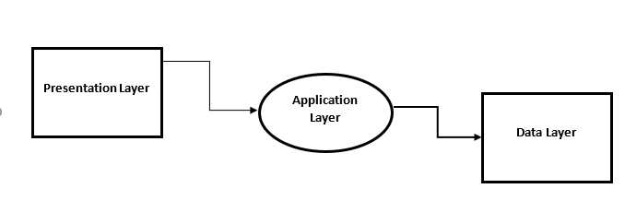

**Figure 3.3: Block Diagram of Platform Architecture**

1. **Presentation Layer**

This layer consists of the user interface, developed using HTML, CSS, and React. It provides web pages for different user types (athletes, scouts, and admins), allowing them to register, log in, search, and interact. The use of Materialize CSS ensures the interface is responsive, visually appealing, and easy to navigate.

1. **Application Layer**

The core logic of the platform is handled here and built using Java and Python. This layer processes user requests, manages user sessions, handles data processing, and ensures secure communication between different parts of the system. It also integrates with APIs like Firetbase for real-time data management, user authentication, and notifications.

1. **Data Layer**

Utilizes SQL for managing and querying the relational database. Stores user profiles, connection requests, communication logs, and other relevant data. Firebase API acts as a data management layer, ensuring data consistency and providing an interface for CRUD (Create, Read, Update, Delete) operations.

1. **Block Diagram Description**

The block diagram illustrates the flow of data and interaction between various components. Figure 3.4 illustrates the component's interaction, facilitating the information flow between the registered athletes and team owners.

User Integration

**Athlete Portal**

Registration

Login

Talent Show

**Scout Portal**

Registration

Login

Search for -Talented Athlete

Bid for Athlete

**Admin Panel**

Login

Manage-Transaction

Approve Request (Bid)

Authentication

Traansaction Processing

Notification

API

(Firebase)

Database

User Management

Data Fetching

Scout Profile

Athlete Profile

Admin Information

Transaction Data

User

Front-End

Hosting (Vercel)

**Figure 3.4: Dataflow and User Interaction**

The three layers, Presentation layer, Application layer, and the Data Layer can further be broken down as shown in the Figure 3.4. There interaction is discussed as follows.

**1. User** (Athlete, Scout, Admin)**:** Interacts with the platform, accesses the platform through the User Interface (UI), developed with HTML, CSS, and React. The users can register and log in as athletes or team owners. Their data is then stored in the connected database.

**2. Frontend (HTML, CSS, React)**

1. Displays user interface
2. Collects user input (e.g., registration, profile search)
3. Sends requests to the backend via API

**3. Hosting (Vercel)**

1. Hosts the frontend application
2. Serves the web pages and handles routing
3. Connects the frontend to backend services (API)

**4. API (Firebase)**

1. **Authentication**: Handles login, registration, password reset, and authentication tokens.
2. **User Management**: Manages athlete and scout profiles and enables Admin panel functionality (approval, management).
3. **Data Fetching**: Retrieves user details from the database (e.g., search results, profile information).
4. **Transaction Processing**: Handles interactions between scouts and athletes, such as connection requests or financial transactions.
5. **Notifications**: Sends notifications (via email or platform alerts) to users.

**5. Database (Firebase, MySQL):** Stores all platform data including;

* 1. User Information: Athlete and scout profiles, admin data.
  2. Transaction Data: Records of interactions, transaction logs.
  3. Platform Data: Any additional data needed to maintain the platform.

**6. User Integration**

1. **Athlete**: Accesses profile, updates information, connects with scouts.
2. **Scout**: Searches for athletes, views profiles, initiates connection or transaction.
3. **Admin Panel**: Manages registrations, oversees user activity, handles transactions.

## 3.2.3 System Operation Description

In the platform, the interaction hierarchy begins with the registered scout (user), who initiates the process by searching for an athlete of their choice. The search feature allows the scout to filter athletes based on their profiles, expertise, or sports (football or basketball).

Upon selecting an athlete, the scout can view detailed profiles, including performance statistics and other relevant information. This interaction is made possible by the application layer, which handles the retrieval and presentation of the athlete's data from the database (managed by SQL or Firebase).

The admin panel plays a crucial role in coordinating the interaction between scouts and athletes. Although the scout can view the athlete’s profile, any transaction or engagement (such as initiating contact or making offers) must pass through the admin, ensuring controlled and secure interactions.

Access to the platform depends on the availability of user data, meaning that both scouts and athletes must be registered, and their information must be present and up-to-date in the database. The application checks for data availability before allowing interactions, ensuring the system’s integrity and user accountability.

# 3.3 System Development and Deployment

This section outlines the development and deployment phases of the platform.

1. **Development Phases**
2. **User Interface**: This phase involves the creation of wireframes and prototypes for different user interfaces, ensuring clarity and usability. Develop a technical design document outlining the system architecture, data flow, and module interactions. The interface has a portion for Team and Athlete with fields for users to provide their information.
3. **Admin Panel:** The admin panel is developed for platform administrative management, to coordinate connections and monitor activities on the platform.
4. **Coding Phase**
5. **Front-end Development**: Use of HTML, CSS, React, and Materialize CSS to build responsive web pages.
6. **Back-end Development**: Implement server-side functionalities using Java and Python, including data processing and user authentication.
7. **Integration:** Integrate the Firebase API for real-time data management and user authentication processes. This thus provides optimal security of user’s information on the platform.
8. **Deployment Phase**

Deploy the platform on Vercel, leveraging its capabilities for serverless deployment and static site hosting. Configure the production environment, including security settings, load balancing, and monitoring services. Conduct post-deployment monitoring to ensure the platform functions as intended and make adjustments as necessary.

# 3.4 Testing and Evaluation

Testing and evaluation are required to ensure that the developed platform meet the intended purpose and user’s expectations. This section describes the methods and criteria used for testing and evaluating the platform. The platform is tested with 20 different individuals where 5 of them registered as team owners and 15 as an athlete.

## **3.4.1 Testing Methods**

1. **Functionality Testing**

Individual functionalities, such as user registration, login, search, and data submission, were checked. The system operation is defined by the interaction of connected components (UI, API, Database), which work together. End-to-end testing of all use cases and scenarios is carried out to ensure overall platform functionality is carried out.

1. **Usability Testing**

User testing sessions were conducted to evaluate ease of use, navigation, and overall user experience. The feedback on the accessibility was collected through surveys and interviews with different user types (athletes, scouts, and admins). This information was used for a heuristic evaluation to identify and rectify usability issues.

**3.4.2 Evaluation Metrics**

Post-testing evaluation includes gathering feedback from users and technical staff to identify areas for improvement. The performance of the platform is measured to identify areas for improvement, the following key performance indicators (KPIs) are defined and measured:

1. **User Satisfaction**

Measured through user feedback surveys and ratings, focusing on overall satisfaction with the platform's usability, design, and functionality. This metric helps gauge how well the platform meets user expectations.

1. **Task Completion Rates**

Monitors the percentage of successfully completed tasks, such as athlete registrations, scout connections, and profile updates. High task completion rates indicate an intuitive and efficient user interface.

1. **Error Rates**

Tracks the frequency and types of errors encountered by users, such as failed form submissions or login issues. Lower error rates suggest a more reliable and user-friendly platform.

1. **System Response Times**

Measures the time taken by the platform to respond to user actions, like page loads or data submissions. Faster response times are critical for ensuring a smooth user experience

## 3.4.3 Result Analysis

After testing and evaluating the system’s performance, user feedback will be analyzed through both qualitative and quantitative measures. This approach will provide insights into user satisfaction and help identify areas for improvement, ensuring that any flaws in the system can be addressed effectively.

1. **Quantitative Analysis**

In the context of this study, quantitative analysis measures the performance of the sports registration platform through numerical and statistical data. Metrics like system response time, task completion rates, user registration volume, and the number of active users provide a clear understanding of platform efficiency. For instance, the average time taken for scouts to search for athletes, the frequency of successful athlete-scout connections, and system uptime are critical factors to evaluate. These metrics can be captured through monitoring tools, logging system activity, and tracking database queries. This helps identify bottlenecks, assess server loads, and measure the platform’s scalability and user accessibility.

1. **Qualitative Analysis**

The qualitative analysis focuses on understanding user experience and satisfaction with the platform. It involves gathering subjective feedback from athletes, scouts, and admins through surveys, interviews, or focus groups. Feedback about ease of navigation, platform usability, and user-friendliness provides valuable insights into areas requiring improvement. Additionally, qualitative measures such as error rates, security concerns, and user recognition issues can be identified through real-world use. For instance, if users experience difficulties in navigating the registration process or slow system response, these can be captured and evaluated through interviews or feedback forms to inform future design improvements.

## 3.5 Ethical Considerations

* 1. **Informed Consent:** Participants are provided with detailed information about the study, including its purpose, procedures, and potential risks.

Informed consent is obtained in writing for surveys and interviews, with an option to withdraw at any stage without any penalty.

* 1. **Confidentiality and Anonymity:** All personal information and responses are anonymized to protect participants’ identities. Data is stored securely in encrypted formats and is only accessible to authorized researchers.
  2. **Voluntary Participation:** Participation is entirely voluntary, and participants are informed that they can withdraw from the study at any time. No incentives are offered that might coerce participation, ensuring that consent is genuinely voluntary.
  3. **Ethical Review:** The research proposal is reviewed and approved by an Institutional Review Board (IRB) or an equivalent ethics committee to ensure that it adheres to ethical standards in research.
  4. **Bias Mitigation:** To mitigate potential bias, multiple researchers are involved in the data analysis process. For qualitative analysis, intercoder reliability is ensured by having multiple coders independently analyse the data before comparing results.

**CHAPTER FOUR**

**4.0 SYSTEM IMPLEMENTATION AND TESTING**

This chapter describes the implementation of the digital sports registration platform and details the testing process, system and hardware requirements, the development environment, and the system’s structure and functionality.

**4.1 System Requirements**

The system requirements include both functional and non-functional specifications that define the platform's capabilities and quality attributes.

**4.1.1 Functional Requirements**

The platform is designed to accommodate some certain usability to fulfill the major objectives for which it is designed. The following functions are performed on the system after the development.

1. User Registration: Users can create accounts and manage profiles.
2. Event Registration: Users can browse, select, and register for events.
3. Payment Integration: The system supports secure payment gateways.
4. Admin Dashboard: Administrators can manage users, events, and registrations.
5. Reports: Admins can generate reports on user activity, event participation, and financials.

**4.1.2 Non-Functional Requirements**

1. Usability: The platform must be easy to navigate, with minimal training required.
2. Scalability: The platform should handle increased traffic during event seasons.
3. Security: Data encryption, authentication, and secure payment handling are essential.
4. Performance: Pages should load in under 3 seconds with optimal database performance.
5. Availability: The platform must maintain 99.9% uptime for user access at all times.

**4.2 Hardware Requirements**

The following hardware specifications support the platform’s functionality and efficiency.

**4.2.1 Server-Side Requirements**

1. Server: Hosted on cloud-based infrastructure (AWS or DigitalOcean) with:
2. Processor: Quad-core Intel Xeon or equivalent.
3. RAM: 16 GB.
4. Storage: SSD with 500 GB space.
5. Bandwidth: High-speed connection of at least 1 Gbps.

**4.2.2 Client-Side Requirements**

* + 1. Operating Systems: Windows, macOS, Linux, Android, iOS.
    2. Browsers: Chrome, Firefox, Safari, or Edge.
    3. Internet: A connection with a minimum 5 Mbps speed.

**4.3 Choice of Development Environment**

Laravel, a robust PHP framework, is chosen for back-end development due to its flexibility, built-in security features, and scalability.

**4.3.1 Front-End Development**

* + 1. HTML5/CSS3: For basic structure and styling.
    2. JavaScript: Chosen for front-end interactivity and dynamic components.
    3. Bootstrap: Ensures a responsive user interface across devices.
    4. **Back-End Development with Laravel**
    5. **Laravel:** The back-end is powered by Laravel, a PHP framework known for its MVC architecture and efficient handling of database operations, routing, and authentication.
    6. **Database:** MySQL is used for relational data management, offering robust scalability and compatibility with Laravel.
    7. **Authentication:** Laravel's built-in authentication and role management systems allow secure login and user access control.

**4.3.3 Development Tools**

* + 1. **IDE:** PHPStorm or Visual Studio Code.
    2. **Version Control:** Git with GitHub or Bitbucket for repository management.
    3. **Testing Tools:** PHP Unit is used for unit testing and Laravel Dusk is used for browser testing.

**4.4 System Implementation Menu**

The system implementation menu defines the platform’s structure, focusing on the navigation options available to users and administrators. The platform contains different functionality features including athlete and scout registration, athlete scouting, profile accessing verification, and admin authentication.

**4.4.1. Athlete Registration and Dashboard**

**4.4.1.1 Registration Page**

On the registration page, there are two different options for registration, either as a scout or an athlete. The athlete can navigate to access the athlete portal provide the required data. The page is shown in Figure 4.1.

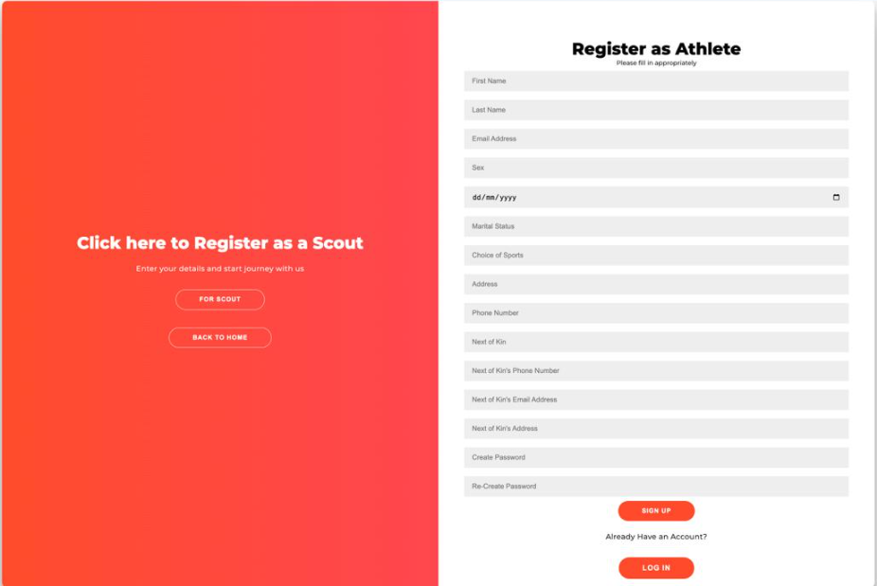

**Figure 4.1: Athlete Registration Page**

The athlete registration form gathers basic details such as:

* + - Name, Age, Country, Height, Weight
    - Position (role), Email, Phone number
    - Social media links

**4.4.1.2 Dashboard (After Submission)**

Figure 4.2 displays the information of the registered athlete after the submission of data. The dashboard contains firsthand information about the athlete which will be available for the scouts upon searching for their ideal players.

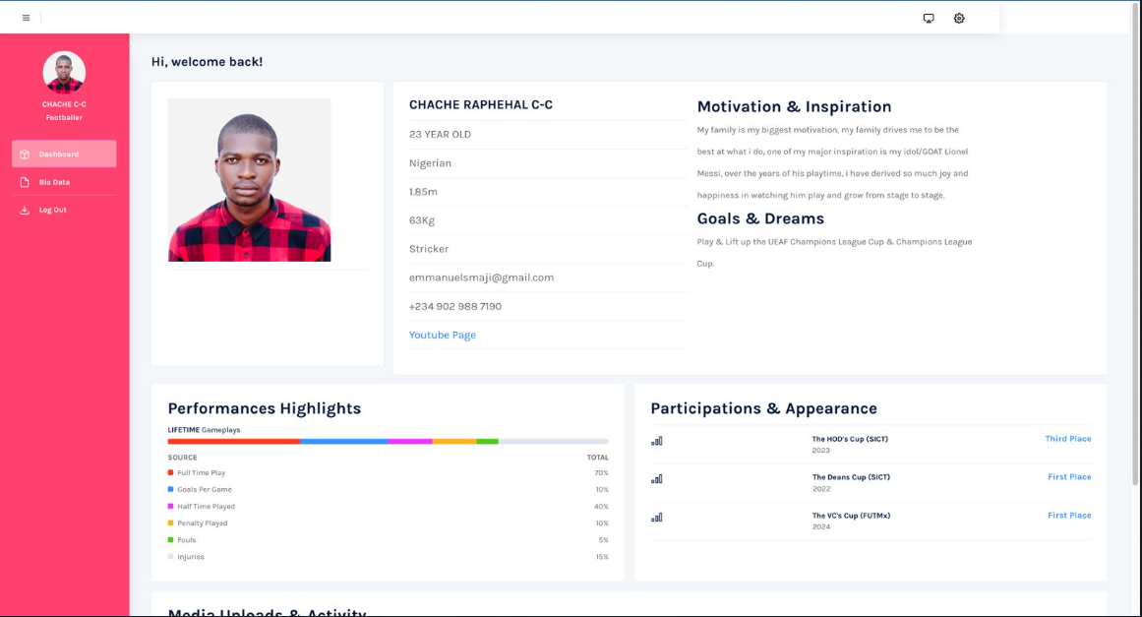

**Figure 4.2: Athlete Dashboard Outlook**

Upon successful registration, the athlete is redirected to their dashboard, displaying their profile, as shown in Figure 4.3.

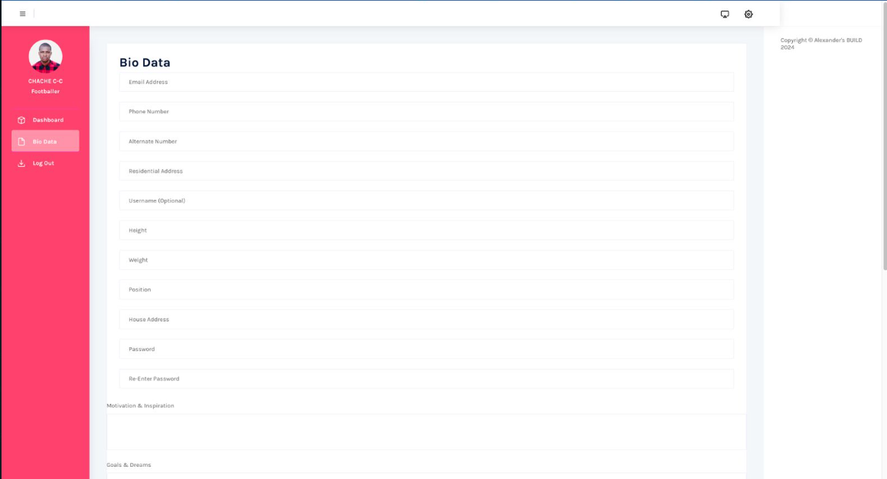

**Figure 4.3: Athlete Biodata**

At the dashboard, the following functionalities are available for the user

1. Offers options for modifying personal details such as username, email, phone number, and password.
2. Allows updating of profile pictures and other visual data visible to scouts.

The information that describes the athlete is also displayed on this page, including;

* + 1. **Athlete identity**-related information like name, age, country, height, weight, position, email, phone number, and social links.
    2. **Motivation and Inspiration:** Outlines the athlete's vision and aspirations, serving as an introduction to their mindset and personal drive.
    3. **Goals and Dreams:** Expands on the athlete's motivations by detailing their long-term objectives and desired career achievements.
    4. **Performance and Highlights:** A record of the athlete’s playing history, including:
* Time and duration of games played
* Goals scored, penalties taken, fouls committed, injuries sustained
* This serves as a performance log that scouts can review.
  + 1. **Participation and Appearances:** Lists all major competitions and events the athlete has participated in, including results and achievements.
    2. **Media Upload and Activities:** A section for linking and updating the athlete’s YouTube page or other social media platforms with recent activity.

**4.4.1.3 Security and Privacy Considerations for Athletes**

* + 1. Athletes can adjust the visibility of certain personal information to control what scouts can see.
    2. There are measures to protect sensitive information from being accessed by unauthorized users.

**4.4.2 Scout's Registration and Dashboard**

**4.4.2.1 Register Page**

Upon accessing the platform, scouts are required to fill out a basic registration form, providing essential information as illustrated in Figure 4.4. This ensures a streamlined onboarding process.

**Registration Details Include:**

* + - Name, Age, Country, Email, Phone number
    - Social media links

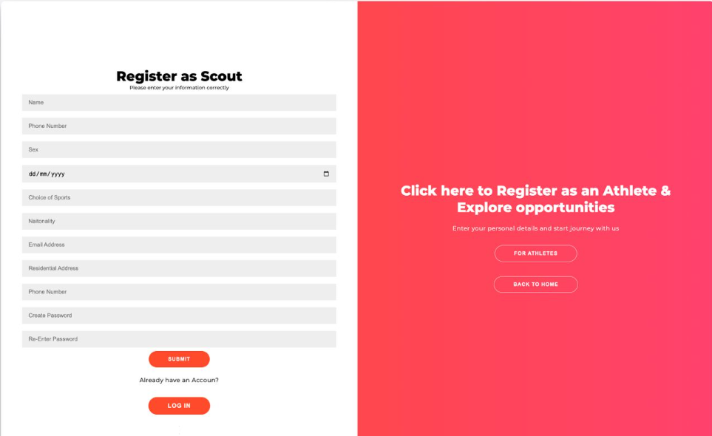

**Figure 4.4: Scout Registration Portal**

**4.4.2.2 Dashboard (After Submission)**

After successfully registering, scouts are directed to their personalized dashboard as shown in Figure 4.5), which is organized into several key sections for managing their profile and interactions with athletes.

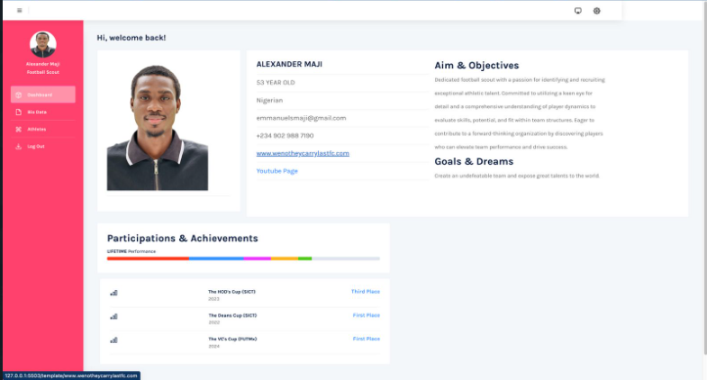

**Figure 4.5: Scout Dashboard Outlook**

* + 1. **Bio Data Section:**

This section allows scouts to update their profiles and ensures they maintain accurate and up-to-date information on the platform. The scout biodata is as shown in Figure 4.6.

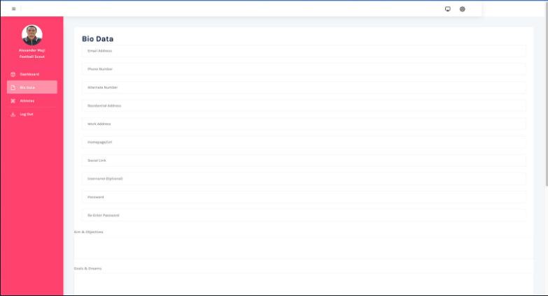

**Figure 4.6 Scout’s Biodata**

* Displays the scout’s personal details such as name, age, country, email, phone number, and social media links.
* Offers options to modify personal information such as username, password, email, phone number, and profile picture.

Further information that describes the scout is also displayed on this page, including;

* + 1. **Aims and Objectives**
* Outlines the scout's vision and strategies for identifying and developing new talent.
* Shows how they plan to support and nurture athletes as they progress in their careers.

This section provides insights into the scout’s professional focus and approach, giving athletes and admins a better understanding of their goals.

* + 1. **Goals and Dreams**
* Expands on the scout's aims and objectives, detailing long-term aspirations within the scouting profession.
* Scouts can use this section to showcase their career plans and future goals, reinforcing their commitment to discovering talent.
  + 1. **Participation and Achievements**
* A comprehensive record of the scout's background, including experiences in coaching or supervising athletes.
* Highlights challenges encountered during their scouting journey and achievements attained over time.

This section serves as a portfolio for scouts, where they can document their career milestones, making it easier for admins and athletes to evaluate their track records.

* + 1. **Athlete Access**

To ensure the safety of athletes, full access to athlete profiles requires a verification process overseen by the admin. This step ensures that only verified scouts can view sensitive athlete details, minimizing risks like impersonation or other fraudulent activity. Figure 4.7 illustrates the scouting process of athlete by the scout.

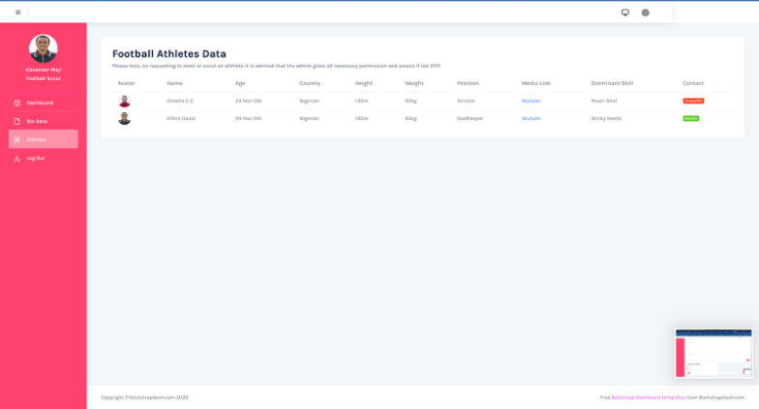

**Figure 4.7: Scout Accessing Athlete Profile**

* Scouts can browse basic profiles of registered athletes, including those who are actively available for scouting.
* For security reasons, only limited information is accessible before verification.
* Scouts must contact the admin for full access after completing a verification process to ensure the legitimacy of the scout’s interest and avoid risks such as impersonation or kidnapping.
  + - 1. **Key Features of the Scout Dashboard**

1. **Security and Access Control:**

* Sensitive athlete data remains restricted until the scout completes a verification process.
* The platform employs security measures to prevent unauthorized access, protecting both athletes and scouts from potential risks such as identity theft or unauthorized use.

This ensures that the platform maintains a high level of trust and security for all users.

1. **Dashboard Customization**

* Scouts, like athletes, can customize their dashboards by updating biodata, profile pictures, and other personal information.

This feature allows scouts to keep their profiles relevant and personalized, ensuring their presence on the platform accurately reflects their current status and goals.

# 4.5 System Testing

**4.5.1 Usability Testing**

In this section, our testing was conducted with an estimate of about 10 users to assess the overall user experience of the platform. Users were required to engage in some specific tasks, such as resgistering as a scout and also an athlete and navigating through different sections of the website/platform. Conclusion from the feedbacks indicated that 95% of the users found the platfrom’s interface intuitive and user friendly to navigate through. The average task completion time was recorded at 5 minutes, which is well within the inputting of personal informations as an athlete and as a scout. From observations discovered users emphasized on the ease of input fields and it subsequte and flexible nature to accommodate Bio data updates for both user, and also appreciated the clatiy of the displays/interface on their individual dashboard and labeling of buttons and the straightforward layout, which facilitated a smooth interaction.

## 4.5.2 System Integration Testing

System integration testing focused on verifying the interoperability of various components of the platform, including the payment gateway, user database, and notification systems. A total of 10 test cases were executed, covering different scenarios to ensure that data transfer between systems occurred without errors. All test cases passed successfully, confirming that the platform can handle various inputs and outputs effectively. This testing also revealed that the integration of third-party services functioned as intended, further validating the robustness of the backend systems. As a result, the system is deemed reliable for processing transactions and user data efficiently.

## 4.5.3 Performance

Performance testing evaluated the platform’s capacity to maintain responsiveness and stability under various conditions. The system was stress-tested with up to 100 concurrent users simulating peak traffic, revealing that average response times remained consistently under 2 seconds. This performance metric indicates that the platform can handle high volumes of transactions without noticeable delays. Additionally, load testing confirmed that the server infrastructure effectively managed simultaneous requests without crashing or slowing down, ensuring a seamless user experience even during busy periods.

# 4.6 Performance Evaluation

1. Satisfaction: User satisfaction was assessed through a comprehensive survey conducted with 50 participants, yielding a 90% positive response rate. Many users praised the platform’s straightforward design and ease of use, highlighting that they could complete transactions quickly without encountering any significant obstacles. The high satisfaction rate suggests that the platform meets user expectations and provides a positive experience.
2. Response Times: Performance metrics revealed that the platform maintains average response times of under 2 seconds, even during peak usage periods. This swift response time is critical for maintaining user engagement and satisfaction, as delays can lead to frustration and potential abandonment of the payment process. The quick response is attributed to efficient backend optimization and resource management.
3. Transaction Accuracy: The platform achieved a transaction accuracy rate of 99.5%, with only 0.5% of transactions encountering errors. This high level of accuracy is vital for user trust and confidence in the system, ensuring that payments are processed correctly. Regular monitoring and error tracking are in place to address any issues that may arise, further enhancing the reliability of the platform.
4. Security: The platform has undergone extensive security evaluations, passing all assessments with no vulnerabilities identified. Security measures include SSL encryption for data transmission, regular audits, and compliance with industry standards. These measures ensure that user data is well-protected, fostering a sense of safety for users when conducting transactions. Continuous monitoring is implemented to safeguard against potential threats, maintaining a secure environment for all users.

# CHAPTER FIVE

# 5.0 SUMMARY, CONCLUSIONS, AND RECOMMENDATIONS

This chapter provides an overview of the project, presents conclusions based on the implementation, and offers recommendations for further development and improvement of the online sports registration platform.

**5.1 Summary**

The project focused on the creation of an online sports registration platform that digitizes the registration and interaction process between athletes and scouts. The goal was to develop a streamlined, user-friendly platform that allows athletes to register, track their career progress, and enables scouts to discover and manage talent efficiently.

Key features of the platform include:

1. **Athlete Registration and Dashboard:** Athletes can register by submitting personal information, manage their profiles, update performance statistics, and showcase their achievements.
2. **Scout Registration and Dashboard:** Scouts are able to register, view athlete profiles, and request further access through an admin-verified process, ensuring secure and controlled access to athlete data.
3. **Security and Privacy Measures:** Security protocols were incorporated to safeguard user data, including multi-factor authentication and restricted access for scouts based on verification.
4. **Performance Tracking:** The platform allows athletes to log their career highlights and performance data, giving scouts access to valuable metrics for evaluating talent.
5. **Customizable Dashboards:** Both athletes and scouts have the ability to manage and update their profiles, ensuring that relevant information is always up-to-date.

The project successfully addressed the challenges of manually registering athletes and scouting talent by providing a digital solution that emphasizes user convenience, data security, and efficient performance monitoring.

**5.2 Conclusion**

The online sports registration platform marks a significant advancement in modernizing interactions between athletes and scouts. By offering a secure and efficient registration and management system, the platform benefits athletes by showcasing their talents and making it easier for scouts to discover and assess potential recruits. The use of Laravel for backend development and Vue.js for the front end resulted in a scalable and powerful solution capable of managing a large user base while delivering real-time performance tracking, secure access controls, and customizable user dashboards.

The implementation demonstrated that digital transformation in sports registration is both achievable and advantageous. It reduces administrative tasks, improves data accessibility, and ensures user data protection, thereby enhancing the overall experience for both athletes and scouts.

**5.3 Recommendations**

Although the platform meets its primary objectives, several enhancements can be introduced to improve its functionality, security, and scalability:

1. **Enhanced Search and Filtering for Scouts:** Incorporating more advanced search and filtering capabilities for scouts will improve their ability to find athletes based on specific criteria such as performance metrics, recent achievements, or position availability. Real-time search functions can further enhance accessibility to athlete profiles.
2. **Mobile Application Development:** Developing a mobile application will extend the platform's reach and improve accessibility for athletes and scouts. A mobile app will allow users to register, update their profiles, and interact with the platform conveniently from any location.
3. **Advanced Security Features:** Implementing biometric authentication methods, such as fingerprint or facial recognition, will add another layer of security. Integrating blockchain technology to manage athlete performance records and scout interactions can enhance data integrity and reduce the risk of fraud.
4. **Automated Event Scheduling:** Adding a feature for event management where athletes can automatically register for upcoming competitions based on their interests and availability would streamline the event registration process. Personalized event recommendations can be offered to athletes to increase their participation in relevant competitions.
5. **Enhanced Analytics for Athletes:** Providing athletes with detailed performance analytics will help them track their progress and growth over time. This data will also be beneficial for scouts, offering them deeper insights into athlete potential and performance trends.
6. **Global Reach and Localization:** Expanding the platform to accommodate international athletes and scouts by incorporating multi-language support, currency conversions for event fees, and region-specific competitions will increase the platform’s global reach and usability.

# REFERENCES

Asri. (2024). Implementation of Online Registration Applications in Vocational High Schools Using the QRCode Method. *Jurnal Abdimas Cendekiawan Indonesia*, *1*(2), 21–26. https://doi.org/10.56134/jaci.v1i2.90

Cahyana, R., Setiawan, R., & Nugraha, I. (2023). Development of Web-Based Rtikabdimas Application With a Rapid Unified Process Approach. *JURNAL TEKNIK INFORMATIKA*, *16*(1), 15–24. https://doi.org/10.15408/jti.v16i1.28585

Clarsen, B., Myklebust, G., & Bahr, R. (2012). Development and validation of a new method for the registration of overuse injuries in sports injury epidemiology: the Oslo Sports Trauma Research Centre (OSTRC) Overuse Injury Questionnaire. *British Journal of Sports Medicine*, *47*(8), 495–502. https://doi.org/10.1136/bjsports-2012-091524

Gilyazetdinova, G. (2024). The Correlation Between the Concepts of Cyber Sports, Computer Sports, Electronic Sports, Distance Sports, Online Sports, Digital Sports. *Sports: Economics, Law, Management*, 9–11. https://doi.org/10.18572/2070-2175-2024-2-9-11

Issurin, V. B. (2017). Evidence-Based Prerequisites and Precursors of Athletic Talent: A Review. *Sports Medicine*, *47*(10), 1993–2010. https://doi.org/10.1007/s40279-017-0740-0

Jacquelin, N., Vuillemot, R., & Duffner, S. (2022). Efficient One-Shot Sports Field Image Registration with Arbitrary Keypoint Segmentation. *2022 IEEE International Conference on Image Processing (ICIP)*. https://doi.org/10.1109/icip46576.2022.9897170

Khatimah, K., Rahmawati, Y., & Halim, A. (2021). Familiarity of Online Learning Platform in Catching Up the Academic Accomplishment in East Kalimantan Sport School. *EDUKATIF : JURNAL ILMU PENDIDIKAN*, *3*(6), 4777–4785. https://doi.org/10.31004/edukatif.v3i6.1290

Leite, N., Calvo, A. L., Cumming, S., Gonçalves, B., & Calleja-Gonzalez, J. (2021). Editorial: Talent Identification and Development in Sports Performance. *Frontiers in Sports and Active Living*, *3*. https://doi.org/10.3389/fspor.2021.729167

Lin, C.-F., Fu, Y.-C., Lin, L.-S., & Fu, C.-S. (2022). Minimal Human Interaction in Hospitals: Effective Online Registration System Design. *SAGE Open*, *12*(3), 215824402211226. https://doi.org/10.1177/21582440221122695

Liu, X., & Zhu, W. (2022). Design and implementation of an online registration system based on Siemens low-code platform. *2022 5th International Conference on Advanced Electronic Materials, Computers and Software Engineering (AEMCSE)*. https://doi.org/10.1109/aemcse55572.2022.00160

Lu, Z. (2016). From E-Heroin to E-Sports: The Development of Competitive Gaming in China. *The International Journal of the History of Sport*, *33*(18), 2186–2206. https://doi.org/10.1080/09523367.2017.1358167

Maduekwe, N. I., Banjo, O. O., & Sangodapo, M. O. (2016). The Nigerian Civil Registration and Vital Statistics System: Contexts, Institutions, Operation. *Social Indicators Research*, *134*(2), 651–674. https://doi.org/10.1007/s11205-016-1448-5

Morath, F., & Münster, J. (2018). Online Shopping and Platform Design with Ex Ante Registration Requirements. *Management Science*, *64*(1), 360–380. https://doi.org/10.1287/mnsc.2016.2595

Nie, H. (2024). Design and Implementation of a Campus Sports Meet Management System. *Frontiers in Computing and Intelligent Systems*, *8*(2), 47–51. https://doi.org/10.54097/2j6xr577

Nie, X., Chen, S., & Hamid, R. (2021). A Robust and Efficient Framework for Sports-Field Registration. *2021 IEEE Winter Conference on Applications of Computer Vision (WACV)*. https://doi.org/10.1109/wacv48630.2021.00198

Pacheco, A., Sanchez, K., Cardenas-Quispe, M., Uribe-Blaz, Y., & Ortiz-Salguero, M. (2024). A Virtual Platform Solution for Secure Sales Registration and Management in the retail sector. *F1000Research*, *13*, 558. https://doi.org/10.12688/f1000research.144254.1

Palomar, I. J., García Valldecabres, J. L., Tzortzopoulos, P., & Pellicer, E. (2020). An online platform to unify and synchronise heritage architecture information. *Automation in Construction*, *110*, 103008. https://doi.org/10.1016/j.autcon.2019.103008

Qi, Y., Sajadi, S. M., Baghaei, S., Rezaei, R., & Li, W. (2024). Digital technologies in sports: Opportunities, challenges, and strategies for safeguarding athlete wellbeing and competitive integrity in the digital era. *Technology in Society*, *77*, 102496. https://doi.org/10.1016/j.techsoc.2024.102496

Setyandari, R. E., Sanjaya, R., & Nugroho, A. C. (2023). Development of a Web-based Application for Offline Mass Registration. *Journal of Business and Technology*, *3*(2), 47–55. https://doi.org/10.24167/jbt.v3i2.4990

Smith, J., & Doe, A. (2022). The Benefits of Digital Transformation in Sports Administration. *Journal of Sports Management and Commercialization,* , *10*(3), 150–165.

Suryadi, A., & Balakrishnan, T. A. (2023). Website Based Patient Clinical Data Information Filling and Registration System. *Proceedings of the International Conference on Nursing and Health Sciences*, *4*(1), 197–206. https://doi.org/10.37287/picnhs.v4i1.1764

Syahidin, Y., Mahpud, E. D., Serina, D., & Hidayati, M. (2022). DESIGN INFORMATION SYSTEM ONLINE REGISTRATION VACCINE COVID-19 AT RSAU DR. M. SALAMUN. *JURTEKSI (Jurnal Teknologi Dan Sistem Informasi)*, *8*(3), 247–252. https://doi.org/10.33330/jurteksi.v8i3.1233

Team, S. (2023). From Pencils to Pixels: Digital School Processes vs. Paper-based Methods. In *Scribsoft.com*. https://blog.scribsoft.com/blog/from-pencils-to-pixels-digital-school-processes-vs.-paper-based-methods

Thamrin, R. M. H., & Andriani, R. (2021). Design Web-Based Registration And Data Management Of Student Thesis Information System. *SISFOTENIKA*, *11*(1), 101. https://doi.org/10.30700/jst.v11i1.1111

Till, K., & Baker, J. (2020). Challenges and [Possible] Solutions to Optimizing Talent Identification and Development in Sport. *Frontiers in Psychology*, *11*(11). https://doi.org/10.3389/fpsyg.2020.00664

Tshering, Y., Yangchan, T., Wangchuk, K. J., Bhujel, S., & Gurung, B. (2024). Empowering Sports Enthusiasts and Facility Owners: An Online Sports Field Booking System for Bhutan. *Journal of Applied Engineering Technology and Management*, *4*(1), 60–64. https://doi.org/10.54417/jaetm.v4i1.125

Wang, H. (2023). Evolution of the Online Rating Platform Data Structures and its Implications for Recommender Systems. *ArXiv (Cornell University)*. https://doi.org/10.48550/arxiv.2303.14419

Wang, J., Shi, D., & Tsai, S.-B. (2022). An Empirical Study on the Construction Path of Sports Public Service Platform under the Background of “Internet +” by Fuzzy Computing. *Mathematical Problems in Engineering*, *2022*, 1–10. https://doi.org/10.1155/2022/3052350

Widiyatmoko, A. T., Nugroho, A., & Wiyanto, W. (2024). Development of Web-Based Student Registration Information System with Rapid Application Development Approach. *Journal Of Computer Networks Architecture and High Performance Computing*, *6*(1). https://doi.org/10.47709/cnahpc.v6i1.3459

Xue, T. (2023). *Innovative Practice of Blended Higher Education Sports Teaching Model Based on Online Teaching Platforms*. https://doi.org/10.4108/eai.8-9-2023.2340011

Zhou, Y., & Wang, X. (2024). Analysis of the Main Body of Traditional Sports System from the Perspective of National Fitness. *Transactions on Social Science Education and Humanities Research*, *8*, 118–123. https://doi.org/10.62051/z1jk9a79