Mapreduce

Job1

(ticker, variazione media, minimo, massimo, volume medio)

EAF 374900.0,0.0020000000949949,22.3700008392334,1245139.0
PUB 224899.0,0.00899999961256981,135.0,34449.0
ORGS 217415.0,0.00313999992795289,19.7999992370605,8570.0
CCD 148366.0,0.0149999996647239,25.5499992370605,105416.0
SAB 112005.0,1.39849996566772,318800.0,1695378.0
RMP 102790.0,0.0299999993294477,78.5498504638672,120487.0
KE 99400.0,0.0149999996647239,22.2000007629395,73249.0
LN 96700.0,0.0149999996647239,49.6300010681152,394344.0
CTZ 96220.0,0.00499999988824129,26.7299995422363,52050.0
RRR 82475.0,0.00499999988824129,36.6399993896484,600103.0

Job2

2008_BASIC INDUSTRIES vol: 2225134.8225806453, var: -42.05483870967744, quot: -13.04925892947585
2008_CAPITAL GOODS vol: 1346687.8339622642, var: -46.35849056603773, quot: -0.05675793742231432
2008_CONSUMER DURABLES vol: 751250.8823529412, var: -39.45196078431371, quot: -0.02839905896069646
2008_CONSUMER NON-DURABLES vol: 1793668.6560509554, var: -37.62101910828027, quot: -0.013466333399603774
2008_CONSUMER SERVICES vol: 1797142.966367713, var: -41.303587443946235, quot: -0.45474310391079187
2008_ENERGY vol: 3346068.8757763975, var: -47.17639751552796, quot: -0.08902055151928644
2008_FINANCE vol: 1420721.8110516935, var: -30.36666666666666, quot: 0.00877185220626226
2008_HEALTH CARE vol: 1259352.7659574468, var: -38.56322188449848, quot: -0.18399740771957593
2008_MISCELLANEOUS vol: 2094344.076923077, var: -42.8054945054945, quot: -0.010187381373300735
2008_PUBLIC UTILITIES vol: 1622624.9644970414, var: -31.667455621301748, quot: 0.14124446184816292

Job3
INTERNATIONAL BANCSHARES CORPORATION,MIDDLESEX WATER COMPANY 2016_64,2017_-3,2018_18
"COMPASS MINERALS INTERNATIONAL, INC.",SIGNATURE BANK 2016_3,2017_-8,2018_-15
"PENNYMAC FINANCIAL SERVICES, INC.",LEAR CORPORATION 2016_10,2017_33,2018_-8
"CALERES, INC.",GENTEX CORPORATION 2016_25,2017_3,2018_11
ISTAR FINANCIAL INC.,NEVRO CORP. 2016_9,2017_-8,2018_-5
"DUNKIN&#39; BRANDS GROUP, INC.",TERRENO REALTY CORPORATION 2016_28,2017_23,2018_9
"HAWAIIAN ELECTRIC INDUSTRIES, INC.",GLADSTONE LAND CORPORATION 2016_15,2017_10,2018_-1
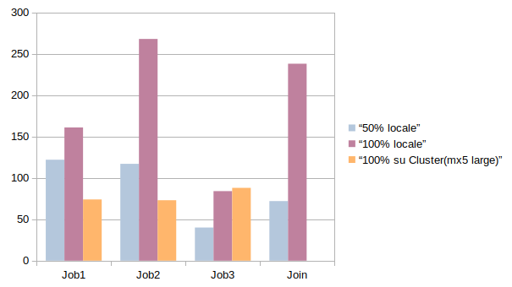Figura 1: secondi impiegati in base a dimensione file e sistema utilizzati

