Spark

Job1

(ticker,variazione media,minimo,massimo,volume medio)

EAF 267757.1,0.00499999988824129,0.00700000021606684,1245139.0
ORGS 217415.9,0.00313999992795289,0.00313999992795289,8570.0
ORGS 217415.9,0.00313999992795289,0.00313999992795289,8570.0
RMP 121081.6,0.0410000011324883,0.0529999993741512,120487.0
CTZ 120300.0,0.0199999995529652,0.025000000372529,52050.0
CCD 111250.0,0.0149999996647239,0.0199999995529652,105416.0
SAB 110428.8,188.5,194.300003051758,1695378.0
KE 99400.0,0.0199999995529652,0.0199999995529652,73249.0
LN 96700.0,0.0450000017881393,0.0450000017881393,394344.0
GHG 64850.0,0.0199999995529652,0.0199999995529652,607659.0

Job2

2008
BASIC INDUSTRIES:
-42.05483870967742, 2225134.8225806453, -0.19498246859881935
… ← per ogni anno stampa i dati per ogni settore
2009
BASIC INDUSTRIES:
82.31927083333332, 2341934.59375, 0.12264472435510312
...
2010
BASIC INDUSTRIES:
32.8930693069307, 1901442.2772277228, 0.03737217099748541
...
2011
BASIC INDUSTRIES:
-11.344230769230771, 1787235.8846153845, -0.07719378427787937
...
2012
BASIC INDUSTRIES:
8.187203791469194, 1512021.0284360189, 0.012737090391625547
...
2013
BASIC INDUSTRIES:
18.849773755656106, 1463277.5067873304, 0.02392476629410557
...
2014
BASIC INDUSTRIES:
-3.3517094017094013, 1403944.3547008547, -0.0474785799533301
...
2015
BASIC INDUSTRIES:
123.46178861788617, 1551627.430894309, -0.06812072624381041
...
2016
CAPITAL GOODS:
27.637951807228912, 907569.8313253012, 0.0781275536962275
...
2017
BASIC INDUSTRIES:
16.695019157088126, 1534243.7892720306, -0.03870194552529176
...
2018
BASIC INDUSTRIES:
-4.050950570342206, 1420554.4486692015, -0.09870275314978995

Job3

2016 8%, 2017 -5%, 2018 16% :
{ANCHOR BANCORP, ACTUANT CORPORATION }
2016 10%, 2017 33%, 2018 -8% :
{ALGONQUIN POWER & UTILITIES CORP., "PENNYMAC FINANCIAL SERVICES, INC." }
2016 4%, 2017 9%, 2018 -9% :
{STANTEC INC, LANDMARK INFRASTRUCTURE PARTNERS LP }
2016 8%, 2017 -8%, 2018 -5% :
{ISTAR FINANCIAL INC., BUNGE LIMITED }
2016 17%, 2017 26%, 2018 0% :
{BOOKING HOLDINGS INC., LOCKHEED MARTIN CORPORATION }
2016 1%, 2017 1%, 2018 0% :
{SNAP-ON INCORPORATED, WALT DISNEY COMPANY (THE) }
2016 -12%, 2017 -13%, 2018 1% :
{VIACOM INC., VUZIX CORPORATION }
2016 -1%, 2017 7%, 2018 4% :
{COVANTA HOLDING CORPORATION, "UDR, INC." }
2016 29%, 2017 14%, 2018 9% :
{"DIGITAL REALTY TRUST, INC.", "GENESEE & WYOMING, INC." }
2016 16%, 2017 20%, 2018 -8% :
{INVESCO MORTGAGE CAPITAL INC, BROOKFIELD RENEWABLE PARTNERS L.P. }
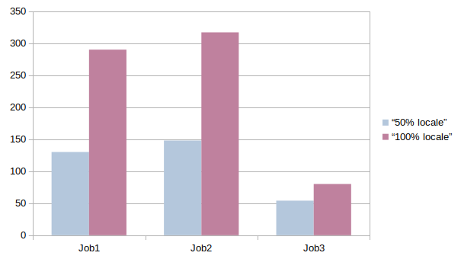Figura 1: secondi impiegati in base a dimensione del file e sistema utilizzato

