

NORDIC GEO SUPPORT

Fosroc Waterproofing Systems

**FOR**

**CONSTRUCTION**

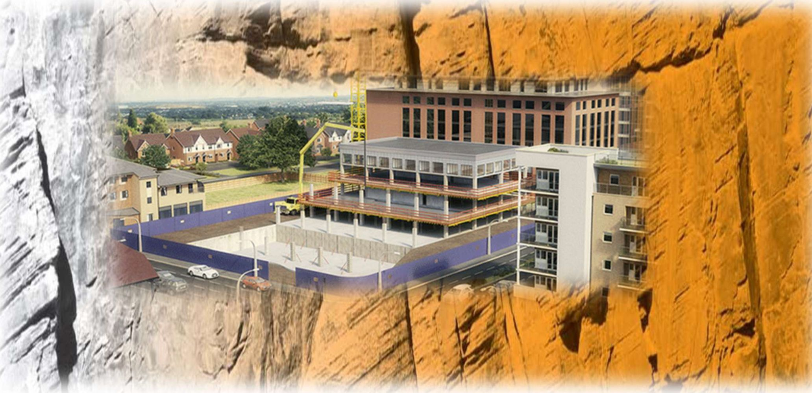

GEO

**SUPPORT**

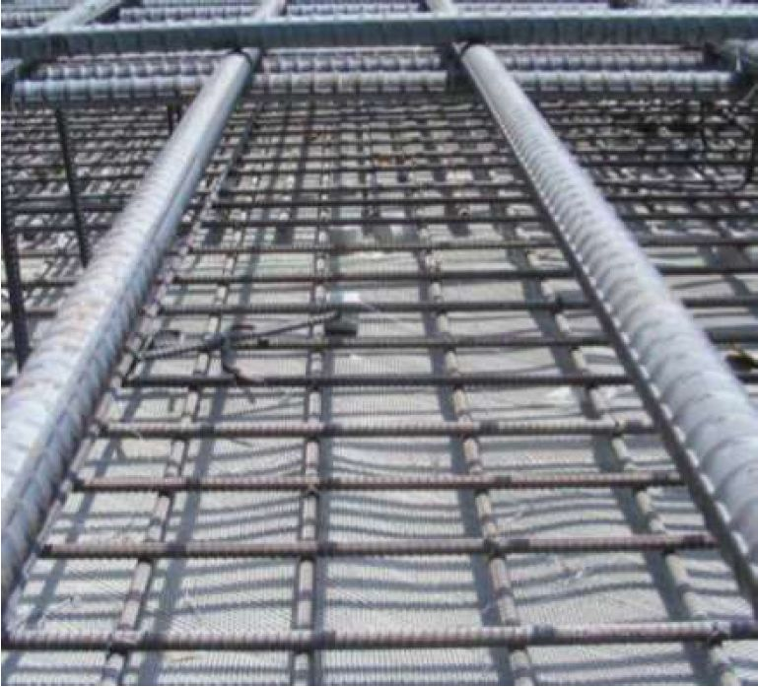

**Page**

2

3

3

3

4

5

**Sealing Solutions**

Proofex Systems

2

Proofex Engage

Proofex 3000

Proofex 3000MR

Proofex Total

Proofex Ancillaries

Typical Below Ground Design

Fosroc Water Stops

6

Dialation Joint Band

8

Grouts & Mortars

8

Drainage Systems

10

NORDIC GEO SUPPORT offers a comprehensive range of Sealing Solutions to mining, tunnelling, energy, construction  
and geotechnical applications. Working with leading certified suppliers in combination with experienced manufacturers that are  
employing leading edge, innovative production facilities, we offer high quality, high performance solutions to your project  
challenges.

**Nordic Geo Support Product Offer**



Cement-Based  
Additives

Cement based  
admixtures and  
additives:

> Concrete Repair

> Admixtures

> Modifiers

> Waterproofing

> Joint Sealants

High Performance rock  
drilling tools and  
consumables:

* DTH Hammers
* Bits
* Shanks
* Rods
* Drill Pipes
* Adapters

> Augers, Accessories

Leading edge resin  
injection technology for  
demanding cases:  
> Water Stopping  
> Sealing

> Ground Consolidation  
> Ground Stabilisation  
> Construction and

structural repairs

Grouting technologies  
offering ease of use,  
clean and fast setting:  
> Capsules  
> Cartridges  
> Pumpable grouts  
> Additives

A broad range of rock  
bolting and anchoring  
technologies:  
> Double and single  
coated protected steel

* Steel Self Drilling  
  Anchors
* GFRPbolrs of all types
* Standard bolts and  
  meshes

Other products



A range of other  
products:

> Coatings & sealants

> Personal protective  
products

> Mining accessories

Cement and resin mixing  
and pumping technologies:  
> Cement Pumps  
> Resin Pumps  
> Transfer systems  
> Dataloggers  
> Hoses, lances, packers

Waterproofing, drainage and  
pumping:

* TunnelDrain innovative  
  strip drainage system
* Drainage pipes
* Waterproofing grouts,  
  additives and sealants
* A broad range of  
  dewatering pumps

Air quality, ventilation and  
safety solutions:

* Ventilation bagsand  
  systems, including  
  Mecanicad's rigid ducts
* Fans & inline coolers
* Water atomisers

Developed in the Nordics,  
fast, easy to use & reuse:  
> Services Hooks for  
ventilation systems,  
water and pneumatic  
lines, electrical cables  
and distribution boards

* Blasting hooks

**GEO**

**SUPPORT**

**Proofex Systems**

PRROFEX ENGAGE

Based on a typical 1,000m2 project area, Proofex Engage can be installed up to 5 days faster than a PVC waterproofing  
membrane type system. The Proofex Engage option uses roughly 12 fewer concrete mixer trucks since it does not need  
protection screed, saving in installation time and labour. It also saves vehicle fuel which is better for the environment.

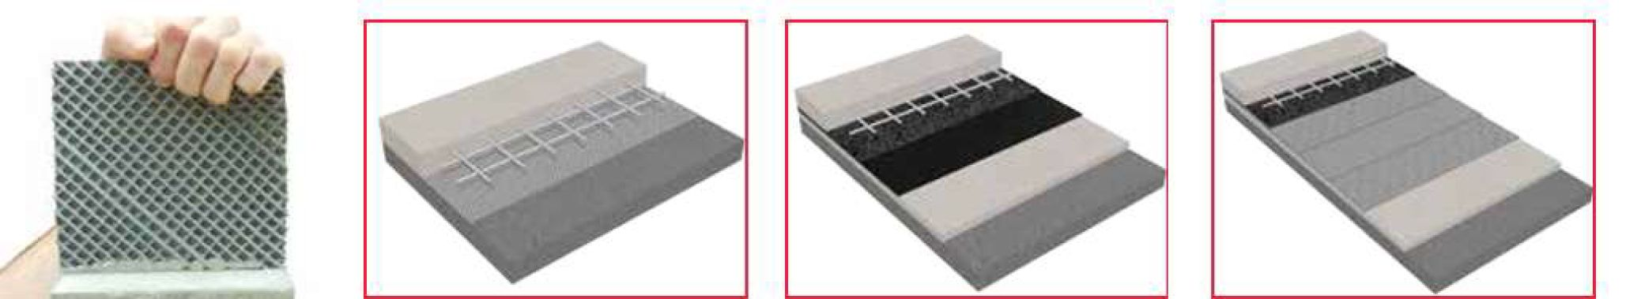

**Proofex Engage** Pre-applied  
premium waterproofing system  
• Structural concrete

* Steel reinforcement
* Proofex Engage membrane

**Self-Adhesive / Torch-on**waterproofing system

* Structural concrete
* Steel reinforcement
* Screed or board protection
* Self-adhesive /

Torch-on membrane

* Blinding concrete

**PVC** Waterproofing System

* Structural concrete
* Steel reinforcement
* Screed or board protection
* Geotextile
* PVC loose laid membrane
* Geotextile
* Blinding concrete

**Remove the risks.** For below-ground structures where the exterior face of the structural concrete is inaccessible, the  
waterproofing must be applied prior to pouring the concrete. Conventional systems are either loose-laid or self-  
adhering to the substrate not the structural concrete, this means there is no seal between the waterproofing and the  
structural concrete which can lead to water travelling between the waterproofing and the structure from any leakages  
that may occur. BS8102:2009 highlights this problem and recommends that a fully bonded, pre-applied waterproofing  
system be used to mitigate this risk. A similar problem occurs where ground settlement takes place.

**Proofex Engage is a unique patented waterproof membrane system** comprising a cell mesh bonded to a  
blended polyethylene / polypropylene membrane which allows poured concrete to interlock, forming a tenacious  
mechanical bond. Proofex Engage mechanically bonds to freshly placed concrete giving a tenacious waterproof seal,  
preventing water migration even if ground settlement occurs. Proofex Engage is supplied with a self-adhesive  
selvedge along one side of the roll and a comprehensive range of auxiliary products. It is installed rapidly with no  
need for blinding concrete, priming or protection and can be trafficked immediately after application.

Proofex Engage provides water, water vapour and gas protection to water excluding structures and protects concrete  
from aggressive ground salts, chemicals and hydrocarbons. Quality is assured through BBA and EN13967:2004 and  
the system is suitable for use in accordance with BS8102:2009 Grades 1, 2 and 3.

* Rapid installation - no blinding concrete or protection required.
* No water-tracking.
* Integrity assured at pile heads.
* Excellent solution for precast concrete.
* Long term watertight durability.
* Assured watertight integrity even in the event of ground settlement.
* Easy jointing and compatible full range of ancillaries.
* Protects structure against ground contaminants.

|  |  |  |
| --- | --- | --- |
| Grade | Example of use of Structure | Performance Level |
| 1 | Car parking; Plant rooms (excluding electrical equipment); Workshops. | Some seepage and damp areas tolerable, dependent on the intended use. Local drainage might be necessary to deal with seepage. |
| 2 | Plant rooms and Workshops requiring a drier environment (than grade 1); Storage areas. | No water penetration acceptable. Damp areas tolerable; ventilation might be required. |
| 3 | Ventilated residential and commercial areas, including offices, restaurants etc ; Leisure centres. | No water penetration acceptable. Ventilation, dehumidification or air conditioning necessary, appropriate to the intended use. |

Packaging: Delivery in rolls 5mm x 1.27m x 30m Coverage approximately 38m2

GEO

SUPPORT

PROOFEX 3000

Proofex 3000 is a black coloured radon resistant cold-working, bitumen-based, adhesive waterproofing 1.5mm  
membrane, with built-in/inlaid cross-laminated HDPE and polymer-modified bitumen. The adhesive side is protected  
by heavy white silicone-treated paper that is removed when mounted. A protective foil at the top of the roller is  
removed by overlap for optimal adhesion, bitumen against bitumen.

The cross laminated HDPE film offers protection against damage and is dimensionally stable. Supplied with self-  
adhesive layer system helps fast installation. Resistant to ground water, soluble sulfates and chlorides the system is  
suitable for grades 2 and 3 for basement waterproofing as defined in BS 8102:2009 and Radon protection as defined  
by BRE report 211.

Applications include waterproofing of, floors, walls, buildings, basements and underground structures, foundations,  
sockets, etc. Proofex 3000 protects the structures even in aggressive environments. Proofex 3000 can be used in  
basements such as waterproofing classes 2 and 3, defi neret in BS 8102 : 1990, "Protection of structures against  
rising water/groundwater".

**Supplied in 1.5mm x 1m x 20m rolls**

PROOFEX 3000MR

Proofex 3000MR brings together the benefits of the PROOFEX 3000 system and was developed for the use where  
there is a presence of methane in the subsoil. An aluminum film provides methane, radon and CO2 resistance,  
creating a stable membrane. A solar reflective finish reduces heat during construction phase. Proofex 3000MR  
provides a vapour and waterproof membrane protecting the concrete from attack from aggressive ground conditions  
such as salts. The tough, flexible design gives improved detailing in and around corners and pipes.

**Supplied in 1.5mm x 1m x 20m rolls**

PROOFEX TOTAL

The system is a 5 layer, reinforced, gas impermeable black/silver membrane comprising of an aluminium foil layer  
and polyester reinforcing grid sandwiched between three layers of polyolefins. The multilayer system is designed for  
maximum gas protection with for use in many applications including ground bearing floors or suspended concrete  
slabs or beams. .

**Supplied in 0.4mm x 2m x 50m rolls**

PREPARATIONS FOR USE

Preparations by smoothing of rough or uneven concrete surfaces using Renderoc ST05 (please see separated  
Technical Data Sheet) and repairs to damage concrete areas and smoothening of sharp surfaces through  
appropriate Renderoc repair products. All surfaces shall be clean, dry and free of ice, dust, cement sludges, paints,  
solvents and oils etc.

r I NORDIC

PROOFEX ANCILLARY PRODUCTS L*iGEO

**SUPPORT  
Proofex LM**

A two-component trowel able membrane for sealing around intricate details such as pipe entries, penetrations, pile  
caps, etc.

**Proofex corner pieces** 125 mm internal and external corner pieces made from polyethylene membrane with a 100  
mm butyl selvedge.

**Proofex “L” section** This 10 m long x 250 mm wide section of polyethylene has 2 butyl selvedge strips. It is used by  
bending at 90o along its length for application between horizontal and vertical membrane to provide waterproofing  
continuity and it also connects with internal and external corner pieces. Proofex “L” section is supplied with a butyl  
“closure” strip at each end, if the “L” section is cut this strip must be replaced with Proofex Engage Detail Strip or  
Total Tape.

Proofex Engage Detail Strip

A double sided waterproof adhesive tape for sealing and jointing roll ends, cut edges and corner pieces. It consists of  
a strong synthetic fibre fabric impregnated and coated both sides with a rubber bitumen adhesive, which is protected  
by a removable siliconised paper. Supplied in rolls of 200m x 10m.

Proofex LM Mesh

A reinforced mesh used in conjunction with Proofex LM for areas of extreme loading (covings, edges and pipe  
penetrations).

Proofex Top Hat

Waterproof pipe entry consisting of polyethylene / polypropylene membrane, which includes an aluminum foil layer.  
0 110mm to 330mm x 330mm

0 160mm to 380mm x 330mm

Proofex Total Tape

To adhere Proofex Top Hats to Proofex Engage and as a closure strip to Proofex “L” section. 50mm x 30m

Nitoseal MS600

A single component grout to seal between Proofex Top Hat and penetration pipe. Packet of 10 x 600ml cartridges

Fosroc Polyurea WCS Gun Grade

**t**o seal between joints in Proofex Engage, around pile caps etc

Fosroc Proofex Welding Rod

To seal overlaps in Proofex Engage whenever necessary

Proofex Primer

A single component bitumen-based primer. Delivered in 5 liter or 25 liter containers

Nitobond HAR

A single component acrylate-based primer. Delivered in 5 liter containers

CONSIDERATIONS

For cold weather working below +5°C, Proofex Engage can normally be applied if the following additional measures  
are taken; apply heat using a hot air blower to all adhesive tapes, store all materials in heated conditions and mix  
Proofex LM in heated conditions. In some cases, a heated tented working area should be used especially where  
Proofex LM and Proofex self-adhesive membranes are used. Normal precautions for winter working should be  
adopted when placing concrete. During installation the membrane should not be left exposed for more than 6 to 8  
weeks.

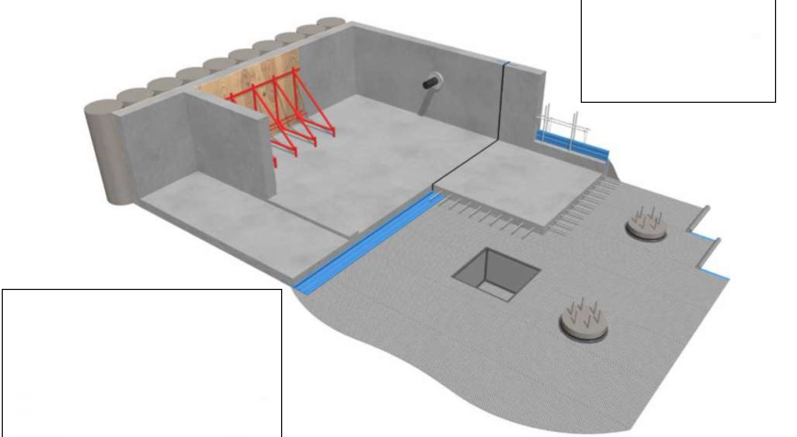

**GEO**

**SUPPORT**

CONSTRUCTION APPLICATIONS

* Single-sided formwork concrete walls
* Double-sided formwork concrete walls
* Pile caps
* Lift pits
* Pipe penetrations
* Expansion and construction joints

TYPICAL BELOW GROUND WATERPROOFING SOLUTION

FOSCROC SYSTEMS

* Proofex Engage pre-applied anti-tracking waterproofing  
  membrane
* Proofex “L” section, Proofex Detail Strip and Polyurea  
  WCS - ancillary products
* Proofex WG / Supercast EPT - waterproof grout for pile  
  heads
* Supercast SW - swellable hydrophilic waterstops for joints
* Supercast Rearguard / Hydrofoil - PVC waterstops for  
  joints
* Supercast Twinstop - composite PVC and Hydrophilic  
  waterstop for joints
* Nitoseal MS300 - one-component flexible sealant for joints
* Hydrocell XL - rot-proof non-absorbent filler board for  
  joints
* Conplast and Structuro - concrete admixtures
* Auramol - mould release agents

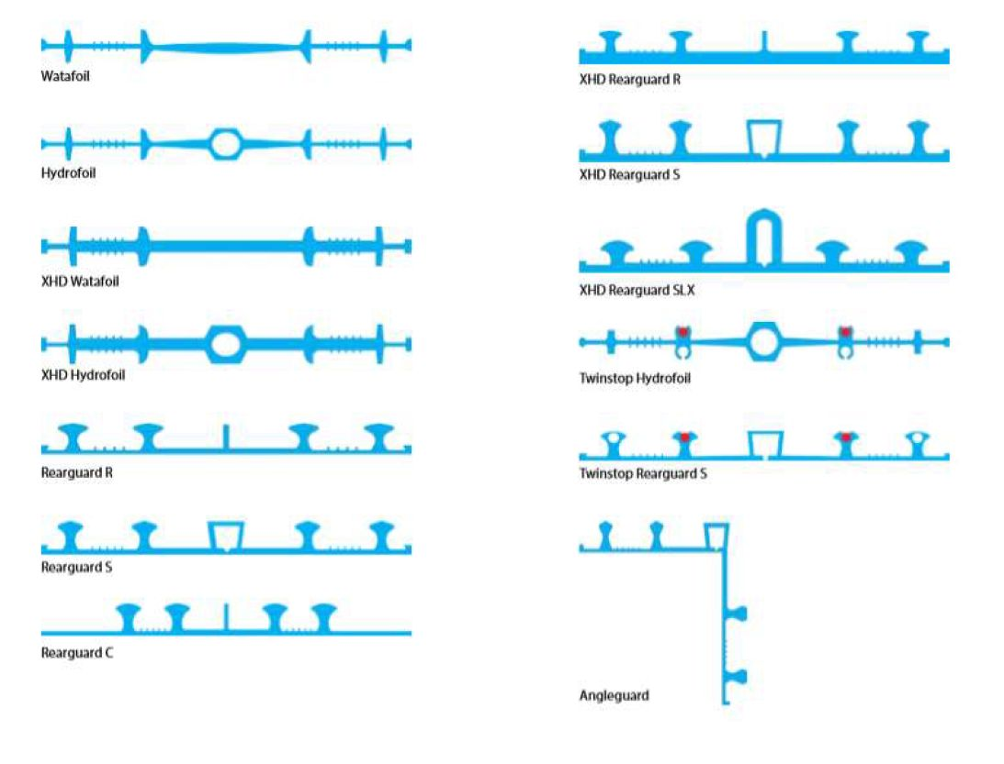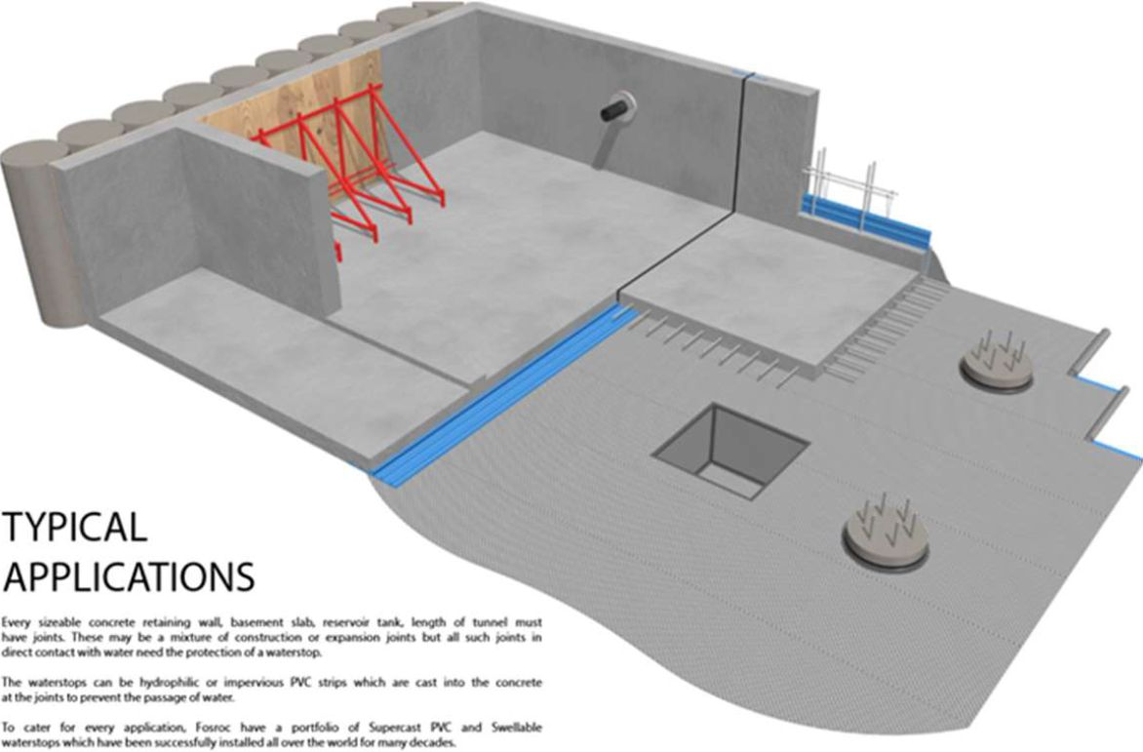

**GEO**

**SUPPORT**

SUPERCAST PVC PROFILES

FOSROC WATER STOP SOLUTIONS

SUPERCAST PVC WATERSTOP PROFILES

Designed with high performance at their core. These profiles capture the best principles of PVC waterstop engineering  
utilising tortuous path ribs, correct bulb shapes giving excellent sealing effect acting as valves, eyelets for secure  
placement and sloping web thickness to avoid cracking. For over four decades Supercast PVC waterstops have been  
installed in many projects throughout the world achieving assured long-term performance even in extreme conditions,  
resulting in prevention of unwanted water penetration.

APPLICATIONS

Every sizeable concrete retaining wall, basement slab, reservoir tank, length of tunnel must have joints. These may be a  
mixture of construction or expansion joints but all such joints in direct contact with water need the protection of a  
waterstop.

The waterstops can be hydrophilic or impervious PVC strips which are cast into the concrete at the joints to prevent the  
passage of water. To cater for every application, The portfolio of Supercast PVC and Swellable waterstops which have  
been successfully installed all over the world for many decades.

SUPERCAST PVC PROFILE SELECTOR

|  |  |  |  |  |  |
| --- | --- | --- | --- | --- | --- |
| Product | 150 | 200 | 250 | 330 | Description |
| Watafoil | * | * | * | * | Centrally placed construction joint |
| Hydrofoil | * | * | * | * | Centrally placed construction joint |
| XHD Watafoil |  |  | * |  | Heavy duty centrally placed construction joint |
| XHD Hydrofoil |  |  | * |  | Heavy duty centrally placed construction joint |
| Rearguard R | * | * | * | * | Externally placed construction joint |
| Rearguard S | * | * | * | * | Externally placed construction joint |
| XHD Rearguard R |  |  | * |  | Heavy Duty externally placed construction joint |
| XHD Rearguards |  |  | * |  | Heavy Duty externally placed construction joint |
| XHD Rearguard SLX |  |  | * |  | Heavy Duty externally placed settlements and high movements |
| Twinstop Hydrofoil |  |  | * |  | Centrally placed composite hydrophilic / pvc |
| Twinstop Rearguard S |  |  | * |  | Externally placed composite hydrophilic / pvc |
| Angleguard |  |  | * |  | Externally placed 90° angled waterstop |
| Rearguard C |  |  | * |  | Compartmernt waterstop for PVC membranes |

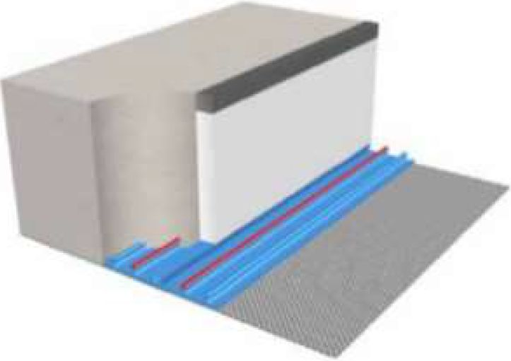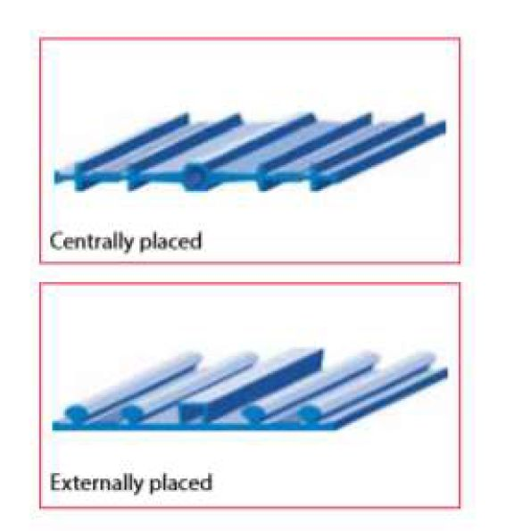Where high water tables exist in deep basement construction and the highest  
possible watertight design is required, then use Fosroc Supercast Twinstop.

SUPERCAST TWINSTOP

GEO

**SUPPORT**

Fosroc Supercast Twinstop is a combined PVC and hydrophilic waterstop for  
extra protection. The PVC profile performs as normal but when water reaches  
the hydrophilic inserts, they expand to form a sealed barrier.

The hydrophilic inserts are based on Fosroc’s basic polymer swellable  
compound which is post-inserted into the PVC waterstop meaning there is no  
chance of pre-swell prior to concrete casting. The hydrophilic insert has a large  
surface area allowing excellent swelling performance. Fosroc Supercast  
Twinstop is available in 250mm width for both centrally and externally placed  
expansion joints.

Fosroc Supercast PVC compound when tested to BS 2782 @ 25oC achieved  
the following test results;

Tensile Strength >15N/mm2

Elongation at break >300%

Hardness 80 to 90 Shore A.

Hydrostatic head of water up to 100m (10 bar)

Movement capability up to 10mm

Hydrofoil rearguard S up to 40mm

Hydrofoil rearguard SLx xHD up to 60mm.

Fosroc Supercast PVC compound meets the US Corps of Engineers  
specification CrD-C 572-74 requiring a tensile strength in excess of 14N/mm2  
and an elongation at break in excess of 300%.

SUPERCAST SWELLABLE

Fosroc Supercast SW waterstop strips use basic-polymer hydrophilic technology which allows them to swell on contact  
with water creating a positive pressure against the faces of the joint thus preventing the passage of water.

The main advantage they have over conventional PVC waterstops for non-movement joints is that they provide a problem  
solving solution for applications where, traditionally, complex formwork would have been required. They provide an  
excellent solution for pipe entry sealing and also do not require hot welding on site.

Fosroc Supercast SW waterstops may be used for the integral sealing of construction joints. However due to the fact they  
must be fully restrained to function properly, they should not be used in movement joints. In this instance a traditional  
Fosroc Supercast PVC waterstop with expansion profile designed to accommodate movement should be used.

|  |  |
| --- | --- |
| **Products** | **Supplied in** |
| SW 10 | 5mm x 20mm x 15m rolls |
| SW 20 | 10mm x 20mm x 5m rolls |

SUPERCAST SWX

Supercast SWX is a 1-component paste used for waterproofing at casting slabs in concrete structures and as adhesive for  
Supercast SW products. Grows up to 200% when in contact with water. It is resistant to aggressive water and  
microorganisms as well as the most water-soluble acids and bases. Supercast SWX is also used for grouting for cable  
and pipe penetrations, elements, between untreated uppers, etc.

**NORDIC**

**GEO**

**SUPPORT**

|  |  |
| --- | --- |
| **Products** | **Supplied in** |
| 600ml cartridges | 10 cartridges per box |

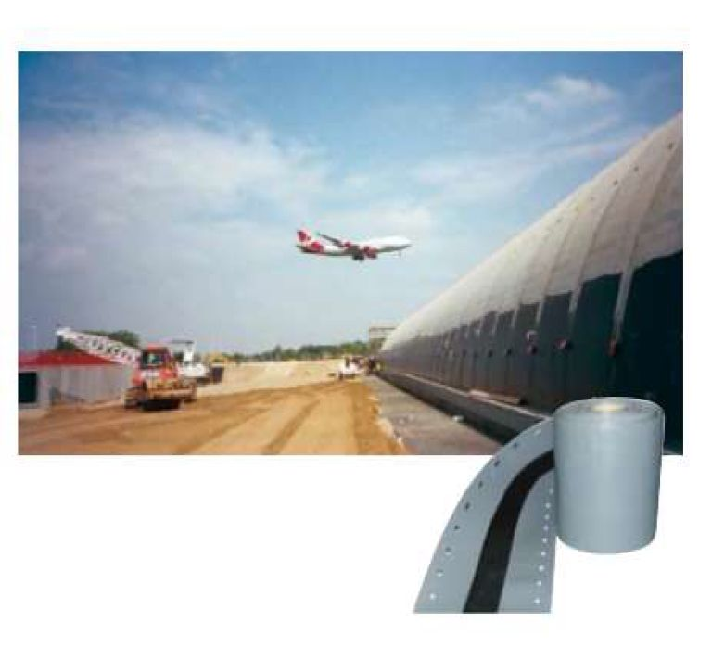Expoband H45 is an un-reinforced Hypalon membrane incorporating a  
central release tape which is designed to be bonded over movement  
joints or crack in structures to prevent the passage of water. It is  
suitable in constriction use and repair/remedial applications

DIALATION JOINT BAND

connection of seams.

Expoband H45 is available in 1mm thickness and widths of 100mm and  
200mm, supplied in a 25metre roll. When longer lengths are required

Expoband H45 can be joined by hot welding. It is bonded to the structure  
on both sides of the joint using Supastik E10 two-part epoxy adhesive.

The band accommodates continuous and pronounced cyclic movement,  
with excellent resistance to weathering, waterproof and chemical  
resistance for joints above and below ground. It uses heat welding for

**Supplied in**

1mmx 100mm x 25m rolls

1mm x 200mm x 25m rolls

GROUTS AND MORTARS

PROOFEX DAMPSTOP (FUGTSTOP) AKTIV

Proofex Dampstop Aktiv is based on a blend of cements, graded sand and a mixture of active chemicals that have the  
property to form insoluble crystals in the concrete / mortar and masonry to protect the surface against water  
penetration and moisture. When the product is applied on damp surfaces, the active chemicals in Proofex Dampstop  
Aktiv react with different reactive salt in the structure and forms insoluble waterproofed crystals in all structure pores.  
This reaction continues whilst there is moisture present and can eventually penetrate the structure. This crystal  
increase can occur with or against water pressure and therefore it is not necessary to apply Proofex Dampstop on the  
side of the structure that faces against the water pressure. The product exhibits excellent thermal compatibility with  
concrete and is fully compatible with other Renderoc mortars.

**Supplied in**

25 kg bags

PROOFEX BB

Proofex BB is a cement-based suction mortar for the protection of concrete and masonry from ingress water  
and moisture, both active and passive water pressure, against aggressive groundwater, certain chemicals  
and acids, and for improving wear resistance. Can also be used on construction blocks, e.g. Leca, gas  
concrete and the like. Used on floors, walls and ceilings, indoors as well as outdoors. Typical applications are  
the sealing of basement exterior walls, castings, swimming pools, marine structures, drinking water  
reservoirs, sewage treatment plants, balconies, concrete decks, etc.

**Supplied in**

6 kg buckets

20 kg buckets

RENDERIC PLUG - QUICK SET MORTAR

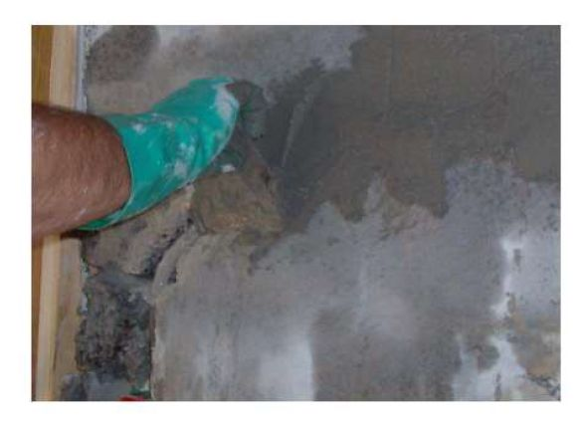The material is based on a blend of cement, graded aggregates, special fillers and  
chemical additives which control the rate of set and minimise the risk of thermal  
cracking. Renderoc Plug provides an initial set time of approximately one minute.

**GEO**

**SUPPORT**

For applications including emergency water-stopping work. Excellent working  
properties; high bond to the substrate, low exotherm minimising thermal cracking and  
contains no chloride.

**Renderoc Plug 1** Lightning mortar for quick repropriation/sealing of leaking concrete with running water. Minimum layer  
thickness 15 mm. Sequestration time about 1 minute (at +20°C).

**Renderoc Plug 5** Lightning mortar for minor repairs where relatively quick untying is required (seeping water). Minimum  
layer thickness 15 mm. Sequestration time about 5 minutes (at +20°C).

**Renderoc Plug 20** Fast-curing mortar for sealing leaking concrete where no leaking water occurs for the first 20 minutes,  
e.g. in the upper part of sewer systems, wells, etc. Minimum layer thickness 15 mm. Sequestration time about 20 minutes  
(at +20°C). Also available for the casting of bolts, depths, etc. and filling of holes, cracks, etc. Similarly, the sequestration  
time is reduced at higher temperatures.

Characteristics

|  |  |  |  |
| --- | --- | --- | --- |
| **Time** | **Renderoc Plug 1** | **Renderoc Plug 5** | **Renderoc Plug 20** |
| 1 hr | 10 MPa | - | - |
| 6 hr | - | 10 MPa | 7 MPa |
| 1 day | 10 MPa | 14 MPa | 11 MPa |
| 28 days | 23 MPa | 27 MPa | 25 MPa |

|  |  |  |  |
| --- | --- | --- | --- |
| **Supplied in** | **Yeild** | | |
| **Renderoc Plug 1** | **Renderoc Plug 5** | **Renderoc Plug 20** |
| 1 kg bucket | 0.5ltr | 0,5ltr | - |
| 6 kg bucket | 3 Itr | 3 Itr | 3 Itr |
| 14 kg bucket | - | 7 ltr | 7 ltr |

NITOCOTE CM210 - WATERPROOF COATING

It is a two-component polymer modified cementitious coating is supplied in a pre-packaged form. The product has  
been designed to be easily mixed on-site using a slow speed drill and paddle and then applied to the substrate using a  
brush, roller, trowel or by spray application. Nitocote CM210, available in grey and white, cures to form a  
flexible impermeable membrane. Nitocote CM210 withstands high positive and negative hydrostatic pressures,  
excellent bond characteristics to concrete and masonry with long working life, bonds to green and damp concrete  
forming an effective barrier to sulphates and chlorides.

|  |  |
| --- | --- |
| **Supplied in Sets** | **Total Weight 23.2 kg** |
| Powder | 18.2 kg sacks |
| Liquid | 5 kg bottle |

BRUSHBOND FLX III - WATERPROOF COATING

Brushbond FLXIII consists of specially selected cements, graded hard wearing aggregates and additives supplied in  
powder form together with a liquid component of polymers providing exceptional adhesion, resiliency, flexibility,  
toughness and durability. Brushbond FLXIII can be applied to damp substrates, requires no primer and has  
elastomeric characteristics enabling bridging of cracks.

|  |  |
| --- | --- |
| **Supplied in Sets** | **Total Weight 25 kg** |
| Powder | 15 kg sacks |
| Liquid | 2 x 5 kg bottle |

|  |  |
| --- | --- |
| **Supplied in rolls** | **Total Weight** |
| 1.0m x 20m | 10 kg |
| 1,5m x 20m | 15 kg |
| 2.0m x 20m | 20 kg |

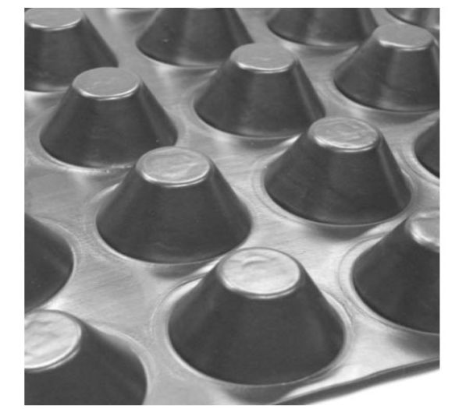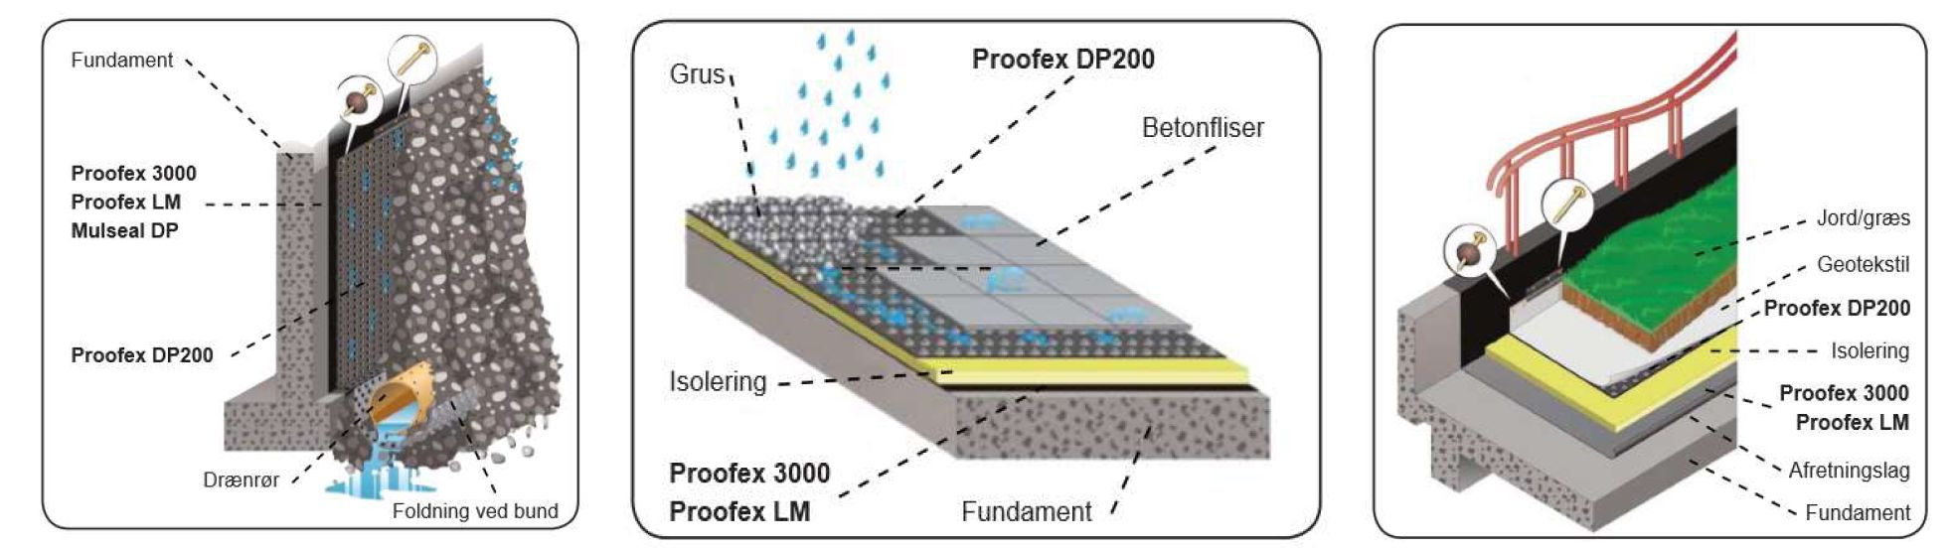

DRAINAGE SYSTEMS

PROOFEX DP200

GEO

SUPPORT

Proofex DP200 is used to protect bitumen membranes on foundations and retaining  
walls during terrain, as the special "knob" surface on the drainage plate allows air to  
circulate, thus keeping the foundation dry.

Proofex DP200 is ideal for protecting the waterproofing membrane so that it is not  
damaged by soil filling. Where there are no water pressure effects, Proofex DP200  
may constitute the very protection against water in the soil, which, due to the fact  
that the water is not water-pressured, can be used to protect the environment. the  
drain plate structure - easily drained to the bottom of the foundation.

Proofex DP200 is also used for terraces and fl ade roofs, where the bitumen membrane needs protection against  
damage and pierce. Here, Proofex DP200 is used as a separation layer between the bitumen membrane and the final  
layer, for example, the bitumen membrane. gravel/sand and concrete

Proofex DP200 is also ideal as an "anti-root" barrier by, for example, roof gardens and turf roofs so that plant roots do  
not perforate the water sealing membrane, as the drainage plate is resistant to chemical and biological substances  
(fungi and bacteria) normally present in the soil, the filling material and the water.

WALLS

ROOF GARDENS

GRASSED ROOF

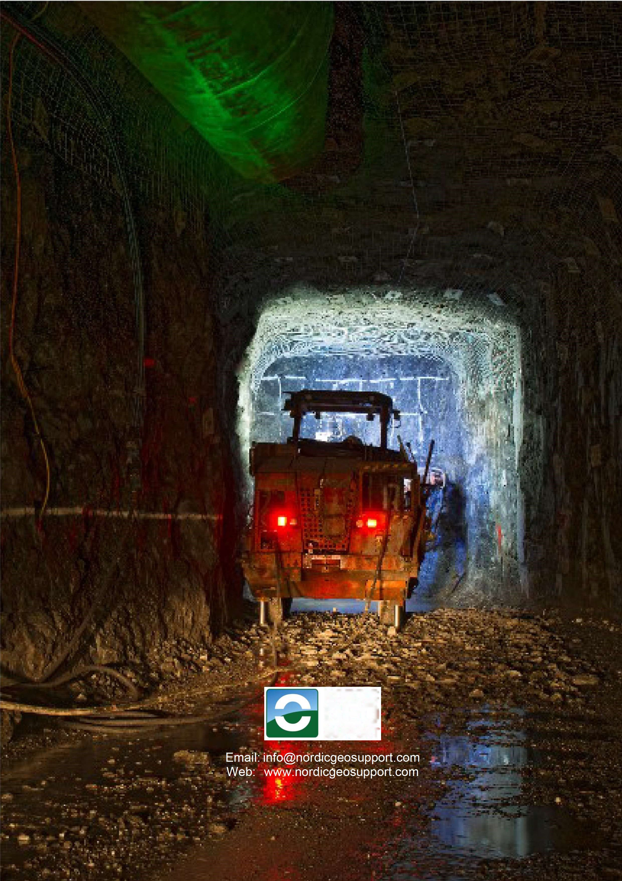

**NORDIC**

GEO

**SUPPORT**