**GUI04**

# Directions

As you have already seen the JLabel class can display simple text on the frame window. JLabel can also be used to display images. Look at the sample program below.

import java.util.*;

import java.awt.*;

import javax.swing.*;

import java.awt.event.*;

public class GUI04 extends JFrame

{

// Step 1 : declare JLabel variable

private JLabel label;

// constructor

public GUI04()

{

// Step 2: create ImageIcon object using an image file as a parameter

ImageIcon image = new ImageIcon("bugsdaffy.jpg");

// Step 3: create label using ImageIcon variable as parameter

label = new JLabel(image);

// Step 4: set label attributes

label.setLocation(0,0);

label.setSize(image.getIconWidth(), image.getIconHeight());

// Step 5: add label to frame

getContentPane().add(label);

// set frame attributes

setLayout(null);

setSize(450, 400);

setDefaultCloseOperation(JFrame.EXIT_ON_CLOSE);

setVisible(true);

}

// main method

public static void main(String[] args)

{

GUI04 app = new GUI04();

}

}

### Step 1: Declare JLabel Variable

You must declare a JLabel instance variable to store the JLabel object.

private JLabel label;

### Step 2: Create ImageIcon Object

There is a Java Swing class named **ImageIcon** that can be used to store images that have an image format type of GIF, JPEG, or PNG.

ImageIcon image = new ImageIcon("bugsdaffy.jpg");

The code above creates an ImageIcon object with the specified image file and stores its reference in a variable named image. The image file must be located in the same folder as your programs class file; otherwise it requires a directory path.

### Step 3: Create JLabel

Once the ImageIcon object has been created you can create the JLabel by passing the ImageIcon variable as a parameter to the JLabel constructor.

label = new JLabel(image);

### Step 4 : Set JLabel Attributes

You can set the size of the JLabel to the dimensions of the image be using the following code.

label.setSize(image.getIconWidth(), image.getIconHeight());

### Step 5 : Add Label to ContentPane

Inorder for the label to appear in the frame window it must be added to the content pane layer.

getContentPane().add(label);

# Exercise

1. Create a java file named GUI04 and add the code above.
2. Right-click on the image below and select Save Picture As....  
   Save it in the GUI folder on your home directory (same location as the java file) with the name bugsdaffy.jpg.

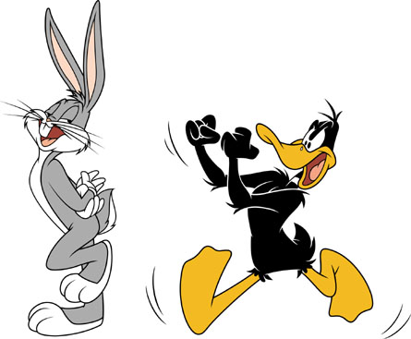

1. Execute the program.

# Source File

GUI04.java

# Sample Run

