Working Functionalities of SwasthyaSync HMS

Product Name | SwasthyaSync
Version | 1.0.0
Document Type | Working Functionalities Reference
Technology Stack | React 18 (Vite) · Node.js (Express) · PostgreSQL
Date | June 2026

1. System Overview
SwasthyaSync is a full-stack, cloud-native Hospital Management System (HMS) designed to digitise and unify all hospital workflows into a single integrated platform. The system covers 40+ hospital modules spanning patient registration, clinical care, diagnostics, pharmacy, billing, revenue cycle, and administration.

System Architecture
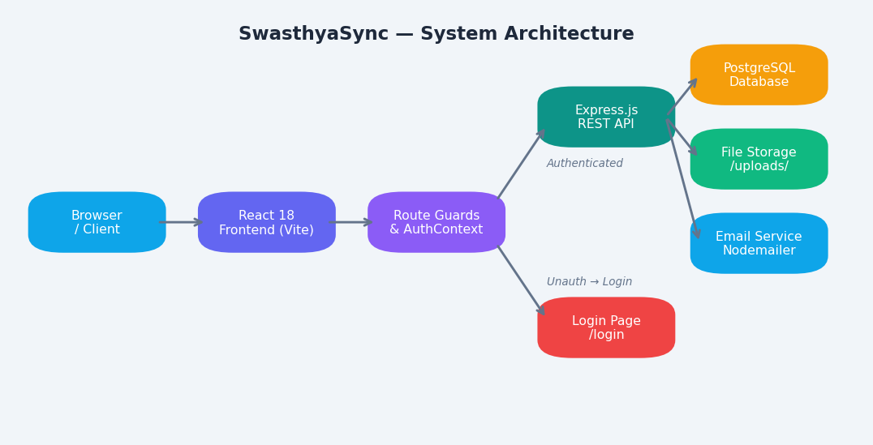
Figure 1.1 — High-Level System Architecture

Key Highlights
Feature | Details
Modules | 40+ fully integrated hospital modules
Compliance | NABH documentation standards, Insurance audit trails
Access Control | Role-based access control (Admin / Staff)
Security | JWT-based authentication, bcrypt-encrypted credentials
PDF Generation | Built-in lab reports, discharge summaries, invoices
Form System | PDF annotation engine for hospital consent forms
Deployment | Docker-ready, Vite-built frontend, Express backend

2. Authentication & Access Control
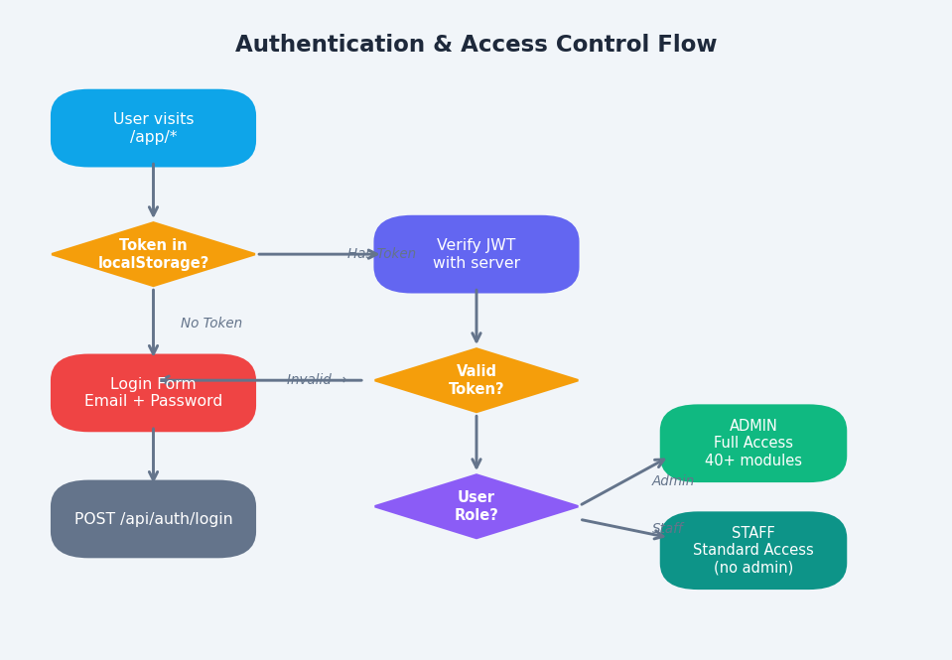
Figure 2.1 — Authentication & Role-Based Access Control Flow

2.1 Login
- Email + password authentication
- JWT tokens issued on login and stored in browser localStorage
- Token verified on every protected route via AuthContext
- Automatic redirect to /login for unauthenticated sessions
- Loading state prevents flash of unauthenticated content

2.2 Registration
- New hospital/user registration form
- Fields: Hospital name, user name, email, password, confirm password
- Password hashing handled server-side (bcrypt)

2.3 Role-Based Access Control
Role | Access Level | Restricted Modules
Admin | Full system access | None — access to all 40+ modules
Staff | Operational access | Staff Management, Form Templates, Audit Log

3. Dashboard & Analytics
The main authenticated landing page provides hospital-wide at-a-glance metrics with live data from all connected modules.

KPI Stat Cards
Metric | Description | Trend
Total Patients | All patients registered in the system | ↑ % vs last period
Bed Occupancy | Current % with bed detail (occupied/total) | ↑ % change
Pending Notes | Clinical notes awaiting digitisation | ↓ (target: reduce)
Today OPD | Outpatient visits today | ↑ % change
Revenue (Month) | Monthly billed revenue vs. last month | ↑/↓ %
Pending Lab Tests | Lab orders awaiting results | Count
Critical Patients | Patients flagged as critical | Count
Today Revenue | Billing amount generated today | Rs value

Module Launcher — 13 Category Tabs
Category Tab | Key Modules
Patient Administration | Registration, OPD, IPD, Queue, QR, Barcode, Merging, Medical Records
Clinical | Doctors Workbench, Clinical Notes, Discharge Summary, Patient Forms
Patient Billing | OPD Billing, IPD Billing, Payment Collection, GST Management
Revenue Cycle | Claims Processing, Claim Submission, Medical Audit, Alerts
Radiology | Radiology Orders, Report Management, PACS Integration
Laboratory | Lab Orders, Result Entry, Sample Collection, Lab Reports
Nursing Management | Nurse Station, Medication Admin, Vitals Monitoring, Ward Rounds
Operation Theatre | OT Scheduling, OT Notes, Anaesthesia Notes, OT Reports
Blood Bank | Blood Inventory, Donor Management, Blood Requests, Reports
Pharmacy | Drug Dispensing, Drug Inventory, Pharmacy Billing, Prescriptions
Inventory Management | Stock Management, Purchase Orders, Vendor Management
Analytics | MIS Dashboard, MIS Reports, Revenue Analytics, Operational Reports
Emergency | Emergency Triage, Ambulance Management, Critical Care

4. Patient Administration

4.1 Patient Lifecycle
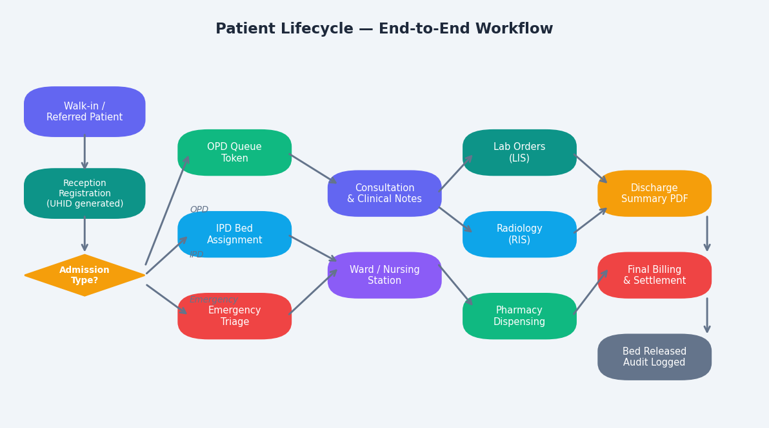
Figure 4.1 — Patient End-to-End Lifecycle

4.2 Patient Registration — 4-Step Wizard
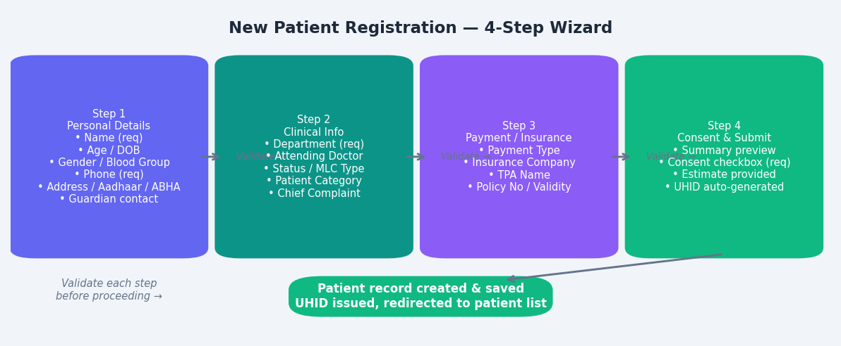
Figure 4.2 — New Patient Registration Wizard Flow

Step 1  Personal Details  Name · Age · Gender · Blood Group · Contact · Address · ABHA · Guardian | Step 2  Clinical Info  Department · Doctor · Status · MLC Type · Chief Complaint | Step 3  Payment/Insurance  Payment Type · Insurance · TPA · Policy No · Validity | Step 4  Consent & Submit  Summary review · Consent checkbox · Estimate provided · UHID issued

Step 1 — Personal Details Fields
Field | Details | Required
Full Name | Patient full name | Yes
Admission Type | OPD / IPD / Emergency / Day Care / ICU Direct | Yes
Age | Numeric (years) | Yes
Date of Birth | Date picker | No
Gender | Male / Female / Other / Prefer not to say | Yes
Blood Group | A+/A-/B+/B-/AB+/AB-/O+/O-/Unknown | No
Mobile Number | 10-digit mobile | Yes
Aadhaar Number | XXXX XXXX XXXX format | No
ABHA Health ID | 14-digit ABHA number | No
Address | Street, city, state (all Indian states), PIN | No
Guardian Name / Relation / Phone | Emergency contact details | No

Step 2 — Clinical Info Fields
Field | Details
Department | 30+ departments (General Medicine, ICU, Cardiology, Neurology, etc.)
Attending Doctor | Dropdown from registered doctors
Initial Status | Stable / Critical / Recovering / Under Obs / Serious
Patient Category | General / BPL / Senior Citizen / Divyangjan / VIP / Staff
MLC Type | None / Road Accident / Assault / Poisoning / Burns / Suicide Attempt / etc.
Chief Complaint | Free-text textarea for presenting symptoms

Step 3 — Payment / Insurance Fields
Field | Details
Payment Type | Self Pay (Cash/UPI) / Insurance/TPA / CGHS / ECHS / ESI / Ayushman Bharat / Govt/Free
Insurance Company | Visible only when Insurance/TPA selected
TPA Name | Third-party administrator name
Policy / Member ID | Policy number
Policy Validity | Expiry date picker

4.3 Patient Detail Panel — Tabs
Tab | Contents
Overview | MLC alert banner, key info grid, chief complaint, quick navigation to Forms tab
Clinical | Full demographics, Aadhaar, ABHA ID, insurance details section
Forms | Assigned form instances, assign new template, open FormViewer PDF annotator
Discharge | Assigned discharge summaries, assign template, open DischargeEditor HTML editor

5. Inpatient Department (IPD)
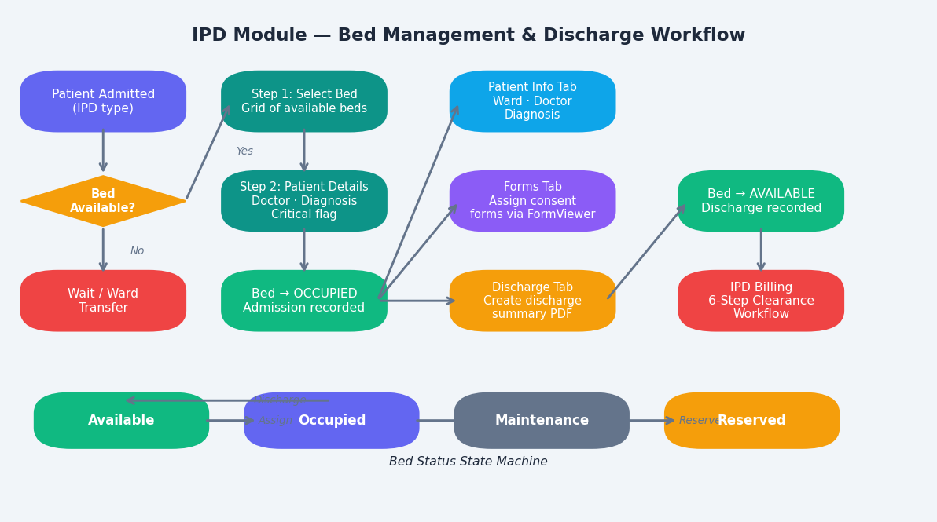
Figure 5.1 — IPD Bed Management & Discharge Workflow

Bed Status Definitions
Status | Colour | Description | Action on Click
Occupied | 🟣 Purple | Patient assigned: shows name, age, doctor, diagnosis | Open Bed Detail Panel
Available | 🟢 Green | No patient assigned | Open Assign Bed modal
Alert | 🔴 Red dot | Pulsing indicator — critical patient | Open Bed Detail Panel
Maintenance | ⚙️ Gray | Under repair/cleaning | No action
Reserved | 🟡 Amber | Reserved for upcoming admission | No action

Bed Detail Panel Tabs
Tab | Contents & Actions
Patient Info | Ward, bed type, attending doctor, admission date, diagnosis. Quick links to Forms and Discharge tabs. Buttons: View Full Record, Write Clinical Note, Generate Discharge Summary, Release Bed
Forms | List of assigned forms with status (Blank/In Progress/Completed). Assign new templates from categorised library. Opens FormViewer on click.
Discharge | Assign discharge summary templates. Opens DischargeEditor (HTML rich text). Download as PDF. Track status.

6. Emergency Module
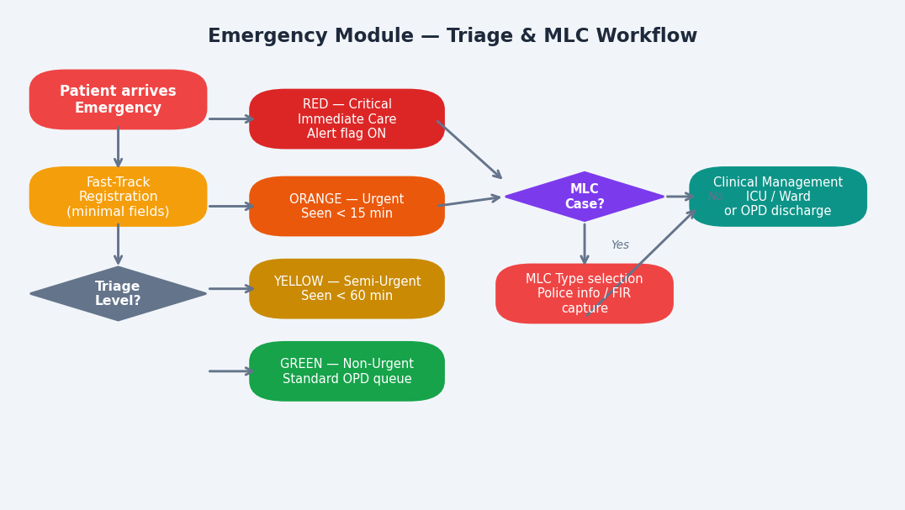
Figure 6.1 — Emergency Triage & MLC Workflow

Triage Levels
Level | Colour | Description | Response Time
Red — Critical | 🔴 | Life-threatening. Alert flag ON. Immediate care required. | Immediate
Orange — Urgent | 🟠 | Serious condition. Priority care. | Within 15 minutes
Yellow — Semi-Urgent | 🟡 | Moderate condition. Can wait briefly. | Within 60 minutes
Green — Non-Urgent | 🟢 | Minor condition. Standard OPD queue. | Standard queue

MLC (Medico-Legal Case) Types
MLC Type
Road Traffic Accident (RTA)
Assault
Poisoning
Burns
Sexual Assault
Suicide Attempt
Industrial Accident
Other MLC

7. Appointments & Scheduling
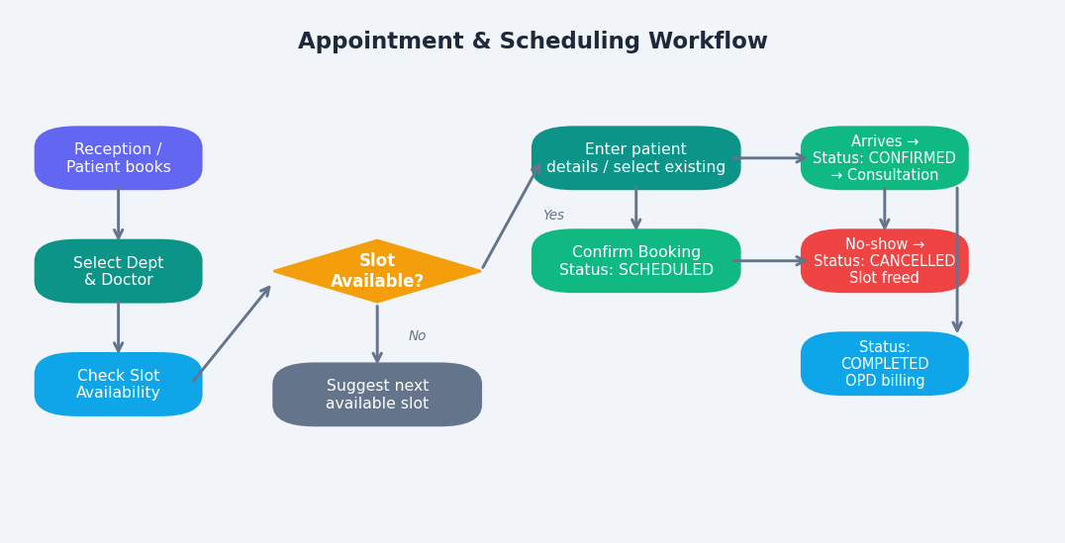
Figure 7.1 — Appointment Booking Workflow

Status | Description
Scheduled | Appointment booked, patient not yet arrived
Confirmed | Patient has arrived and checked in
Completed | Consultation done, OPD workflow begins
Cancelled | Patient did not arrive or appointment was cancelled

8. Clinical Modules

8.1 CPOE — Computerised Physician Order Entry
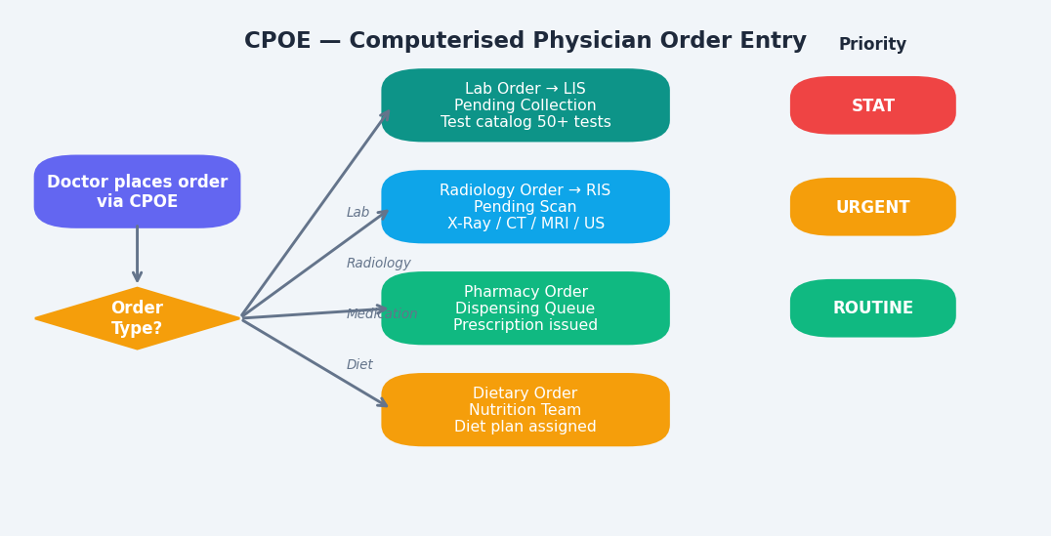
Figure 8.1 — CPOE Order Entry Flow

8.2 Discharge Summary Workflow
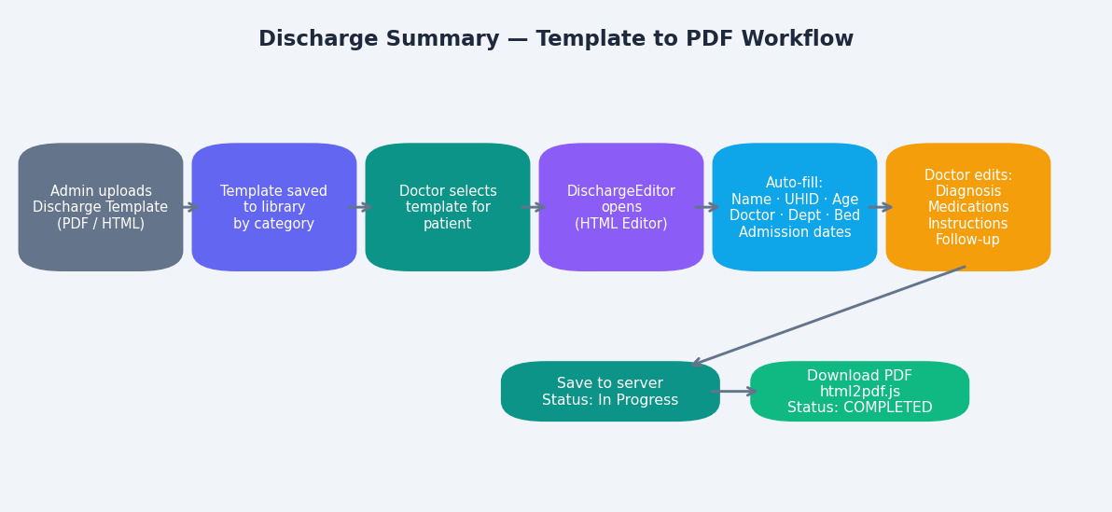
Figure 8.2 — Discharge Summary Template to PDF Workflow

8.3 Patient Forms & Consent Management — FormViewer
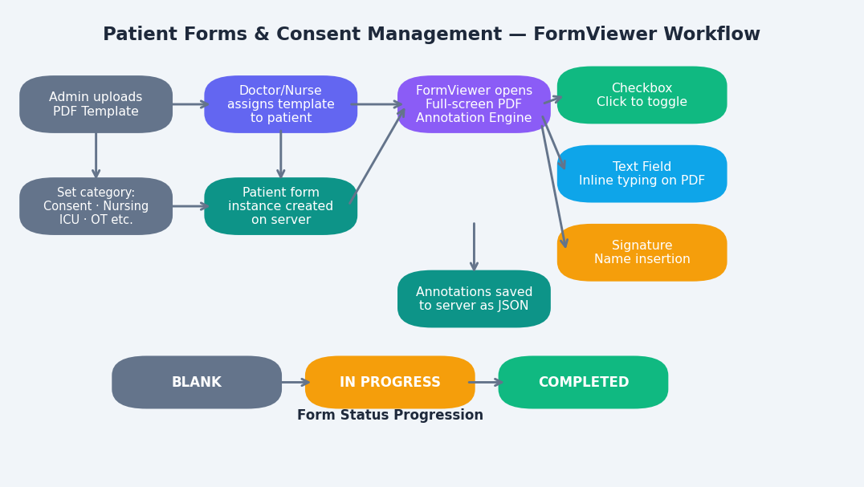
Figure 8.3 — FormViewer PDF Annotation Engine Workflow

Form Categories
Category | Typical Forms
Consent | General Consent for Treatment, Surgical Consent, Anaesthesia Consent
Assessment | Initial Assessment Form, Nursing Assessment, Pain Assessment
Nursing | Nursing Notes, Medication Administration Record (MAR)
ICU | ICU Admission Form, Critical Care Daily Assessment
OT | Pre-operative Checklist, OT Consent, Post-op Record
Emergency | Emergency Assessment, MLC Documentation Form
Discharge | Discharge Instructions, Against Medical Advice (AMA) Form
General | Patient Rights & Responsibilities, Hospital Policy Acknowledgement

Clinical Note Types
Note Type | Description
Admission Note | Initial assessment on patient admission
Progress Note | Daily/shift update on patient condition
Procedure Note | Documentation of a clinical procedure performed
Consultant Note | Opinion from a specialist consultant
Nursing Note | Nursing observations and care provided

9. Laboratory Information System (LIS)
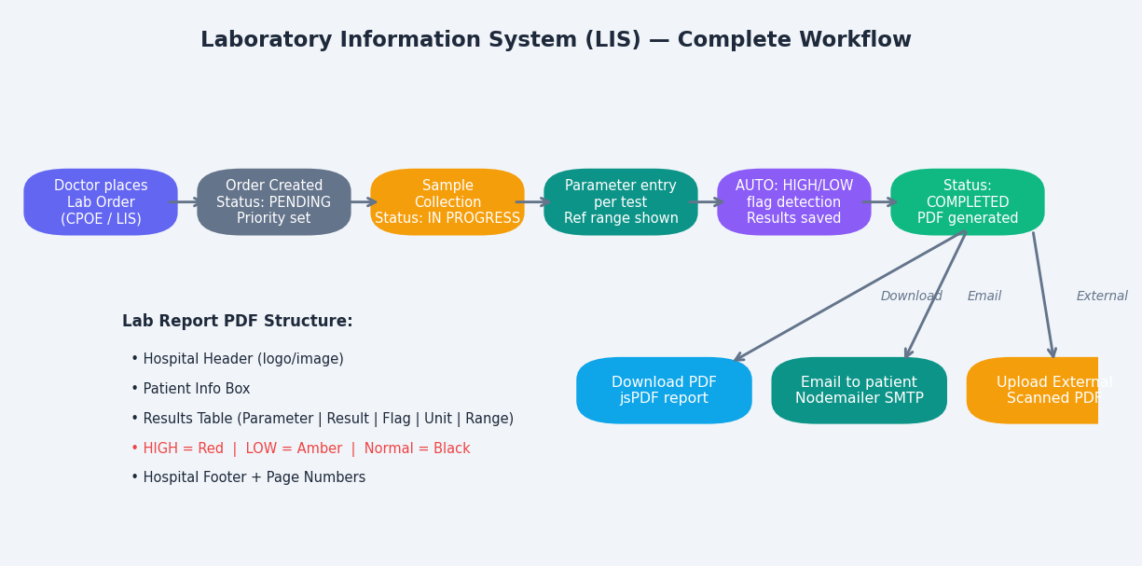
Figure 9.1 — Lab Order to PDF Report Complete Workflow

Lab Test Catalog — 50+ Tests by Category
Category | Tests (examples)
Haematology | CBC, ESR, PT/INR, APTT, D-Dimer, G6PD, Blood Group & Rh
Biochemistry | LFT, KFT, Lipid Profile, Blood Sugar (Fasting/PP/Random), ABG, Amylase, Lipase, Electrolytes
Pathology | Thyroid Profile (T3/T4/TSH), HbA1c, Vitamin D, B12, PSA, CEA, CA125, CA19-9, AFP, Beta HCG
Microbiology | Widal, Dengue NS1/IgG/IgM, Malaria Antigen, HIV, HBsAg, HCV, VDRL, Blood/Urine Cultures, Mantoux
Immunology | CRP, RA Factor, ASO Titre
Cardiology | Troponin I/T, CPK, CPK-MB, LDH

Lab Order Priority Levels
Priority | Description | Turnaround
STAT | Life-threatening emergency — process immediately | Immediate
URGENT | Clinically significant — process as soon as possible | Within 1-2 hours
ROUTINE | Standard testing — normal processing queue | Standard TAT

Lab Report PDF Contents
PDF Section | Contents
Header | Hospital logo + name + address + tagline (Text/Logo mode) OR full header image (Image mode)
Report Title | LABORATORY TEST REPORT
Patient Info Box | Patient Name, Patient ID, Requesting Doctor, Report Date & Time
Investigation Title | Test name (e.g. CBC, LFT, etc.)
Results Table | Parameter | Result | Flag (HIGH/LOW) | Unit | Biological Reference Range
Flag Indicators | HIGH values in Red, LOW values in Amber, Normal values in Black
Footer | Lab director signature, accreditation info, page numbers (Text mode) OR full footer image

10. Billing & Revenue Cycle
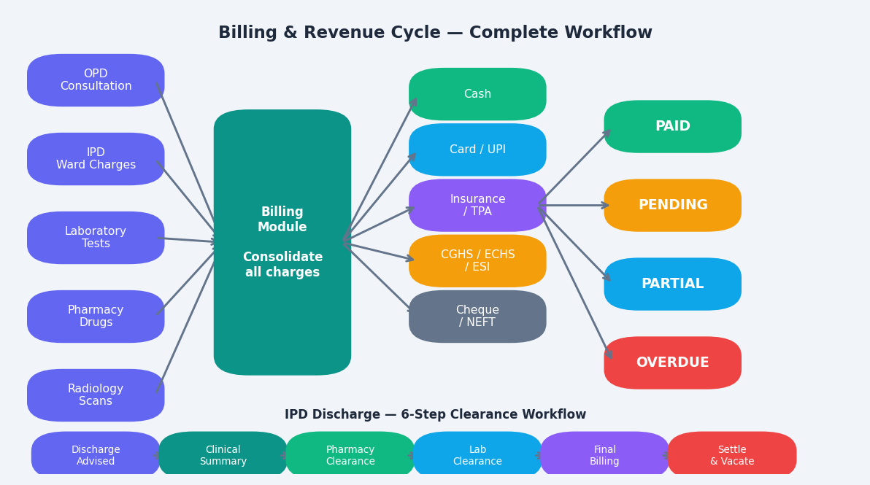
Figure 10.1 — Complete Billing & Revenue Cycle Workflow

Invoice Status Types
Status | Description
Paid ✅ | Full payment collected. Bill settled.
Pending ⏳ | Invoice generated, payment not yet received.
Partial 💳 | Partial payment received, balance outstanding.
Overdue ⚠ | Payment due date passed, not yet settled.

Accepted Payment Methods
Method | Description
Cash | Cash payment at counter
Card | Debit/Credit card payment
UPI | UPI payment (GPay, PhonePe, Paytm etc.)
Insurance | Third-party insurance settlement
Cheque | Cheque payment
NEFT | Bank transfer via NEFT/RTGS

IPD Discharge Billing — 6-Step Clearance Workflow
Step | Stage | Description
0 | Discharge Advised | Doctor advises discharge. Process initiated.
1 | Clinical Summary | Doctor completes clinical summary and signs off on case.
2 | Pharmacy Clearance | All pharmacy charges verified and added to bill.
3 | Laboratory Clearance | All lab test charges verified and added to bill.
4 | Final Billing | All charges consolidated: ward, nursing, OT, lab, pharmacy, radiology.
5 | Settle & Vacate | Patient pays final bill. Bed released. Admission closed.

TPA / Insurance Management
- Insurance company and TPA master data management
- Pre-authorisation request tracking and submission
- Claims processing and submission to insurance company
- Medical audit trail — full documentation for insurance review
- Technical audit documentation for claim processing
- Alerts management for claim status updates and queries

11. Settings & Hospital Configuration
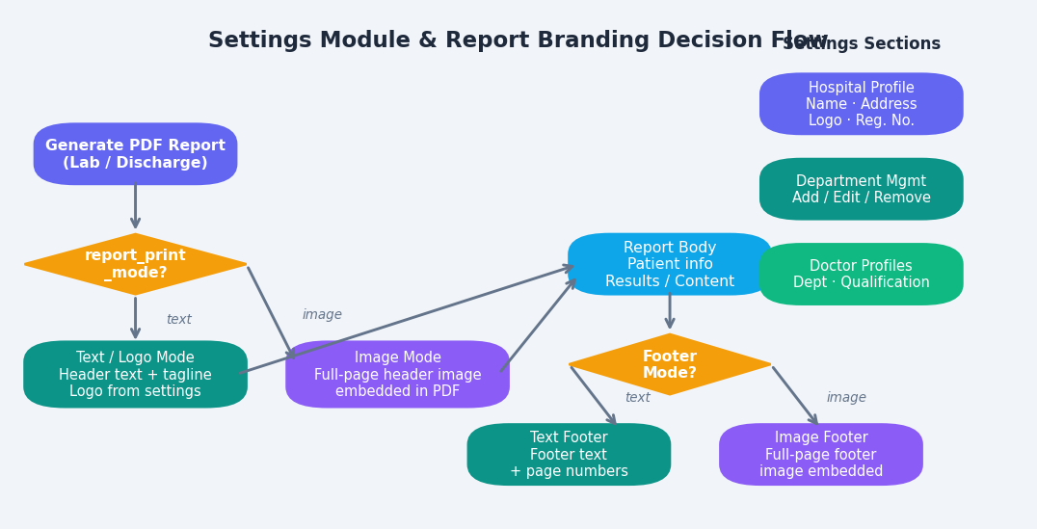
Figure 11.1 — Settings Module & Report Branding Decision Flow

Report Print Modes
Mode | Header | Footer | Use Case
Text / Logo | Hospital name + tagline + logo from settings | Text footer + page numbers | Standard branded reports
Image Mode | Full-page header image (uploaded by admin) | Full-page footer image (uploaded by admin) | Pre-designed letterhead/stationery

12. Other Clinical & Operational Modules

12.1 Radiology Information System (RIS)
Feature | Details
Order Creation | Radiology order linked to patient and requesting doctor
Investigation Types | X-Ray, CT Scan, MRI, Ultrasound, ECG, Echo, and more
PACS Integration | Integration point for PACS (Picture Archiving and Communication System)
Report Management | Type report in system or upload scanned PDF
Status Tracking | Pending → Scanned → Reported

12.2 Pharmacy Management
Feature | Details
Drug Dispensing | Prescription-based drug dispensing from doctor orders
Drug Inventory | Stock tracking with low-stock alerts
Pharmacy Billing | Drug charges automatically added to patient bill
Drug Catalog | Medicine master with dosage and category

12.3 Blood Bank
Feature | Details
Inventory Management | Blood stock tracking by blood group (A+/A-/B+/B-/AB+/AB-/O+/O-)
Donor Management | Donor registration, donation history, eligibility check
Blood Components | Whole Blood, Packed RBCs, Platelets, FFP, Cryoprecipitate
Blood Requests | Request linked to patient, compatibility verification

12.4 Operation Theatre (OT)
Stage | Documentation
Scheduling | OT booking: date, time, OT room, surgeon, anaesthesiologist
Pre-operative | Surgery checklist, pre-op notes, patient briefing
Anaesthesia | Anaesthesia notes by anaesthesiologist
Intra-operative | OT notes: surgical findings, procedure steps
Post-operative | Recovery room monitoring, post-op instructions

12.5 Inventory Management
- Stock item master: medicines, consumables, medical equipment
- Purchase order creation and vendor tracking
- Goods receipt and automatic stock increment on receipt
- Stock level monitoring with configurable low-stock alerts
- Vendor master management with contact and payment terms
- Reports: current stock, stock movement, inventory valuation

12.6 Staff Management (Admin Only)
- Staff registration: doctors, nurses, administrative staff, lab technicians
- Role assignment: Admin or Staff
- Department allocation and designation management
- Active / Inactive status control
- Staff list with search and filter

13. Reports & MIS
Report Type | Contents
MIS Dashboard | Hospital-level KPI overview with live metrics
MIS Reports | Exportable data: admissions, discharges, OPD visits
Revenue Analytics | Revenue trend, department-wise collections, insurance vs. cash split
Operational Reports | Bed occupancy, average length of stay, OT utilisation, lab TAT
Clinical Audit | Quality metrics, clinical outcome tracking, NABH documentation

14. Audit Log (Admin Only)
Complete chronological log of all system actions, tamper-proof for compliance and investigation purposes.
Event Type | Details Logged
Patient created / updated | UHID, fields changed, user, timestamp
Bed assigned / released | Bed ID, patient, doctor, action, timestamp
Lab order / result entered | Order ID, test name, result, user, timestamp
Bill generated / payment received | Invoice ID, amount, payment method, user
Form assigned / completed | Form ID, patient, template, status change
User login / logout | Username, IP, timestamp
Settings changed | Field changed, old value, new value, user

15. Technical Architecture

Frontend Technology Stack
Component | Technology | Purpose
Framework | React 18 with Vite | UI framework with fast HMR development
Routing | React Router v6 | Client-side routing with protected routes
Charts | Recharts | Area, Bar, and Pie charts for analytics
Icons | Lucide React | Consistent icon library
PDF Generation | jsPDF + jsPDF-AutoTable + html2pdf.js | Lab reports, discharge summaries, invoices
PDF Rendering | pdfjs-dist | Render PDF forms in browser
QR Code | html5-qrcode | QR code scanning for patient registration
State Management | React Context (AuthContext) | Global auth state management
Styling | Vanilla CSS + CSS custom properties | Design system with tokens

Backend Technology Stack
Component | Technology | Purpose
Runtime | Node.js | JavaScript server runtime
Framework | Express.js | REST API server
Database | PostgreSQL | Relational data storage
Authentication | JWT (jsonwebtoken) + bcrypt | Token auth + password hashing
File Storage | Local filesystem /server/uploads/ | PDFs, images, logos
Email | Nodemailer (SMTP) | Lab report email delivery

Key Database Tables
Table | Purpose
patients | Master patient record with all demographics, clinical info, payment details
beds | IPD bed registry with status, ward, patient assignment
lab_orders | Lab test orders, results (JSON), PDF path, status
radiology_orders | Radiology investigation orders and reports
billing | Invoice and payment records with status tracking
appointments | OPD appointment bookings with slot management
doctors | Doctor master: name, department, qualification
clinical_notes | Doctor clinical documentation with priority and type
form_templates | Uploaded PDF form templates with category
patient_forms | Patient-specific form instances with annotations JSON
discharge_templates | Discharge summary template library
discharge_summaries | Patient-specific discharge summary instances
staff | Staff and user records with role and department
audit_log | Tamper-proof system action audit trail
hospital_settings | Hospital profile, branding, report configuration

Deployment Configuration
Component | Details
Containerisation | Docker + Docker Compose
Frontend build | npm run build (Vite production bundle)
Dev server | npm run dev (Vite with HMR on port 5173)
Backend | Node.js Express server (port configurable via .env)
Database | PostgreSQL (Docker container or managed instance)
Environment | .env file for DB credentials, JWT secret, SMTP config

Document prepared from codebase analysis of the SwasthyaSync HMS project.
© 2026 SwasthyaSync. All rights reserved.

