Alexsandria Ryan  
APPD 1001  
Assignment #2  
Colour Palette  
November 4, 2022

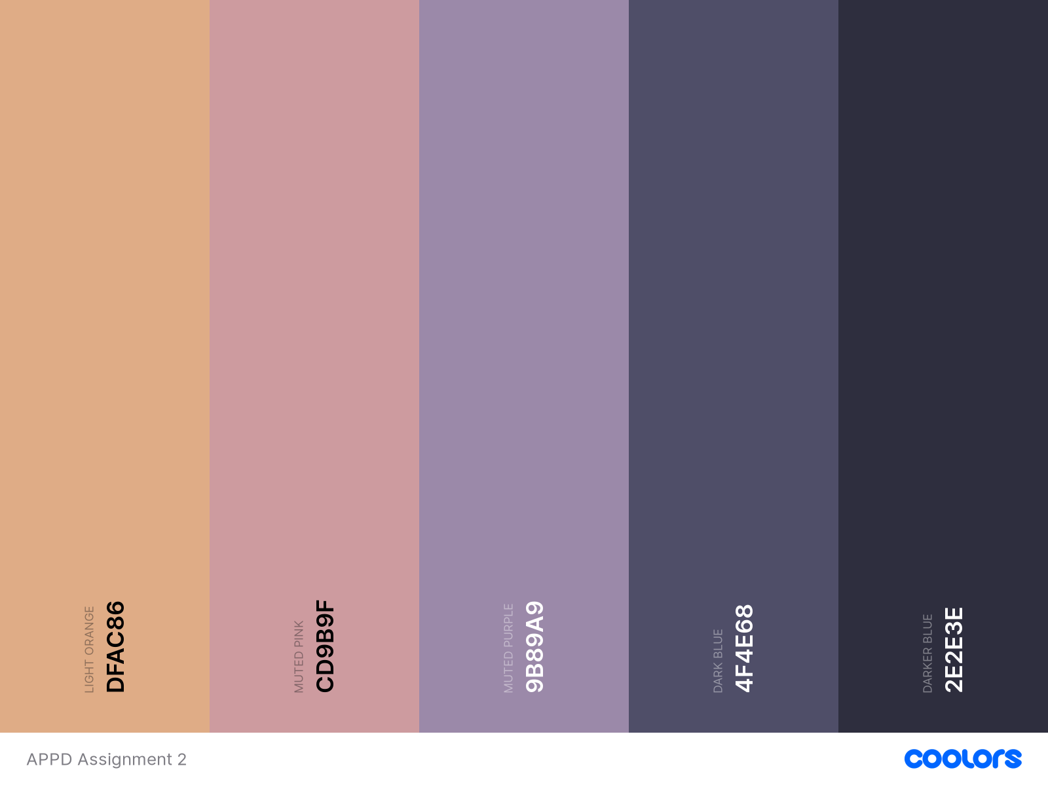Palette generated from background image (downloaded from FreePik.com -- <https://www.freepik.com/free-vector/gradient-lo-fi-illustrations_23987053.htm#&position=0&from_view=undefined>)

# References

pikisuperstar. (n.d.). *Gradient lo-fi illustrations.* Retrieved from Freepik: https://www.freepik.com/free-vector/gradient-lo-fi-illustrations_23987053.htm#&position=0&from_view=undefined