## INTRODUCTION:

### OVER VIEW:

Empathy map[stop child labour],Brainstroming[Stop child labour]and Stop child labour post.

## PURPOSE:

How to create stop child labour post and procrdure.It is a way to know the information and current affairs.

## C:\Users\pc\AppData\Local\Microsoft\Windows\INetCache\Content.Word\IMG_20231018_215455.jpgPROBLEM DEFINITION AND DESIGN THINKING : BRAIN STROME EMPATHY MAP

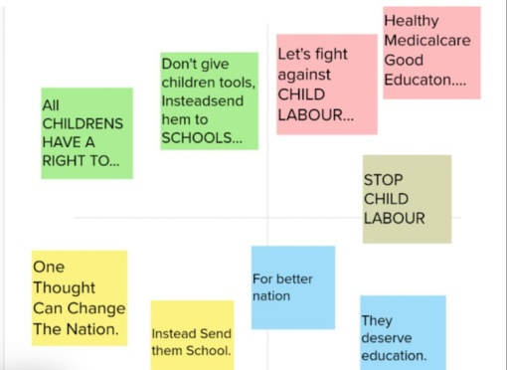

## RESULT:

## STOP CHILD LABOUR POST IN CANVA

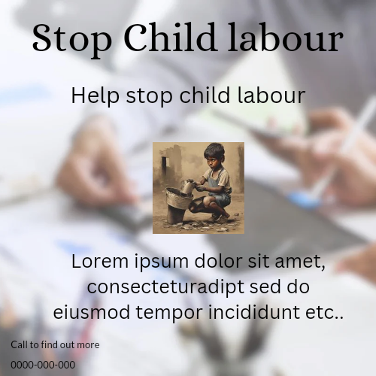

## APPLICATION:

Governments should tighten the laws against it as well as fight poverty as a major cause for this exploitation.

## CONCLUSION:

In conclusion, Child labour is a crime that should be stopped.