CONTENT

USER MANUAL 2

USER MANUAL
- Run “Scrappy 1.0.0.exe”
- Choose working mode. “File” – you will have access to files only in 1 specific “input - output” directory , or “Dir” – you can choose which directory use as “input – output”.

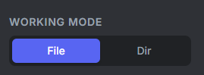
- If you want to parse “JSON” file. Press button “Parse JSON” ,and select file you need to parse.
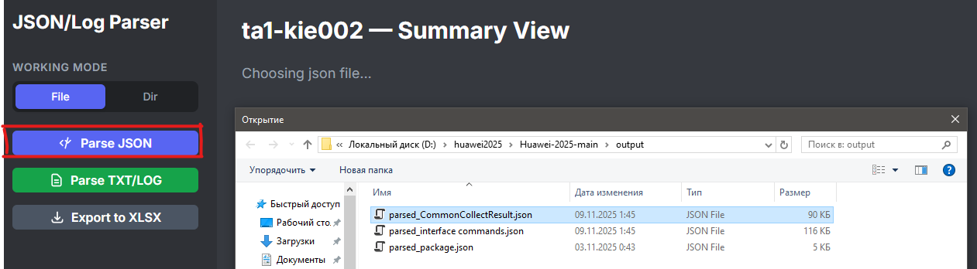
3.1) Wait until analysis over and displayed summary view on the right side of the app. 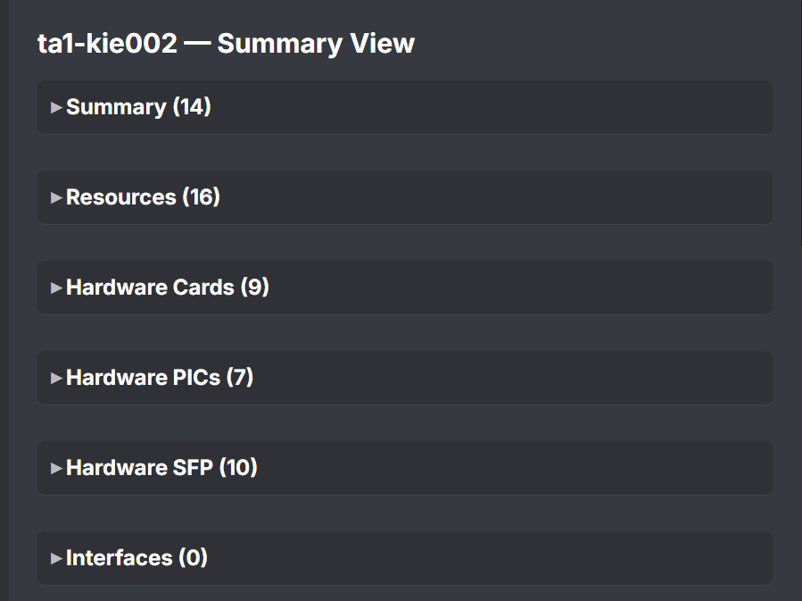
- If you want to parse “TXT\LOG” file. Press button “Parse TXT\LOG” ,and select file you need to parse. 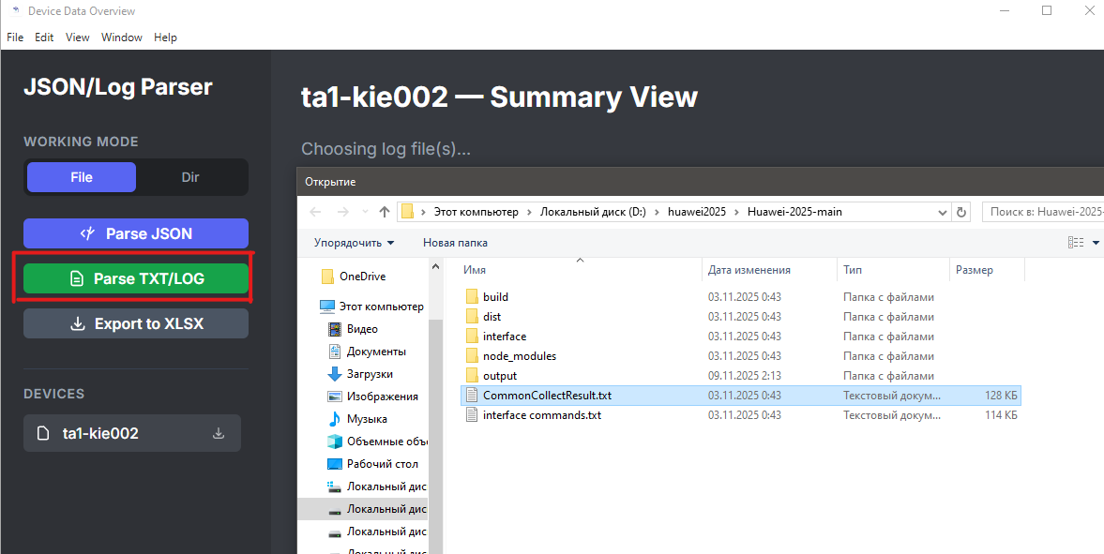

4.1) Wait until analysis over and displayed summary view on the right side of the app.

- All the devices you are working with displayed in table on the left side, under the work buttons.
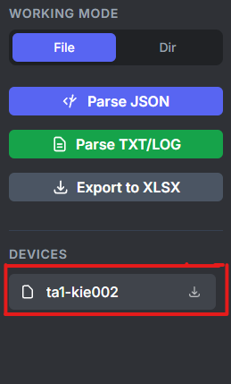

- If you want to export data into XLSX, press the download icon, on the device whose file you want to export. “.xlsx” will be saved in the “input-output” folder.
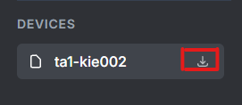
6.1) OR choose “Export to xlsx” option and select JSON file that you want to export
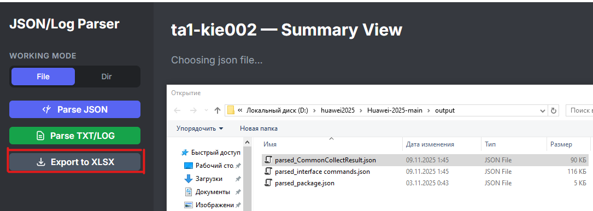
6.2) Await succeed massage
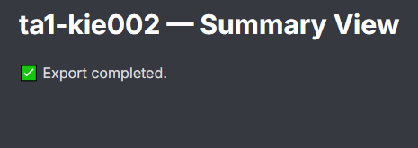
6.3) And XLSX file will be saved on the output folder in exe file directory.
- After you finish all the work that must be done, close program by pressing red “windows app” cross in the top-right corner.

