PPL - Spring 2025/Lab report

**Lab 3 - Report**

**Students:**

1. Nguyễn Đình Khánh Ngân – ITCSIU22236
2. Phan Trần Thanh Huy – ITCSIU22056

**1 Overview**

*In this section, briefly listing the issues that the class today covers.*

# Results

**Exercise 1: Accept a sentence starting with “Are”, followed by a lowercase-word identifier, and end ing with a question mark.**

Language design

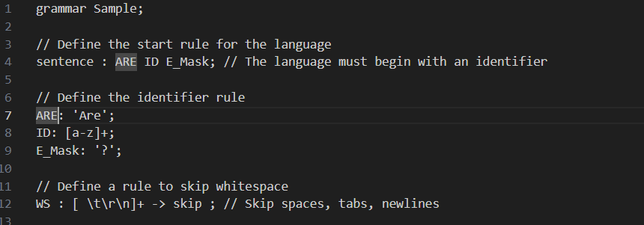

Input/ Output

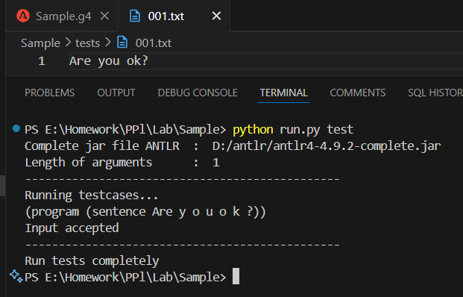

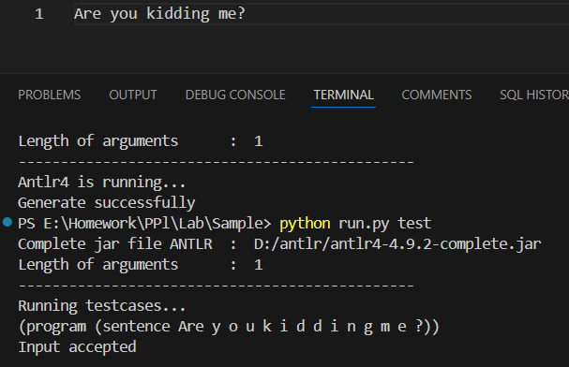

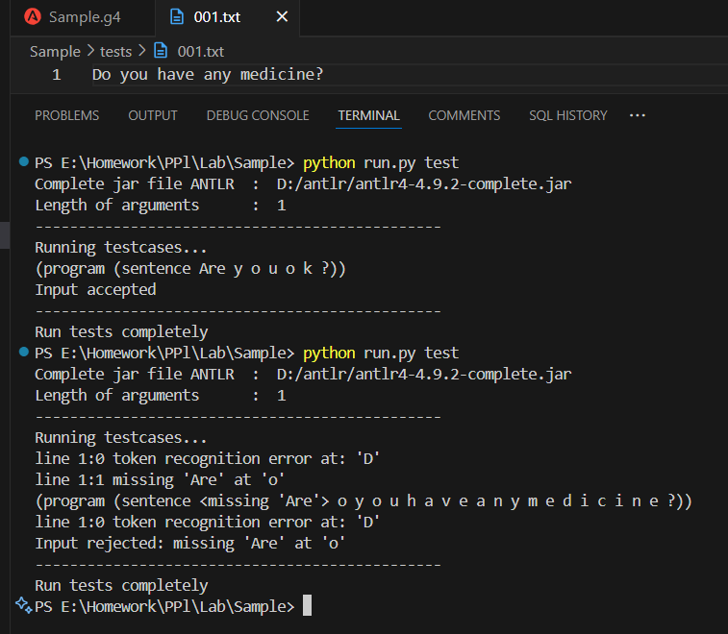

**Exercise 2: Accept questions that start with “Can”, “Could”, “Should”, or “Would”, followed by a lowercase identifier, ending with a question mask**

Language design

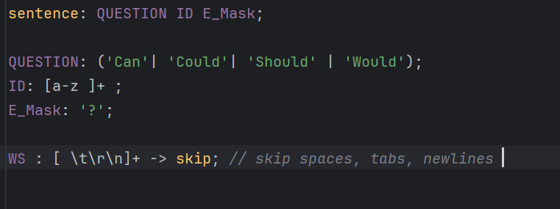

Input/ Output

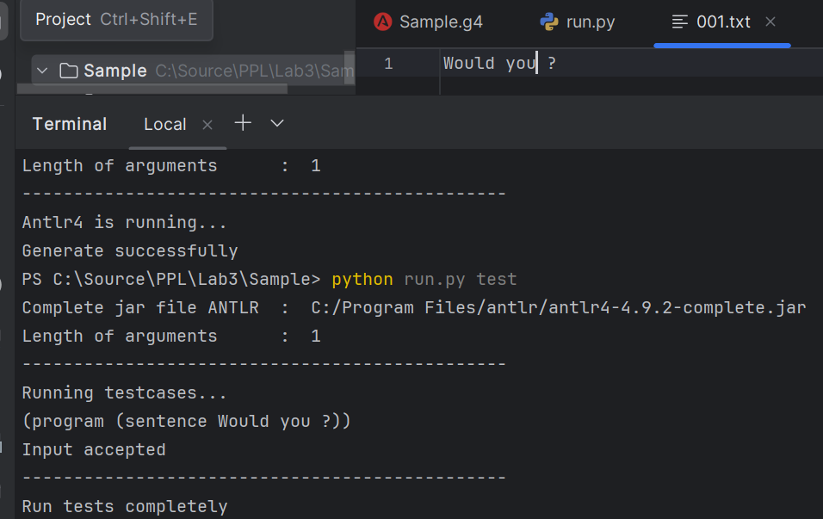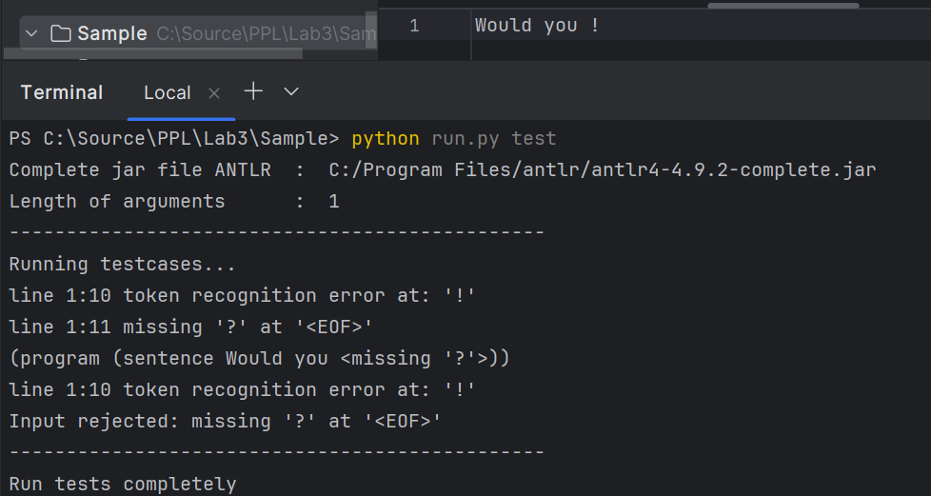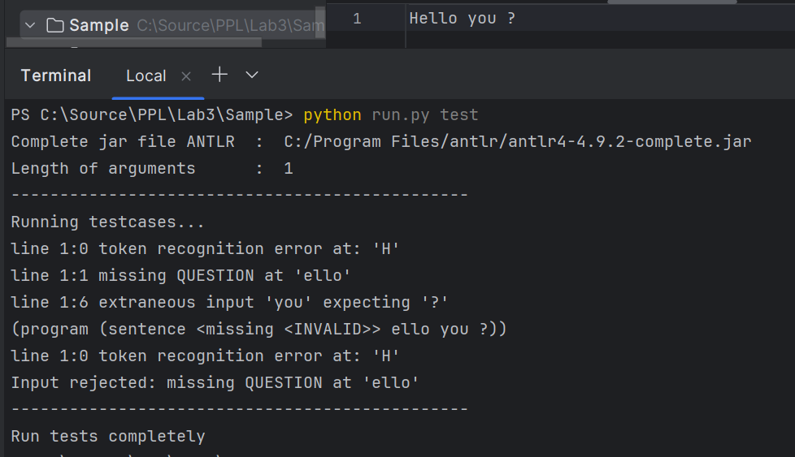

**Exercise 3: Extend Exercise 2 by allowing an optional subject pronoun (he, she, they, we) before the verb.**

Language design

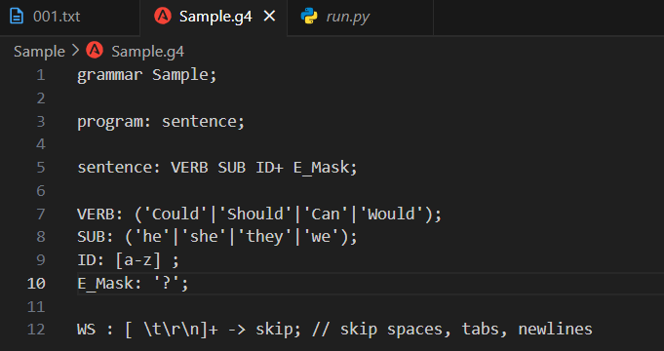

Input/ Output

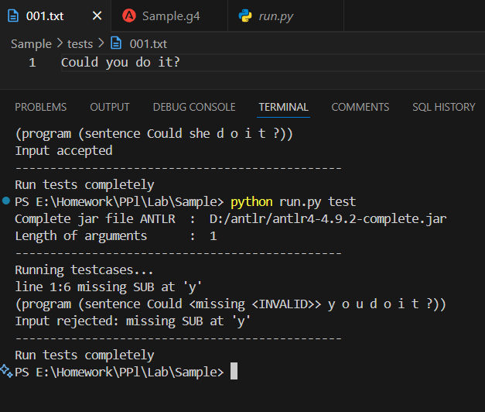

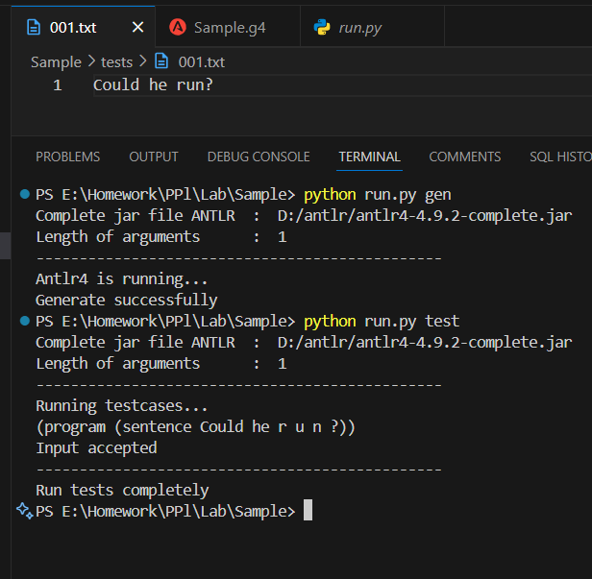

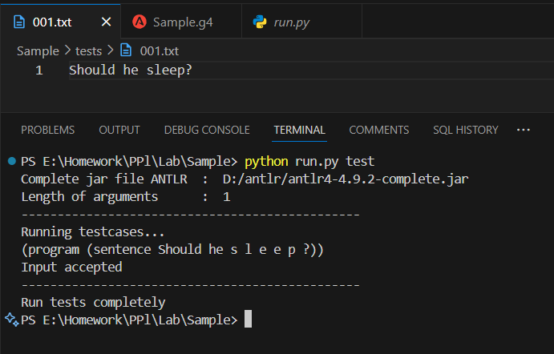

**Exercise 4: Extend the verb to support two-word verb phrases such as: “wake up”, “log in”, “check out”**

Language design 1

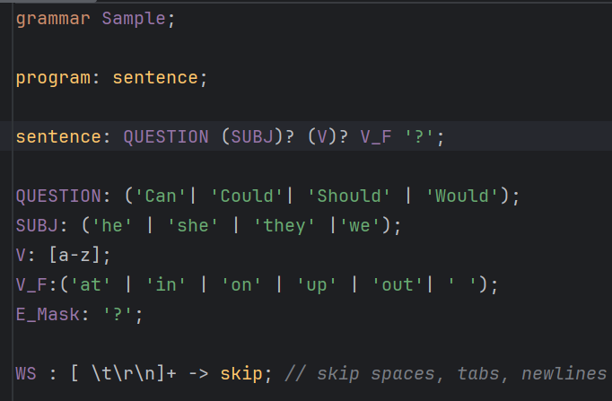

Input/ Output

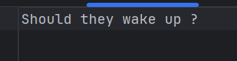

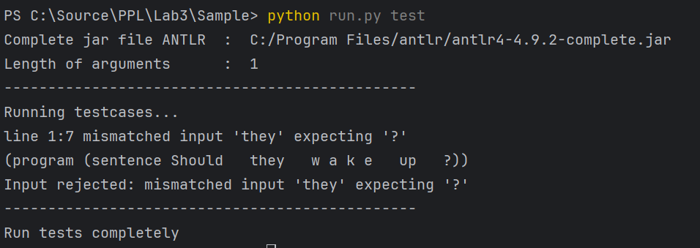

Language design 2

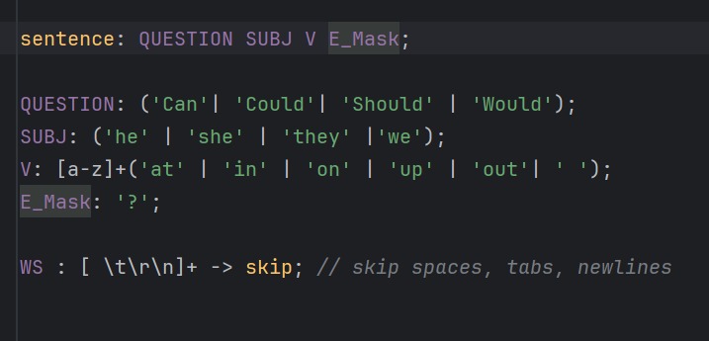Test case



Output

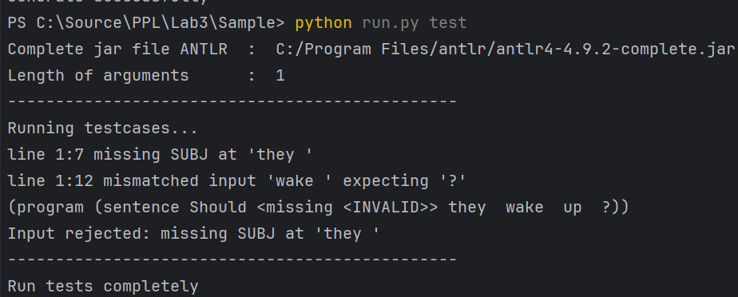Language design 3

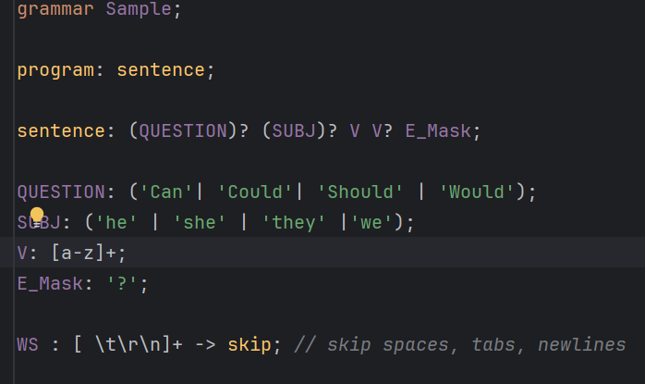Output

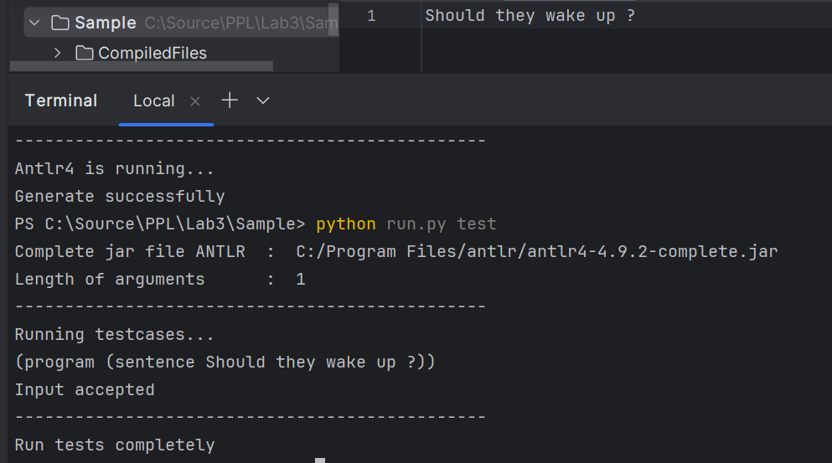

**Exercise 5:**

**Exercise 6:**

## CSE, HCMIU - VNU 1