Основы компьютерного моделирования
Практическое задание №1
Выполнил: Студент группы ВМ-41 Леонов А.С.
Вариант №5
Модель численного дифиренцированния
Исходный код:
using System;
using System.Collections.Generic;
using System.Linq;
using System.Text;
using System.Threading.Tasks;
using System.Windows;
using System.Windows.Controls;
using System.Windows.Data;
using System.Windows.Documents;
using System.Windows.Input;
using System.Windows.Media;
using System.Windows.Media.Imaging;
using System.Windows.Navigation;
using System.Windows.Shapes;
namespace Dif
{

public partial class MainWindow : Window
{
public MainWindow()
{
InitializeComponent();
Table.Rows = 6;
Table.Columns = 4;
Table.Children.Add(new TextBlock(new Run("X")));
Table.Children.Add(new TextBlock(new Run("Y")));
Table.Children.Add(new TextBlock(new Run("yE")));
Table.Children.Add(new TextBlock(new Run("E")));
}
private void Button_Click(object sender, RoutedEventArgs e)
{
Differ ras = new Differ();
ras.raschet();
for (int i = 0; i <= ras.b; i++)
{
if (i == 0)
{
Table.Children.Add(new TextBlock(new Run(Convert.ToString(ras.znach[i, 0]))));
Table.Children.Add(new TextBlock(new Run(Convert.ToString(Math.Round(ras.znach[i, 1], 3)))));
Table.Children.Add(new TextBlock(new Run(" ")));
Table.Children.Add(new TextBlock(new Run(" ")));
}

else
{
Table.Children.Add(new TextBlock(new Run(Convert.ToString(ras.znach[i, 0]))));
Table.Children.Add(new TextBlock(new Run(Convert.ToString(Math.Round(ras.znach[i, 1], 3)))));
Table.Children.Add(new TextBlock(new Run(Convert.ToString(Math.Round(ras.yE[i], 3)))));
Table.Children.Add(new TextBlock(new Run(Convert.ToString(Math.Round(ras.E[i], 3))))); ;
}
}
}
}

class Differ
{ public double x = 0, y = -1, b = 1;
public double[,] znach;
public double[] yE;
public double[] E;
public static double h0 = 0.4;
public double h = h0 / 2;
public double k0, k1, k2, k3;

public void raschet()
{
b = (b - x) / h;
int r = Convert.ToInt32(b);
znach = new double[r+1, 2];
yE = new double[r+1];
E = new double[r+1];
for (int i = 0; i <= r; i++ )
{
if (i == 0)
znach[i, 0] = x;
else
znach[i, 0] = x + h * i;

}
for (int j=0; j<=r; j++)
{
if (j == 0)
{
znach[j, 1] = y;
}
else
{
k0 = h * Math.Pow(znach[j - 1, 1], 2) * Math.Cos(znach[j - 1, 0]);
k1 = h * Math.Pow(znach[j - 1, 1] + k0 / 2, 2) * Math.Cos(znach[j - 1, 0] + h / 2);
k2 = h * Math.Pow(znach[j - 1, 1] + k1 / 2, 2) * Math.Cos(znach[j - 1, 0] + h / 2);
k3 = h * Math.Pow(znach[j - 1, 1] + k2, 2) * Math.Cos(znach[j - 1, 0] + h);
znach[j, 1] = znach[j - 1, 1]+(1*(k0 + 2 * k1 + 2 * k2 + k3)/6);
}
for (int i = 1; i <= r; i++)
{
yE[i] = znach[i - 1, 1] + h * (Math.Pow(znach[i - 1, 1], 2) * Math.Cos(znach[i - 1, 0]));
}

}

for (int k=1; k<=r;k++)
{

if (k != 0)
E[k] = Math.Abs(yE[k] - znach[k, 1]);
}
}}}

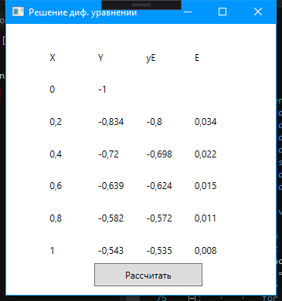
Рис 1 – выполнение задания по дифференцированию
Модель численного интегрирования.
Исходный код:
using System;
using System.Collections.Generic;
using System.Linq;
using System.Text;
using System.Threading.Tasks;
using System.Windows;
using System.Windows.Controls;
using System.Windows.Data;
using System.Windows.Documents;
using System.Windows.Input;
using System.Windows.Media;
using System.Windows.Media.Imaging;
using System.Windows.Navigation;
using System.Windows.Shapes;

namespace Integral
{
public partial class MainWindow : Window
{
public MainWindow()
{
InitializeComponent();
Table.Rows = 15;
Table.Columns = 4;
Table.Children.Add(new TextBlock(new Run("k")));
Table.Children.Add(new TextBlock(new Run("X")));
Table.Children.Add(new TextBlock(new Run("Y")));
Table.Children.Add(new TextBlock(new Run("F''")));
}

private void Button_Click(object sender, RoutedEventArgs e)
{
Integ ras = new Integ();
ras.raschet();
for (int i = 0; i < ras.r; i++)
{
Table.Children.Add(new TextBlock(new Run(Convert.ToString(i))));
Table.Children.Add(new TextBlock(new Run(Convert.ToString(Math.Round(ras.znach[i, 0], 5)))));
Table.Children.Add(new TextBlock(new Run(Convert.ToString(Math.Round(ras.znach[i, 1], 5)))));
Table.Children.Add(new TextBlock(new Run(Convert.ToString(Math.Round(ras.znach[i, 2], 5)))));
}
L1.Content = "Inegral = " + Math.Round((ras.integ), 5);
L2.Content = "Max F = " + Math.Round((ras.maxF), 5);
L3.Content = "Погрешность = " + Math.Round((ras.pogr), 5);

}

}

class Integ
{
static double a = 1, b = 3, h = 0.125, n = 16;
public double alf = a + h / 2;
public double[,] znach;
public double integ=0;
public double maxF = 0;
public double pogr;
public int r = Convert.ToInt32(n);
public void raschet()
{

znach = new double[r + 1, 3];
for (int i=0; i<r; i++)
{
znach[i, 0] = alf + i * h;
}
for (int i = 0; i < r; i++)
{
znach[i, 1] = 4 * ((Math.Pow(znach[i, 0],2)) + 1) * Math.Log(znach[i, 0],Math.E) - 1;
}
for (int i = 0; i < r; i++)
{
znach[i, 2] = 8 * Math.Log(znach[i, 0],Math.E) - 4 * Math.Pow(znach[i, 0],-2) + 12;
}
for (int i = 0; i < r; i++)
{
integ = integ + znach[i, 1];
}
integ = integ * h;
for (int i = 0; i < r; i++)
{
maxF = Math.Max(maxF, znach[i, 2]);
}
pogr = (Math.Pow((b - a), 3) / (24 * Math.Pow(n, 2))) * maxF;
}
}
}

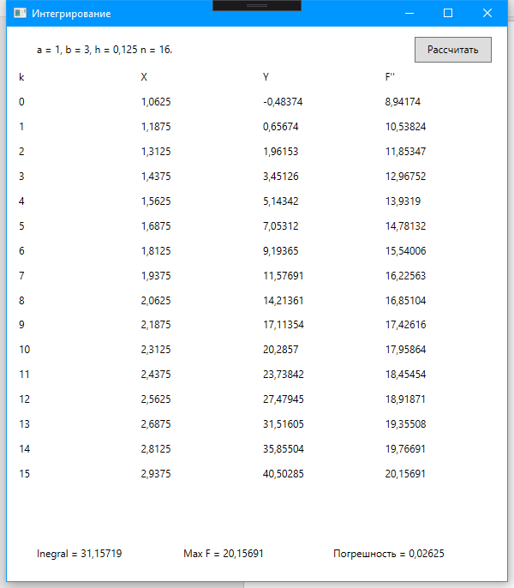
Рис 2 – выполнение задания по интегрированию

