Cyclistic Bike-Share Analysis

Professional Data Analytics Case Study

Google Data Analytics Professional Certificate

Prepared by

Aleksandar Pavloski

July 2026

Table of Contents

- Executive Summary 3
- Business Understanding 4
2.1. Company Background 4
2.2. Business Problem 4
2.3. Stakeholders 4
2.4. Business task 5
2.5. Project Objectives 5
- Dataset Overview 7
3.1. Data Source 7
3.2. Dataset Description 7
3.3. Variables Used 7
3.4. Data Limitations 8
3.5. Why This Data Is Suitable 8
- Methodology 9
4.1. Analytical Approach 9
4.2. Ask 9
4.3. Prepare 9
4.4. Process 9
4.5. Analyze 10
4.6. Share 10
4.7. Act 10
- Data Preparation 12
5.1. Data Collection 12
5.2. Combining the Monthly Datasets 12
5.3. Data Structure Validation 12
5.4. Feature Engineering 13
5.5. Preparation Outcome 13
- Data Cleaning 14
6.1. Objective 14
6.2. Removing Duplicate Records 14
6.3. Removing Invalid Ride Durations 14
6.4. Handling Missing Values 15
6.5. Data Validation 15
6.6. Cleaning Summary 16
6.7. Conclusion 16
- Exploratory Data Analysis 17
7.1. Introduction 17
7.2. Rider Type Overview 17
7.3. Ride Activity by Day of Week 18
7.4. Ride Activity by Hour of Day 19
7.5. Monthly Ride Trends 20
7.6. Rideable Bike Type Preferences 21
7.7. Round Trip Analysis 22
7.8. Start Station Analysis 23
7.9. End Station Analysis 24
7.10. Route Analysis 24
7.11. Summary of Findings 25
- Dashboard Analysis 26
8.1. Introduction 26
8.2. Dashboard 1 – Executive Summary 27
8.3. Dashboard 2 – Station Analysis 29
8.4. Dashboard Summary 30
- Business Recommendations 31
9.1. Target High – Traffic Casual Rider Stations 31
9.2. Launch Seasonal Membership Campaigns 31
9.3. Introduce Weekend – Focused Memberships Promotions 32
9.4. Emphasize Electric Bike Access in Membership Marketing 32
9.5. Promote Membership Beyond Commuting 32
9.6. Recommended Marketing Strategy 33
- Conclusion 34
10.1. Project Conclusion 34
10.2. Answer to the Business Question 34
10.3. Final Takeaway 35
- References 36
11.1. Data and Documentation Resources 36
- Appendix 37
12.1. Purpose of the Appendix 37
12.2. Duplicate Removal 37
12.3. Feature Engineering 37
12.4. Rider Behavior Analysis 39
12.5. Station Analysis 39
12.6. Round Trip Analysis 40
12.7. Project Deliverables 40
- Executive Summary

The purpose of this case study is to analyze twelve months of Cyclistic bike-share trip data in order to identify the behavioral differences between annual members and casual riders. The primary business objective is to provide data-driven insights that can help Cyclistic develop effective marketing strategies for converting casual riders into annual members.
The project was completed as part of the Google Data Analytics Professional Certificate and follows the complete data analytics process: Ask, Prepare, Process, Analyze, Share, and Act. The analysis was performed using Google BigQuery (SQL) for data preparation, cleaning, transformation, feature engineering, and exploratory data analysis, while Tableau Public was used to develop interactive dashboards for presenting the results.
The original dataset consisted of 5,932,349 ride records collected over a twelve-month period. After a comprehensive data cleaning process—including the removal of duplicate records and unrealistic ride durations—the final analytical dataset contained 5,924,928 valid ride records, providing a reliable foundation for the analysis.
The analysis revealed clear behavioral differences between the two rider groups. Annual members completed significantly more rides throughout the year and exhibited strong commuting patterns, particularly during weekday morning and evening peak hours. In contrast, casual riders generally took longer rides, were more active during weekends and summer months, and frequently started and ended their trips near parks, waterfront locations, and popular tourist attractions. These findings suggest that annual members primarily use Cyclistic bikes for routine transportation, whereas casual riders use the service mainly for leisure and recreational purposes.
Based on these findings, several business recommendations were developed, including targeted membership campaigns at locations frequently used by casual riders, seasonal promotional offers during periods of high recreational demand, and marketing initiatives highlighting the convenience of annual memberships for both commuting and leisure travel.
This report documents the complete analytical workflow—from understanding the business problem and preparing the data to performing exploratory analysis, developing interactive dashboards, and delivering actionable business recommendations. The objective is not only to answer the original business question but also to demonstrate a structured, end-to-end data analytics project following industry best practices.

- Business Understanding

  - Company Background
Cyclistic is a bike-share company operating in Chicago, offering a network of bicycles available to customers through a flexible rental system. Riders can choose between two types of access: annual memberships, designed for frequent users, and casual passes, intended for short-term or occasional riders.
The company has established a strong presence across the city with numerous bike stations located near residential neighborhoods, business districts, parks, and popular tourist attractions. This extensive network allows customers to use bicycles for a wide range of purposes, including daily commuting, recreation, sightseeing, and short-distance transportation.
While Cyclistic has successfully attracted both annual members and casual riders, the company's long-term profitability depends on increasing the number of annual memberships. Annual members provide a more stable and predictable source of revenue, making membership growth one of the company's primary strategic objectives.

  - Business Problem
Although Cyclistic serves both annual members and casual riders, the company aims to increase the number of annual memberships rather than relying primarily on occasional customers.
The marketing team believes that understanding how annual members and casual riders use the bike-sharing service differently is essential for developing effective membership conversion strategies. By identifying behavioral differences between the two rider groups, Cyclistic can design targeted marketing campaigns that encourage casual riders to become long-term members.
This project focuses on uncovering those behavioral differences through data analysis and translating the findings into practical business recommendations.

  - Stakeholders
The primary stakeholder for this project is Lily Moreno, Director of Marketing, who is responsible for developing strategies that increase annual memberships.
Additional stakeholders include:
- Cyclistic Marketing Analytics Team
- Cyclistic Executive Team
These stakeholders will use the analytical findings to support data-driven decision-making and evaluate potential marketing initiatives aimed at increasing customer retention and long-term profitability.

  - Business Task
The main business task of this project is to answer the following question:
How do annual members and casual riders use Cyclistic bikes differently?
Answering this question requires analyzing rider behavior across multiple dimensions, including ride frequency, trip duration, riding patterns, bicycle preferences, seasonal trends, and station usage. The resulting insights will serve as the foundation for business recommendations designed to increase annual membership adoption.

  - Project Objectives
To answer the business question, the project was designed around the following objectives:
- Prepare and validate twelve months of Cyclistic trip data for analysis.
- Clean and standardize the dataset by removing duplicate and invalid records.
- Create additional analytical variables through feature engineering.
- Identify behavioral differences between annual members and casual riders using SQL.
- Develop interactive Tableau dashboards to communicate analytical findings.
- Provide actionable business recommendations based on the observed rider behavior.
- Dataset Overview

  - Data source
The dataset used in this project consists of twelve months of historical Cyclistic bike-share trip data provided by Divvy Bikes and made available through the Google Data Analytics Professional Certificate Capstone Project.
The data contains anonymized trip-level information for each completed ride and is intended for educational and analytical purposes. Personally identifiable customer information is not included in the dataset, ensuring compliance with data privacy requirements.

  - Dataset Description
The analysis covers a continuous twelve-month period from July 2025 to June 2026, providing a complete view of rider behavior across all seasons. Instead of analyzing individual monthly files separately, all twelve datasets were merged into a single raw table in Google BigQuery using the UNION ALL statement. This approach ensured that every ride was preserved while creating one centralized dataset for subsequent cleaning and analysis.
The original dataset contained:
- Time period: July 2025 – June 2026
- Original records: 5,932,349 rides
- Final cleaned records: 5,924,928 rides
- Storage platform: Google BigQuery
The final dataset served as the foundation for all exploratory analyses and dashboard visualizations.

  - Variables Used
The dataset contains information describing each individual ride. The most important variables used throughout the analysis include:
Variable | Description
ride_id | Unique identifier for each ride
rideable_type | Type of bicycle used (Classic or Electric)
started_at | Ride start timestamp
ended_at | Ride end timestamp
start_station_name | Name of the departure station
end_station_name | Name of the destination station
start_lat / start_lng | Geographic coordinates of the start location
end_lat / end_lng | Geographic coordinates of the destination
member_casual | Rider category (Annual Member or Casual Rider)

These variables provided the basis for calculating ride duration, identifying temporal riding patterns, analyzing station popularity, and comparing the behavior of the two rider groups.

  - Data Limitations
Several limitations should be considered when interpreting the results.
The dataset does not include demographic information such as customer age, gender, occupation, or income level. Additionally, external factors such as weather conditions, public events, holidays, and pricing information are not available.
A substantial proportion of rides also contain missing values in station-related fields. Rather than removing these records, they were retained because excluding more than one-fifth of the dataset would unnecessarily reduce the sample size and could introduce bias into the analysis. These missing values do not affect analyses based on ride duration, rider type, temporal patterns, or bicycle preferences.

  - Why This Dataset Is Suitable
Despite these limitations, the dataset is highly suitable for answering the project's business question.
Its large sample size, full-year coverage, and detailed trip-level information make it possible to identify meaningful differences between annual members and casual riders. The combination of temporal, geographic, and behavioral variables provides sufficient information to support reliable exploratory analysis and develop actionable business recommendations.

- Methodology

  - Analytical Approach
This project follows the Google Data Analytics framework, which consists of six structured phases: Ask, Prepare, Process, Analyze, Share, and Act. This methodology provides a systematic approach for transforming raw data into meaningful business insights and actionable recommendations.
Each phase builds upon the previous one, ensuring that analytical decisions are based on validated data and aligned with the original business objective.

  - Ask
The first phase focused on understanding the business problem and defining the analytical objective.
Cyclistic aims to increase the number of annual memberships by encouraging casual riders to become long-term members. To support this objective, the following business question was established:
How do annual members and casual riders use Cyclistic bikes differently?
Answering this question required identifying behavioral differences between the two rider groups and translating those findings into practical business recommendations.

  - Prepare
The preparation phase involved collecting and organizing twelve months of historical trip data.
Each monthly CSV dataset was uploaded to Google Cloud Storage and imported into Google BigQuery as an individual table. After verifying that all datasets shared the same schema, they were combined into a single raw table using the UNION ALL statement.
This approach ensured that every ride record was preserved while creating one centralized dataset for analysis.

  - Process
The processing phase focused on preparing the dataset for reliable analysis.
Several data quality checks were performed to evaluate duplicate records, missing values, ride duration, schema consistency, and data completeness.
The dataset was then cleaned by:
- Removing exact duplicate records.
- Removing rides with zero or negative duration.
- Removing rides lasting longer than twenty-four hours.
- Validating the final cleaned dataset before analysis.
Additional analytical variables—including ride duration, day of week, month, and hour of day—were created to simplify the exploratory analysis and improve SQL query readability.

  - Analyze
Exploratory Data Analysis (EDA) was performed using SQL in Google BigQuery.
The analysis compared annual members and casual riders across multiple behavioral dimensions, including:
- Rider distribution
- Average ride duration
- Riding activity by weekday
- Riding activity by hour
- Monthly ride trends
- Bike type preferences
- Round trips
- Most popular start stations
- Most popular end stations
- Most frequently used routes
The objective of this phase was to identify statistically meaningful patterns that could support the project's business recommendations.

  - Share
The analytical findings were communicated through interactive dashboards developed in Tableau Public.
Rather than importing the complete dataset of more than 5.9 million ride records into Tableau, an aggregated visualization dataset was created in SQL. This significantly improved dashboard performance while ensuring consistency between the analytical results and the visualizations.
Two dashboards were developed:
- Executive Summary Dashboard
- Station Analysis Dashboard

  - Act
The final phase focused on transforming analytical findings into actionable business recommendations.
Based on the observed behavioral differences, several marketing strategies were proposed to help Cyclistic increase annual memberships. These recommendations are directly supported by the analysis and are intended to improve customer conversion while supporting the company's long-term business objectives.
- Data Preparation

  - Data Collection
The analysis is based on twelve monthly Cyclistic trip datasets covering the period from July 2025 to June 2026. Each monthly dataset was initially stored as a separate CSV file.
To prepare the data for analysis, all files were uploaded to Google Cloud Storage and subsequently imported into Google BigQuery, where each month was stored as an individual database table. This approach ensured efficient storage, fast querying, and scalability throughout the analytical process.

  - Combining the Monthly Datasets
Since the analysis required a full-year perspective, the twelve monthly tables were merged into a single raw dataset using the SQL UNION ALL statement.
The resulting table, bike_trips_full_year_raw, preserved every original ride record without modification and became the primary source for all subsequent cleaning and analytical operations.
Example: Combining all twelve monthly tables
CREATE OR REPLACE TABLE `project-d1b48c9e-9e7f-4667-9ca.bikes_info_507.bike_trips_full_year_raw` AS
SELECT * FROM `project-d1b48c9e-9e7f-4667-9ca.bikes_info_507.tripdata_202507`
UNION ALL
SELECT * FROM `project-d1b48c9e-9e7f-4667-9ca.bikes_info_507.tripdata_202508`
UNION ALL
SELECT * FROM `project-d1b48c9e-9e7f-4667-9ca.bikes_info_507.tripdata_202509`
UNION ALL
SELECT * FROM `project-d1b48c9e-9e7f-4667-9ca.bikes_info_507.tripdata_202510`
UNION ALL
. . .

  - Data Structure Validation
Before beginning the cleaning process, the combined dataset was validated to ensure structural consistency.
Several validation checks were performed, including:
- Verification of the total number of records.
- Validation of data types.
- Duplicate ride ID detection.
- Missing value assessment.
- Ride duration inspection.
- Coordinate validation.
These preliminary checks confirmed that the imported data maintained a consistent schema across all twelve monthly datasets and was suitable for further processing.

  - Feature Engineering
To simplify the exploratory analysis and improve SQL query readability, a separate analysis-ready table was created from the cleaned dataset.
Several new analytical variables were derived directly from the timestamp fields, including:
- Ride duration (minutes)
- Day of week
- Day number
- Hour of day
- Month number
- Month name
- Ride year
Creating these derived variables eliminated the need to repeatedly calculate values within individual SQL queries and significantly improved the readability and efficiency of the analytical workflow.

  - Preparation Outcome
At the end of the preparation phase, the project contained three distinct datasets, each serving a specific purpose:
Dataset | Purpose
bike_trips_full_year_raw | Combined raw dataset containing all original records
bike_trips_full_year_clean | Cleaned dataset used for analysis
bike_trips_full_year_analysis | Analysis-ready dataset containing engineered variables

Separating the project into multiple datasets ensured that the original data remained unchanged while allowing cleaning and feature engineering to be performed safely and transparently. This structure also improved reproducibility and followed common data analytics best practices.

- Data Cleaning

  - Objective
Before conducting the analysis, the dataset was thoroughly cleaned to ensure accuracy, consistency, and reliability. The primary objective of the cleaning process was to remove records that could negatively influence the analytical results while preserving all valid ride information.
To maintain data integrity, the original raw dataset remained unchanged throughout the project. A separate working table, bike_trips_full_year_clean, was created, and all cleaning operations were performed on this copy. This approach ensured that the raw data could always be referenced if necessary and follows common data management best practices.

  - Removing Duplicate Records
The first cleaning step focused on identifying duplicate ride records.
Since every ride should have a unique ride_id, duplicate records could potentially distort ride counts and summary statistics. A SQL query using the ROW_NUMBER() window function was applied to retain only the first occurrence of each duplicated ride while removing all exact duplicates.
This process removed 35 duplicate records, reducing the dataset from 5,932,349 to 5,932,314 rides. A validation query confirmed that no duplicate ride IDs remained after the cleaning process.
SQL example:
CREATE OR REPLACE TABLE
`project-d1b48c9e-9e7f-4667-9ca.bikes_info_507.bike_trips_full_year_clean` AS

SELECT *
FROM (
SELECT *,
ROW_NUMBER() OVER (
PARTITION BY ride_id
ORDER BY started_at
) AS row_num
FROM `project-d1b48c9e-9e7f-4667-9ca.bikes_info_507.bike_trips_full_year_clean`
)
WHERE row_num = 1;

  - Removing Invalid Ride Durations
The second step focused on ride duration. Two categories of unrealistic trips were identified:
- Rides with a duration of zero or negative seconds
- Rides lasting more than 24 hours
Trips with zero or negative duration indicate inconsistent timestamps, while rides longer than twenty-four hours are unlikely to represent normal customer behavior and could significantly skew average ride duration calculations.
A total of:
- 1,854 rides with invalid duration
- 5,532 rides longer than 24 hours
were removed from the dataset.

  - Handling Missing Values
Missing values were primarily observed in the station-related fields:
- start_station_name
- start_station_id
- end_station_nameend_station_id
Approximately 21–22% of rides contained missing station information.
Rather than removing these records, they were intentionally retained. Eliminating such a large proportion of the dataset would substantially reduce the available data and could introduce unnecessary bias into the analysis.
Since the primary business question focused on rider behavior rather than station completeness, retaining these observations ensured that analyses involving ride duration, rider type, weekday activity, hourly trends, and seasonal behavior remained representative of the full population.

  - Data Validation
After completing the cleaning process, a final validation was performed to confirm that all cleaning rules had been applied successfully.

The validation verified that:
- no duplicate ride IDs remained,
- no rides had zero or negative duration,
- no rides exceeded twenty-four hours,
- all essential analytical fields contained valid values.
These checks confirmed that the dataset was internally consistent and suitable for exploratory data analysis.

  - Cleaning Summary
The completed cleaning process produced the following results:
Cleaning Step | Records Removed
Exact duplicate records | 35
Ride duration ≤ 0 seconds | 1854
Ride duration > 24 hours | 5532
Total records removed | 7421

Final analytical dataset: 5,924,928 rides.

  - Conclusion
The data cleaning phase successfully transformed the original raw dataset into a reliable analytical dataset suitable for exploratory analysis and visualization.By removing duplicate records and unrealistic ride durations while retaining meaningful observations with missing station information, the final dataset preserves as much valuable information as possible without compromising analytical quality.
The cleaned dataset served as the foundation for all subsequent SQL analyses and Tableau dashboards.

- Exploratory Data Analysis

  - Introduction
After completing the data preparation and cleaning phases, the dataset was ready for exploratory data analysis (EDA). The purpose of this phase was to identify behavioral patterns, trends, and meaningful differences between annual members and casual riders.
Rather than focusing solely on descriptive statistics, the analysis aimed to answer the project's central business question by examining rider behavior from multiple perspectives, including ride frequency, trip duration, temporal usage patterns, bicycle preferences, station popularity, and travel behavior.
Each analysis was designed to provide evidence supporting the final business recommendations and to improve the understanding of how the two rider groups interact with the Cyclistic bike-sharing service.

  - Rider Type Overview
Objective
The first analysis compares the total number of rides completed by each rider type and their average ride duration.
Understanding these metrics provides an initial overview of customer behavior and establishes the foundation for the remaining analyses.
Results

Rider Type | Total Rides | Average Ride Duration
Annual Member | 3,813,586 | 12.06 minutes
Casual Rider | 2,111,342 | 18.57 minutes

Interpretation
The results demonstrate a clear behavioral difference between the two rider groups.
Annual members completed substantially more rides throughout the year, indicating that they use Cyclistic bikes more frequently as part of their daily routines.
Casual riders, on the other hand, completed fewer rides but spent significantly more time on each trip. Their average ride duration was more than six minutes longer than that of annual members.
This suggests that annual members prioritize convenience and efficiency, whereas casual riders are more likely to use the bicycles for recreational or leisure purposes.

Business Insight
The findings indicate that the two customer groups have fundamentally different usage patterns.
Annual members appear to rely on Cyclistic bikes for regular transportation, while casual riders primarily use the service for longer recreational trips.
These behavioral differences suggest that marketing campaigns promoting the convenience and long-term value of annual memberships could encourage casual riders to incorporate Cyclistic into their everyday transportation habits.

  - Ride Activity by Day of Week
Objective
Analyze ride activity across the days of the week to determine whether annual members and casual riders exhibit different weekly riding patterns.
Understanding how ride activity changes throughout the week provides valuable insight into whether customers primarily use Cyclistic bicycles for commuting or recreational purposes.

Results
The analysis revealed clear differences between the two rider groups.
Annual members recorded their highest number of rides between Tuesday and Thursday, while ride activity gradually declined during the weekend.
Casual riders followed a different pattern. Their ride activity increased significantly on Friday, Saturday, and Sunday, with Saturday representing the highest level of weekly usage.
In addition to completing more rides during weekends, casual riders also recorded longer average ride durations on both Saturday and Sunday compared to weekdays. Annual members maintained relatively consistent ride durations throughout the entire week.

Interpretation
The weekly riding patterns strongly suggest that the two customer groups use the bike-sharing service for different purposes.
Annual members exhibit a typical commuting pattern, using bicycles regularly during working days to travel to and from work or other daily activities.
Casual riders, however, become substantially more active during weekends when recreational activities, sightseeing, and leisure travel are more common.
These observations indicate that casual riders are less dependent on bicycles for routine transportation and instead use the service primarily during their free time.

Business Insight
The weekly behavior of casual riders presents an opportunity for targeted marketing campaigns.
Since casual rider activity peaks during weekends, promotional campaigns encouraging annual memberships could be scheduled during these periods when customer engagement is highest.
Weekend membership promotions, mobile advertisements near recreational areas, and QR-code campaigns at popular casual rider stations may increase membership conversions.

  - Ride Activity by Hour of Day
Objective
The objective of this analysis is to examine daily riding patterns and identify how bicycle usage changes throughout the day for both annual members and casual riders.
By comparing hourly ride activity, it is possible to distinguish commuting behavior from recreational travel and better understand customer habits.

Results
Annual members displayed two distinct riding peaks.
The first occurred during the morning commuting period between 7:00 and 9:00 AM, while the second—and larger—peak occurred between 4:00 PM and 6:00 PM.
Casual riders exhibited a different daily pattern.
Instead of morning commuting peaks, their activity gradually increased throughout the day and reached its highest levels during the afternoon and early evening. Casual riders also recorded their longest average ride durations between late morning and mid-afternoon, indicating extended leisure trips rather than routine transportation.

Interpretation
The hourly riding patterns provide strong evidence supporting the project's central hypothesis.
Annual members rely on Cyclistic bicycles as part of their daily commuting routine, using the service before and after standard working hours.
Casual riders demonstrate a more flexible riding schedule, with usage concentrated during leisure hours rather than traditional commuting periods.
These patterns reinforce the conclusion that the two customer groups have fundamentally different transportation needs.

Business Insight
Cyclistic could use these findings to schedule marketing campaigns during periods when casual riders are most active.
Membership advertisements displayed during afternoon and early evening hours may reach a larger audience of casual riders and improve campaign effectiveness.
Additionally, emphasizing the convenience of annual memberships for everyday transportation may encourage recreational riders to consider using Cyclistic more frequently throughout the week.

  - Monthly Ride Trends
Objective
This analysis examines seasonal changes in rider behavior throughout the twelve-month period.
The goal is to determine whether annual members and casual riders exhibit different seasonal riding patterns and identify the periods with the greatest potential for membership conversion.

Results
Both rider groups experienced increased bicycle usage during the warmer months. However, the seasonal variation differed considerably between them.
Annual members maintained relatively stable ride activity throughout the year, although moderate increases were observed during late spring and summer.
Casual riders displayed much stronger seasonal fluctuations. Ride activity increased rapidly during spring, reached its highest level during July and August, and declined sharply during late autumn and winter.
Average ride duration for casual riders also increased during the summer months, suggesting longer recreational trips under favorable weather conditions.

Interpretation
Seasonal trends indicate that weather conditions and tourism have a much greater influence on casual rider behavior than on annual members.
Members continue using Cyclistic bicycles throughout the year as part of their daily routines, while casual riders appear to use the service primarily when environmental conditions are favorable.

Business Insight
Late spring and summer represent the strongest opportunity for converting casual riders into annual members.
Marketing campaigns launched during these months are likely to reach the largest number of active casual riders and therefore have the highest potential impact.

  - Rideable Bike Type Preferences
Objective
The objective of this analysis is to determine whether annual members and casual riders differ in their preference for bicycle type. Understanding bike type preferences can provide additional insight into rider behavior and support future operational and marketing decisions.

Results
Both rider groups demonstrated a clear preference for electric bikes over classic bikes. Electric bikes accounted for the majority of rides for both rider categories, with casual riders showing a slightly higher preference for electric bikes than annual members. However, the difference between the two groups was relatively small, indicating that electric bicycles are broadly preferred regardless of membership status.

Interpretation
The results suggest that bicycle type is not a primary factor distinguishing annual members from casual riders.
Instead, both groups appear to value the convenience and accessibility offered by electric bicycles. The slightly higher usage among casual riders may reflect a preference for comfortable leisure trips requiring less physical effort.

Business Insight
Cyclistic could highlight the availability and convenience of electric bikes in future membership campaigns.
Since both customer groups strongly prefer electric bicycles, promotional messages emphasizing unlimited access to electric bikes through annual memberships may increase the attractiveness of membership offers.

  - Round Trip Analysis
Objective
The purpose of this analysis is to compare how frequently annual members and casual riders complete round trips, where the ride begins and ends at the same station.
Round trips often indicate recreational riding rather than transportation between two different locations.

Results
The analysis revealed that casual riders completed a substantially higher proportion of round trips than annual members.
Annual members rarely returned bicycles to their original station, whereas casual riders frequently started and ended their rides at the same location, particularly near parks, waterfronts, and tourist destinations.

Interpretation
These findings further reinforce the behavioral differences observed throughout the previous analyses.
Annual members generally use Cyclistic bicycles to travel from one location to another as part of their daily routines.
Casual riders, in contrast, often ride for enjoyment rather than transportation, returning to their original departure point after completing recreational rides.

Business Insight
Cyclistic could introduce marketing campaigns targeting casual riders at locations where round trips are most common.
These campaigns could promote annual memberships as a convenient option not only for leisure riding but also for everyday transportation, encouraging riders to extend their usage beyond recreational trips.

  - Start Station Analysis
Objective
This analysis identifies the most frequently used departure stations for each rider group in order to understand where trips most commonly begin.
Station popularity provides valuable insight into rider purpose and geographic usage patterns.

Results
The most popular departure stations for casual riders were concentrated around parks, waterfront areas, beaches, and major tourist attractions, including locations such as Streeter Dr & Grand Ave, Millennium Park, and Navy Pier.
Annual members, however, most frequently started their trips from stations located within the city's business districts and residential commuting corridors.

Interpretation
The geographic distribution of departure stations supports previous findings.
Casual riders tend to begin trips in areas associated with recreation and tourism, while annual members primarily use stations located near workplaces and residential neighborhoods.

Business Insight
Cyclistic should consider placing promotional materials, QR codes, and membership advertisements at stations heavily used by casual riders.
These locations provide direct access to the customer segment most likely to convert into annual members.

  - End Station Analysis
Objective
The objective of this analysis is to identify where riders most frequently end their journeys and determine whether destination patterns differ between rider groups.

Results
Destination stations closely mirrored the patterns observed in the start station analysis.
Casual riders most frequently ended their trips at popular recreational destinations and tourist attractions.
Annual members primarily completed their rides at stations located within commercial districts and areas associated with daily commuting.

Interpretation
The similarity between departure and destination patterns further confirms that casual riders often travel within recreational areas, whereas annual members use Cyclistic bicycles to travel between residential and business locations.
Business Insight
The concentration of casual rider activity around tourist attractions provides Cyclistic with excellent opportunities for location-based membership marketing.
Strategically placed advertisements and promotional offers at these stations may significantly improve customer conversion rates.

  - Route Analysis
Objective
The final exploratory analysis examines the most frequently used travel routes in order to identify common travel patterns and better understand rider behavior.

Results
The most frequently used routes differed considerably between annual members and casual riders.
Annual members primarily traveled between stations located within business and residential areas, suggesting routine transportation and commuting.
Casual riders most often traveled between stations located near parks, waterfronts, and tourist destinations, reinforcing the recreational nature of their trips.

Interpretation
The route analysis provides additional evidence supporting the conclusions drawn throughout the previous analyses.
Rather than representing isolated findings, the observed behavioral differences remain consistent across ride frequency, ride duration, temporal patterns, station popularity, and travel routes.

  - Summary of Findings
The exploratory data analysis identified several consistent behavioral differences between annual members and casual riders.

The most important findings include:
- Annual members completed significantly more rides throughout the year.
- Casual riders spent considerably more time on each ride.
- Members primarily rode during weekday commuting hours.
- Casual riders were substantially more active during weekends.
- Casual rider activity increased significantly during the summer months.
- Both rider groups preferred electric bicycles, although casual riders showed a slightly stronger preference.
- Casual riders frequently completed round trips.
- Annual members primarily used stations located in business districts, while casual riders concentrated around parks and tourist attractions.
- Route analysis consistently supported the conclusion that annual members mainly use Cyclistic for transportation, whereas casual riders primarily use the service for recreation.
Overall, every analysis conducted in this project supports the original business hypothesis: annual members and casual riders exhibit fundamentally different riding behaviors. These findings provide a strong analytical foundation for the business recommendations presented in the following chapter.
- Dashboard Analysis

  - Introduction
After completing the exploratory data analysis in Google BigQuery, the validated analytical results were visualized using Tableau Public.
Rather than importing the complete dataset of more than 5.9 million records, an aggregated dataset containing only the summarized analytical results was created specifically for visualization purposes.
This approach significantly improved dashboard performance while ensuring that every visualization accurately represented the validated SQL analysis.
Two interactive dashboards were developed to communicate the key findings to business stakeholders:
- Executive Summary Dashboard
- Cyclistic Station Analysis Dashboard
Together, these dashboards provide both a high-level overview of rider behavior and a detailed examination of station usage patterns.
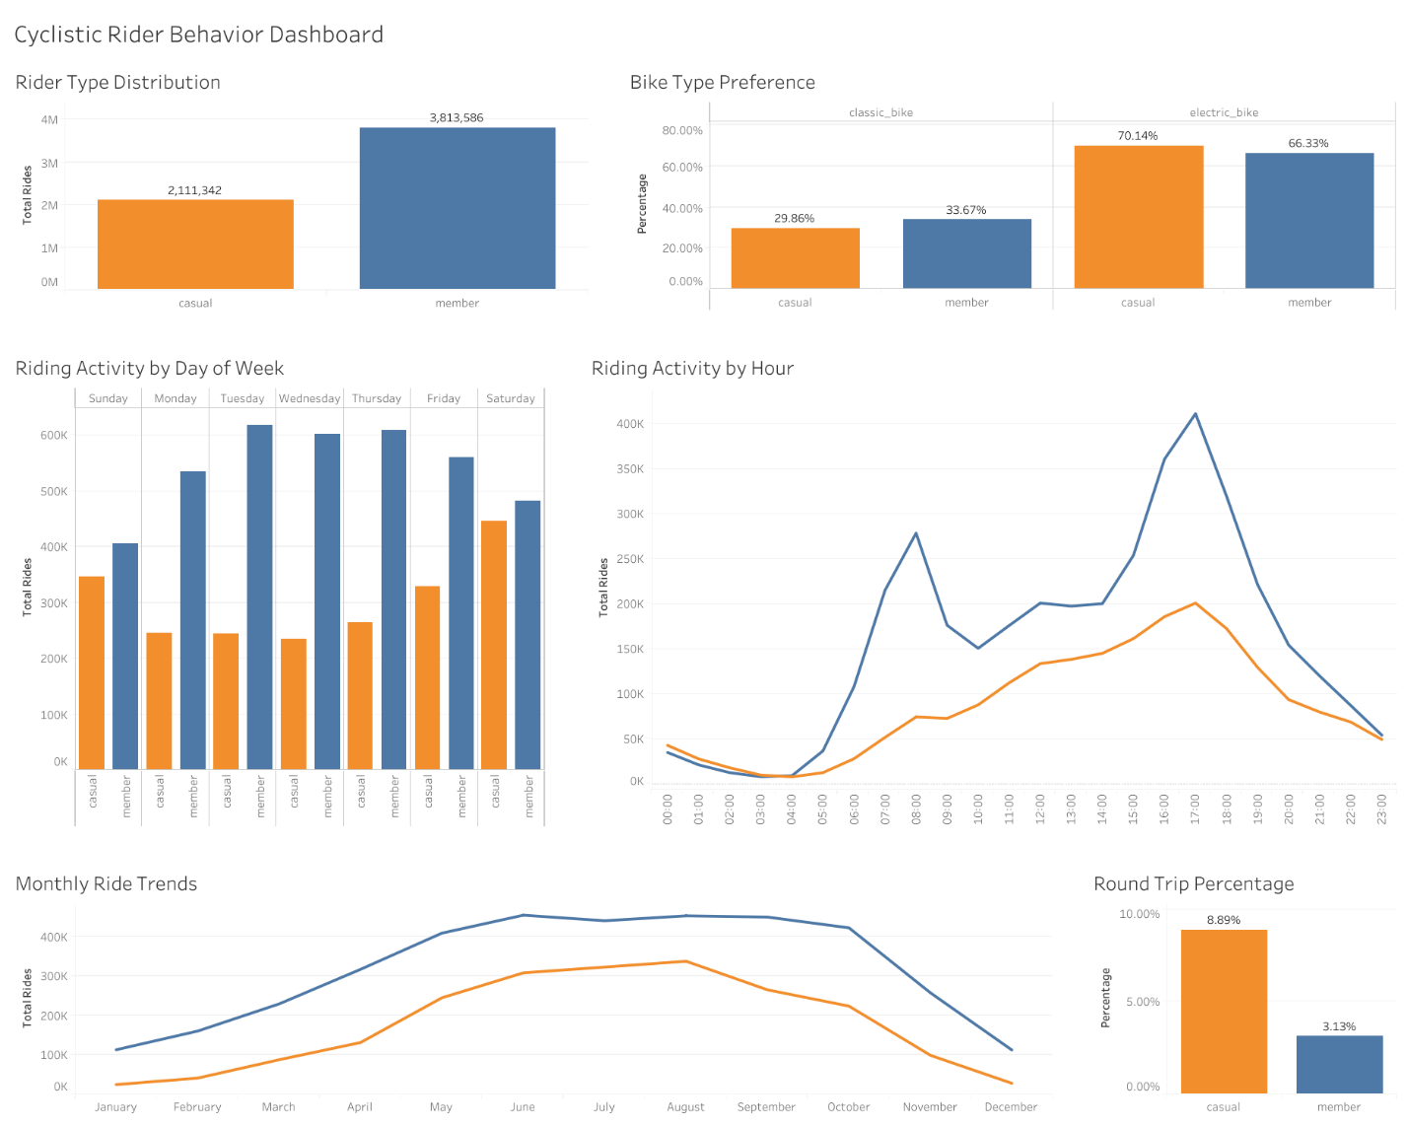
  - Dashboard 1 – Executive Summary
Figure 1. Executive Summary Dashboard

Dashboard Purpose
The Executive Summary dashboard was designed to provide management with a concise overview of the most important behavioral differences between annual members and casual riders.
Rather than presenting detailed SQL results, the dashboard summarizes the project's key performance indicators through interactive visualizations that can be quickly interpreted by business stakeholders.

Dashboard Components
The dashboard includes:
- Rider type distribution
- Average ride duration
- Bike type preferences
- Riding activity by weekday
- Riding activity by hour
- Monthly ride trends
- Round trip analysis
Each visualization contributes to answering the project's primary business question by highlighting a different aspect of rider behavior.

Key Insights
Several important findings can immediately be observed from the Executive Summary dashboard.
Annual members generate substantially more rides throughout the year, while casual riders consistently spend more time on each trip.
Temporal analyses demonstrate that members primarily ride during weekday commuting hours, whereas casual riders exhibit stronger weekend activity and increased seasonal usage during the summer months.
These findings consistently indicate that annual members rely on Cyclistic bicycles for everyday transportation, while casual riders primarily use the service for recreational purposes.

  - Dashboard 2 – Station Analysis
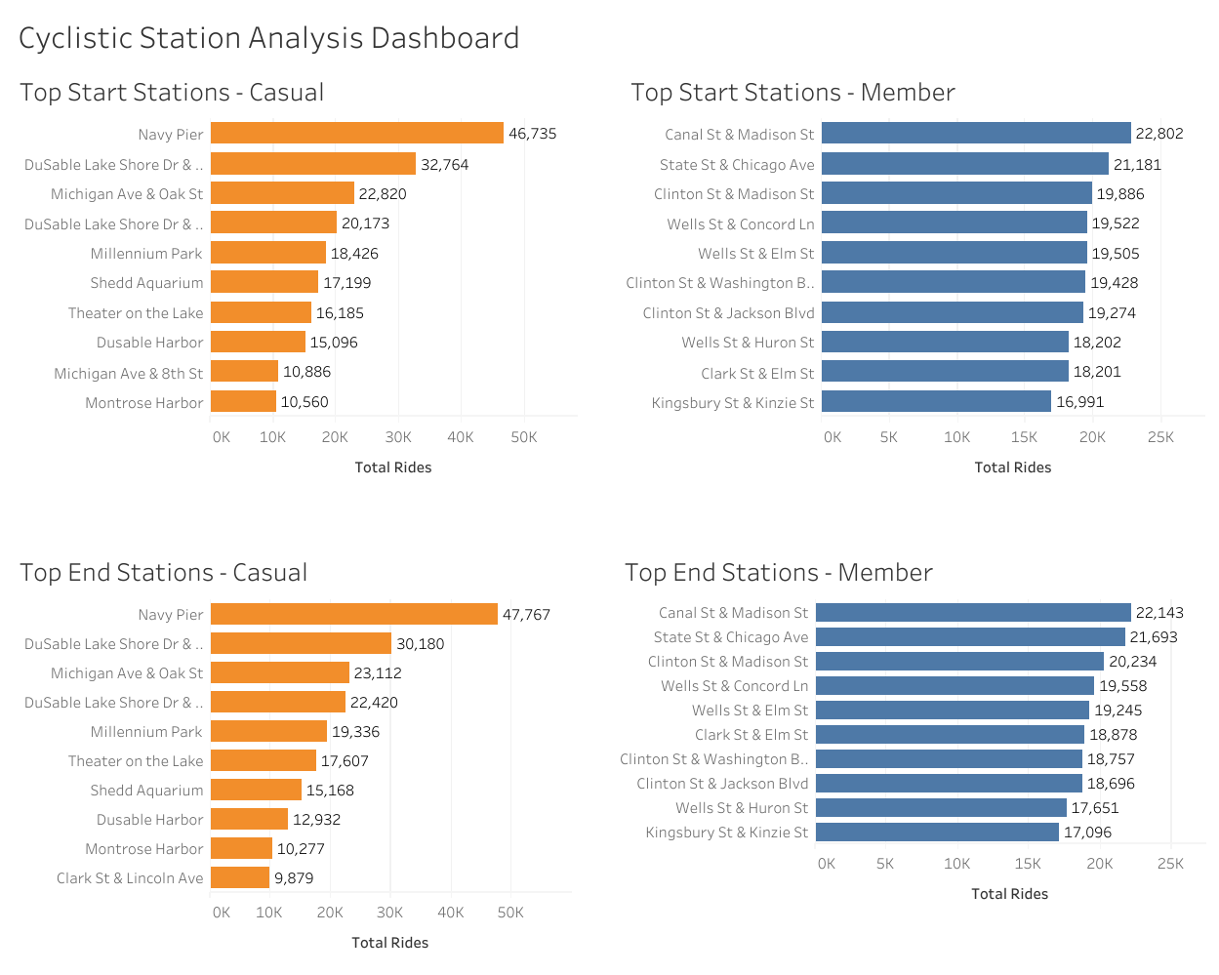

Figure 2. Cyclistic Station Analysis Dashboard

Dashboard Purpose
The Station Analysis dashboard provides a detailed comparison of station usage between annual members and casual riders.
The objective is to identify the locations most frequently used by each rider group and determine whether station popularity reflects different travel purposes.

Dashboard Components
The dashboard contains:
- Top 10 Start Stations (Members)
- Top 10 Start Stations (Casual)
- Top 10 End Stations (Members)
- Top 10 End Stations (Casual)

These visualizations provide geographical insight into customer behavior and support location-based marketing recommendations.

Key Insights
The dashboard reveals a clear geographical distinction between the two rider groups.
Casual riders frequently begin and end their trips near parks, waterfronts, beaches, and major tourist attractions.
Annual members, however, predominantly use stations located within residential neighborhoods, commercial districts, and business areas.
These differences strongly support the conclusion that members primarily use Cyclistic bicycles for commuting, while casual riders mainly ride for leisure and tourism.

  - Dashboard Summary
The Tableau dashboards successfully transform the SQL analysis into intuitive business visualizations.
Together, they communicate the project's key findings in a format that is accessible to both technical and non-technical stakeholders.
The dashboards confirm the conclusions reached during the exploratory data analysis and provide clear visual evidence supporting the final business recommendations presented in the next chapter.

- Business Recommendations

The exploratory analysis identified clear and consistent behavioral differences between annual members and casual riders. Annual members primarily use Cyclistic bikes for routine transportation and commuting, while casual riders demonstrate stronger recreational, seasonal, and weekend-oriented usage patterns.
Based on these findings, the following recommendations are proposed to help Cyclistic increase the conversion of casual riders into annual members.

  - Target High-Traffic Casual Rider Stations
Cyclistic should prioritize membership marketing at stations with the highest concentration of casual riders.
The station analysis revealed that casual riders frequently begin their trips near major tourist and recreational locations, including Navy Pier, Millennium Park, Shedd Aquarium, DuSable Harbor, and the Lake Shore Drive waterfront. Navy Pier alone recorded 46,735 casual ride starts, making these locations particularly valuable points of contact with potential members.
Cyclistic could place QR codes, digital advertisements, promotional signs, or membership information directly at these high-traffic stations. Marketing customers at the moment they are already using the service provides an opportunity to demonstrate the potential benefits of becoming an annual member.
This location-based strategy would allow Cyclistic to concentrate marketing resources on areas where the likelihood of reaching active casual riders is highest.

  - Launch Seasonal Membership Campaigns
Cyclistic should increase membership conversion efforts during late spring and summer, when casual rider activity is at its highest.
The monthly analysis showed strong seasonal behavior among casual riders. Their activity increased rapidly during spring and reached its highest levels during July and August, before declining significantly during the colder months. In comparison, annual members demonstrated considerably more consistent usage throughout the year.
Seasonal promotions could include limited-time membership discounts, introductory annual membership offers, or incentives for riders who have completed multiple casual trips during the summer.
Launching these campaigns when casual riders are already highly engaged with the service could increase the probability of converting frequent seasonal users into long-term customers.

  - Introduce Weekend-Focused Membership Promotions
Weekend periods represent another important opportunity for targeted membership campaigns.
Casual riders are substantially more active on weekends, particularly on Saturday, while annual members demonstrate stronger weekday usage patterns. Casual riders also tend to complete longer trips during weekends, further supporting the conclusion that much of their activity is recreational.
Cyclistic could introduce weekend-specific promotional messages encouraging casual riders to compare the cost and benefits of repeated individual rides with an annual membership.
These promotions could be delivered through the Cyclistic mobile application, station advertisements, email campaigns, or QR codes at popular recreational locations.
The objective would be to convert riders who already use Cyclistic repeatedly for leisure into customers who recognize the longer-term value of annual membership.

  - Emphasize Electric Bike Access in Membership Marketing
Electric bicycles should play a prominent role in future membership campaigns.
The analysis showed that electric bikes are the preferred bicycle type for both customer groups, accounting for approximately 70.14% of casual rides and 66.33% of annual member rides.
Because casual riders already demonstrate a particularly strong preference for electric bicycles, Cyclistic could use this existing behavior as part of its membership value proposition.
Marketing messages could emphasize the convenience of accessing electric bikes for both recreational and everyday transportation. Rather than attempting to change the type of bicycle customers prefer, Cyclistic can use an already popular product feature to make annual membership more attractive.

  - Promote Membership Beyond Commuting
Cyclistic should avoid positioning annual membership exclusively as a product for commuters.
The analysis consistently indicates that casual riders primarily use the service for leisure and recreation. They take longer rides, are more active during weekends and summer months, frequently use stations near tourist and recreational areas, and complete round trips considerably more often than annual members.
Approximately 8.89% of casual rides with valid start and end station information were round trips, compared with only 3.13% of member rides. This provides additional evidence that casual riders frequently use Cyclistic for recreational activities.
Instead of asking these customers to change their existing behavior, Cyclistic could present annual membership as a valuable option for people who regularly cycle for recreation as well as transportation.
Campaigns could emphasize flexibility, frequent leisure riding, spontaneous weekend trips, and convenient access to bicycles throughout the city. This approach aligns the membership offer with the behavior casual riders already demonstrate.

  - Recommended Marketing Strategy
The strongest approach would be to combine these recommendations rather than implement them independently.
Cyclistic could launch a summer weekend conversion campaign focused on high-traffic casual rider locations such as Navy Pier and Millennium Park. The campaign could highlight electric bike access and demonstrate the value of annual membership for frequent recreational riders.

This strategy would simultaneously target:
- The right customer segment — casual riders,
- At the right locations — high-traffic recreational stations,
- During the right period — late spring and summer,
- On the right days — weekends,
- With a product feature they already prefer — electric bikes.
By aligning marketing activities with observed rider behavior, Cyclistic can develop a more focused and data-driven approach to increasing annual membership conversions.

- Conclusion

  - Project Conclusion
The objective of this project was to determine how annual members and casual riders use Cyclistic bikes differently and to identify opportunities that could help Cyclistic convert casual riders into annual members.
The analysis of more than 5.9 million rides revealed clear and consistent behavioral differences between the two customer groups.
Annual members completed more rides overall and demonstrated usage patterns strongly associated with routine transportation. Their activity was concentrated during weekdays, with distinct morning and evening peaks that correspond with typical commuting hours.
Casual riders exhibited a different pattern. They completed fewer rides overall but spent considerably more time on each trip. Their activity was concentrated during weekends, afternoons, and the warmer months of the year, with particularly strong usage during July and August. These patterns suggest that casual riders are more likely to use Cyclistic for leisure and recreational purposes.
Geographic analysis further supported this distinction. Casual riders frequently used stations near tourist and recreational destinations such as Navy Pier, Millennium Park, Shedd Aquarium, and the Lake Shore Drive waterfront. Annual members were more concentrated around business districts and commuter corridors.
Additional behavioral indicators reinforced these findings. Both groups preferred electric bikes, with casual riders showing a slightly stronger preference. Casual riders were also considerably more likely to complete round trips, with 8.89% of eligible casual rides returning to the same station compared with 3.13% of member rides.

  - Answer to the Business Question
The central business question of this project was:
How do annual members and casual riders use Cyclistic bikes differently?

The analysis indicates that annual members primarily use Cyclistic as a practical and recurring transportation service, while casual riders predominantly use the service for leisure, recreation, and seasonal activities.

This distinction is visible across multiple dimensions—including ride frequency, duration, day of week, time of day, seasonality, station usage, round trips, and travel routes—rather than being based on a single analytical measure.

  - Final Takeaway
The findings suggest that Cyclistic's strongest conversion opportunity lies in targeting casual riders based on their existing behavior, rather than attempting to immediately transform them into traditional commuters.
By concentrating membership marketing around high-traffic recreational stations, weekends, summer activity, and electric bike usage, Cyclistic can align its marketing strategy with the periods, locations, and services that casual riders already value.
Overall, this project demonstrates how large-scale trip data can be transformed through SQL analysis and Tableau visualization into actionable insights that support a clearly defined business objective.

- References

The following resources were used throughout this project for data access, analysis, visualization, and methodology:

Divvy Bikes – Historical Trip Data
Historical bike-share trip data used as the primary dataset for this analysis.

Google Data Analytics Professional Certificate – Capstone Project
Provided the Cyclistic case study scenario, business context, and analytical framework used throughout the project.

Google BigQuery
Used for data storage, preparation, cleaning, transformation, feature engineering, and exploratory data analysis using SQL.

Tableau Public
Used to create and publish the interactive dashboards presenting the key analytical findings.

  - Data and Documentation Resources
- Divvy Bikes – Historical Trip Data
- Google Data Analytics Professional Certificate
- Google BigQuery Documentation
- Tableau Documentation

- Appendix

  - Purpose of the Appendix
This appendix provides selected SQL queries used during the Cyclistic analysis. The examples demonstrate key stages of the analytical workflow, including data cleaning, feature engineering, behavioral analysis, and station-level analysis.
The complete SQL script is available separately in the project's GitHub repository.

  - Duplicate Removal

Duplicate ride records were identified using the ROW_NUMBER() window function. Each ride_id was evaluated independently, allowing duplicate observations to be removed while retaining one valid record for each ride.
CREATE OR REPLACE TABLE
`project-d1b48c9e-9e7f-4667-9ca.bikes_info_507.bike_trips_full_year_clean` AS

SELECT *
FROM (
SELECT *,
ROW_NUMBER() OVER (
PARTITION BY ride_id
ORDER BY started_at
) AS row_num
FROM `project-d1b48c9e-9e7f-4667-9ca.bikes_info_507.bike_trips_full_year_clean`
)
WHERE row_num = 1;

Purpose:
Ensures that each ride is represented only once in the analytical dataset and prevents duplicate records from affecting ride counts and other summary statistics.

  - Feature Engineering

Additional variables were derived from the original timestamp fields to support temporal and behavioral analysis.

These included:
- ride duration in minutes,
- day of week,
- hour of day,
- month,
- year.

CREATE OR REPLACE TABLE
`project-d1b48c9e-9e7f-4667-9ca.bikes_info_507.bike_trips_full_year_analysis` AS

SELECT
ride_id,
rideable_type,
started_at,
ended_at,
start_station_name,
start_station_id,
end_station_name,
end_station_id,
start_lat,
start_lng,
end_lat,
end_lng,
member_casual,

ROUND(
TIMESTAMP_DIFF(ended_at, started_at, SECOND) / 60.0,
2
) AS ride_length_minutes,

EXTRACT(DAYOFWEEK FROM started_at) AS day_number,

FORMAT_TIMESTAMP('%A', started_at) AS day_name,

EXTRACT(HOUR FROM started_at) AS hour_of_day,

EXTRACT(MONTH FROM started_at) AS month_number,

FORMAT_TIMESTAMP('%B', started_at) AS month_name,

EXTRACT(YEAR FROM started_at) AS ride_year

FROM
`project-d1b48c9e-9e7f-4667-9ca.bikes_info_507.bike_trips_full_year_clean`;

Purpose:
Transforming timestamp information into reusable analytical variables simplified subsequent SQL queries and enabled comparisons across different time dimensions.

  - Rider Behavior Analysis

One of the core analytical queries compared total ride activity and average ride duration between annual members and casual riders.
SELECT
member_casual,
COUNT(*) AS total_rides,
ROUND(AVG(ride_length_minutes),2) AS avg_ride_minutes
FROM
`project-d1b48c9e-9e7f-4667-9ca.bikes_info_507.bike_trips_full_year_analysis`
GROUP BY member_casual
ORDER BY total_rides DESC;

Purpose:
This analysis established the first major behavioral distinction between the two customer groups: annual members completed more rides overall, while casual riders spent more time on each individual ride.

  - Station Analysis
The following analysis identified the most frequently used start stations for each rider type. A window function was used to rank stations independently for annual members and casual riders.

SELECT
member_casual,
start_station_name,
COUNT(*) AS total_rides
FROM
`project-d1b48c9e-9e7f-4667-9ca.bikes_info_507.bike_trips_full_year_analysis`
WHERE
start_station_name IS NOT NULL
GROUP BY
member_casual,
start_station_name
QUALIFY
ROW_NUMBER() OVER (
PARTITION BY member_casual
ORDER BY total_rides DESC
) <= 10
ORDER BY
member_casual,
total_rides DESC;

Purpose:
This query identifies the ten most frequently used departure stations for each rider group. The results revealed a strong geographic distinction: casual riders concentrated around tourist and recreational destinations, while annual members primarily used stations associated with downtown business areas and commuter corridors.

  - Round Trip Analysis
Another important query examined how frequently riders returned bicycles to the same station where their trip began.

SELECT
member_casual,
COUNT(*) AS total_rides,
COUNTIF(start_station_name = end_station_name) AS round_trips,
ROUND(
COUNTIF(start_station_name = end_station_name)
* 100.0 / COUNT(*),
2
) AS round_trip_percentage
FROM
`project-d1b48c9e-9e7f-4667-9ca.bikes_info_507.bike_trips_full_year_analysis`
WHERE
start_station_name IS NOT NULL
AND end_station_name IS NOT NULL
GROUP BY
member_casual;

Purpose:
This query measures the proportion of trips that begin and end at the same station. Casual riders recorded an 8.89% round-trip rate, compared with 3.13% for annual members, providing additional evidence of stronger recreational usage among casual riders.

  - Project Deliverables
The complete Cyclistic portfolio project includes:
- Full SQL analysis script
- Tableau packaged workbook
- Executive Summary Dashboard
- Cyclistic Station Analysis Dashboard
- Project README
- Professional Case Study report
These materials collectively document the complete analytical workflow, from raw data preparation and SQL analysis to visualization, interpretation, and business recommendations.

