Statistics for Big Data – Main Project

Introduction
The aim of this report is to use the marketing data set to regress Income on a relevant subset of the other 13 variables.

As all of the variables are represented by discrete values, it was first of all necessary to decide which of these should be factors and which are ordered, categorical variables. After going through the variables, the unordered ones that we changed to factors are: Sex, Marital, Occupation, Dual-income, Status, Home type, Ethnic and Language. We considered changing 'Edu' to a factor, but after checking the box-plot once it was a factor, we decided there was some clear ordering.

We chose to leave the categorical variables in as the discrete values, rather than changing them to numbers that represented more clearly the values they are. This choice was made as changing the values would not affect the final model or our plots, and it is still clear that the variables are increasing.

Dealing with the Missing Data
To input the missing data, we decided to use the 'mice' package. We chose this package as it gives a lot of options for how the data is imputed. We decided to go with the default method of 'pmm': predictive mean matching, as this predicts the value of the missing value and then uses a random value from a set of observations. This allows for some variation in the answers imputed, so seemed good for our data set.

Plotting the Data
The next obvious step was to plot all of the variables against Income, to get an idea of the relationships we were expecting to see.
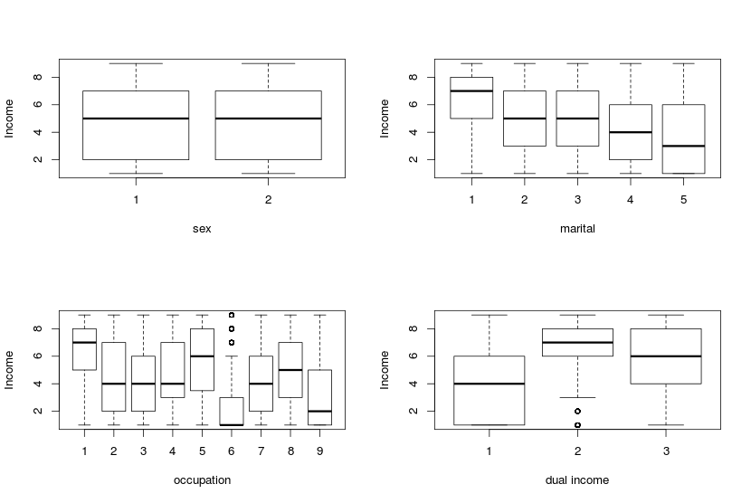
There does not seem to be a clear difference between the sexes and their respective incomes. There does, however, seem to be a significant difference between the levels of the other three plots, above. The income of a married couple seems to be significantly higher than that of a singleton, and the income based on occupation alone is varied, as expected. Therefore, we would expect to see some, if not all, of these levels represented in our final model. The dual income of those who are married is clearly different from those who are not, but whether or not there is a dual income (levels 2 and 3), does not seem to have a large difference between the averages.

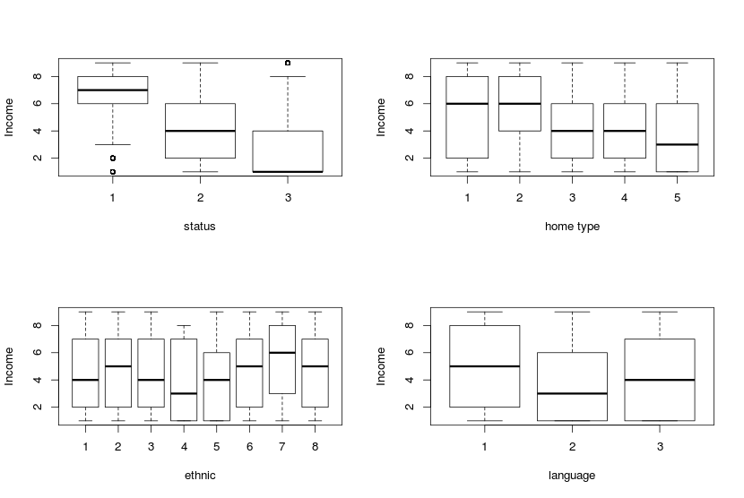
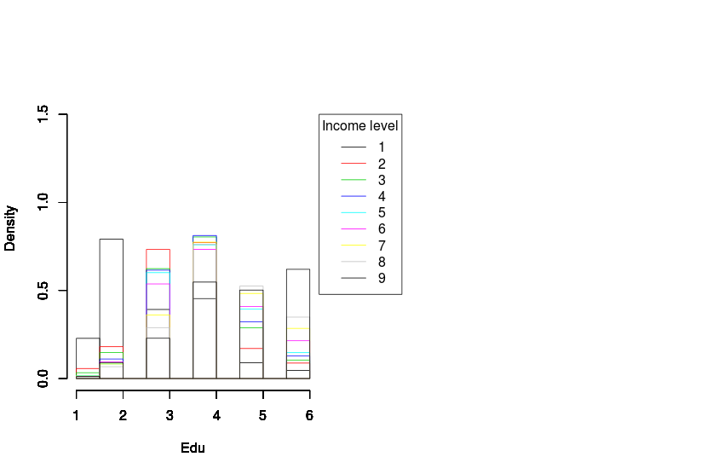
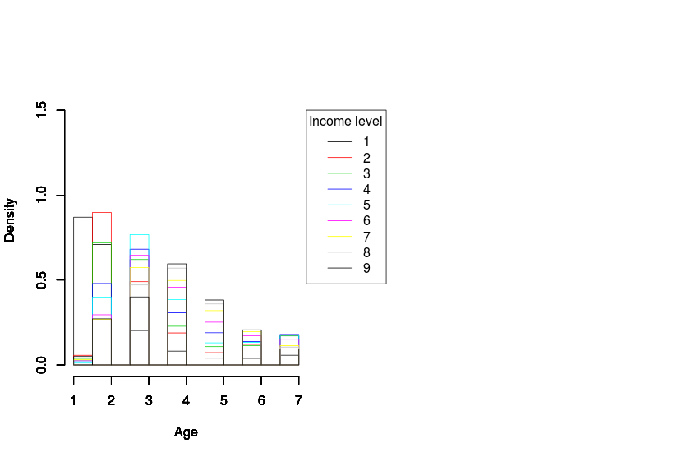

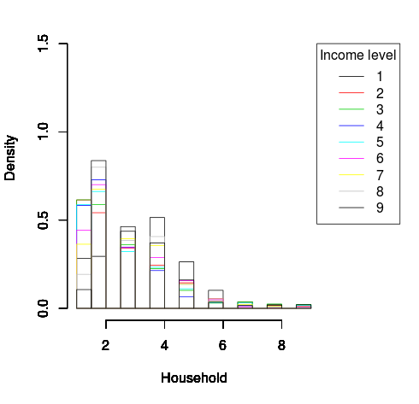
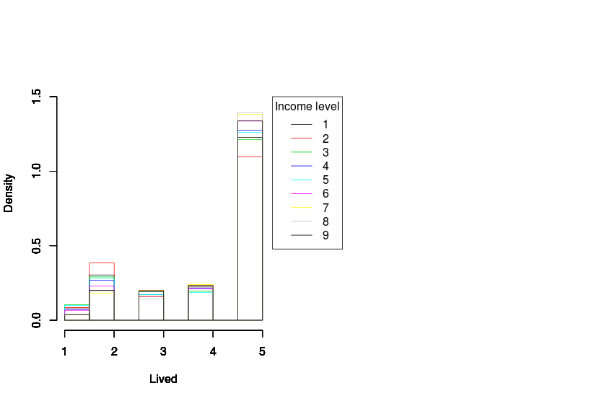

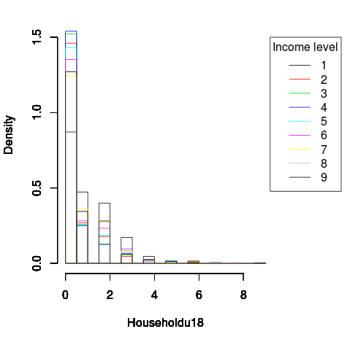

Frequentist Model
Best subset selection and Lasso
K-fold Cross-Validation

Bayesian Model
One-Way ANOVA with fixed and random effects

Comparison of Models

Conclusion

