Unit 4: Activity 2: Assignment 1

User Guide

ICS4UE

Date: August 21, 2018

Teacher: Jeganathan Nanthivarman

By: Alex Guo

Installation Instructions

Note: This program requires an IDE like NetBeans to run properly. For information on how to install NetBeans IDE, visit <https://netbeans.org/>.

1. Download the “ConnectScore” zip file.
2. Inside, there should be two folders called “Application” and “Documentation”. Open the “Application” folder.
3. Inside, you will see four folders and several different images. Open the “src” folder.
4. Inside the “src” folder, open the “connectscore” folder.
5. Inside, there will be some images along with three .form files and four .java files. The file called “MainMenu.java” is the one you will be running.

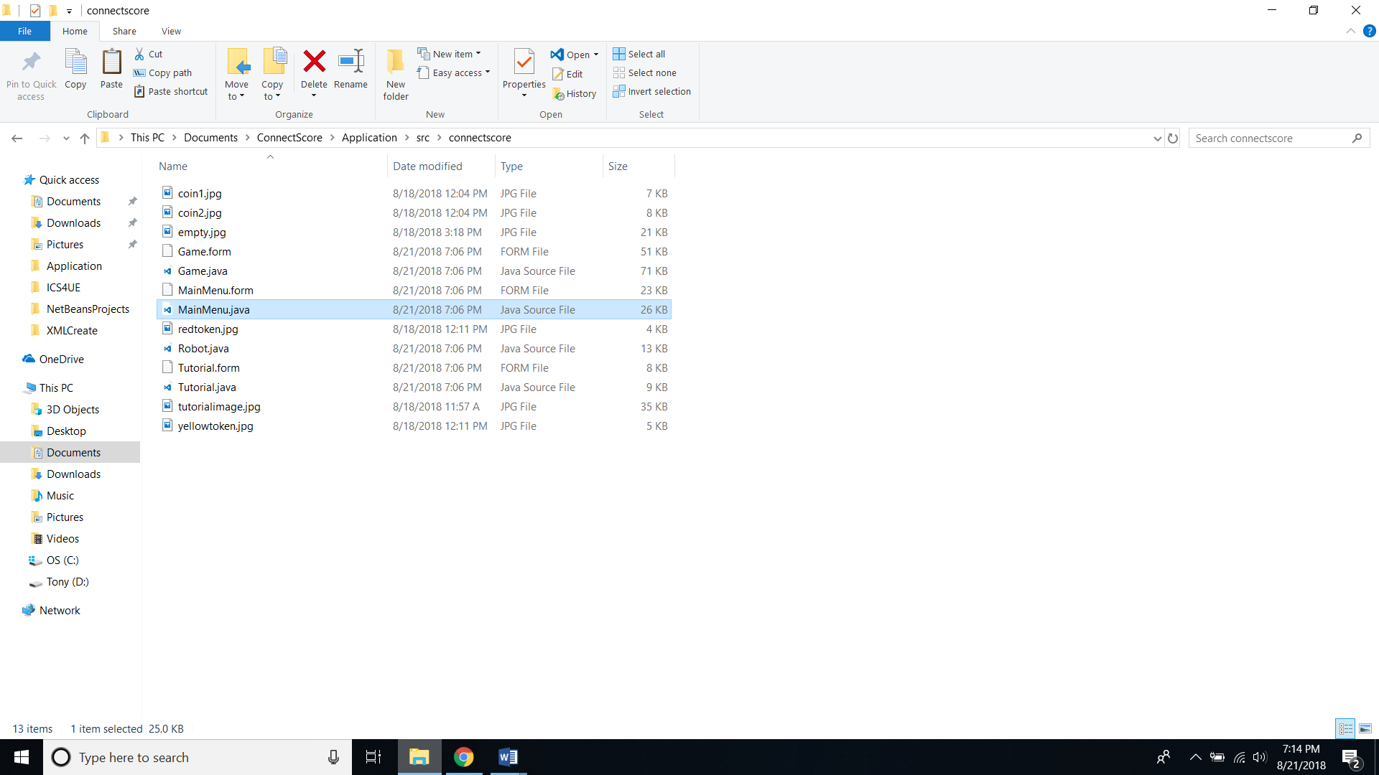

1. Launch your IDE.
2. Under “file”, select “open project” and navigate to the “Application” folder.
3. Open the project.
4. Find the “MainMenu.java” file under the “connectscore” folder which is under the “Source Packages” folder. Right click it and choose “run file”.

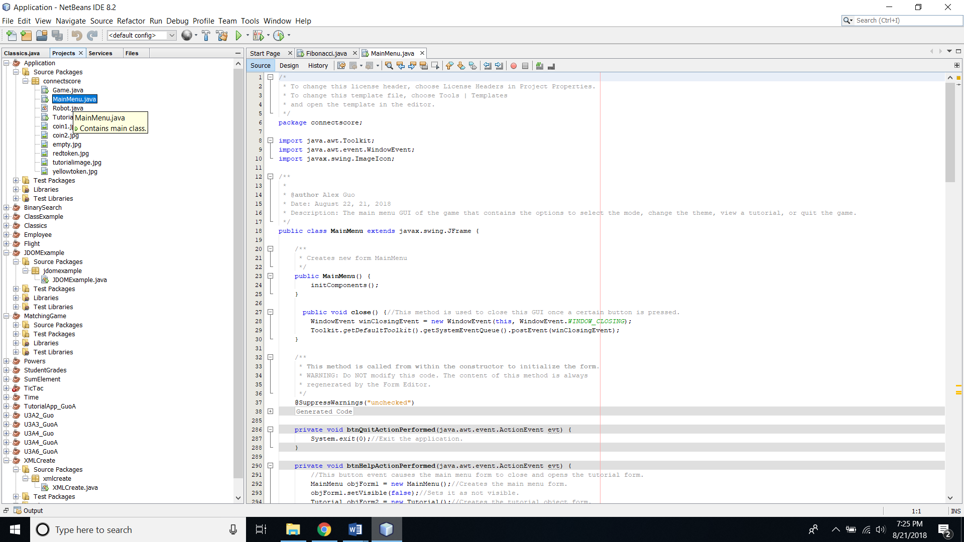

Program Description

This program allows the user to play a simple connect four game. It is intended to have a slightly different look and design in order to appeal to younger audiences, and to be accessible to people of all ages. It includes a two player mode where two users can play against each other and a computer mode where the user can play against a computer-controlled player with varying levels of difficulty.

Using the Program

After you’ve ran the “MainMenu.java” file, you will be taken to a screen with various buttons and features.

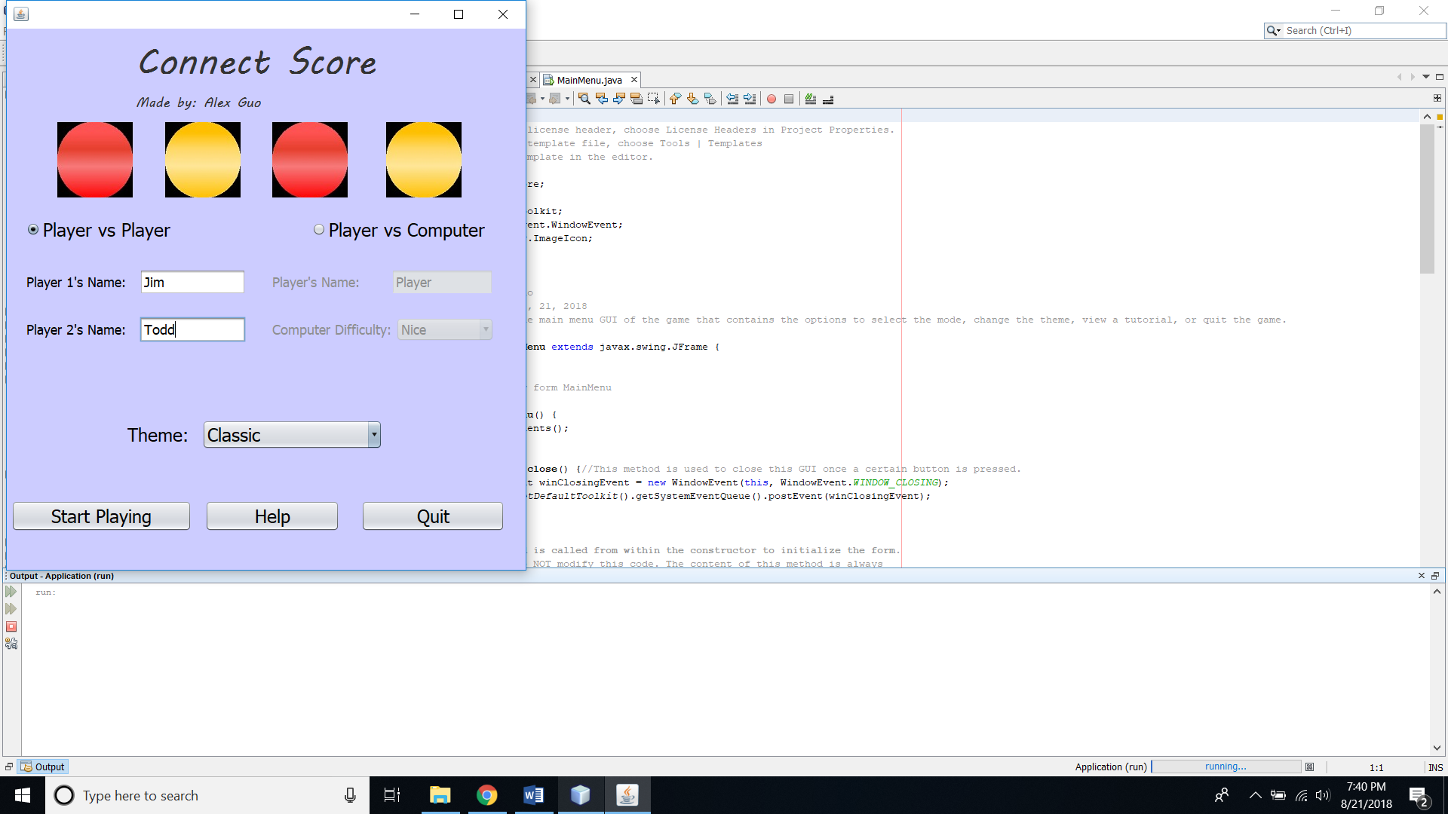

11

1

2

3

4

5

6

7

8

9

10

1: The title and author of the game.

2: The “Player vs Player” option. This will be selected by default upon opening the game. Selecting this will set the game mode to player versus player and will allow the user to enter in a name for player 1 and player 2.

3: Player 1’s name goes here.

4: Player 2’s name goes here.

5: This is the “Player vs Computer” option. Selecting this will set the game mode to player versus computer and will allow the user to input their name and the difficulty of the computer.

6: The player’s name when facing the computer goes here.

7: The computer’s difficulty is selected here.

8: The user can select a theme here, which will change the tokens into different icons. To see a theme, simply select it from the drop-down menu and the tokens at the top of the main menu will change.

9: The button to start a game. This opens the game form and closes the main menu. The game mode will be based on what option is selected when this button is pressed.

10: A button to view a simple explanation on the rules of connect score.

11: A button to quit the application.

Once you start playing the game, you will be taken to the game window.

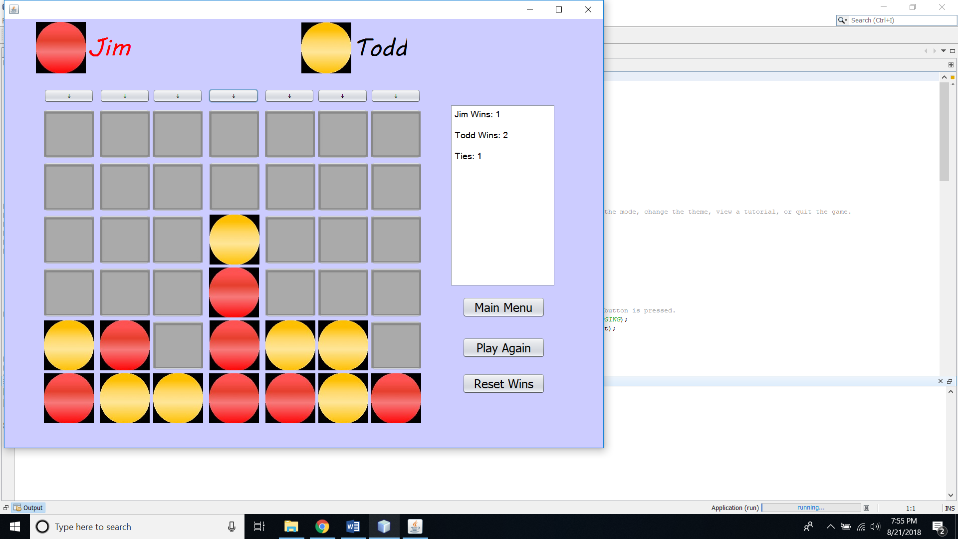

1

2

3

4

5

6

7

8

1: Player 1’s name and token. Whenever it’s a player’s turn to go, they will have their name highlighted in red.

2: Player 2’s name and token. In player vs computer mode, the name is replaced with “Robot” plus the difficulty level (Robot – Nice, Robot – Average, Robot – Tough).

3: The column buttons. The user presses these to drop tokens into the board. Once a column is filled up, that column’s button becomes disabled.

4: The playing board that displays all of the tokens.

5: The statistics box which displays how many times each player has won and how many ties there have been.

6: The main menu button which allows the user to return to the main menu.

7: This button allows the user to start a new game after a game has been completed or restart a current game.

8: This button resets the number of wins and ties to zero.

Program Features

Player vs Player mode: In this mode, two people can play against each other. Users can customize their names in the main menu. By default, player 1 always has the red token and player 2 has the yellow token. In the first game, player 1 gets the first move. Who goes first swaps after each game is completed. Whenever it is a player’s turn, their name is highlighted red to notify them.

Player vs Computer mode: In this mode, one user plays against a computer opponent whose difficulty can be customized in the main menu. The game works the same way as player versus player mode, with player 1 being the user and player 2 being the computer. The three levels of difficulty, ordered from easiest to hardest are nice, average, and tough. In nice mode, the AI will simply go randomly without considering any conditions. In average mode, the AI can now detect when the play is about to win and block them. In tough more, the AI can detect when it has three in a row and play the winning move. It can also detect any “double threes” and block them or play them depending on who has the double three. Finally, it will avoid making a move that helps the player win, such as by placing a token in such a way that the player can then place their token on top and win.

Theme: This game comes with the option to customize the theme, which means changing the token icons. This can be done from the main menu and will show up during a game.