МИНОБРНАУКИ РОССИИ
Санкт-Петербургский государственный
электротехнический университет
«ЛЭТИ» им. В.И. Ульянова (Ленина)
Кафедра МО ЭВМ

отчет
по лабораторной работе №2
по дисциплине «Сети и телекоммуникации»
Тема: Настройка IP-адресов в сети

Студент гр. 3384 |  | Рудаков А.Л.
Преподаватель |  | Фирсов М.А.

Санкт-Петербург
2025
Цель работы.
Изучение и практическое освоение основ адресации, разрешения физических адресов и маршрутизации в IP-сетях путем настройки таблиц маршрутизации.

Задание.
Вариант 22(8).
1. Для всех узлов сети установить IP-адреса, маски подсетей и шлюзы по умолчанию, чтобы добиться успешного выполнения Echo-запроса ближайших соседей (находящихся в одной подсети).
2. Настроить таблицы маршрутизации на маршрутизаторах, чтобы до биться доставки пакетов от узла K1 к узлу K2 и обратно, от узла K2 к K3 и обратно, от узла K3 к K1 и обратно. Пакеты должны доходить до узлов кратчайшим путем.
3. Настроить таблицы маршрутизации на узлах K1, K2 и K3, чтобы обеспечить кратчайшую доставку пакетов между этими узлами, если это невозможно было обеспечить в п. 2.
В отчете привести конфигурацию TCP/IP для каждого из узлов, таблицы маршрутизации, результаты Echo-запросов между узлами K1, K2 и K3, а также обоснование правильности и оптимальности выбранных маршрутов.
Файл со схемой сети: lab2_var8.jfst. Сеть между узлами R1, R2, R3: 192.115.120.0. Сеть между узлами R4 и R7: 192.115.108.0. Сеть между узлами R6 и R7: 192.115.96.0. Компьютер PC1 имеет IP-адрес 192.115.128.1. Компьютер PC2 имеет IP-адрес 192.115.112.4. Компьютер PC3 имеет IP-адрес 192.115.88.2. Длина маски подсети должна быть минимально возможной. Обозначения в задании: K1 – PC1, K2 – PC2, K3 – PC3.
Схема сети приведена на рис.1.
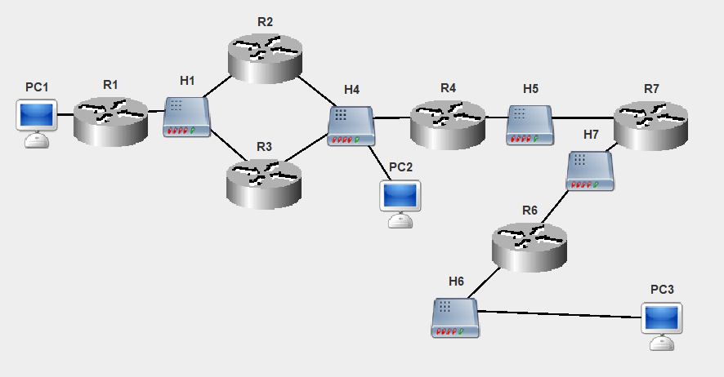
Рисунок 1 – Схема сети.
Выполнение работы.
- Настройки узлов сети приведены в табл.1.
Таблица 1 – Настройки сети.
Узел | Интерфейс | IP-адрес | Маска | Шлюз по умолчанию
K1(PC1) | eth0 | 192.115.128.1 | 255.255.128.0/17 | 192.115.128.2
K2(PC2) | eth0 | 192.115.112.4 | 255.255.248.0/21 | 192.115.112.3
K3(PC3) | eth0 | 192.115.88.2 | 255.255.248.0/21 | 192.115.88.1
R1 | eth0 | 192.115.128.2 | 255.255.128.0/17 | 192.115.120.2
R1 | eth1 | 192.115.120.1 | 255.255.248.0/21 | 192.115.120.2
R2 | eth0 | 192.115.120.2 | 255.255.248.0/21 | 192.115.112.3
R2 | eth1 | 192.115.112.1 | 255.255.248.0/21 | 192.115.112.3
R3 | eth0 | 192.115.120.3 | 255.255.248.0/21 | 192.115.120.1
R3 | eth1 | 192.115.112.2 | 255.255.248.0/21 | 192.115.120.1
R4 | eth0 | 192.115.112.3 | 255.255.248.0/21 | 192.115.108.2
R4 | eth1 | 192.115.108.1 | 255.255.252.0/22 | 192.115.108.2
R6 | eth0 | 192.115.96.2 | 255.255.248.0/21 | 192.115.96.1
R6 | eth1 | 192.115.88.1 | 255.255.248.0/21 | 192.115.96.1
R7 | eth0 | 192.115.108.2 | 255.255.252.0/22 | 192.115.96.2
R7 | eth1 | 192.115.96.1 | 255.255.248.0/21 | 192.115.96.2
Распределение сети на подсети приведено на рис.2.
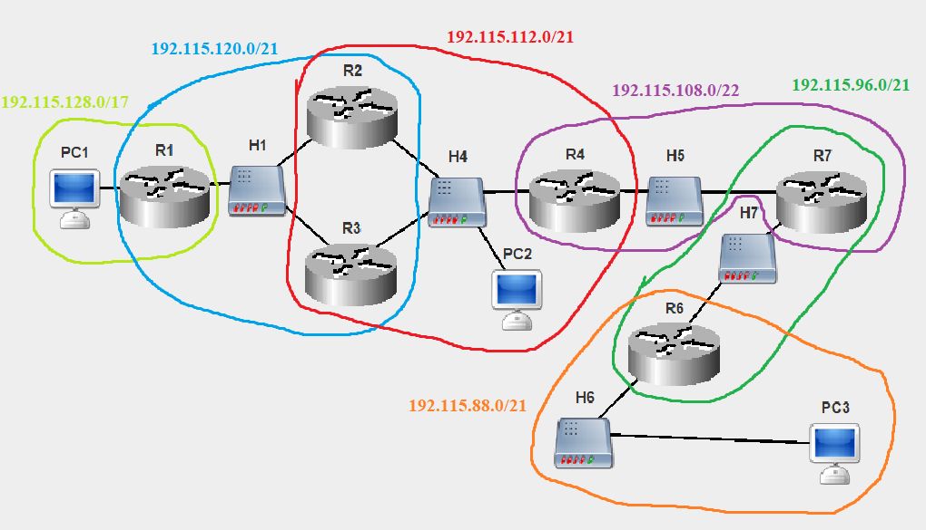
Рисунок 2 – Распределение сети на подсети.
Диапазоны возможных IP-адресов для заданных сетей указаны в табл.2.
Таблица 2 – Диапазоны IP-адресов.
IP-адрес сети | Маска | Диапазон
192.115.128.0 | 255.255.128.0/17 | 192.115.128.1 – 192.115.255.254
192.115.120.0 | 255.255.248.0/21 | 192.115.120.1 – 192.115.127.254
192.115.112.0 | 255.255.248.0/21 | 192.115.112.1 – 192.115.119.254
192.115.108.0 | 255.255.252.0/22 | 192.115.108.1 – 192.115.111.254
192.115.96.0 | 255.255.248.0/21 | 192.115.96.1 – 192.115.103.254
192.115.88.0 | 255.255.248.0/21 | 192.115.88.1 – 192.115.95.254
Логи выполнения Echo-запросов ближайшим соседям (узлам, находящимся в одних подсетях):
- Логи выполнения Echo-запроса с K1(PC1) на R1.
16:22:43-683 PC1 Echo Request Packet Network Created Echo Request packet to 192.115.128.2
16:22:43-683 PC1 ARP Discovery Packet DataLink Created ARP discovery packet to source MAC address for IP 192.115.128.2
...
16:22:43-683 PC1 ICMP_packet Network Sending packet from ProtocolStack (to 192.115.128.2).
16:22:43-683 PC1 Ethernet Packet Link Sending packet from interface 26:85:75:2E:C5:AB
16:22:43-683 R1 Ethernet Packet Link Recieved and accepted packet at interface 74:62:20:89:B9:46
16:22:43-683 R1 ICMP_packet Network ProtocolStack received packet from local Interface.
16:22:43-683 R1 ICMP_packet Network Confirmed Packet is for this Network Layer Device.
16:22:43-683 R1 Echo Reply Packet Network Created Echo Reply packet to 192.115.128.1
16:22:43-683 R1 ICMP_packet Network Sending packet from ProtocolStack (to 192.115.128.1).
16:22:43-683 R1 Ethernet Packet Link Sending packet from interface 74:62:20:89:B9:46
16:22:43-683 PC1 Ethernet Packet Link Recieved and accepted packet at interface 26:85:75:2E:C5:AB
16:22:43-683 PC1 ICMP_packet Network ProtocolStack received packet from local Interface.
16:22:43-683 PC1 ICMP_packet Network Confirmed Packet is for this Network Layer Device.
16:22:43-683 PC1 Echo Reply Packet Network Echo reply packet received from 192.115.128.2

- Логи выполнения Echo-запроса с R1 на R2.
16:28:41-129 R1 Echo Request Packet Network Created Echo Request packet to 192.115.120.2
16:28:41-129 R1 ARP Discovery Packet DataLink Created ARP discovery packet to source MAC address for IP 192.115.120.2
...
16:28:41-129 R1 ICMP_packet Network Sending packet from ProtocolStack (to 192.115.120.2).
16:28:41-129 R1 Ethernet Packet Link Sending packet from interface C3:48:91:67:BF:BA
...
16:28:41-129 R2 Ethernet Packet Link Recieved and accepted packet at interface A6:14:6C:5F:4B:44
16:28:41-129 R2 ICMP_packet Network ProtocolStack received packet from local Interface.
16:28:41-129 R2 ICMP_packet Network Confirmed Packet is for this Network Layer Device.
16:28:41-129 R2 Echo Reply Packet Network Created Echo Reply packet to 192.115.120.1
16:28:41-129 R2 ICMP_packet Network Sending packet from ProtocolStack (to 192.115.120.1).
16:28:41-129 R2 Ethernet Packet Link Sending packet from interface A6:14:6C:5F:4B:44
...
16:28:41-129 R1 Ethernet Packet Link Recieved and accepted packet at interface C3:48:91:67:BF:BA
16:28:41-129 R1 ICMP_packet Network ProtocolStack received packet from local Interface.
16:28:41-129 R1 ICMP_packet Network Confirmed Packet is for this Network Layer Device.
16:28:41-129 R1 Echo Reply Packet Network Echo reply packet received from 192.115.120.2

- Логи выполнения Echo-запроса с R1 на R3.
16:36:14-980 R1 Echo Request Packet Network Created Echo Request packet to 192.115.120.3
16:36:14-981 R1 ARP Discovery Packet DataLink Created ARP discovery packet to source MAC address for IP 192.115.120.3
...
16:36:14-981 R1 ICMP_packet Network Sending packet from ProtocolStack (to 192.115.120.3).
16:36:14-981 R1 Ethernet Packet Link Sending packet from interface C3:48:91:67:BF:BA
16:36:14-981 R3 Ethernet Packet Link Recieved and accepted packet at interface 12:9F:AC:11:54:7C
16:36:14-981 R3 ICMP_packet Network ProtocolStack received packet from local Interface.
16:36:14-981 R3 ICMP_packet Network Confirmed Packet is for this Network Layer Device.
16:36:14-981 R3 Echo Reply Packet Network Created Echo Reply packet to 192.115.120.1
16:36:14-981 R3 ICMP_packet Network Sending packet from ProtocolStack (to 192.115.120.1).
16:36:14-981 R3 Ethernet Packet Link Sending packet from interface 12:9F:AC:11:54:7C
...
16:36:14-981 R1 Ethernet Packet Link Recieved and accepted packet at interface C3:48:91:67:BF:BA
16:36:14-981 R1 ICMP_packet Network ProtocolStack received packet from local Interface.
16:36:14-981 R1 ICMP_packet Network Confirmed Packet is for this Network Layer Device.
16:36:14-981 R1 Echo Reply Packet Network Echo reply packet received from 192.115.120.3

- Логи выполнения Echo-запроса с R2 на R3 (по подсети 192.115.120.0/21).
16:38:23-069 R2 Echo Request Packet Network Created Echo Request packet to 192.115.120.3
16:38:23-069 R2 ARP Discovery Packet DataLink Created ARP discovery packet to source MAC address for IP 192.115.120.3
...
16:38:23-069 R2 ICMP_packet Network Sending packet from ProtocolStack (to 192.115.120.3).
16:38:23-069 R2 Ethernet Packet Link Sending packet from interface A6:14:6C:5F:4B:44
16:38:23-069 R3 Ethernet Packet Link Recieved and accepted packet at interface 12:9F:AC:11:54:7C
16:38:23-069 R3 ICMP_packet Network ProtocolStack received packet from local Interface.
16:38:23-069 R3 ICMP_packet Network Confirmed Packet is for this Network Layer Device.
16:38:23-069 R3 Echo Reply Packet Network Created Echo Reply packet to 192.115.120.2
16:38:23-069 R3 ICMP_packet Network Sending packet from ProtocolStack (to 192.115.120.2).
16:38:23-069 R3 Ethernet Packet Link Sending packet from interface 12:9F:AC:11:54:7C
16:38:23-069 R2 Ethernet Packet Link Recieved and accepted packet at interface A6:14:6C:5F:4B:44
16:38:23-069 R2 ICMP_packet Network ProtocolStack received packet from local Interface.
16:38:23-069 R2 ICMP_packet Network Confirmed Packet is for this Network Layer Device.
16:38:23-069 R2 Echo Reply Packet Network Echo reply packet received from 192.115.120.3

- Логи выполнения Echo-запроса с R2 на R3 (по подсети 192.115.112.0/20).
16:40:19-828 R2 Echo Request Packet Network Created Echo Request packet to 192.115.112.2
16:40:19-828 R2 ARP Discovery Packet DataLink Created ARP discovery packet to source MAC address for IP 192.115.112.2
...
16:40:19-828 R2 ICMP_packet Network Sending packet from ProtocolStack (to 192.115.112.2).
16:40:19-828 R2 Ethernet Packet Link Sending packet from interface 6A:C3:4F:8C:2B:8F
...
16:40:19-828 R3 Ethernet Packet Link Recieved and accepted packet at interface 82:97:3E:3F:18:6D
16:40:19-828 R3 ICMP_packet Network ProtocolStack received packet from local Interface.
16:40:19-828 R3 ICMP_packet Network Confirmed Packet is for this Network Layer Device.
16:40:19-828 R3 Echo Reply Packet Network Created Echo Reply packet to 192.115.112.1
16:40:19-828 R3 ICMP_packet Network Sending packet from ProtocolStack (to 192.115.112.1).
16:40:19-828 R3 Ethernet Packet Link Sending packet from interface 82:97:3E:3F:18:6D
...
16:40:19-828 R2 Ethernet Packet Link Recieved and accepted packet at interface 6A:C3:4F:8C:2B:8F
16:40:19-828 R2 ICMP_packet Network ProtocolStack received packet from local Interface.
16:40:19-828 R2 ICMP_packet Network Confirmed Packet is for this Network Layer Device.
16:40:19-828 R2 Echo Reply Packet Network Echo reply packet received from 192.115.112.2

- Логи выполнения Echo-запроса с R2 на R4.
16:42:13-710 R2 Echo Request Packet Network Created Echo Request packet to 192.115.112.3
16:42:13-710 R2 ARP Discovery Packet DataLink Created ARP discovery packet to source MAC address for IP 192.115.112.3
...
16:42:13-711 R2 ICMP_packet Network Sending packet from ProtocolStack (to 192.115.112.3).
16:42:13-711 R2 Ethernet Packet Link Sending packet from interface 6A:C3:4F:8C:2B:8F
...
16:42:13-711 R4 Ethernet Packet Link Recieved and accepted packet at interface 50:8E:8D:93:91:12
16:42:13-711 R4 ICMP_packet Network ProtocolStack received packet from local Interface.
16:42:13-711 R4 ICMP_packet Network Confirmed Packet is for this Network Layer Device.
16:42:13-711 R4 Echo Reply Packet Network Created Echo Reply packet to 192.115.112.1
16:42:13-711 R4 ICMP_packet Network Sending packet from ProtocolStack (to 192.115.112.1).
16:42:13-711 R4 Ethernet Packet Link Sending packet from interface 50:8E:8D:93:91:12
...
16:42:13-711 R2 Ethernet Packet Link Recieved and accepted packet at interface 6A:C3:4F:8C:2B:8F
16:42:13-711 R2 ICMP_packet Network ProtocolStack received packet from local Interface.
16:42:13-711 R2 ICMP_packet Network Confirmed Packet is for this Network Layer Device.
16:42:13-711 R2 Echo Reply Packet Network Echo reply packet received from 192.115.112.3

- Логи выполнения Echo-запроса с R2 на K2(PC2).
16:43:49-522 R2 Echo Request Packet Network Created Echo Request packet to 192.115.112.4
16:43:49-522 R2 ARP Discovery Packet DataLink Created ARP discovery packet to source MAC address for IP 192.115.112.4
...
16:43:49-523 R2 ICMP_packet Network Sending packet from ProtocolStack (to 192.115.112.4).
16:43:49-523 R2 Ethernet Packet Link Sending packet from interface 6A:C3:4F:8C:2B:8F
16:43:49-523 PC2 Ethernet Packet Link Recieved and accepted packet at interface 97:90:32:50:27:9D
16:43:49-523 PC2 ICMP_packet Network ProtocolStack received packet from local Interface.
16:43:49-523 PC2 ICMP_packet Network Confirmed Packet is for this Network Layer Device.
16:43:49-523 PC2 Echo Reply Packet Network Created Echo Reply packet to 192.115.112.1
16:43:49-523 PC2 ICMP_packet Network Sending packet from ProtocolStack (to 192.115.112.1).
16:43:49-523 PC2 Ethernet Packet Link Sending packet from interface 97:90:32:50:27:9D
...
16:43:49-523 R2 Ethernet Packet Link Recieved and accepted packet at interface 6A:C3:4F:8C:2B:8F
16:43:49-523 R2 ICMP_packet Network ProtocolStack received packet from local Interface.
16:43:49-523 R2 ICMP_packet Network Confirmed Packet is for this Network Layer Device.
16:43:49-523 R2 Echo Reply Packet Network Echo reply packet received from 192.115.112.4

- Логи выполнения Echo-запроса с R3 на R4.
16:45:17-438 R3 Echo Request Packet Network Created Echo Request packet to 192.115.112.3
16:45:17-438 R3 ARP Discovery Packet DataLink Created ARP discovery packet to source MAC address for IP 192.115.112.3
...
16:45:17-438 R3 ICMP_packet Network Sending packet from ProtocolStack (to 192.115.112.3).
16:45:17-438 R3 Ethernet Packet Link Sending packet from interface 82:97:3E:3F:18:6D
...
16:45:17-438 R4 Ethernet Packet Link Recieved and accepted packet at interface 50:8E:8D:93:91:12
16:45:17-438 R4 ICMP_packet Network ProtocolStack received packet from local Interface.
16:45:17-438 R4 ICMP_packet Network Confirmed Packet is for this Network Layer Device.
16:45:17-438 R4 Echo Reply Packet Network Created Echo Reply packet to 192.115.112.2
16:45:17-438 R4 ICMP_packet Network Sending packet from ProtocolStack (to 192.115.112.2).
16:45:17-438 R4 Ethernet Packet Link Sending packet from interface 50:8E:8D:93:91:12
...
16:45:17-438 R3 Ethernet Packet Link Recieved and accepted packet at interface 82:97:3E:3F:18:6D
16:45:17-438 R3 ICMP_packet Network ProtocolStack received packet from local Interface.
16:45:17-438 R3 ICMP_packet Network Confirmed Packet is for this Network Layer Device.
16:45:17-438 R3 Echo Reply Packet Network Echo reply packet received from 192.115.112.3

- Логи выполнения Echo-запроса с R3 на K2(PC2).
16:46:45-592 R3 Echo Request Packet Network Created Echo Request packet to 192.115.112.4
16:46:45-592 R3 ARP Discovery Packet DataLink Created ARP discovery packet to source MAC address for IP 192.115.112.4
...
16:46:45-592 R3 ICMP_packet Network Sending packet from ProtocolStack (to 192.115.112.4).
16:46:45-592 R3 Ethernet Packet Link Sending packet from interface 82:97:3E:3F:18:6D
16:46:45-592 PC2 Ethernet Packet Link Recieved and accepted packet at interface 97:90:32:50:27:9D
16:46:45-592 PC2 ICMP_packet Network ProtocolStack received packet from local Interface.
16:46:45-592 PC2 ICMP_packet Network Confirmed Packet is for this Network Layer Device.
16:46:45-592 PC2 Echo Reply Packet Network Created Echo Reply packet to 192.115.112.2
16:46:45-592 PC2 ICMP_packet Network Sending packet from ProtocolStack (to 192.115.112.2).
16:46:45-592 PC2 Ethernet Packet Link Sending packet from interface 97:90:32:50:27:9D
...
16:46:45-592 R3 Ethernet Packet Link Recieved and accepted packet at interface 82:97:3E:3F:18:6D
16:46:45-592 R3 ICMP_packet Network ProtocolStack received packet from local Interface.
16:46:45-592 R3 ICMP_packet Network Confirmed Packet is for this Network Layer Device.
16:46:45-592 R3 Echo Reply Packet Network Echo reply packet received from 192.115.112.4

- Логи выполнения Echo-запроса с R4 на R7.
16:48:19-476 R4 Echo Request Packet Network Created Echo Request packet to 192.115.108.2
16:48:19-476 R4 ARP Discovery Packet DataLink Created ARP discovery packet to source MAC address for IP 192.115.108.2
...
16:48:19-476 R4 ICMP_packet Network Sending packet from ProtocolStack (to 192.115.108.2).
16:48:19-476 R4 Ethernet Packet Link Sending packet from interface 90:1A:43:49:95:8E
16:48:19-476 R7 Ethernet Packet Link Recieved and accepted packet at interface 16:78:54:87:AD:95
16:48:19-476 R7 ICMP_packet Network ProtocolStack received packet from local Interface.
16:48:19-476 R7 ICMP_packet Network Confirmed Packet is for this Network Layer Device.
16:48:19-476 R7 Echo Reply Packet Network Created Echo Reply packet to 192.115.108.1
16:48:19-476 R7 ICMP_packet Network Sending packet from ProtocolStack (to 192.115.108.1).
16:48:19-476 R7 Ethernet Packet Link Sending packet from interface 16:78:54:87:AD:95
16:48:19-476 R4 Ethernet Packet Link Recieved and accepted packet at interface 90:1A:43:49:95:8E
16:48:19-476 R4 ICMP_packet Network ProtocolStack received packet from local Interface.
16:48:19-476 R4 ICMP_packet Network Confirmed Packet is for this Network Layer Device.
16:48:19-476 R4 Echo Reply Packet Network Echo reply packet received from 192.115.108.2

- Логи выполнения Echo-запроса с R7 на R6.
16:49:22-839 R7 Echo Request Packet Network Created Echo Request packet to 192.115.96.2
16:49:22-839 R7 ARP Discovery Packet DataLink Created ARP discovery packet to source MAC address for IP 192.115.96.2
...
16:49:22-839 R7 ICMP_packet Network Sending packet from ProtocolStack (to 192.115.96.2).
16:49:22-839 R7 Ethernet Packet Link Sending packet from interface 6A:12:84:8F:3F:20
16:49:22-839 R6 Ethernet Packet Link Recieved and accepted packet at interface 9D:73:2F:AD:C7:B7
16:49:22-839 R6 ICMP_packet Network ProtocolStack received packet from local Interface.
16:49:22-839 R6 ICMP_packet Network Confirmed Packet is for this Network Layer Device.
16:49:22-839 R6 Echo Reply Packet Network Created Echo Reply packet to 192.115.96.1
16:49:22-839 R6 ICMP_packet Network Sending packet from ProtocolStack (to 192.115.96.1).
16:49:22-839 R6 Ethernet Packet Link Sending packet from interface 9D:73:2F:AD:C7:B7
16:49:22-839 R7 Ethernet Packet Link Recieved and accepted packet at interface 6A:12:84:8F:3F:20
16:49:22-839 R7 ICMP_packet Network ProtocolStack received packet from local Interface.
16:49:22-839 R7 ICMP_packet Network Confirmed Packet is for this Network Layer Device.
16:49:22-839 R7 Echo Reply Packet Network Echo reply packet received from 192.115.96.2

- Логи выполнения Echo-запроса с R6 на K3(PC3).
16:50:29-800 R6 Echo Request Packet Network Created Echo Request packet to 192.115.88.2
16:50:29-800 R6 ARP Discovery Packet DataLink Created ARP discovery packet to source MAC address for IP 192.115.88.2
...
16:50:29-800 R6 ICMP_packet Network Sending packet from ProtocolStack (to 192.115.88.2).
16:50:29-800 R6 Ethernet Packet Link Sending packet from interface AF:3B:32:25:B1:70
16:50:29-800 PC3 Ethernet Packet Link Recieved and accepted packet at interface AA:2D:B5:5D:A1:72
16:50:29-800 PC3 ICMP_packet Network ProtocolStack received packet from local Interface.
16:50:29-800 PC3 ICMP_packet Network Confirmed Packet is for this Network Layer Device.
16:50:29-800 PC3 Echo Reply Packet Network Created Echo Reply packet to 192.115.88.1
16:50:29-800 PC3 ICMP_packet Network Sending packet from ProtocolStack (to 192.115.88.1).
16:50:29-800 PC3 Ethernet Packet Link Sending packet from interface AA:2D:B5:5D:A1:72
16:50:29-800 R6 Ethernet Packet Link Recieved and accepted packet at interface AF:3B:32:25:B1:70
16:50:29-800 R6 ICMP_packet Network ProtocolStack received packet from local Interface.
16:50:29-800 R6 ICMP_packet Network Confirmed Packet is for this Network Layer Device.
16:50:29-800 R6 Echo Reply Packet Network Echo reply packet received from 192.115.88.2
Исходя из логов видно, что все узлы, находящиеся в одних подсетях, могут достигнуть друг друга.
- Добавление записей в таблицы маршрутизации маршрутизаторам.
Для корректной отправки пакетов в области R1-R2-R3-R4 у маршрутизаторов R2 и R3 шлюзы по умолчанию заданы так, чтобы при попадании сигнала на R2, он отправлял бы его по умолчанию в подсеть 192.115.112.0/21 (на R4), а при попадании сигнала на R3, он отправлял бы его по умолчанию в подсеть 192.115.120.0/21 (на R1). Поэтому для отправки через данную область сигнала на K1(PC1) требуется направить сигнал на R3. Направления шлюзов по умолчанию показаны на рис.3. Шлюзы по умолчанию изображены красным цветом, направления, которые требуется добавить для корректной доставки сигнала на K1(PC1) от K2(PC2) и K3(PC3) изображены синим цветом, направления, которые требуется добавить для корректной доставки сигнала от K3(PC3) к K2(PC2) изображены зеленым цветом.
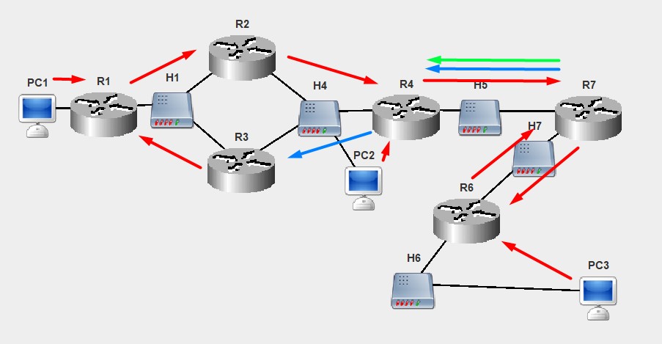
Рисунок 3 – Шлюзы по умолчанию
Настройка таблицы маршрутизации для R4:
R4# conf t
Enter configuration commands, one per line. End with 'exit'
R4(config)# ip route 192.115.128.0 225.225.128.0 192.115.112.2 eth0
Route added.

R4(config)# write mem
Writing is complete

R4(config)# show ip route
Codes: C - connected, S - static, R - RIP,
B - BGP, O - OSPF, * - candidate default

S 192.115.128.0/225.225.128.0[0] via 192.115.112.2 (eth0)
S* default/0.0.0.0[0] via 192.115.108.2 (eth0)
C 192.115.108.1/255.255.252.0 is directly connected, eth1
C 192.115.112.3/255.255.248.0 is directly connected, eth0

Настройка таблицы маршрутизации для R7:
R7# conf t
Enter configuration commands, one per line. End with 'exit'
R7(config)# ip route 192.115.128.0 255.255.128.0 192.115.108.1 eth0
Route added.

R7(config)# ip route 192.115.112.0 255.255.248.0 192.115.108.1 eth0
Route added.

R7(config)# write mem
Writing is complete

R7(config)# show ip route
Codes: C - connected, S - static, R - RIP,
B - BGP, O - OSPF, * - candidate default

S 192.115.128.0/255.255.128.0[0] via 192.115.108.1 (eth0)
S* default/0.0.0.0[0] via 192.115.96.2 (eth0)
S 192.115.112.0/255.255.248.0[0] via 192.115.108.1 (eth0)
C 192.115.96.1/255.255.248.0 is directly connected, eth1
C 192.115.108.2/255.255.252.0 is directly connected, eth0

Логи выполнения Echo-запросов c Ki на Kj:
- Логи выполнения Echo-запроса с K1(PC1) на K2(PC2).
17:31:21-080 PC1 Echo Request Packet Network Created Echo Request packet to 192.115.112.4
17:31:21-080 PC1 ARP Discovery Packet DataLink Created ARP discovery packet to source MAC address for IP 192.115.128.2
...
17:31:21-080 PC1 ICMP_packet Network Sending packet from ProtocolStack (to 192.115.128.2).
17:31:21-080 PC1 Ethernet Packet Link Sending packet from interface 26:85:75:2E:C5:AB
17:31:21-080 R1 Ethernet Packet Link Recieved and accepted packet at interface 74:62:20:89:B9:46
17:31:21-080 R1 ICMP_packet Network ProtocolStack received packet from local Interface.
17:31:21-080 R1 ICMP_packet Network Packet Received: Network Layer Device is Routable forwarding packet.
17:31:21-080 R1 ARP Discovery Packet DataLink Created ARP discovery packet to source MAC address for IP 192.115.120.2
...
17:31:21-080 R1 ICMP_packet Network Forwarding packet from ProtocolStack(to 192.115.120.2).
17:31:21-080 R1 Ethernet Packet Link Sending packet from interface C3:48:91:67:BF:BA
...
17:31:21-080 R2 Ethernet Packet Link Recieved and accepted packet at interface A6:14:6C:5F:4B:44
17:31:21-080 R2 ICMP_packet Network ProtocolStack received packet from local Interface.
17:31:21-080 R2 ICMP_packet Network Packet Received: Network Layer Device is Routable forwarding packet.
17:31:21-080 R2 ARP Discovery Packet DataLink Created ARP discovery packet to source MAC address for IP 192.115.112.4
...
17:31:21-080 R2 ICMP_packet Network Forwarding packet from ProtocolStack(to 192.115.112.4).
17:31:21-080 R2 Ethernet Packet Link Sending packet from interface 6A:C3:4F:8C:2B:8F
17:31:21-080 PC2 Ethernet Packet Link Recieved and accepted packet at interface 97:90:32:50:27:9D
17:31:21-080 PC2 ICMP_packet Network ProtocolStack received packet from local Interface.
17:31:21-080 PC2 ICMP_packet Network Confirmed Packet is for this Network Layer Device.
17:31:21-080 PC2 Echo Reply Packet Network Created Echo Reply packet to 192.115.128.1
17:31:21-080 PC2 ARP Discovery Packet DataLink Created ARP discovery packet to source MAC address for IP 192.115.112.3
...
17:31:21-080 PC2 ICMP_packet Network Sending packet from ProtocolStack (to 192.115.112.3).
17:31:21-080 PC2 Ethernet Packet Link Sending packet from interface 97:90:32:50:27:9D
17:31:21-080 R4 Ethernet Packet Link Recieved and accepted packet at interface 50:8E:8D:93:91:12
17:31:21-080 R4 ICMP_packet Network ProtocolStack received packet from local Interface.
17:31:21-080 R4 ICMP_packet Network Packet Received: Network Layer Device is Routable forwarding packet.
17:31:21-080 R4 ARP Discovery Packet DataLink Created ARP discovery packet to source MAC address for IP 192.115.112.2
...
17:31:21-080 R4 ICMP_packet Network Forwarding packet from ProtocolStack(to 192.115.112.2).
17:31:21-080 R4 Ethernet Packet Link Sending packet from interface 50:8E:8D:93:91:12
...
17:31:21-080 R3 Ethernet Packet Link Recieved and accepted packet at interface 82:97:3E:3F:18:6D
17:31:21-080 R3 ICMP_packet Network ProtocolStack received packet from local Interface.
17:31:21-080 R3 ICMP_packet Network Packet Received: Network Layer Device is Routable forwarding packet.
17:31:21-080 R3 ARP Discovery Packet DataLink Created ARP discovery packet to source MAC address for IP 192.115.120.1
...
17:31:21-080 R3 ICMP_packet Network Forwarding packet from ProtocolStack(to 192.115.120.1).
17:31:21-080 R3 Ethernet Packet Link Sending packet from interface 12:9F:AC:11:54:7C
...
17:31:21-080 R1 Ethernet Packet Link Recieved and accepted packet at interface C3:48:91:67:BF:BA
17:31:21-080 R1 ICMP_packet Network ProtocolStack received packet from local Interface.
17:31:21-080 R1 ICMP_packet Network Packet Received: Network Layer Device is Routable forwarding packet.
17:31:21-080 R1 ICMP_packet Network Forwarding packet from ProtocolStack(to 192.115.128.1).
17:31:21-080 R1 Ethernet Packet Link Sending packet from interface 74:62:20:89:B9:46
17:31:21-080 PC1 Ethernet Packet Link Recieved and accepted packet at interface 26:85:75:2E:C5:AB
17:31:21-080 PC1 ICMP_packet Network ProtocolStack received packet from local Interface.
17:31:21-080 PC1 ICMP_packet Network Confirmed Packet is for this Network Layer Device.
17:31:21-080 PC1 Echo Reply Packet Network Echo reply packet received from 192.115.112.4
Путь от K1(PC1) к K2(PC2): K1(PC1) – R1 – R2 – K2(PC2).
Путь от K2(PC2) к K1(PC1): K2(PC2) – R4 – R3 – R1 – K1(PC1).
Более оптимальный путь от K2(PC2) к K1(PC1) будет настроен в задании 3.

- Логи выполнения Echo-запроса с K1(PC1) на K3(PC3).
17:38:13-840 PC1 Echo Request Packet Network Created Echo Request packet to 192.115.88.2
17:38:13-840 PC1 ARP Discovery Packet DataLink Created ARP discovery packet to source MAC address for IP 192.115.128.2
...
17:38:13-840 PC1 ICMP_packet Network Sending packet from ProtocolStack (to 192.115.128.2).
17:38:13-840 PC1 Ethernet Packet Link Sending packet from interface 26:85:75:2E:C5:AB
17:38:13-840 R1 Ethernet Packet Link Recieved and accepted packet at interface 74:62:20:89:B9:46
17:38:13-840 R1 ICMP_packet Network ProtocolStack received packet from local Interface.
17:38:13-840 R1 ICMP_packet Network Packet Received: Network Layer Device is Routable forwarding packet.
17:38:13-840 R1 ARP Discovery Packet DataLink Created ARP discovery packet to source MAC address for IP 192.115.120.2
...
17:38:13-840 R1 ICMP_packet Network Forwarding packet from ProtocolStack(to 192.115.120.2).
17:38:13-840 R1 Ethernet Packet Link Sending packet from interface C3:48:91:67:BF:BA
...
17:38:13-840 R2 Ethernet Packet Link Recieved and accepted packet at interface A6:14:6C:5F:4B:44
17:38:13-840 R2 ICMP_packet Network ProtocolStack received packet from local Interface.
17:38:13-840 R2 ICMP_packet Network Packet Received: Network Layer Device is Routable forwarding packet.
17:38:13-840 R2 ARP Discovery Packet DataLink Created ARP discovery packet to source MAC address for IP 192.115.112.3
...
17:38:13-840 R2 ICMP_packet Network Forwarding packet from ProtocolStack(to 192.115.112.3).
17:38:13-840 R2 Ethernet Packet Link Sending packet from interface 6A:C3:4F:8C:2B:8F
...
17:38:13-840 R4 Ethernet Packet Link Recieved and accepted packet at interface 50:8E:8D:93:91:12
17:38:13-840 R4 ICMP_packet Network ProtocolStack received packet from local Interface.
17:38:13-840 R4 ICMP_packet Network Packet Received: Network Layer Device is Routable forwarding packet.
17:38:13-840 R4 ARP Discovery Packet DataLink Created ARP discovery packet to source MAC address for IP 192.115.108.2
...
17:38:13-840 R4 ICMP_packet Network Forwarding packet from ProtocolStack(to 192.115.108.2).
17:38:13-840 R4 Ethernet Packet Link Sending packet from interface 90:1A:43:49:95:8E
17:38:13-840 R7 Ethernet Packet Link Recieved and accepted packet at interface 16:78:54:87:AD:95
17:38:13-840 R7 ICMP_packet Network ProtocolStack received packet from local Interface.
17:38:13-840 R7 ICMP_packet Network Packet Received: Network Layer Device is Routable forwarding packet.
17:38:13-840 R7 ARP Discovery Packet DataLink Created ARP discovery packet to source MAC address for IP 192.115.96.2
...
17:38:13-840 R7 ICMP_packet Network Forwarding packet from ProtocolStack(to 192.115.96.2).
17:38:13-840 R7 Ethernet Packet Link Sending packet from interface 6A:12:84:8F:3F:20
17:38:13-840 R6 Ethernet Packet Link Recieved and accepted packet at interface 9D:73:2F:AD:C7:B7
17:38:13-840 R6 ICMP_packet Network ProtocolStack received packet from local Interface.
17:38:13-840 R6 ICMP_packet Network Packet Received: Network Layer Device is Routable forwarding packet.
17:38:13-840 R6 ARP Discovery Packet DataLink Created ARP discovery packet to source MAC address for IP 192.115.88.2
...
17:38:13-840 R6 ICMP_packet Network Forwarding packet from ProtocolStack(to 192.115.88.2).
17:38:13-840 R6 Ethernet Packet Link Sending packet from interface AF:3B:32:25:B1:70
17:38:13-840 PC3 Ethernet Packet Link Recieved and accepted packet at interface AA:2D:B5:5D:A1:72
17:38:13-840 PC3 ICMP_packet Network ProtocolStack received packet from local Interface.
17:38:13-840 PC3 ICMP_packet Network Confirmed Packet is for this Network Layer Device.
17:38:13-840 PC3 Echo Reply Packet Network Created Echo Reply packet to 192.115.128.1
17:38:13-840 PC3 ICMP_packet Network Sending packet from ProtocolStack (to 192.115.88.1).
17:38:13-840 PC3 Ethernet Packet Link Sending packet from interface AA:2D:B5:5D:A1:72
17:38:13-840 R6 Ethernet Packet Link Recieved and accepted packet at interface AF:3B:32:25:B1:70
17:38:13-840 R6 ICMP_packet Network ProtocolStack received packet from local Interface.
17:38:13-840 R6 ICMP_packet Network Packet Received: Network Layer Device is Routable forwarding packet.
17:38:13-840 R6 ICMP_packet Network Forwarding packet from ProtocolStack(to 192.115.96.1).
17:38:13-840 R6 Ethernet Packet Link Sending packet from interface 9D:73:2F:AD:C7:B7
17:38:13-840 R7 Ethernet Packet Link Recieved and accepted packet at interface 6A:12:84:8F:3F:20
17:38:13-840 R7 ICMP_packet Network ProtocolStack received packet from local Interface.
17:38:13-840 R7 ICMP_packet Network Packet Received: Network Layer Device is Routable forwarding packet.
17:38:13-840 R7 ICMP_packet Network Forwarding packet from ProtocolStack(to 192.115.108.1).
17:38:13-840 R7 Ethernet Packet Link Sending packet from interface 16:78:54:87:AD:95
17:38:13-840 R4 Ethernet Packet Link Recieved and accepted packet at interface 90:1A:43:49:95:8E
17:38:13-840 R4 ICMP_packet Network ProtocolStack received packet from local Interface.
17:38:13-840 R4 ICMP_packet Network Packet Received: Network Layer Device is Routable forwarding packet.
17:38:13-840 R4 ARP Discovery Packet DataLink Created ARP discovery packet to source MAC address for IP 192.115.112.2
...
17:38:13-840 R4 ICMP_packet Network Forwarding packet from ProtocolStack(to 192.115.112.2).
17:38:13-840 R4 Ethernet Packet Link Sending packet from interface 50:8E:8D:93:91:12
...
17:38:13-840 R3 Ethernet Packet Link Recieved and accepted packet at interface 82:97:3E:3F:18:6D
17:38:13-840 R3 ICMP_packet Network ProtocolStack received packet from local Interface.
17:38:13-840 R3 ICMP_packet Network Packet Received: Network Layer Device is Routable forwarding packet.
17:38:13-840 R3 ARP Discovery Packet DataLink Created ARP discovery packet to source MAC address for IP 192.115.120.1
...
17:38:13-840 R3 ICMP_packet Network Forwarding packet from ProtocolStack(to 192.115.120.1).
17:38:13-840 R3 Ethernet Packet Link Sending packet from interface 12:9F:AC:11:54:7C
...
17:38:13-840 R1 Ethernet Packet Link Recieved and accepted packet at interface C3:48:91:67:BF:BA
17:38:13-840 R1 ICMP_packet Network ProtocolStack received packet from local Interface.
17:38:13-840 R1 ICMP_packet Network Packet Received: Network Layer Device is Routable forwarding packet.
17:38:13-840 R1 ICMP_packet Network Forwarding packet from ProtocolStack(to 192.115.128.1).
17:38:13-840 R1 Ethernet Packet Link Sending packet from interface 74:62:20:89:B9:46
17:38:13-840 PC1 Ethernet Packet Link Recieved and accepted packet at interface 26:85:75:2E:C5:AB
17:38:13-840 PC1 ICMP_packet Network ProtocolStack received packet from local Interface.
17:38:13-840 PC1 ICMP_packet Network Confirmed Packet is for this Network Layer Device.
17:38:13-840 PC1 Echo Reply Packet Network Echo reply packet received from 192.115.88.2
Путь от K1(PC1) к K3(PC3): K1(PC1) – R1 – R2 – R4 – R7 – R6 – K3(PC3).
Путь от K3(PC3) к K1(PC1): K3(PC3) – R6 – R7 – R4 – R3 – R1 – K1(PC1).

- Логи выполнения Echo-запроса с K2(PC2) на K3(PC3).
18:58:08-625 PC2 Echo Request Packet Network Created Echo Request packet to 192.115.88.2
18:58:08-625 PC2 ARP Discovery Packet DataLink Created ARP discovery packet to source MAC address for IP 192.115.112.3
...
18:58:08-625 PC2 ICMP_packet Network Sending packet from ProtocolStack (to 192.115.112.3).
18:58:08-625 PC2 Ethernet Packet Link Sending packet from interface 97:90:32:50:27:9D
18:58:08-625 R4 Ethernet Packet Link Recieved and accepted packet at interface 50:8E:8D:93:91:12
18:58:08-625 R4 ICMP_packet Network ProtocolStack received packet from local Interface.
18:58:08-625 R4 ICMP_packet Network Packet Received: Network Layer Device is Routable forwarding packet.
18:58:08-625 R4 ARP Discovery Packet DataLink Created ARP discovery packet to source MAC address for IP 192.115.108.2
...
18:58:08-625 R4 ICMP_packet Network Forwarding packet from ProtocolStack(to 192.115.108.2).
18:58:08-625 R4 Ethernet Packet Link Sending packet from interface 90:1A:43:49:95:8E
18:58:08-625 R7 Ethernet Packet Link Recieved and accepted packet at interface 16:78:54:87:AD:95
18:58:08-625 R7 ICMP_packet Network ProtocolStack received packet from local Interface.
18:58:08-625 R7 ICMP_packet Network Packet Received: Network Layer Device is Routable forwarding packet.
18:58:08-625 R7 ARP Discovery Packet DataLink Created ARP discovery packet to source MAC address for IP 192.115.96.2
...
18:58:08-625 R7 ICMP_packet Network Forwarding packet from ProtocolStack(to 192.115.96.2).
18:58:08-625 R7 Ethernet Packet Link Sending packet from interface 6A:12:84:8F:3F:20
18:58:08-625 R6 Ethernet Packet Link Recieved and accepted packet at interface 40:17:BC:BC:A2:49
18:58:08-625 R6 ICMP_packet Network ProtocolStack received packet from local Interface.
18:58:08-625 R6 ICMP_packet Network Packet Received: Network Layer Device is Routable forwarding packet.
18:58:08-625 R6 ARP Discovery Packet DataLink Created ARP discovery packet to source MAC address for IP 192.115.88.2
...
18:58:08-625 R6 ICMP_packet Network Forwarding packet from ProtocolStack(to 192.115.88.2).
18:58:08-625 R6 Ethernet Packet Link Sending packet from interface 57:68:7D:81:68:8D
18:58:08-625 PC3 Ethernet Packet Link Recieved and accepted packet at interface AA:2D:B5:5D:A1:72
18:58:08-625 PC3 ICMP_packet Network ProtocolStack received packet from local Interface.
18:58:08-625 PC3 ICMP_packet Network Confirmed Packet is for this Network Layer Device.
18:58:08-625 PC3 Echo Reply Packet Network Created Echo Reply packet to 192.115.112.4
18:58:08-625 PC3 ICMP_packet Network Sending packet from ProtocolStack (to 192.115.88.1).
18:58:08-625 PC3 Ethernet Packet Link Sending packet from interface AA:2D:B5:5D:A1:72
18:58:08-626 R6 Ethernet Packet Link Recieved and accepted packet at interface 57:68:7D:81:68:8D
18:58:08-626 R6 ICMP_packet Network ProtocolStack received packet from local Interface.
18:58:08-626 R6 ICMP_packet Network Packet Received: Network Layer Device is Routable forwarding packet.
18:58:08-626 R6 ICMP_packet Network Forwarding packet from ProtocolStack(to 192.115.96.1).
18:58:08-626 R6 Ethernet Packet Link Sending packet from interface 40:17:BC:BC:A2:49
18:58:08-626 R7 Ethernet Packet Link Recieved and accepted packet at interface 6A:12:84:8F:3F:20
18:58:08-626 R7 ICMP_packet Network ProtocolStack received packet from local Interface.
18:58:08-626 R7 ICMP_packet Network Packet Received: Network Layer Device is Routable forwarding packet.
18:58:08-626 R7 ICMP_packet Network Forwarding packet from ProtocolStack(to 192.115.108.1).
18:58:08-626 R7 Ethernet Packet Link Sending packet from interface 16:78:54:87:AD:95
18:58:08-626 R4 Ethernet Packet Link Recieved and accepted packet at interface 90:1A:43:49:95:8E
18:58:08-626 R4 ICMP_packet Network ProtocolStack received packet from local Interface.
18:58:08-626 R4 ICMP_packet Network Packet Received: Network Layer Device is Routable forwarding packet.
18:58:08-626 R4 ICMP_packet Network Forwarding packet from ProtocolStack(to 192.115.112.4).
18:58:08-626 R4 Ethernet Packet Link Sending packet from interface 50:8E:8D:93:91:12
18:58:08-626 PC2 Ethernet Packet Link Recieved and accepted packet at interface 97:90:32:50:27:9D
18:58:08-626 PC2 ICMP_packet Network ProtocolStack received packet from local Interface.
18:58:08-626 PC2 ICMP_packet Network Confirmed Packet is for this Network Layer Device.
18:58:08-626 PC2 Echo Reply Packet Network Echo reply packet received from 192.115.88.2
Путь от K2(PC2) к K3(PC3): K2(PC2) – R4 – R7 – R6 – K3(PC3).
Путь от K3(PC3) к K2(PC2): K3(PC3) – R6 – R7 – R4 – K2(PC2).

- Добавление записей в таблицы маршрутизации компьютерам.
Для того чтобы пакеты доходили оптимальным образом, требуется оптимизировать маршрут от K2(PC2) к K1(PC1), так как на данном этапе маршрут представляет из себя K2(PC2) – R4 – R3 – R1 – K1(PC1). Этот маршрут можно оптимизировать и привести в данный вид: K2(PC2) – R3 – R1 – K1(PC1). Добавленный маршрут можно увидеть на рис.4 – доработанном рис.2, на котором новый маршрут изображен фиолетовым цветом.
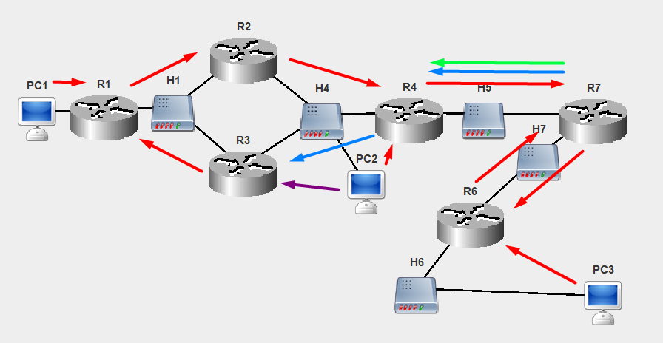
Рисунок 4 – Схема с добавленным маршрутом
Добавление маршрута в таблицу маршрутизации K2(PC2):
PC2# conf t
Enter configuration commands, one per line. End with 'exit'
PC2(config)# ip route 192.115.128.0 255.255.128.0 192.115.112.2 eth0
Route added.

PC2(config)# write mem
Writing is complete

PC2(config)# show ip route
Codes: C - connected, S - static, R - RIP,
B - BGP, O - OSPF, * - candidate default

S 192.115.128.0/255.255.128.0[0] via 192.115.112.2 (eth0)
S* default/0.0.0.0[0] via 192.115.112.3 (eth0)
C 192.115.112.4/255.255.248.0 is directly connected, eth0

Логи выполнения Echo-запроса с K2(PC2) на K1(PC1):
19:20:48-979 PC2 Echo Request Packet Network Created Echo Request packet to 192.115.128.1
19:20:48-979 PC2 ARP Discovery Packet DataLink Created ARP discovery packet to source MAC address for IP 192.115.112.2
...
19:20:48-979 PC2 ICMP_packet Network Sending packet from ProtocolStack (to 192.115.112.2).
19:20:48-979 PC2 Ethernet Packet Link Sending packet from interface 97:90:32:50:27:9D
...
19:20:48-979 R3 Ethernet Packet Link Recieved and accepted packet at interface 82:97:3E:3F:18:6D
19:20:48-979 R3 ICMP_packet Network ProtocolStack received packet from local Interface.
19:20:48-979 R3 ICMP_packet Network Packet Received: Network Layer Device is Routable forwarding packet.
19:20:48-979 R3 ICMP_packet Network Forwarding packet from ProtocolStack(to 192.115.120.1).
19:20:48-979 R3 Ethernet Packet Link Sending packet from interface 12:9F:AC:11:54:7C
...
19:20:48-979 R1 Ethernet Packet Link Recieved and accepted packet at interface C3:48:91:67:BF:BA
19:20:48-979 R1 ICMP_packet Network ProtocolStack received packet from local Interface.
19:20:48-979 R1 ICMP_packet Network Packet Received: Network Layer Device is Routable forwarding packet.
19:20:48-979 R1 ICMP_packet Network Forwarding packet from ProtocolStack(to 192.115.128.1).
19:20:48-979 R1 Ethernet Packet Link Sending packet from interface 74:62:20:89:B9:46
19:20:48-979 PC1 Ethernet Packet Link Recieved and accepted packet at interface 26:85:75:2E:C5:AB
19:20:48-979 PC1 ICMP_packet Network ProtocolStack received packet from local Interface.
19:20:48-979 PC1 ICMP_packet Network Confirmed Packet is for this Network Layer Device.
19:20:48-979 PC1 Echo Reply Packet Network Created Echo Reply packet to 192.115.112.4
19:20:48-979 PC1 ICMP_packet Network Sending packet from ProtocolStack (to 192.115.128.2).
19:20:48-979 PC1 Ethernet Packet Link Sending packet from interface 26:85:75:2E:C5:AB
19:20:48-979 R1 Ethernet Packet Link Recieved and accepted packet at interface 74:62:20:89:B9:46
19:20:48-979 R1 ICMP_packet Network ProtocolStack received packet from local Interface.
19:20:48-979 R1 ICMP_packet Network Packet Received: Network Layer Device is Routable forwarding packet.
19:20:48-979 R1 ARP Discovery Packet DataLink Created ARP discovery packet to source MAC address for IP 192.115.120.2
...
19:20:48-979 R1 ICMP_packet Network Forwarding packet from ProtocolStack(to 192.115.120.2).
19:20:48-979 R1 Ethernet Packet Link Sending packet from interface C3:48:91:67:BF:BA
...
19:20:48-979 R3 Ethernet Packet Link Recieved and dropped packet at interface 12:9F:AC:11:54:7C
19:20:48-979 R2 Ethernet Packet Link Recieved and accepted packet at interface A6:14:6C:5F:4B:44
19:20:48-979 R2 ICMP_packet Network ProtocolStack received packet from local Interface.
19:20:48-979 R2 ICMP_packet Network Packet Received: Network Layer Device is Routable forwarding packet.
19:20:48-979 R2 ARP Discovery Packet DataLink Created ARP discovery packet to source MAC address for IP 192.115.112.4
...
19:20:48-979 R2 ICMP_packet Network Forwarding packet from ProtocolStack(to 192.115.112.4).
19:20:48-979 R2 Ethernet Packet Link Sending packet from interface 6A:C3:4F:8C:2B:8F
19:20:48-979 PC2 Ethernet Packet Link Recieved and accepted packet at interface 97:90:32:50:27:9D
19:20:48-979 PC2 ICMP_packet Network ProtocolStack received packet from local Interface.
19:20:48-979 PC2 ICMP_packet Network Confirmed Packet is for this Network Layer Device.
19:20:48-979 PC2 Echo Reply Packet Network Echo reply packet received from 192.115.128.1
Путь от K1(PC1) к K2(PC2): K1(PC1) – R1 – R2 – K2(PC2).
Путь от K2(PC2) к K1(PC1): K2(PC2) – R3 – R1 – K1(PC1).
Маршрут стал оптимальным.

Выводы.
Была проделана работа по настройке таблиц маршрутизации для обеспечения оптимальной достижимости Echo-запросов для всех узлов сети.

