Ethics Assignment 2 – version 1 - Alex van Alphen

First Impression
My first impression is that the algorithm exhibits indirect discrimination. It arises because the self-learning algorithm mirrors user behavior. By following users’ preferences, it unintentionally disadvantages users with a darker skin tone or non-Dutch background.
A big problem for me is that Breeze doesn’t even clearly know how the algorithm works. Ethically, this is really concerning. When issues like this occur, it becomes very hard to spot and fix the bias. The algorithm also learns from historical data, which means there’s a risk that it perpetuates biases based on standards that were once considered acceptable.

DAG’s

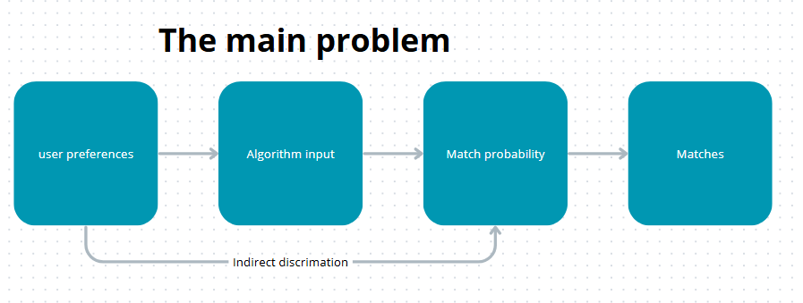

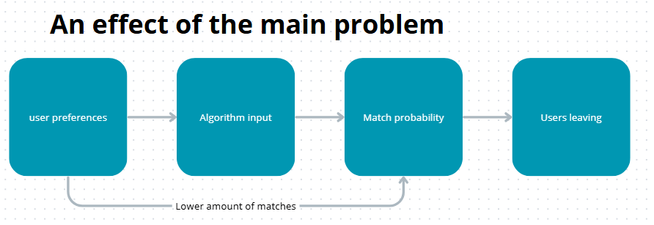
What did I miss?
A thing that I miss is the effect of indirect discrimination. The effect on users was that they had a lower number of matches, and we saw that those users deleted the app. Probably this is how Breeze figured out that there was something wrong with the algorithm. Otherwise, they would never have noticed.
But how they figured this out is something I’m wondering about too. How do you find out that users with a non-Dutch background or darker skin color are deleting the app more than Dutch or white-skinned users? The fact that they are collecting this data is quite strange and using it to determine that their algorithm is not working properly raises some ethical questions.

Recommendation
My recommendation to a data scientist to fix this problem is: first, determine the bias in the algorithm. Start by analyzing the output and calculating the average probability for users grouped by skin color or nationality. If we see that certain groups have consistently lower or higher match scores, we need to act.
Once the bias is identified, we need to understand the algorithm. Breeze doesn’t fully understand how their algorithm works, which means you need to figure out what it does. Since the algorithm is self-learning, it will find patterns in combinations of inputs and follow that logic. You need to understand this logic before fixing the problem, otherwise the bias will appear again.
Next, we can apply a correction factor to match probability for disadvantaged groups. This helps these users have equal chances of getting matches, so that their average match probability is similar to other groups. While using a correction factor, make sure the data stays anonymized, because it relies on nationality or skin color to determine who is eligible for adjustment.
Finally, after applying the correction factor, monitor the outcomes continuously and repeat the process if necessary. Good luck!

