5-2 Milestone Four: Enhancement Three: Databases
Alex Hitchens
Southern New Hampshire University
CS 499 – Computer Science Capstone
Prof. Joseph Conlan
February, 15 2026

- Briefly describe the artifact. What is it? When was it created?
  - This artifact started as a thermostat project I did for CS350. In it we utilized a raspberry pi, a bread board, and a temperature sensor to create a state machine thermostat. We utilized python running on the Ubuntu command line to create the software. Vim was used to edit the code directly from the command line.
- Justify the inclusion of the artifact in your ePortfolio. Why did you select this item? What specific components of the artifact showcase your skills and abilities in software development? How was the artifact improved?
  - I wanted to include this item in my portfolio because I feel like in modern times, it is difficult to have a standout portfolio in the ever-present reality that is AI. How do you prove to potential employers you spent time on a project instead of just prompting your way to success? I think the best answer to that is to include physical systems in your portfolio. There isn’t a way to just “prompt” hooking up the physical components of the system you must do it. In this case it is a simple sensor that uses a shim to attach to the pi, and I want to later include something more detailed in there, but for the purposes of the class I think it works.
  - Getting back to the enhancements that were made to this code. I didn’t actually take my thermostat code, instead I took a simple sensor test we did. I had wanted to make a nice little menu you could set to record, delete data, some other stuff on the command line, but I really ran into issue with getting MongoDB on there and it took me a while to fix. Mongo is not immediately compatible with the pi. To rectify this, I decided to dive into something I had been wanting to learn and gave Docker a shot. I found the specific version that I needed and used docker to install it, linking interactions to it through the default port. I am still a little shaky on exactly how it works but I still learned more then I knew before. With that working I turned to the code on my PC to interact with it. I decided to go with the Matplot library to graph the data because from what I was reading it makes visualizing data in the way I wanted super easy. This code was not in anyway part of my original artifact, so it had to be done from scratch.
- Did you meet the course outcomes you planned to meet with this enhancement in Module One? Do you have any updates to your outcome-coverage plans?
  - I feel like the second outcome “Design, develop, and deliver professional-quality oral, written, and visual communications that are coherent, technically sound, and appropriately adapted to specific audiences and contexts” cover this one because I am adapting the project to visually communicate my ideas to specific audiences. Basically, making the contents of the database easily usable to anyone in the house via an interface. From here I think I want to make sure the MongoDB is secure, even if it is just recording temperatures from my home office, I want to ensure it uses proper security and meets the fifth outcome.
- Reflect on the process of enhancing and modifying the artifact. What did you learn as you were creating it and improving it? What challenges did you face?
  - I’d say the big challenge/learning point was working with Docker. I had been wanting to mess with it for awhile because I heard it was used widely in the industry and was a little behind the curve on that. Utilizing it for Mongo DB was a smart idea as I was figuring out what the right version was. I could simply use docker to remove and install whole installations with minimal fuss and got the perfect version number pinned. I also learned a lot about working over a network in Python, which was one thing I wanted to do from the beginning. It was definitely challenging though, and frankly I messed up a lot, but when lines finally started appearing on my plot, I had the greatest feeling of success. It really helped solidify my personal philosophy of believing that everything I don’t know or have trouble getting is just something I haven’t learned yet.

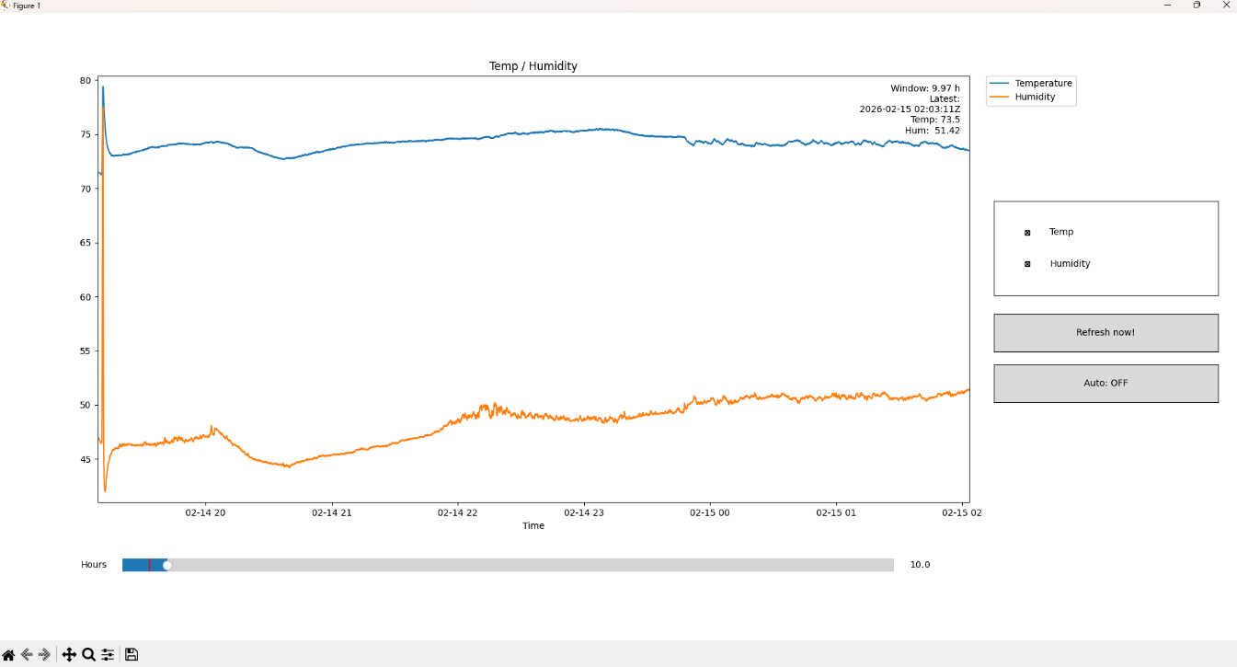
Figure 1 The PC MatPlot Running

