# Main user interface

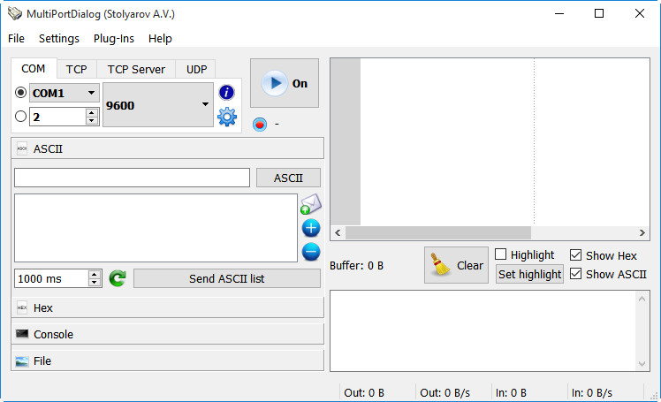

1. Main menu:
   1. **File**:
      * **Exit** – exit the application;
   2. **Settings**:
      * **COM-port settings** – settings for communicating via COM-port;
      * **Preferences** – global application settings;
   3. **Plug-Ins**:
      * List of available plugins;
   4. **Help**:
      * **About…** - about app and it’s author.
2. Communicating channel panel.

Here you can choose what channel to use (COM, TCP, TCP-server, UDP) and setup preferences for it.

1. Start/Stop button and record button.
2. Sending panel.
3. Receiving panel.
4. Status bar.

# Communicating channel panel

COM

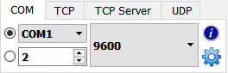

This panel is used for setup COM-port channel.

There are two radio-buttons on the left side for selecting port number from system list or by typing it manually.  In most of cases you can choose port number from the list so the upper radio-button must be checked. The list of ports contains all COM-ports available in the system and it updates every second.

 This field is needed only for specific cases when system doesn’t see port, but it can be communicated. For example some Ethernet devices can be communicated via drivers which are not register COM-port in system but can translate commands from virtual COM-port to Ethernet.

The program connects to the port that is with checked radio-button.

Next you must select baud rate from the list:

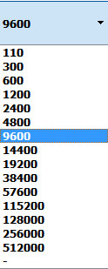

If you need nonstandard speed you can choose “-“ line and type it manually (4000000 is max value): 

Button  shows info about selected port:

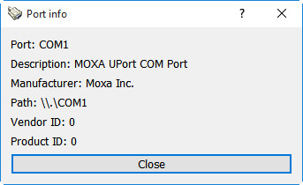

Button  shows Port preferences window:

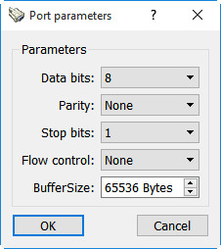

Buffer size of device if bytes

Flow control: None, RTS/CTS, XON/XOFF

Stop bits: 1, 1.5, 2

Parity: None, Even, Odd, Mark, Space

Data bits: 5, 6, 7, 8

TCP

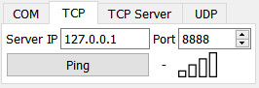

This panel is used for setup TCP-client.

“Server IP” field must contain IP4-adress of the server.

“Port” – number of the server’s port.

Pinger is available only on Windows OS now. Pressing “Ping” button launches ping.exe from the system directory in hidden mode with IP from “Server IP” field. The result is shown in real-time near the button:



TCP Server

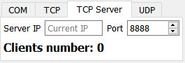

This panel is used for setup TCP-server.

“Server IP” field must be empty in most cases. It is used only if you have several network cards and want to start server on specific IP of one of this cards.

“Port” – number of the server’s port.

“Clients number” – shows how many clients connected to this server.

UDP