LESSON TEN
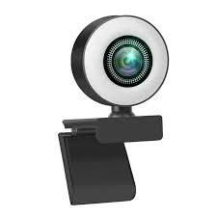
Count from one to ten!
One, two, three, four, five, six, seven, eight, nine, ten.
Count the rabbits! One, two.
Count the chickens! One, two, three.
Does she have a doll? Yes, she does.
Do you have a rabbit? No, I don’t.
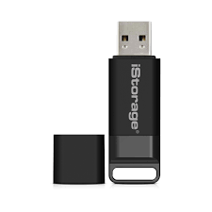
A webcam

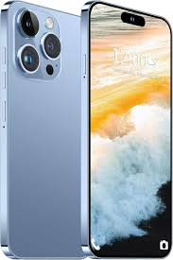

a flash drive

a cell phone

That girl has a laptop and a cell phone. She has a webcam and a flash drive. She makes a video. She connects the webcam and the flash drive to the laptop. She has access to the internet. She posts this video online.
This boy does not have access to the internet. He has a USB drive. He has films on this USB drive. He inserts this USB drive into a USB port and watches a video. In this video he sees five rabbits, ten chicks, five snakes and one wolf.

I connect the flash drive to my laptop. I count the rabbits in this video. I don’t count the chicks in this video. I count from one to five. I don’t count from one to ten.


She has a cell phone. She calls this boy.
She doesn’t call that boy.
She sees a squirrel. She films the squirrel and posts the video online. She posts the video on YouTube.
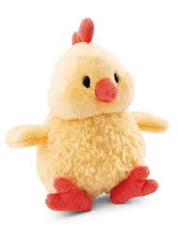

This girl has three rabbits and five chickens.
Does this girl have a kitten? Yes, she does.
Does she have a snake? No, she doesn’t.
That boy has two squirrels and one fox too.
He has nine rabbits and four bats.
Does that boy have a wolf? No, he doesn’t. a chick
Does he have a stick? Yes, he does.
Does he have a ball? Yes, he does.
Do you see the cogs in this clock? Yes, I do. Do you see cogs in this phone? Yes, I do.
Does she have cogs? Yes, she does.

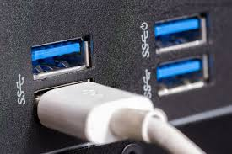

a clock a USB port

Do you have a hat? Yes, I do.
Do you have a stick? No, I don’t.
Do you have a laptop? Yes, I do.
Do you have access to the internet? No, I don’t.
Do you have a cog? No, I don’t.
Do you see fog? Yes, I do.
Does she have a webcam? No, she doesn’t.
Catch that rabbit!
Insert this flash drive into the USB port. cogs


Words
- ten [ten] — десять
- yes [jes] — так
- you [juː] — ти, ви
- no [nəʊ] — ні
- a rabbit [ə ˈræbɪt] — кролик
- a chick [ə ˈtʃɪkɪn] — курча
- to count [kaʊnt] — рахувати
- from … to … — від … до …
- to catch [kætʃ] — ловити
- into - в
- webcam [ˈweb.kæm] – вебкамера
- flash drive [flæʃ draɪv] – флешка
- USB drive = flash drive
- connect [kəˈnekt] – з’єднувати, підключати
- insert [ɪnˈsɝːt] – вставляти
- USB port - USB порт
- clock - годинник
Завдання
- Прочитайте й перекладіть текст.
II. Прочитайте і перекладіть:
- Does she have a cell phone? No, she doesn’t.
- Do you have a ball? Yes, I do.
- Show me the ball!
- Do you go to hospital. No, I don’t.
- Cat, cat, catch a bat!
- Does she post this video online? Yes, she does.
- Count the chicks!
- Does this boy insert this USB drive into the USB port? Yes, he does.
- Catch that boy!
- Show me this rabbit!
- Count from ten to one!
- Do you have a doll? No, I don’t.
- Say ten words!
- I don’t watch this video.
- He connects the flash drive to the laptop.
III. Перекладіть на англійську мову:
- Порахуй від десяти до одного!
- У тебе є м’яч? Так, є.
- Встав цю флешку в ноутбук.
- В тебе є годинник? Ні, нема
- Лови того хлопчика!
- Не опубліковуй це відео.
- Я не бачу ці шестерні в моеєму телефоні.
- Під’єднай цю флешку до свого нотбуку и подивись цей фільм.
- Кіт, кіт, лови кажана!
- У тебе є лялька? Ні, немає.
- Покажи мені м’яч!
- Порахуй курчат!
- Покажи мені цього кролика!
- Скажи десять слів!

