LESSON THIRTEEN

Where is the girl? She is in the room.
Where is your book? It is on the table.
Where is the table? It is in the house.
Where is the house? It is in the garden.
Uninstall this game from your laptop. It drains the battery.
Do not install this app on your phone. It drains the battery. The battery is dead. Charge your phone. to uninstall a game

That girl downloaded this app from the internet. She has access to the internet. She makes a video. She uploads this video to YouTube. She doesn’t download videos from YouTube. She watches videos online. She watches films online
That boy has a phone. He has internet. He makes a post on Facebook. He has internet. He dials this number. He calls this boy. He doesn’t call that boy.

to make a post on Facebook
This girl has a website. She posts videos on this website. The website is good. She removes bad videos from this website. She uploads good videos to this website. She made this website.
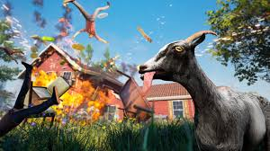
Where is the boy? He is in the garden.
Where are you? I am in the garden too.
Where is your pen? My pen is on the table.
Where is your notebook? It is on the table too.
Where is your goat? My goat is in the garden.
Where is your horse? My horse is under that tree. a goat in a game

Do you have a house? Yes, we do.
Do you have a garden? Yes, we do.

a red cow
Do you have a charger? Yes, I do.
Does he have this app? No, he doesn’t.
Do they see the fog? Yes, they do.

Is your garden big? Yes, it is.
Is your goat under the tree? Yes, it is.
Is your car under the tree too? No, it isn’t.
My room is very good.
My gun is very good.
My garden is very big.
He uninstalled this app from his phone. It drained the battery. The battery was dead. He connected the charger to the phone. He charged the phone.
a house in fog

They play a game. In this game they have ten goats, eleven pigs and a cow.
Is your goat white? Yes, my goat is white.
Is your cow red? No, my cow isn’t red.
He downloaded this game on his laptop.
Give me my hat! Thank you.
Words

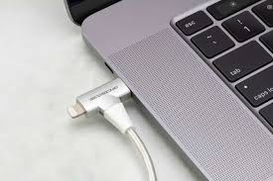
- thirteen /ˌθɜːˈtiːn/ — тринадцять
- where /weə/ — де
- a room /ə ruːm/ — кімната
- your /jɔː/ — твій, ваш
- a table /ə ˈteɪbl/ — стіл
- a house /ə haʊs/ — будинок a charger is connected to a laptop
- a garden /ə ˈɡɑːdn/ — сад
- I am /aɪ æm/ — я є
he is /hiː ɪz/ — він є
she is /ʃiː ɪz/ — вона є
it is /ɪt ɪz/ — воно є
- my /maɪ/ — мій
- under /ˈʌndə/ — під
- a tree /ə triː/ — дерево
- very /ˈveri/ — дуже
- uninstall /ˌʌnɪnˈstɔːl/ — видалити (програму)
- remove /rɪˈmuːv/ — прибрати, видалити
- download /ˈdaʊnləʊd/ — завантажити (з інтернету)
- upload /ˈʌpləʊd/ — завантажити (в інтернет)
- on YouTube /ɒn ˈjuːtjuːb/ — в YouTube
- website /ˈwebsaɪt/ — вебсайт
- Thank you. /θæŋk juː/ — Дякую.

Завдання
- Прочитайте й перекладіть текст.
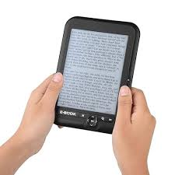
II. Прочитайте і перекладіть:
- Where is my pen? It is on the table.
- Where is my book? It is on the table too.
- Where is your car? It is in the street.
- Where are you? I am in my room.
- This is a very good book.
- Don’t make a post on Facebook.
- He uninstalled the game from his laptop. an electronic book
- Your white goat is under that tree.
- Show me that vase! Thank you.
III. Перекладіть на англійську мову:
- Це дуже гарна книга.
- Де моя ручка? Вона на столі.
- Покажіть мені ту вазу! Дякую.
- Де ви? Я в своїй кімнаті.
- Він завантажив цю гру на свій ноутбук. *
- Не видаляй цю гру.
- Під’єднай флешку до ноутбука і збережи це відео на ньому.
- Опублікуй це відео в інтернеті.
- Зателефонуй своїй матері.
- Де ваша машина? Вона на вулиці.
- Ваша біла коза під тим деревом.
- Де моя книга? Вона теж на столі.
IV. Розмовка
Boy: Where is your doll?
Girl: My doll is on the bed.
Boy: Where is your ball?
Girl: It is under the table.
Boy: Do you have red ribbons?
Girl: Yes, I do.
Boy: Where are your red ribbons?
Girl: They are in the box.
Boy: Show me your ribbons! Thank you.
V. Назвіть англійською картинки з попередніх уроків.


