LESSON FIFTEEN
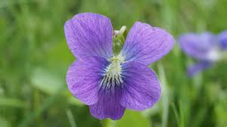

Look, what is this? It is a flower.
These flowers are red and those flowers are blue.
What is this? It is a rose.
a violet
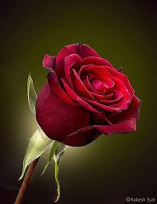
They sell flowers. They sell flowers in this flower shop.

They sold the flowers yesterday.
They bought these flowers yesterday.
They paid for these flowers yesterday.
They will sell flowers tomorrow. a rose
They will buy these flowers tomorrow.
They will pay for these flowers tomorrow.

What is this? It is a violet.
Is this a violet or a rose? It is a rose.
Is this a rose too? No, it isn’t.
These girls are in a flower shop. They see many flowers in this shop. They take a violet and a rose. They pay money. Now they have these flowers.

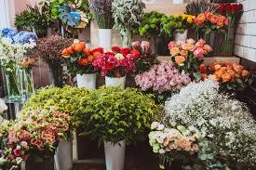
That girl has many violets in her garden.
She has many red roses too. She has many flowers in her garden.
Is this a chicken? No, it isn’t. What is this? It is a bird.
Where is the bird? It is in the cage.
Is this bird big or little? It is little.

a flower shop
Those boys sell flowers. They have many flowers in this shop. Two girls are in this flower shop. They buy three flowers from these boys.
Is this a stick? No, it isn’t. What is this? It is an umbrella.
What colour is the umbrella? It is yellow.
How many umbrellas do you have? I have two umbrellas.
Give me one umbrella!

Does he buy this flower? Yes, he does.
Does he sell this flower? No, he doesn’t
Does he have this app? Yes, he does.
This bird is in the cage. This girl is in the room.
That rose is red. That flower is yellow.
This book is on the table. This kitten is in the box. an umbrella
These birds are in the tree.
These girls are in the garden.
Those roses are red. Those flowers are not yellow.
These pants are not bad.

What do they see in this shop? They see pants and an umbrella.
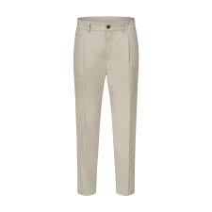
What do they do? They pay money. They buy the pants and the umbrella.
Now they have pants and an umbrella.
Now these girls have many flowers. They bought these flowers. They paid money.
What did he buy yesterday? He bought a new tablet.

pants
Words

- fifteen [ˌfɪfˈtiːn] — п’ятнадцять
- to look [lʊk] — дивитися
  - Look! — Дивись!
- a flower [ə ˈflaʊə] — квітка
- these [ðiːz] — ці
- those [ðəʊz] — ті
- a rose [ə rəʊz] — троянда
- a violet [ə ˈvaɪəlɪt] — фіалка
- or [ɔː] — або
- a bird [ə bɜːd] — птах
- a cage [ə keɪdʒ] — клітка
- little [ˈlɪtl] — маленький
- an umbrella [ən ʌmˈbrelə] — парасолька
- yellow [ˈjeləʊ] — жовтий
- trousers [ˈtraʊzəz] — штани
- bad [bæd] — поганий
- pay [peɪ] — платити
- paid [peɪd] — заплатив / оплачений (V2, V3)
- sell [sel] — продавати
- sold /soʊld/ - продав, продано
- money [ˈmʌni] — гроші
- now [naʊ] — зараз
- buy [baɪ] — купувати
- bought [bɔːt] — купив (V2, V3)
- yesterday [ˈjestədeɪ] — вчора
- tomorrow [təˈmɒrəʊ] — завтра
- pants = trousers

Завдання
- Прочитайте й перекладіть текст.
II. Прочитайте, перекладіть, відповіді знайдіть у тексті:
- What does that girl have in her garden?
- Does she have many flowers in her garden?
- Where is this book?
- Where are these birds?
- Where is that kitten?
- What is in the cart?
- What colour are those roses?
- Are these trousers bad?
- Is that violet big?
III. Перекладіть на англійську мову (відповіді дайте відповідно до тексту):
- Ці квітки у візку.
- Ті квітки не у візку.
- Що є в тієї дівчинки в саду?
- У неї багато квітів у саду?
- Що вони купили вчора? *
- Де ця книга?
- Що вони продають у цьому магазині квіток?
- Де ці птахи?
- Де те кошеня?
- Вони продали ці квітки вчора. *
- Вони купили ті квітки вчора *
- Вони заплатили за ті квітки вчора. *
- Що у візку?
- Що вони продають в тому магазині?
- Він платить гроші.
- Якого кольору ті троянди?
- Ці штани погані?
- Та фіалка велика?
IV. Розмовка
Girl: Is this a bird in that tree?
Boy: No, it isn’t a bird.
Girl: What is it?
Boy: It is a squirrel.

