LESSON SIXTEEN
Where are you? I am in a shop.
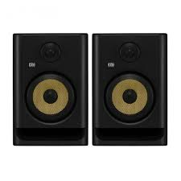
Is the shop big? Yes, the shop is big.
What is it? It is a cart.
What do you have in your cart? I have new good speakers for my laptop.
Where are you? I am at home
I have a book. It is old.
She has a silver bell. It is new.
He has a long stick. It is strong.
You have a new house. It is big.
We have an old garden. It is green. speakers
They have a good cow. It is red.
Is the cow cheap? No, the cow is expensive, but it is good.
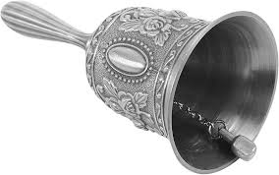
What does this boy have?
He has good trousers and a new shirt. His trousers are grey.
What does this girl have?
She has a bird. Her bird is little.
What do you have? I have a flower. My flower is yellow.
What do I have? You have a dog. Your dog is big.
What do we have? We have a room. Our room is big.
a silver bell
What do they have? They have a car. Their car is old.

What do they do? They install an app on their laptop.
What do they do? They connect good speakers to the laptop.
Is the laptop charged? Yes, the battery is charged. They disconnect the charger from the laptop.
What do they do? They download an expensive app.
What is this app? This app is a map. The app is good, but it is expensive. It is not cheap.
rabbits

Our children have many rabbits. Their rabbits are grey and white.
Are your children at home? Yes, they are.
Is your book new? Yes, my book is new.
Is your house old? Yes, our house is old.
She takes her phone and makes a post on Facebook. The post is good, but it is long.
She doesn’t have a phone. She goes to the shop and buys a phone. She pays money. The phone is good, but it is expensive. She installed many apps on this phone. The phone is not old. The phone is new.
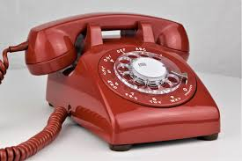
Children, bring Father his stick, please.
Boys, give Mother that new dish, please.
Girls, say these long words!
Our children are not at home.
My goat has a little silver bell.
What do these boys do? They make a post on Facebook.
an old phone
What do those boys do? They upload a video to YouTube. The video is good, but it is short.
Words

- sixteen [ˌsɪksˈtiːn] — шістнадцять
- old [əʊld] — старий
- silver [ˈsɪlvə] — срібний
- a bell [ə bel] — дзвіночок
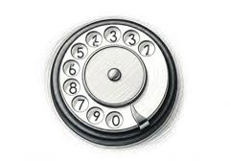
- new [njuː] — новий
- long [lɒŋ] — довгий
- short - короткий
- strong [strɒŋ] — сильний
- our [aʊə] — наш
- their [ðeə] — їх
- children [ˈtʃɪldrən] — діти a dial
- at home — вдома
- Father [ˈfɑːðə] — батько
- Mother [ˈmʌðə] — мати
- to bring [brɪŋ] — приносити
- please [pliːz] — будь ласка

- expensive [ɪkˈspensɪv] — дорогий (за ціною)
- cheap [tʃiːp] — дешевий

Завдання
- Прочитайте й перекладіть текст.
II. Прочитайте і перекладіть:
- Is your umbrella new or old? It is new.
- Are those white bells silver? Yes, those bells are silver.
- Is that long stick strong? Yes, it is.
- Are your father and mother at home? Yes, they are.
- Our children have sixteen yellow chickens and fifteen ducklings.
- Their car is very old.
- Bring your toys!
III. Перекладіть на англійську мову:
- Принеси свої іграшки!
- Їхня машина дуже стара, але вона дорога.
- У наших дітей шістнадцять жовтих курчат і п’ятнадцять каченят.
- Твої тато й мама вдома? Так.
- Та довга палиця міцна? Так.
- Ті білі дзвіночки срібні? Так, ті дзвіночки срібні.
- Твоя парасолька нова чи стара? Вона нова.
- Загрузи ці відео на Ютуб.
- Не завантажуй цей фільм на свій ноутбук с того поганого сайту.
- Не дзвони тому хлопцю.
- Не від’єднуй колонки від ноутбуку.
IV. Розмовка
Father: Children, where is my new book?
Girl: What book, Daddy?
Father: My big green book.
Boy: It is on your table, Daddy.
Father: Bring it, please.

