LESSON SEVENTEEN
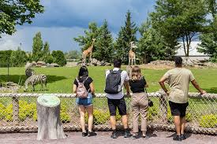

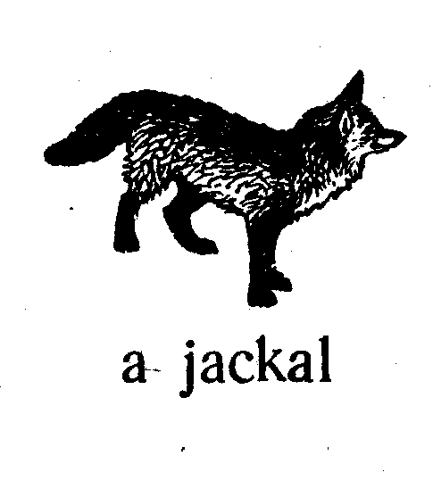

At the zoo

We are at home. We go to the ATM. We insert the card in it and withdraw money.
We go to the zoo. We pay money. We are at the zoo. We see many animals here.
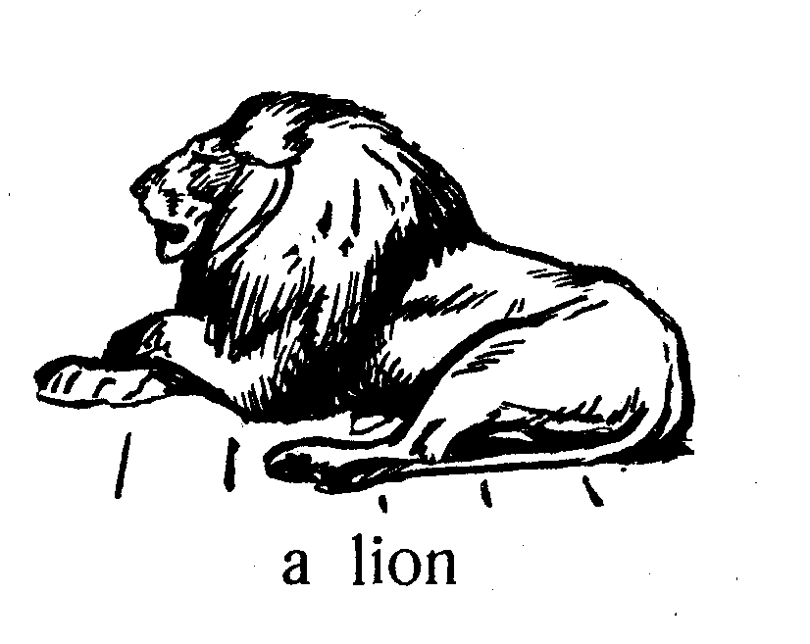
What animal is this?
Is this a zebra or a tiger?
It is a tiger.
Is this a wolf or a jackal?
It is a jackal.
The wolf is big and strong.
The jackal is small and weak.
The zebra, the tiger, the lion, the wolf and the fox are animals.
We go home.

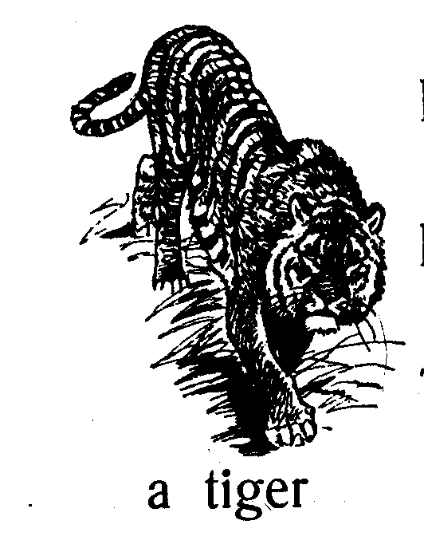
The rose, the violet and the daisy are flowers.
We have many flowers at home.
Do you have many violets in your garden?
What flower is this? It is a daisy.
What animal is this? It is a jackal.
Where is your cat? It is with its kittens.
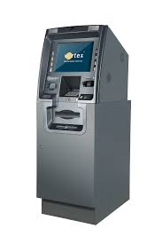
Where is the hen? It is in the yard.
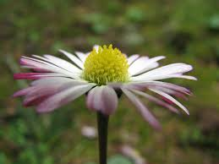
The hen is with its chickens.
The duck is with its ducklings.
This duck is as small as that hen. an ATM
Is the boy strong? Yes, he is.
Is the girl strong? No, she is not. a daisy
The horse is a strong animal.
Is the zebra strong? No, it is not as strong as the horse.
Daddy, show me the animals in your book!
We like to see birds in our garden.
We download an app and install it on our phone. We see many flowers in this app. The app doesn’t drain the battery. The app does not have a virus.
We watch a good video. We save this video on our phone. There are no viruses on our phone.
This ATM is as big as that table.

This phone is not as big as that tablet.

We go to the ATM. We insert the card in it and withdraw money.
to withdraw cash from an ATM
We go to the flower shop and buy flowers. The flowers are expensive.
Insert the USB drive into this USB port!
Do not insert the USB drive into that USB port!
This flash card is not as big as that tablet.
This tablet is as big as that laptop.
What does he do? He withdraws money from an ATM.
What do they do? They withdraw money from an ATM too.
Words

- seventeen — [ˌsevənˈtiːn] — сімнадцять
- what — [wɒt] — який; що за
- what flower — [wɒt ˈflaʊə] — яка квітка
- an animal — [ˈænɪməl] — тварина
- a tiger — [ˈtaɪɡə] — тигр
- a jackal — [ˈdʒækəl] — шакал
- small — [smɔːl] — маленький
- weak — [wiːk] — слабкий
- a lion — [ˈlaɪən] — лев
- a daisy — [ˈdeɪzi] — маргаритка
- its — [ɪts] — його / її (про тварин і речі), свій
- as … as — [æz … æz] — такий же … як
- not as … as — [nɒt æz … æz] — не такий … як
- to see — [siː] — бачити
- a zoo — [zuː] — зоопарк
- a card — [kɑːd] — картка
- an ATM — [ˌeɪ tiː ˈem] — банкомат
- withdraw — [wɪðˈdrɔː] — знімати гроші (з рахунку)
- cash — [kæʃ] — готівка
- virus - вірус

Завдання

II. Прочитайте і перекладіть:
- Is a tiger as strong as a lion? No, a tiger is not as strong as a lion.
- A jackal is as small as a fox.
- What animal is weak? A goat is weak.
- He is as strong as a horse.
- He inserts a USB drive into this USB port.
- I have a black hen, its chickens are yellow.
- He withdraw cash from an ATM.
- He posts a video online.
- They watch films online.
III. Перекладіть на англійську мову:
- Яка тварина слабка? Коза слабка.
- У мене є чорна курка, її курчата жовті.
- Тигр такий же сильний, як лев? Ні, тигр не такий сильний, як лев.
- Він сильний, як кінь.
- Він вставляє карту і знімає готівку з банкомату.
- Шакал маленький, як лисиця.
- Він бере візок.
- Він купляє багато іграшок
- Цей банкомат не такий великий, як той стіл.
- Ця іграшка не така дорога, як той телефон.
- Набери свого батька!
- Не купляй цей телефон.

IV. Розмовка.
Boy: Mammy, Is this a fox or a jackal?
Mother: You see, the fox is red and the jackal is grey.
Boy: Oh, yes, the jackal is as grey as a wolf.



cash

Additional exercises
Read and translate
This USB drive is as big as that pen.
That laptop is not as big as this personal computer.
She is not as smart as him.
He is as smart as her.
They are as rich as us.
We are not as poor as them.

Translate
Ця картка не така велика, як той планшет.
Цей візок такий же маленький, як та іграшка.
Ми не такі багаті, як вони.
Вони не такі бідні, як ми.
Цей планшет не такий дорогий, як той ноутбук.
Ті машини не такі дешеві, як ці коні.

