LESSON EIGHTEEN


a kindergarten

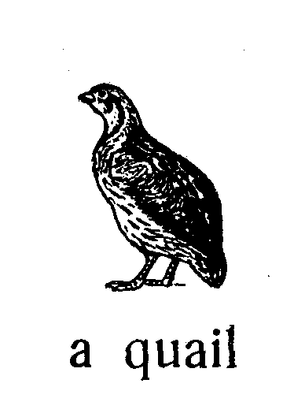
Jimmy has a quail.
Jimmy’s quail is tame.
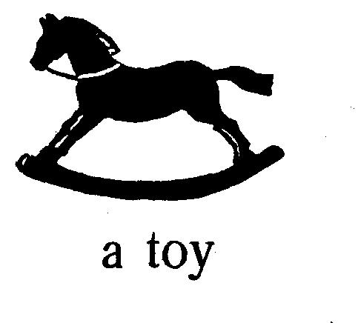
This boy is in his kindergarten. He sees his
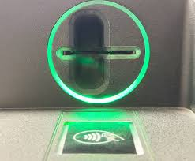
kindergarten teacher. His teacher is good. She is not bad. She shows him an expensive toy eagle. She shows him an expensive toy horse too.
The kindergarten teacher’s name is Jane Christine. a slot

Jane works as a kindergarten teacher.

She likes coffee.
She goes to the coffee machine and inserts the card in the slot. She buys a cup of coffee. The coffee machine is good. The coffee is not expensive. It is cheap.
Jimmy is not in kindergarten.
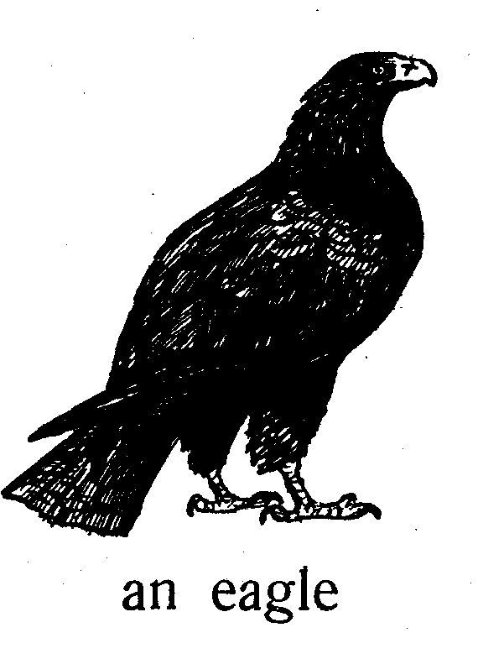
Jimmy has a horse. This is a toy horse.
Jimmy’s horse is big.
What bird is this?
It is an eagle.
The eagle’s beak is very sharp.
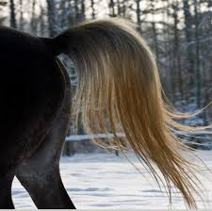
Is this a toy eagle? Yes, this is a toy eagle.
Is this an eagle too?
No, it isn’t.
It is a cock; its legs are yellow.
The hen’s legs are yellow too.
What is yellow? The cock’s legs are yellow.

a tail
Is this quail real? Yes, this quail is real. This is not a toy quail.
What does Polly have?
Polly has a hat.
Polly’s hat is yellow.
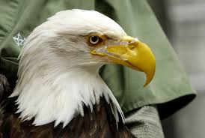
What is long? Jimmy’s stick is long.
The horse’s tail is long.
What is sharp? The eagle’s beak is sharp.
The cat’s claws are sharp.
The quail’s tail is not long. an eagle’s beak
The quail’s beak is not sharp.
Polly’s mother has a ring.
Mother’s ring is gold.
What does Jimmy’s father have?
Jimmy’s father has a coat.
Does he have a toy horse? No, he doesn’t. He doesn’t have toys at all.
His coat is new. His coat is not old.
Is her mother’s ring gold? Yes, it is.
Is his father’s coat new? Yes, it is.
Are your pants grey? No, they aren’t. They are brown.
Are Jimmy’s toys old? No, they aren’t.
They are new.
Are Polly’s chickens yellow? Yes, they are.
Do you have a new coat? Yes, I do.
Show me your new coat!
Call your mother!
Mother, buy this toy!
Words

- eighteen — [ˌeɪˈtiːn] — вісімнадцять
- Polly — [ˈpɒli] — Поллі (жіноче ім’я)
- a quail — [kweɪl] — перепілка
- tame — [teɪm] — ручний
- Jimmy — [ˈdʒɪmi] — Джиммі (чоловіче ім’я)
- an eagle — [ˈiːɡl] — орел
- a beak — [biːk] — дзьоб
- sharp — [ʃɑːp] — гострий
- a cock — [kɒk] — півень
- a leg — [leɡ] — нога
- a tail — [teɪl] — хвіст
- a claw — [klɔː] — кіготь
- a ring — [rɪŋ] — каблучка
- a coat — [kəʊt] — пальто; піджак
- gold — [ɡəʊld] — золотий
- brown — [braʊn] — коричневий
- a toy — [tɔɪ] — іграшка
- coffee — [ˈkɒfi] — кава
- machine — [məˈʃiːn] — машина, пристрій
- slot — [slɒt] — проріз, слот
- kindergarten — [ˈkɪndəˌɡɑːtn] — дитячий садок
- teacher — [ˈtiːtʃər] — вчитель / вихователь
- real — [rɪəl] — справжній, реальний

Завдання
1. Прочитайте й перекладіть текст.
II. Прочитайте і перекладіть:
- Where is this ATM?
- Is this ATM brown? No, it is green.
- The cock’s beak is not as sharp as the eagle’s.
- The tiger’s claws are very sharp.
- Say: “My tame quail has a small tail.”
- How many toys does Jimmy have? He has many.
- Say: “Goat, goat, give me your coat!”
- Jim doesn’t like coffee. He is too little to drink coffee.
III. Перекладіть на англійську мову:
- Чи знімає Поллі готівку з банкомату? Ні.
- Скажи: «У моєї ручної перепілки маленький хвіст».
- Це іграшковий банкомат? Ні, він справжній.
- Скажи: «Козо, козо, дай мені свою шубу (пальто)!»
- Вона працює у цьому дитячому садочку.
- У півня дзьоб не такий гострий, як у орла.
- У тигра кігті дуже гострі.
- Скільки іграшок у Джиммі? У нього багато.

IV. Розмовка.
Polly: Look, Jimmy, that zebra is tame.
Jimmy: Oh, it is black and white.
Polly: Yes, the zebra’s legs are black and white too.

