LESSON NINETEEN
What is your name? My name is Sam. I am a boy.
What is her name? Her name is Polly. She is a girl.
Who is this man? This man is Jimmy’s father.
What is his name? His name is Tom Dale.
Who is this woman? This woman is Molly Dale. She is Jimmy’s mother.
Jimmy wants to order a toy from an online shop. He wants to buy a toy puppy. Jimmy doesn’t have an account on this online shop. He takes his phone and creates an account on this website. He signs up.
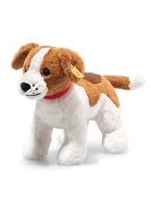
He signs up for this site. Now he has an account here. His father helps him. His father orders a good toy puppy for his son. His son’s name is Jimmy.


a toy puppy

His father goes to a shop and buys a real puppy too.
to create an account on an online shop

Sam has an account on this website too. He doesn’t sign up. He signs in. He signs in to this online shop.

He orders an expensive toy gun from this online shop. He likes this site.


Tom Dale has an expensive phone. He sees a fox and films it. He posts this video on Instagram.
Does he have an account on this online shop? Yes, he does.
Jimmy’s real puppy Roombo


to buy/order from an online shop
Tom Dale doesn’t withdraw money from an ATM. He has his money on his card. He likes to pay online



to post a video on Instagram
Tom Dale is a hunter.
Who is Jimmy? Jimmy is Tom Dale’s son.
What does Tom Dale have? He has a gun and a dog.
Jimmy’s father is a very good hunter.
Jimmy has a puppy. His puppy’s name is Roombo.
Roombo is Jimmy’s puppy.
Is Roombo expensive? Yes, this is an expensive puppy. This puppy is not cheap.
Mr. Dale has a big dog; its name is Reni.
Reni is very clever and strong.

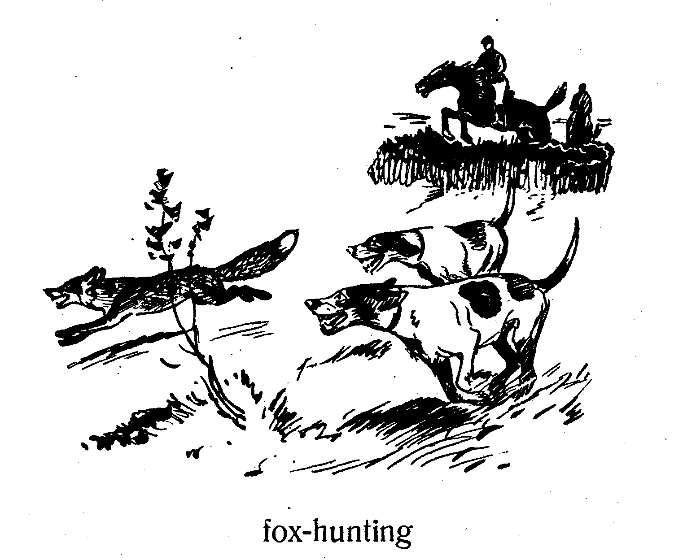



to withdraw money from an ATM
What is the hunter’s name? The hunter’s name is Tom Dale.
What is the boy’s name? The boy’s name is Jimmy Dale.
Who are you? I am Mr. Christine. I am a doctor.
I have a little girl. Her name is Lily. Lily has a brother.
Her brother’s name is Sam.
Tom Dale is Jimmy’s father. Reni is Tom Dale’s dog.
Jimmy is Tom Dale’s son. Roombo is Jimmy’s puppy.
Mr. Christine is Lily’s father. He is a doctor.
Who is Sam? Sam is Lily’s brother.
Lily is Jimmy’s friend. Is Sam a hunter? No, he isn’t. Sam is a little boy.
Jimmy and Sam are friends too. They are very good friends.
Does Sam order tablets and phones from this online shop? No, he doesn’t. His father orders tablets and phones on this website.

Sign up for YouTube, Jimmy!
Sign in to you Youtube, Sam!
Words

- nineteen — [ˌnaɪnˈtiːn] — дев’ятнадцять
- What is your name? — [ˈwɒt ɪz jɔː ˈneɪm] — Як тебе звати?
- Sam — [sæm] — Сем (чоловіче ім’я)
- who — [huː] — хто
- a man — [mæn] — чоловік
- a woman — [ˈwʊmən] — жінка
- Tom Dale — [ˌtɒm ˈdeɪl] — Том Дейл
- a hunter — [ˈhʌntə] — мисливець
- a son — [sʌn] — син
- a puppy — [ˈpʌpi] — цуценя
- Roombo — [ˈruːmbəʊ] — Румбо (кличка)
- Reni — [ˈreni] — Рені (кличка)
- clever — [ˈklevə] — розумний
- Mr. — [ˈmɪstə] — містер
- Mr. Christine — [ˈmɪstə krɪˈstiːn] — містер Крістін
- a doctor — [ˈdɒktə] — лікар
- Lily — [ˈlɪli] — Лілі
- a brother — [ˈbrʌðə] — брат
- a friend — [frend] — друг
- online shop — [ˈɒnlaɪn ʃɒp] — інтернет-магазин
- sign in — [saɪn ɪn] — увійти в акаунт
- sign up — [saɪn ʌp] — зареєструватися
- an account — [əˈkaʊnt] — акаунт / обліковий запис

Завдання
- Прочитайте й перекладіть текст.
II. Прочитайте і перекладіть:
- This man is a hunter. What is his name?
- This man’s name is Tom Dale.
- Mr. Dale has a son. His son’s name is Jimmy.
- Jimmy is a little boy. He has a puppy.
- The puppy’s name is Roombo.
- His has an account on this online shop.
- Is Tom Dale’s gun new? No, it isn’t. Tom Dale’s gun is old.
- His signs in to this online shop.
III. Перекладіть на англійську мову:
- У містера Дейла є син. Його сина звати Джиммі.
- Джиммі — маленький хлопчик. У нього є цуценя.
- Чи є в нього акаунт в цьому онлайн магазині?
- Цей чоловік — мисливець. Як його звати?
- Рушниця Тома Дейла нова? Ні. Рушниця Тома Дейла стара.
- Ім’я цього чоловіка — Том Дейл.
- Цуценя звати Румбо
- Чи заряджена батарея? Так, вона заряджена.
- Подзвони Джиму!

IV. Розмовка.
Mr. Christine: Are you a hunter, Mr. Dale?
Mr. Dale: Oh, I’m an old hunter.
Mr. Christine: Do you have a dog?
Mr. Dale: Yes, I do. I like my dog. It is very strong and clever.

