LESSON TWENTY
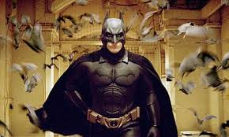

Batman is playing in theaters now

Where are my shoes? They are under the chair.
Where is your friend? He is in my room.
Where are my toys? They are in the box under your bed.
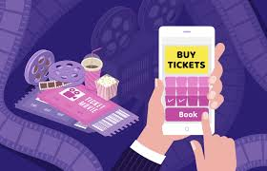
Where is Mother’s hat?
Where is Father’s coat?
Where is Lily’s brother?
Where is Jimmy’s puppy?
Where is the doctor?
Where are this girl’s books?
Where are that boy’s shoes?
Where are your stockings?
Where are my notebooks?
Where are Sam’s friends?

To book movie tickets online


My pencils are in the box.
Your hat is on the chair.
His ball is under the bed.
Her dress is on the sofa.
Our children are at the lake.
Your friends are under the tree.
Their cups are on the table.
The boys are at the cinema.
The girls are at home. She is at the movie
The plates are in the cupboard.
The birds are in the nest.
The squirrels are in the tree.

Is my plate in the cupboard?
Is their car in the street?
Is the squirrel in the cage?
Is your brother at the cinema?
Are your stockings on the chair?
Are the cups in the cupboard?
Are my shoes under the bed?
Are their books on the table?

They are at the lake



He tells her on the phone that...

This is Jimmy’s mother. Her name is Molly. She doesn’t like to order shoes online. She goes to the shop. She takes a cart and puts many things in it. She puts in it toys, socks, a tablet and a phone. She puts stockings in this cart too. She dials her husband’s number. Her husband’s name is Tom Dale. She tells him on the phone that she wants to buy an expensive laptop, but he tells her that he doesn’t want to buy it. He doesn’t want to spend money ON this expensive laptop.

Molly Dale, Jimmy’s mother
Tom Dale signs in to an online shop and orders an expensive USB drive and
expensive speakers. He likes music. He books movie tickets online. In Canada, they call cinemas “movie theaters”. He books four tickets. He wants to go to the movie with his family. A new film is playing at the movie theaters now. Batman is playing in theaters now.



to spend money on a laptop

Jimmy, bring me my shoes. Yes, Daddy.
Lily, put on your socks. Yes, Mommy.
Polly, don’t take off your stockings!
Don’t spend money on this laptop!
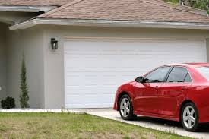
Words

- twenty — [ˈtwenti] — двадцять
- a pair — [peə] — пара
- a shoe — [ʃuː] — туфля, черевик
  - a pair of shoes — [peə əv ʃuːz] — пара туфель
- a chair — [tʃeə] — стілець The car is outside
- a sock — [sɒk] — шкарпетка

- a stocking — [ˈstɒkɪŋ] — панчоха
- a sofa — [ˈsəʊfə] — диван
- at the cinema — [ət ðə ˈsɪnəmə] — у кіно
- a plate — [pleɪt] — тарілка
- a nest — [nest] — гніздо
- a cupboard — [ˈkʌbəd] — шафа-буфет
- to put on — [pʊt ɒn] — надягати
- to put — [pʊt] — класти
- thing — [θɪŋ] — річ, предмет
- husband — [ˈhʌzbənd] — чоловік (у шлюбі) The car is in the street
- wife — [waɪf] — дружина
- tell — [tel] — сказати, розповісти
- that — [ðæt] — той; що
- music — [ˈmjuːzɪk] — музика
- movie — [ˈmuːvi] — фільм
- family — [ˈfæməli] — сім’я
- movie theater — [ˈmuːvi ˌθiːətə] — кінотеатр (американська англійська)
- spend - /spend/ - витрачати

Завдання
III.
- Маленький птах у своєму гнізді.
- Кошенята у своєму ящику.
- Її нова пара туфель під тим стільцем.
- У неї чотири пари коричневих панчох.
- Ми бачимо багато гнізд з пташками на тих деревах.
- Штани Джиммі на дивані.
- Візьми моє пальто і надінь його!
- Постав ці тарілки в буфет!
- Вона витрачає гроші на ці флешки.
- Забронюй ці квітки на цьому сайті. *
- Я на озері.
- Поклади ці шкарпетки у візок.
- Не купляй цей дорогий ноутбук, але купи цей дешевий планшет.
- Зареєструйся на цьому сайті.
- Зараз показують Бєтмен в кінотеатрах.
- Вона в кінотеатрі.

_________________________________
1. Take my coat and put it on!
2. She has four pairs of brown stockings.
3. Put these plates in the cupboard!
4. The little bird is in its nest.
5. Jimmy’s pants are on the sofa.
6.We see many nests with little birds in those trees.
7. Her new pair of shoes is under that chair.
8. The kittens are in their box.

