LESSON TWENTY-ONE
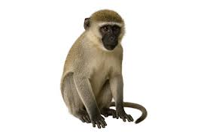
How old are you? I am twelve (years old).
How old is Jimmy? Jimmy is seven years old.
How old is Lily? Lily is four years old.
How old is Jimmy’s friend? He is ten. His name is Sam.
Sam has a monkey. It is very funny.
Sam’s monkey is not in the cage.
What colour is Sam’s monkey? It is grey and brown.
What is its name? Its name is Cheetah. a monkey

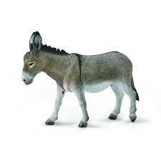

Cheetah has a friend — a donkey.
The donkey’s name is Kicky. Kicky is grey and old.
How old is this donkey? It is seventeen years old.
Cheetah is in the tree. Kicky is under the tree.
The monkey is on the donkey’s back.

a donkey an account on a website
Sam wants to order food and clothes for his monkey. He doesn’t have an account on this website. He signs up for this website. He orders expensive clothes and expensive food for Cheetah. He adds these clothes and food to the cart on this website. But Mr.Christine doesn’t want to have Cheetah. He tells Sam to sign out of this website. He doesn’t want to spend his time and his money on Cheetah.
Sam is sad. Sam is not glad. Sam sells his monkey to his friend. His friend is glad. He is not sad.
Don’t buy this food!
Don’t order these clothes online!
Don’t buy it!
Sign out of it! Sign out of Youtube too! You watch too many videos!

Words
- How old are you? — Скільки тобі років?
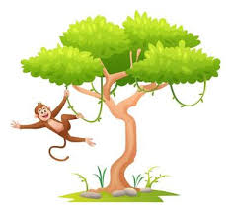
- a year — рік
- a monkey — мавпа
- funny — смішний, кумедний
- Cheetah — Чита
- a donkey — осел
- Kicky — Кікі
- a back — спина
- food
- sign out
- clothes
- time Cheetah is in the tree
- sad
- glad
- add
Завдання

- Sam added these clothes to the cart.
- He paid for the clothes in the cart.
- He ordered expensive things.
- We signed out of this website.
- We are subscribed to Netflix.
- We spent money on a Netflix subscription.
- This boy is in his kindergarten. He is a kindergartener.
- Why did he sell his monkey?
- She installed many apps on this phone.
- These apps drain the battery.

Translate to English
- Мавпочка Сема на дереві. Її звати Чита.
- Кікі — старий ослик. Він дуже слабкий.
- Ослик під деревом.
- Цей ослик сильний чи слабкий? Цей ослик дуже слабкий, він дуже старий.
- Скільки років Лілі? Їй чотири роки.
- Хто друг Лілі? Джиммі Дейл — її друг.
- Мавпочка Сема смішна? Так, вона дуже смішна.
- Хто сильний? Батько Джиммі сильний; він мисливець. Він дуже сильна людина.
- Сем сумний? Так, він сумний.

