1. Diagram

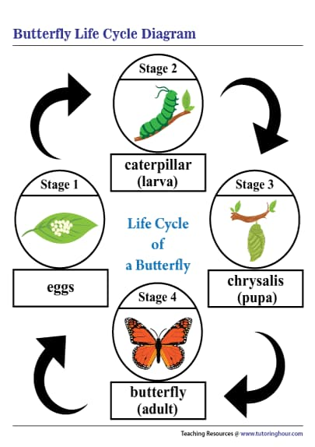

Here is a diagram illustrating the life cycle of a butterfly, showing each of the 4 stages of transformation.

1. Table

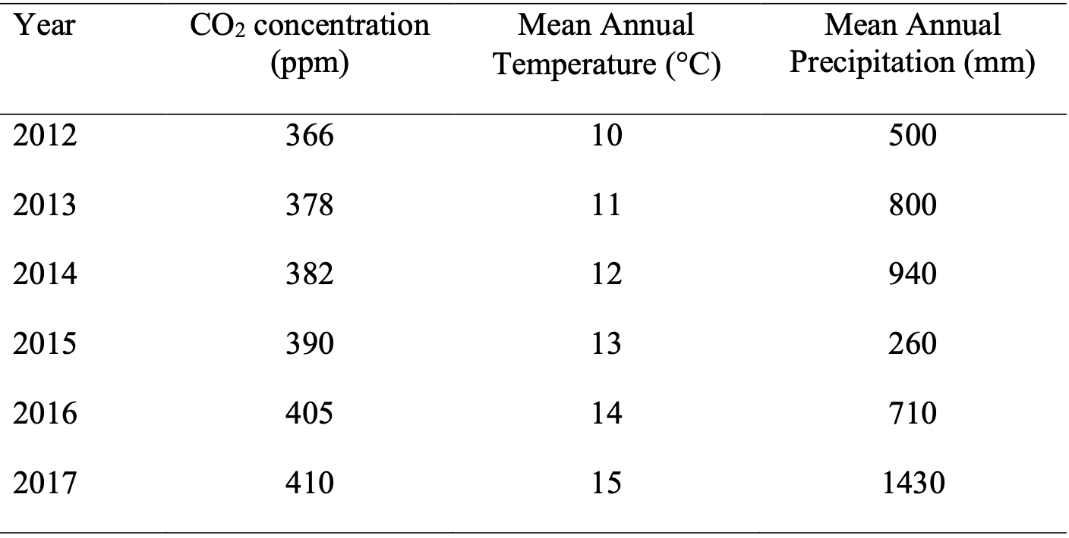

This table presents comparative data for several years, which includes the concentration of carbon dioxide, average annual temperature and precipitation from 2012 to 2017

1. Pie chart

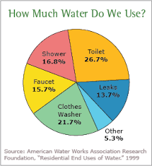

This chart shows the average distribution of the amount of water that the average person uses for various daily needs.

1. Flowchart

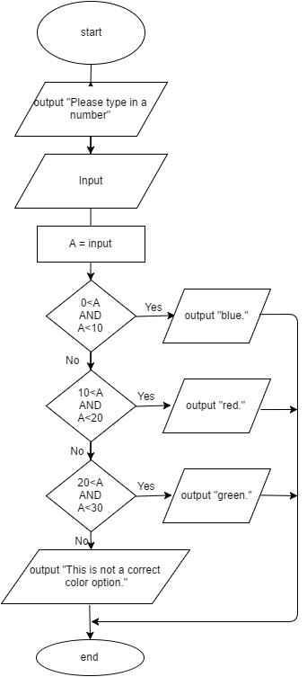

This is a flowchart for a program that ask a user to enter a number. If the number is between 0 and 10, write the word blue. If the number is between 10 and 20, write the word red. If the number is between 20 and 30, write the word green. If it is any other number, write that it is not a correct color option.

1. Line graph

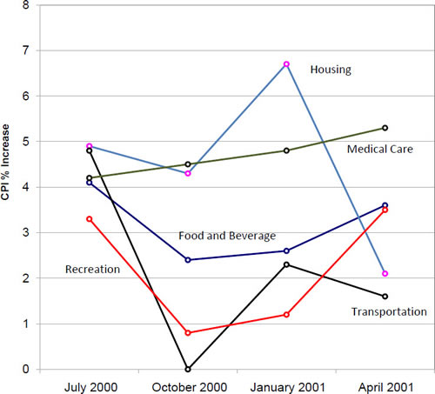

Figure shows percent increases and decreases in five components of the Consumer Price Index (CPI). The figure makes it easy to see that medical costs had a steadier progression than the other components.

1. Bar chart

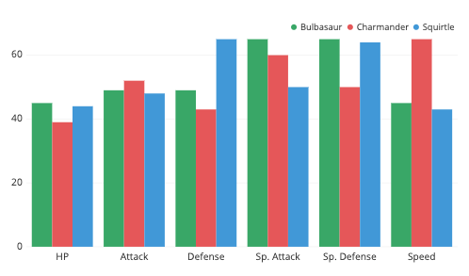

This bar graph shows a comparison of various game characteristics for three characters.