**Tel Aviv University**

[**Faculty of Exact Sciences**](http://in.bgu.ac.il/en/engn/Pages/About.aspx)

**Computer Science**

**Deep Learning**

**Exercise 1**

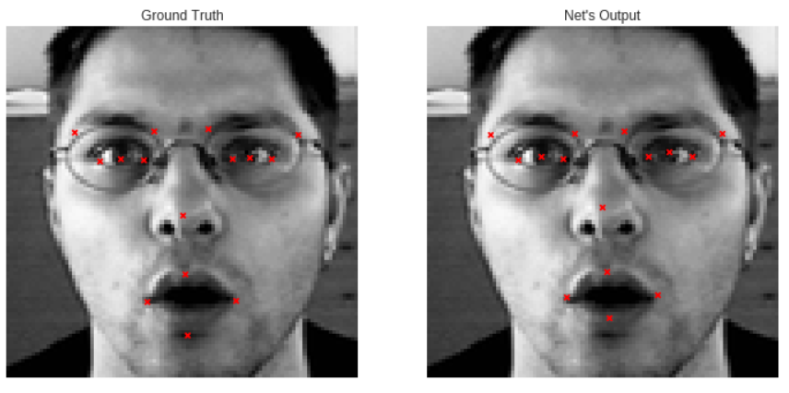



Alex Yudashkin 304325426  
Shani Ben Baruch 203888615  
Nir Zarrabi-Itzhak 201016680

**Question 1: XOR network**

Results are attached as Q1_results.txt

Code is attached as **\ Q1\q1.py**

Results are attached as **\ Q1_results.txt**

Loss function values in last epoch:

Train: 0.000000

Test: 0.000000

**Question 2:ReQU activation**

Code is attached as **\ Q2\q2.py**

Results are attached as **\ Q2_results.png**

Convergence plot:

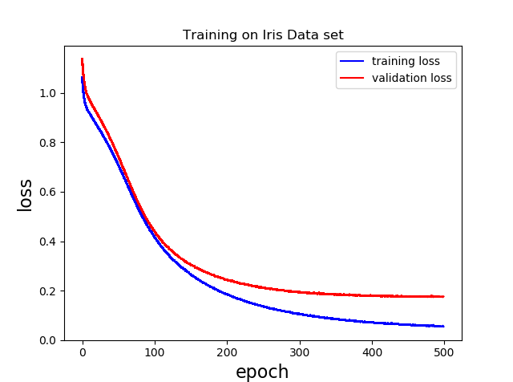

Loss function values in last epoch:

Train: 0.176671

Test: 0. 047522

Network accuracy: 100%

**Question 3:Facial Keypoint Detection**

Question 1: Data normalization

We have used the code in the suggested tutorial to load and normalize data.

Question 2: Fully connected neural network

Code is attached **\Q3\q3_faces_a.py**

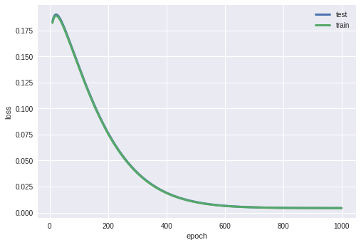The presented plot is the cost function value for test and train after each epoch, starting from epoch 10

A closer look (after 500 epochs):

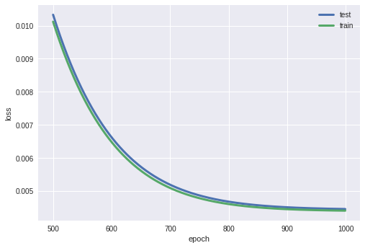

Loss function values in last epoch:

Train: 0.004409

Test: 0.004459

Question 3: Convolutional neural network

Code is attached as **\Q3\q3_faces_b.py**

Convergence plots:

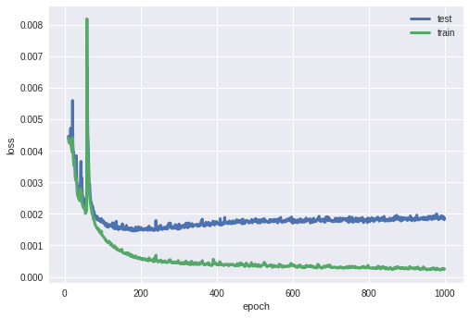Only CNN:

With old version:

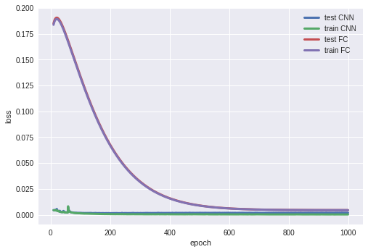

Loss function values in last epoch:

Train: 0.001875

Test: 0.000252