As the analysis from the given data most of data are companies and their revenue and employee rate has much bigger and increase as compare the universities the turn over layout of the universities and number of employees in universities are much lesser then the companies. To increase their turnout and revenue universities enhance their network and spread their campuses all over the countries.

Average degree of the graph is 1.724659606656581

Variance of the graph 3.0618578644652006

As the variance is low not much high which means the outcome of the data is low

It shows that edges of nodes very closely related to each other

Below the frequency table and degree of the edgelist nodes

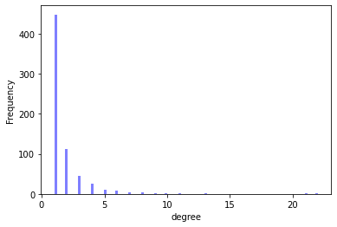

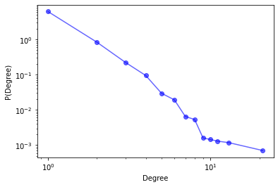

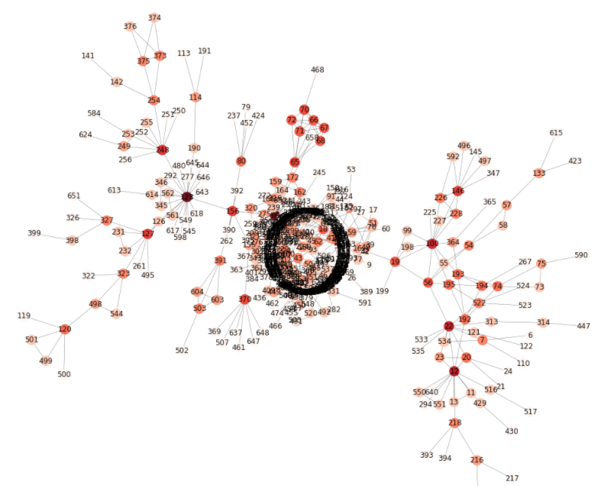

Symmetric network (As the given data and plotting the graph it is observe that is data is symmetric every node has interconnected with each other)