**Dream User Manual**

**User guide**

**Disclaimer**

T

his is alpha version of website which is released to verify and validate the software requirements. The website includes all the features that has been given in first six month of the revised project plan except question/quiz bank. The quiz bank will be released in next two months. After completion of quiz bank, working on framework will begin which will take six months to conclude the plan of first year. After completion of framework, software will be ready for public usage.

**Note:** The version is only for prototyping and for proof of concept. Please consider following points while going through the admin and user manual:

1. Any downloading or uploading of material to the website is done at the user’s own risk and the user will be solely responsible for any loss of data that results from such activities. Any data entered the website will not be saved and retained in future releases.
2. Validate and verify each page of manual and give your feedback at relevant places.
3. All components were tested in latest version of chrome
4. Current release of the website is targeting admin user. However, you may find the functionality for dream user but it has not been completed and tested
5. In case you encounter any bugs, errors or glitches those are restricting you to perform a task (given in manual), please let us know immediately so we can rectify these accordingly. Your help in this regard is greatly appreciated.
6. For any lack of functionality, lack of usability or other problems on the website, should be mentioned in relevant pages of manual or in project feedback report.
7. In case, user fail to give feedback for any component or pages, current version of the component and pages will be considered as final version.
8. Verification and validation of the requirements shall be confirmed in 15 days.

**Table of Contents**

**Dream User Manual** 3

**Register** 4

**Account Registered** 6

**Login** 7

**External** 8

**Dashboard Without Enrolled Dream** 9

**Account Activation** 10

**Account Activated** 11

**Profile Updation** 12

**Profile Completed** 14

**Like a Dream** 15

**Dream Detail** 16

**Enrolled Dream** 17

**Video** 18

**Quiz** 19

**Reading** 20

**External Links** 21

**Game** 22

**Assignment** 23

**Progress** 24

**Dream User Manual**

This document will guide you about Registration, Activation, Enrollment and Completion of a dream. Stay with us :)

**Search Dreams**

User will be able to search the dreams through this control based on Dream Name, Description, and attached tags. This search is predictive and will give spelling corrections upon insertion of words, for example in the below image, we wrote the wrong spelling “Pakisten” just below that text field, corrected word is displayed. Clicking on corrected word will replace the faulty word with corrected one.

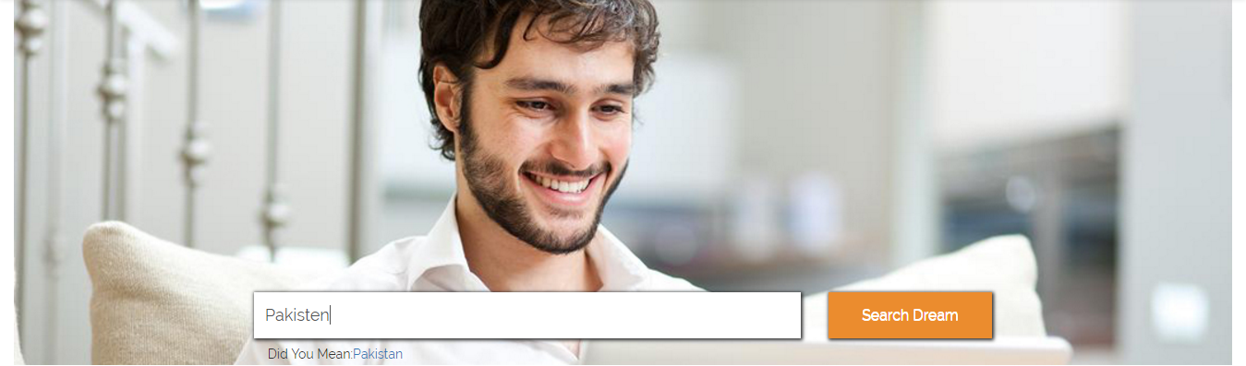

**Share Control**

**Your Comments Here**

User share any activity on social media websites such as Facebook and twitter etc.

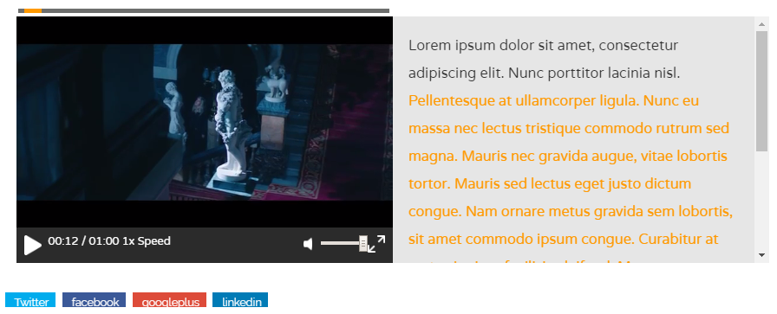

**Your Comments Here**

**News View**

User can also see the news added in the website by clicking on the “News” button on the top navigation bar. The news page shall look like the following.

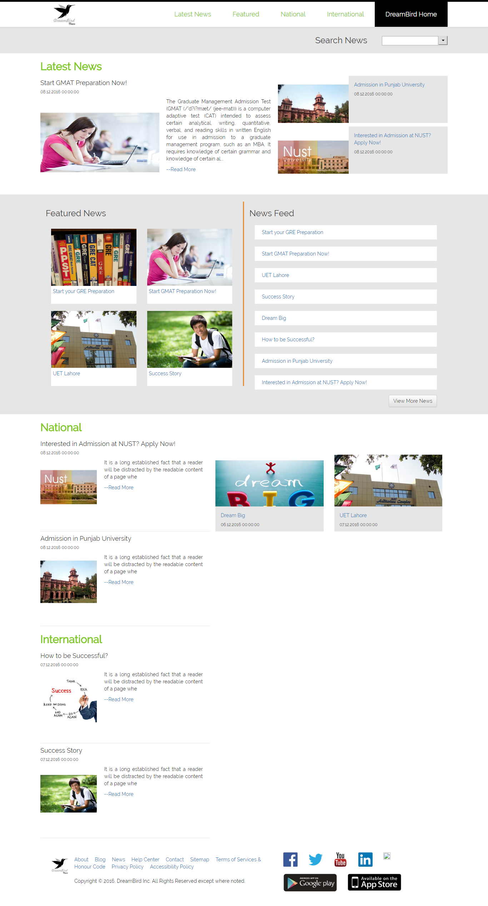

**Register**

Very first step is registration. From Homepage, click on "Register" button and you will be navigated to this page. This page contains the following information.

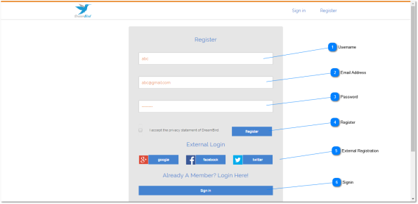

**Your Comments Here**

**Username**

User will enter the Username here. This username will be used for login in the future.

**Email Address**

User will enter the email address here. This email address will be used for future correspondence with user.

**Password**

User will enter the password that will be used to unlock the account and sign in.

**Register**

By Clicking on this button, you will be redirected to User Default page where you will be asked to confirm your registration by visiting your email address.

**External Registration**

User can register through various social media applications such as Facebook, Twitter and LinkedIn.



**Signin**

**Your Comments Here**

If user is already registered, then he can sign in from this button

**Account Registered**

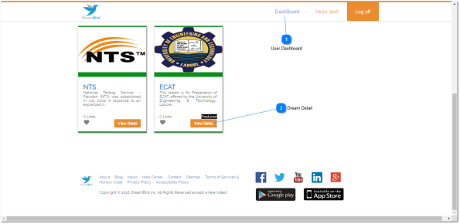

**Your Comments Here**

**User Dashboard**

When registration is completed, the user shall be navigated to this page. This will be user's dashboard in which he will see the list of currently enrolled dreams.

**Dream Detail**

User will be able to view the dream detail from this link. This detail will include the information about contents (videos, quizzes, lessons etc.) of dream, detail of authors etc.

**Login**

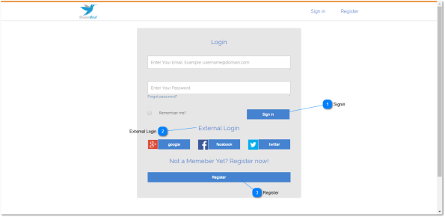

**Signin**

**Your Comments Here**

If the user is already registered, then he can click on "Sign In" button and will be navigated to this page. Here, user name and password will be entered and user will be navigated to user's dashboard.

**External Login**

User can also use external login services using various social media applications including google, Facebook, twitter etc.

**Register**

If the user is not currently registered, then he can go to registration page to get registered and get started.

**External**

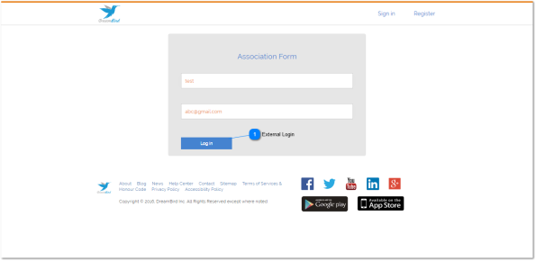

**External Login**

**Your Comments Here**

User will be able to relate the current Dream Bird account with external login accounts. for example, in the above-mentioned snap, user name of dream bird account is "test" and user name of external login is abc@gmail.com. By clicking on Log In button, the said account will be associated with each other’s. This screen will be visible to the user only once, after linking (Association), user will be directly navigated to the user dashboard.

**Dashboard with Enrolled Dream**

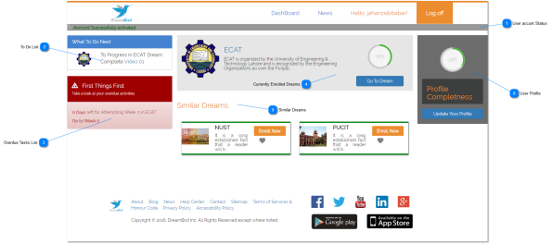

**User accunt Status**

**Your Comments Here**

Upon new registration, user will receive a confirmation email and by clicking on the link given in the email, the account will be fully activated. Till then, the user will be shown this notification (see the below image) and if the user has not received any email, clicking on the link will resend the confirmation email. When the account is activated, the user will be shown this message telling him that the account has been activated.



**To Do List**

User will be shown the list of tasks need to be done as the current activity.

**Overdue Tasks List**

User will be shown the list of over due (pending) tasks for which, final date has passed.

**Currently Enrolled Dreams**

User will be shown a list of currently enrolled dreams in which, he can resume any of it.



**Similar Dreams**

**Your Comments Here**

User will be suggested a list of similar dream with the ones he's currently enrolled.

**User Profile**

User will be shown the current status of his profile with percentage completion and option to update the profile.

**Account Activation**

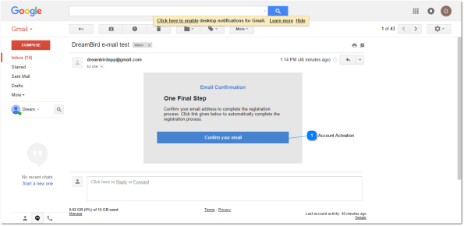

**Account Activation**

**Your Comments Here**

This is the preview of the confirmation email that will be sent to the user upon registration. When the user clicks on "Confirm Your email", he will be navigated to the main website and will be told that the account has been activated.

**Account Activated**

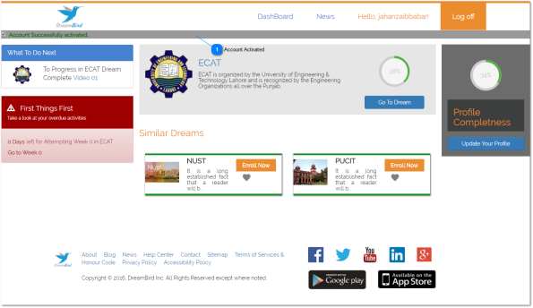

**Your Comments Here**

**Account Activated**

When the user successfully activated the account by clicking on the link given in the confirmation email, this message will be shown telling him that his account has been activated.

**Profile Updation**

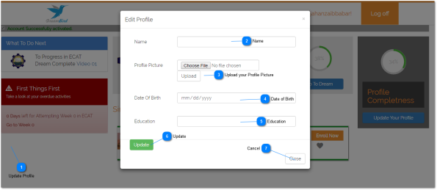

**Update Profile**

**Your Comments Here**

From this link, user's profile can be updated or edited. When the user clicks on this button, a popup window will appear for profile updation.

**Name**

User's Name will be entered here.

**Upload your Profile Picture**

User can upload his profile picture here.

**Date of Birth**

User can add his date of birth here.

**Education**

User can add educational detail here.

**Update**

To Update your profile, click here. Remember, all fields must be filled



**Cancel**

To cancel Updation click here

**Your Comments Here**

**Like a Dream**

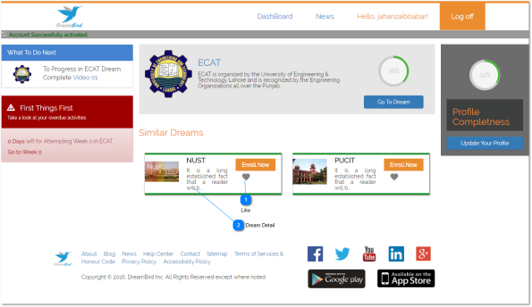

**Like**

**Your Comments Here**

User can like a dream from this "Heart" button. When liked, its color shall turn red.

**Dream Detail**

user will be able to view Dream detail upon clicking on the button

**Dream Detail**

**Your Comments Here**

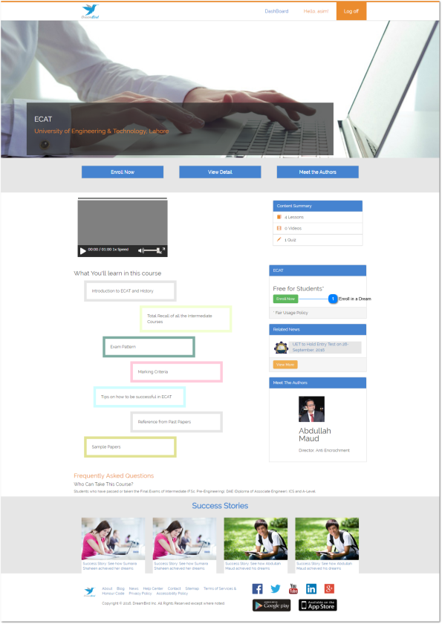

**Enroll in a Dream**

This page will show the dream detail. From this page, different features of dream will be known and user can enroll into the dream from this link.

**Dream Content Summary**



User will be shown the summary of the content (videos, quizzes, lessons etc) currently available in the dream.

**Your Comments Here**

**Enrolled Dream**

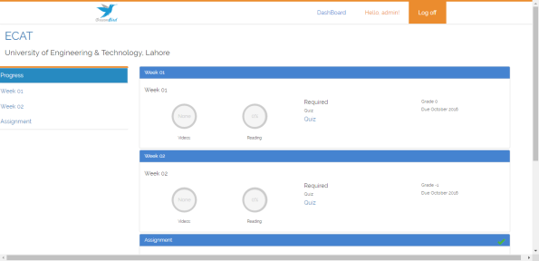

User shall see the progress of all the on-going activities in this section.

**Your Comments Here**

**Video**

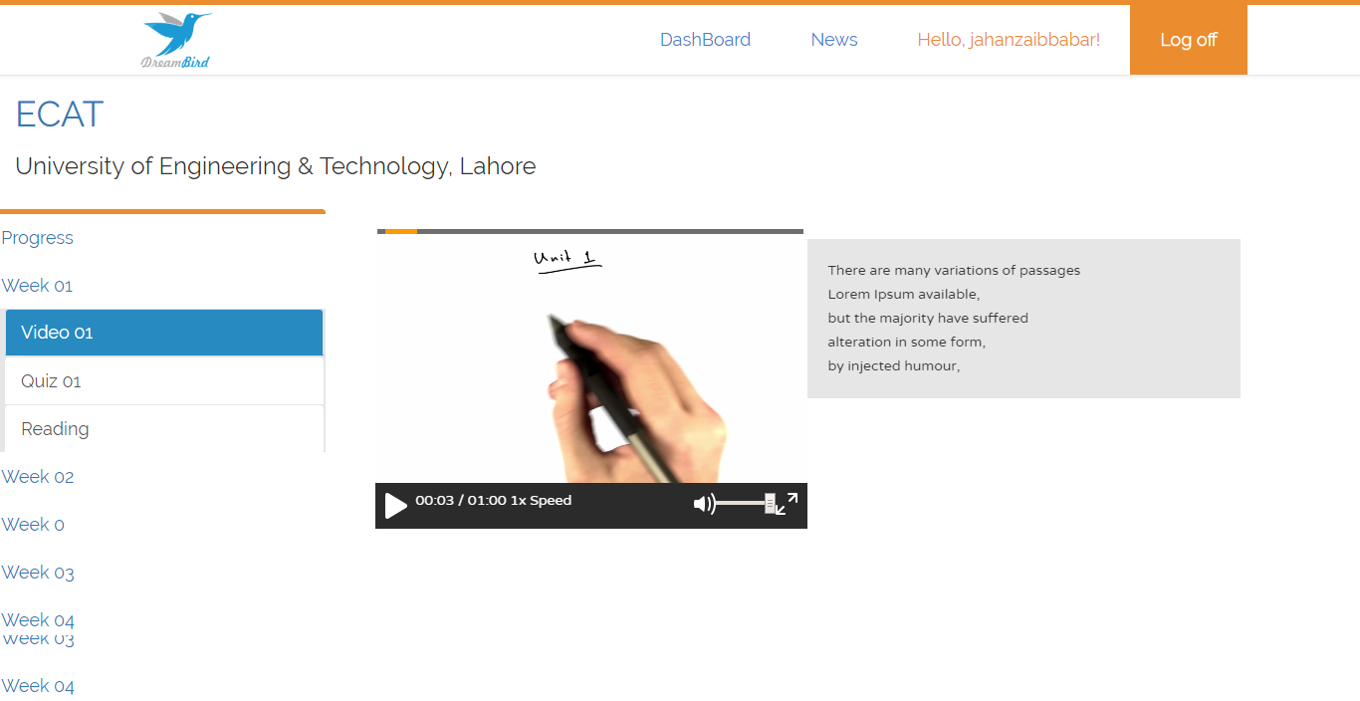

**Lesson 1**

User shall be able to go through lessons in a dream. In current scenario, user is viewing video lesson with its transcript. Once the user has completed watching this video, progress shall be marked in the Progress Dashboard.

**Your Comments Here**

**Reading**

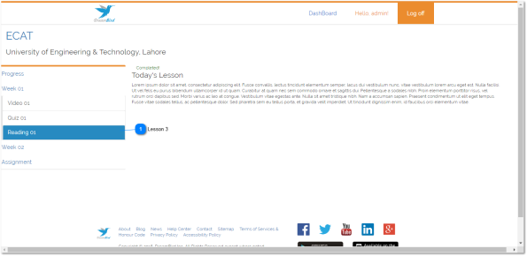

**Lesson 3**

User shall also have to do some reading of lesson during the course of the dream. When user has completed the reading, he will Mark the "**Mark as read**" to tell us that the user has done with reading and its progress will be added in the Progress Dashboard.

**Your Comments Here**

**External Links**

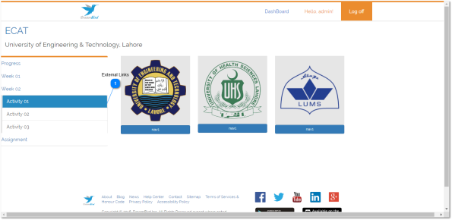

**External Links**

User shall also be required to visit some websites and informational links.

**Your Comments Here**

**Game**

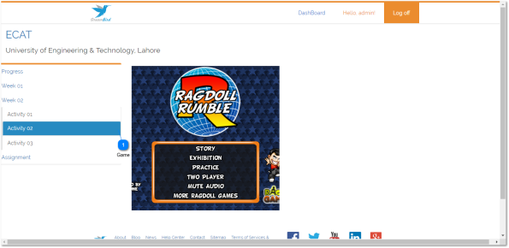

**Game**

User shall be asked to play some games during the dream.

**Your Comments Here**

**Assignment**

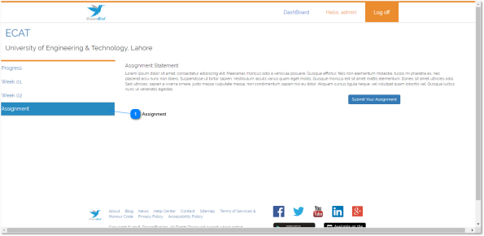

**Assignment**

User shall also be given some assignment work to do at home. When the assignment is prepared, the user can upload it from "Submit Your Assignment" button.

**Your Comments Here**

**Progress**

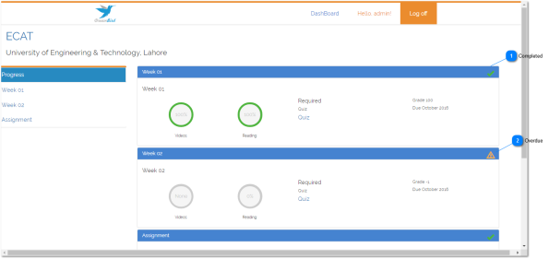

**Your Comments Here**

**Completed**

In progress dashboard, all the completed tasks will be given in the green form with 100% progress.

**Overdue**

When there are overdue task, these will be shown in gray form with 0% and gray border.