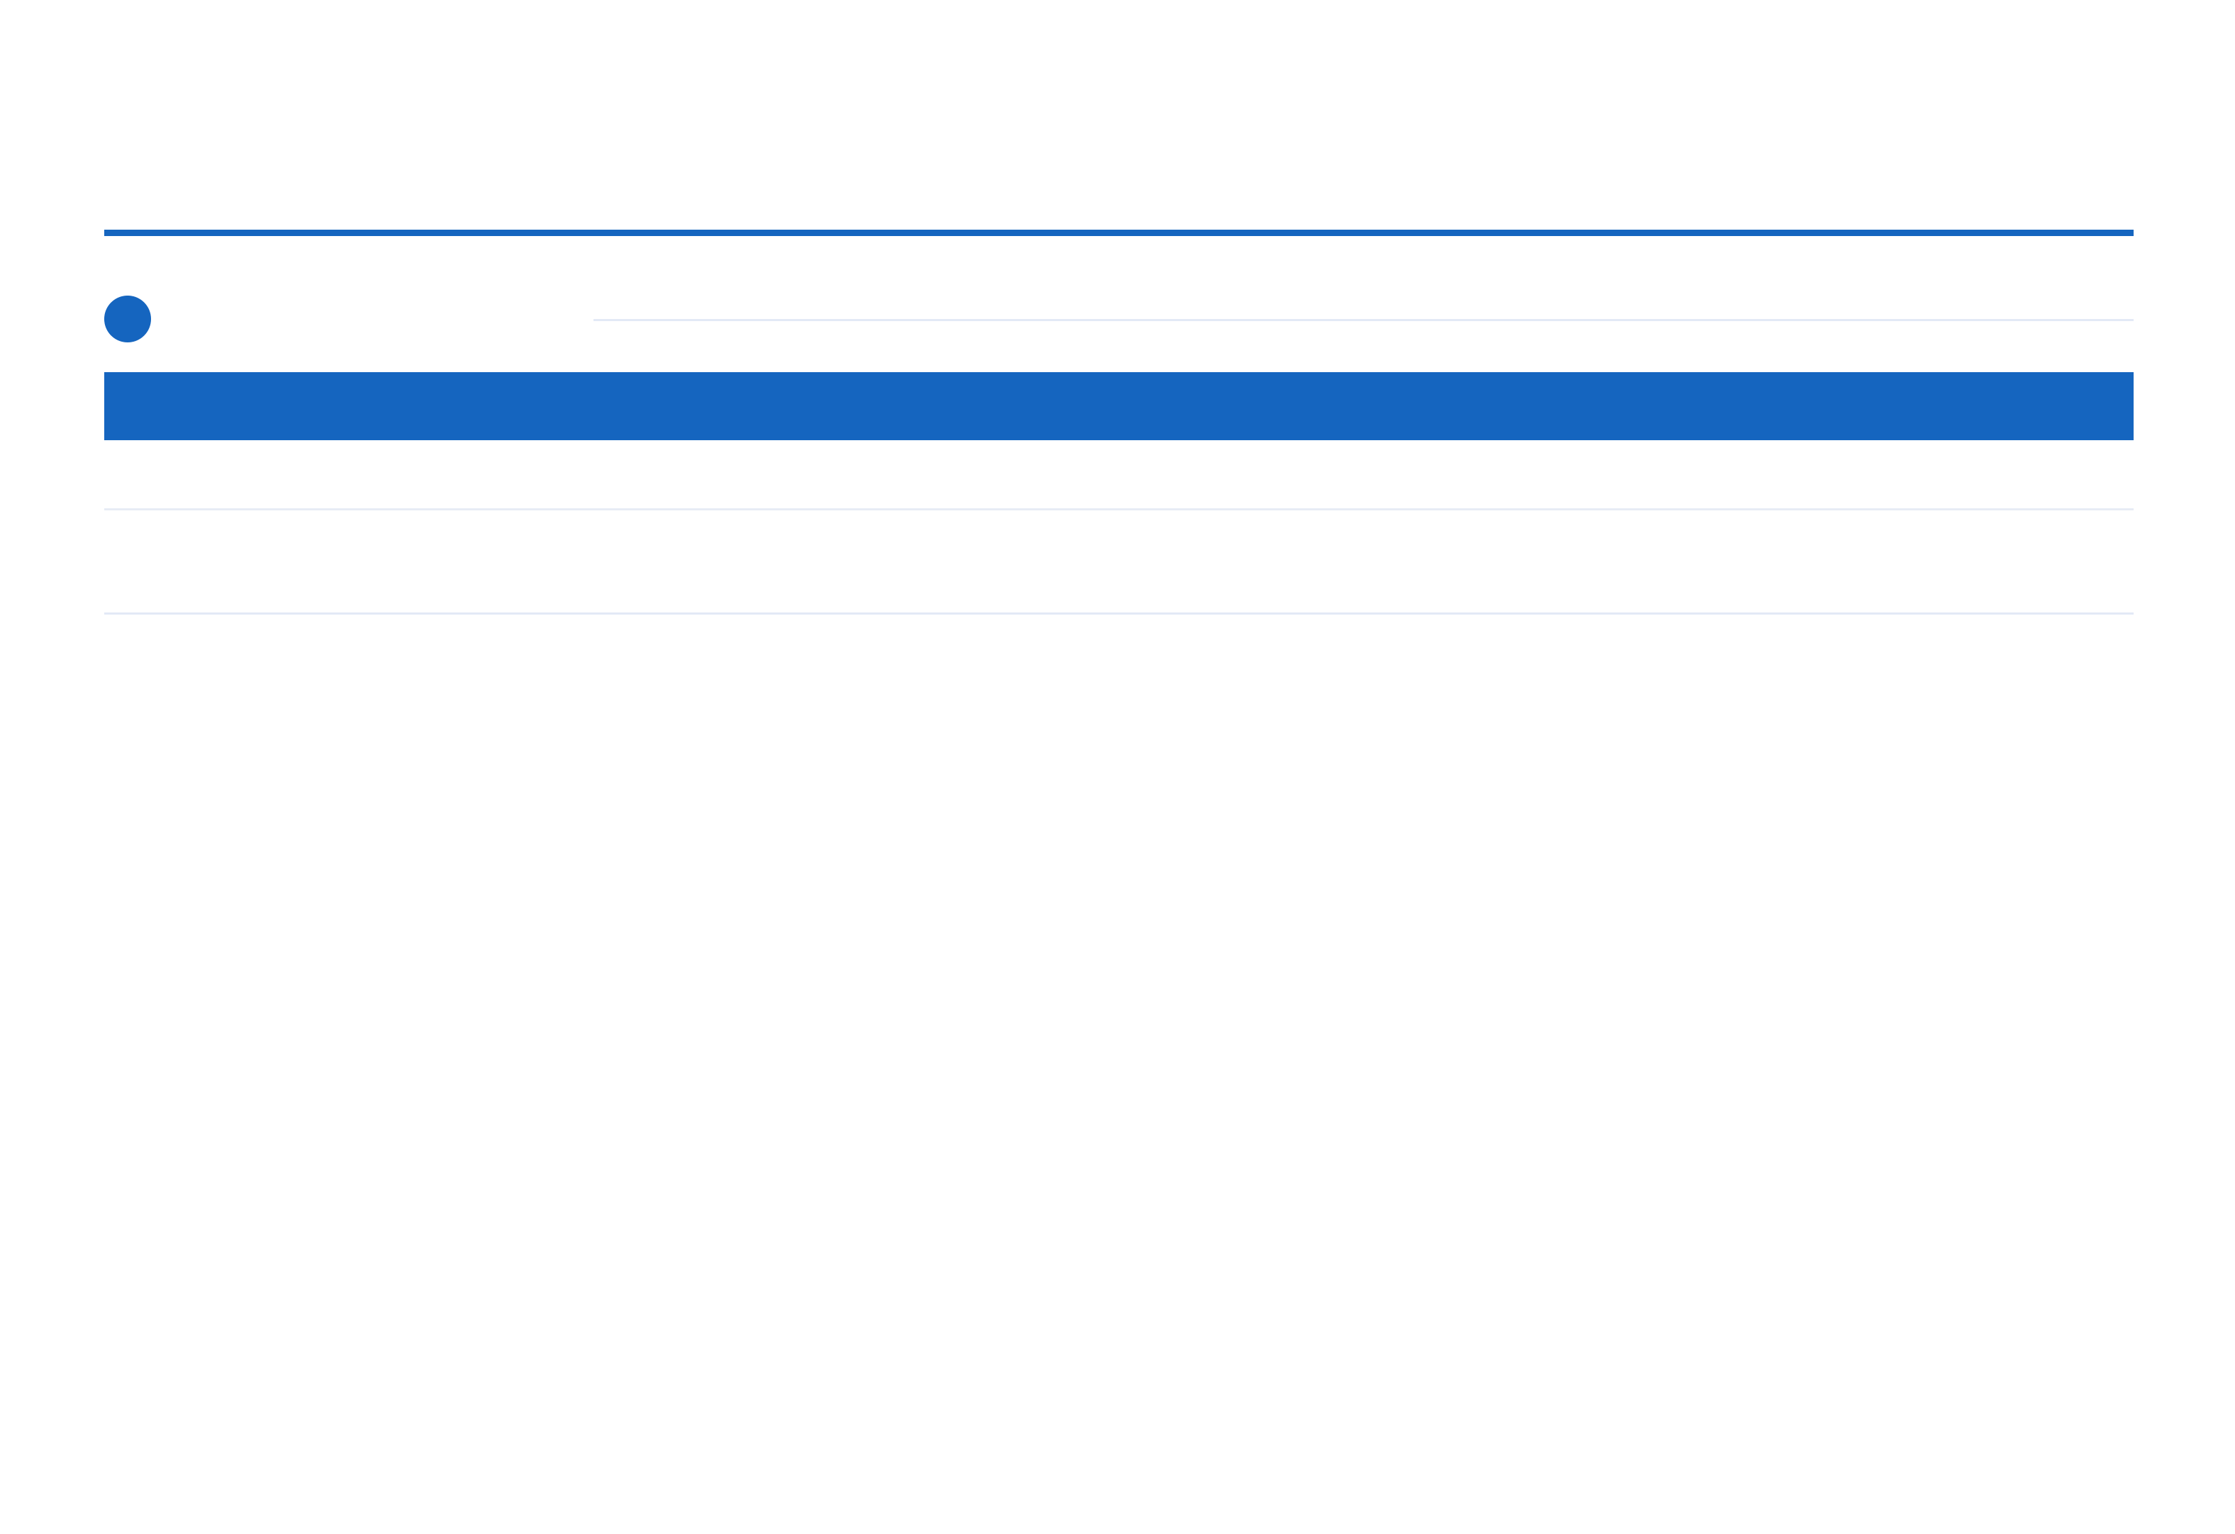

Device Inventory Report

REPORTING PERIOD
01/01/2024 – 31/12/2025

All registered PLC/IoT devices |  |  | Status | Port | Latency (ms) | Auto Reconnect | Generated: 03/03/2026
1 | Device Inventory Report |  |  |  |  |  | Last Error
Name |  | Protocol

Device Inventory Report — Confidential

Period: 01/01/2024 – 31/12/2025 | Generated: 03/03/2026

