

SCHOOL OF COMPUTER SCIENCE AND ENGINEERING

**BACHEL0R OF COMPUTER SCIENCE AND ENGINEERING**

“INTERNET PROGRAMMING LABORATORY”

COURSE CODE: CSE326

**TOPIC:**

**CODER’S.COM**

SUBMITTED BY:

NAME ROLL NO. REG. NO.

ARNAB RAY 49 11917676

PRANJAL RATHI 50 11918042

DEEPAK JANGIR 51 11918248

SUBMITTED TO:

Moin Hasan

Professor, Lovely Professional University

**REPORT FOR PROJECT**

**INTRODUCTION**

CODER’S.COM is a project which aims in developing a computerized system to provide the information about a coding website. Reaching the coders to gain knowledge about the benefits of coding practice.

Through this site you can get to practice coding in various computer languages. Along with that we are providing assistance for beginners who are new to coding.

**PROPOSED METHODOLOGY**

* First, we decided to make the linking webpages which will be later on linked to the home page.
* Then the linking webpages were made using references from a few websites.
* Then a single font and design was applied to the webpages in a single CSS file.
* Then all the webpages were linked to the home page.
* In the end images and transitions were added to make the website more presentable and livelier.

**LITERATURE REVIEW**

* HOME PAGE

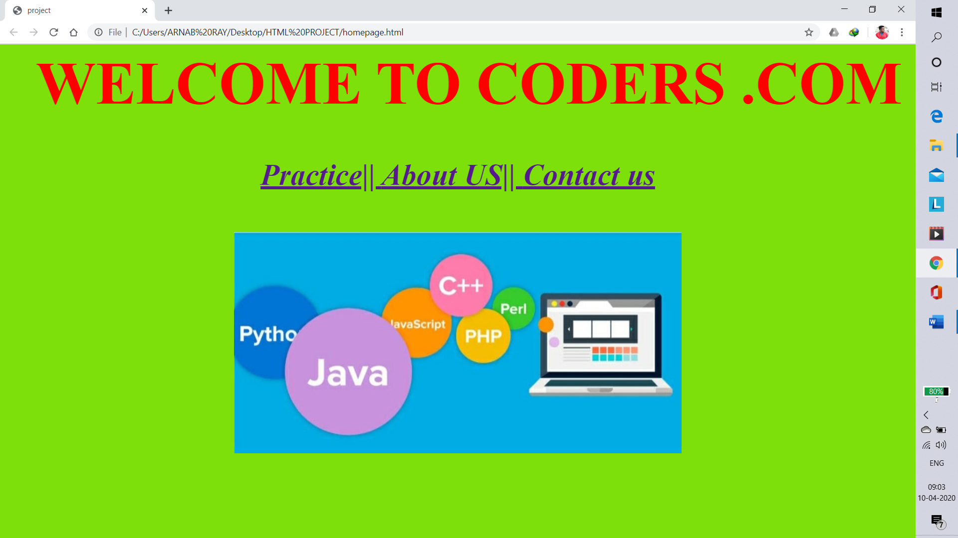

It contains the links to about us, PRACTICE ABOUT US & Contact Us.

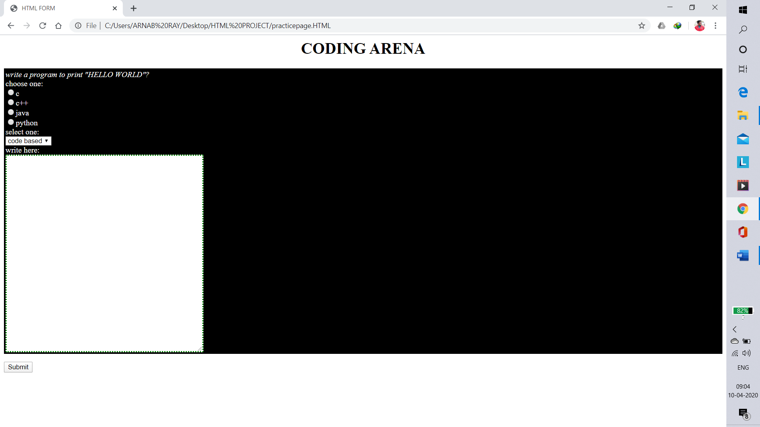

Contains links to the PRACTICE PAGE, link to access the ABOUT US AND CONTACT US. Also contains the Creators e-mail ID.

* ABOUT US

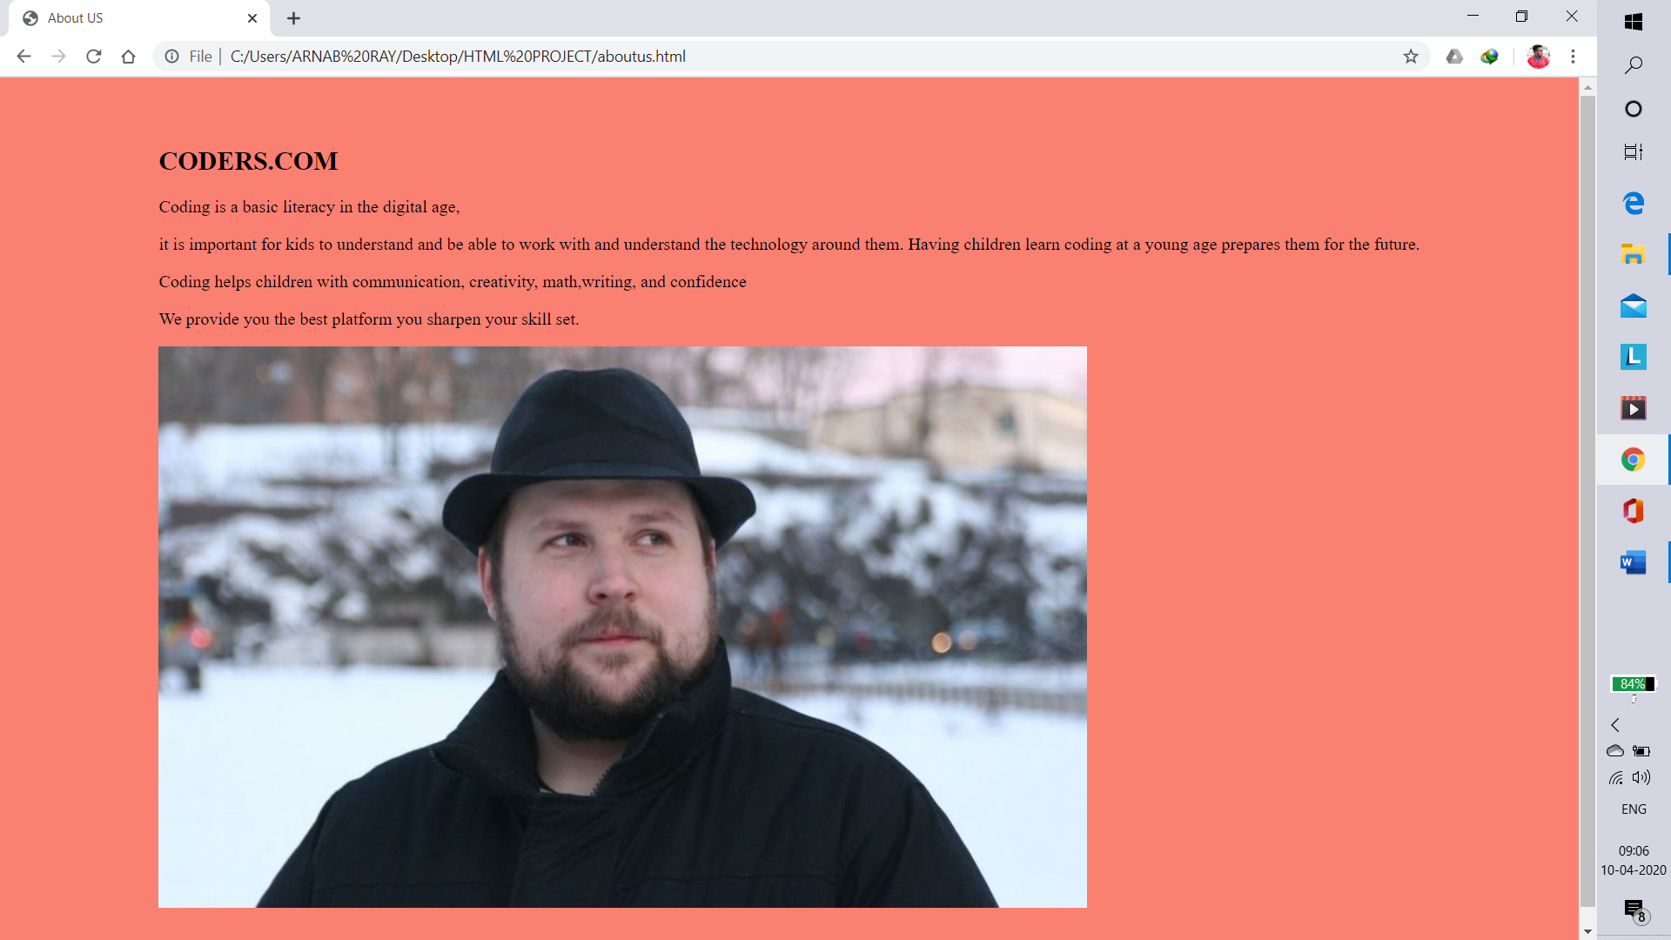

It contains the information about the Website. It will tell the user about the necessity of coding and benefits for using our website.

* CONTACT US

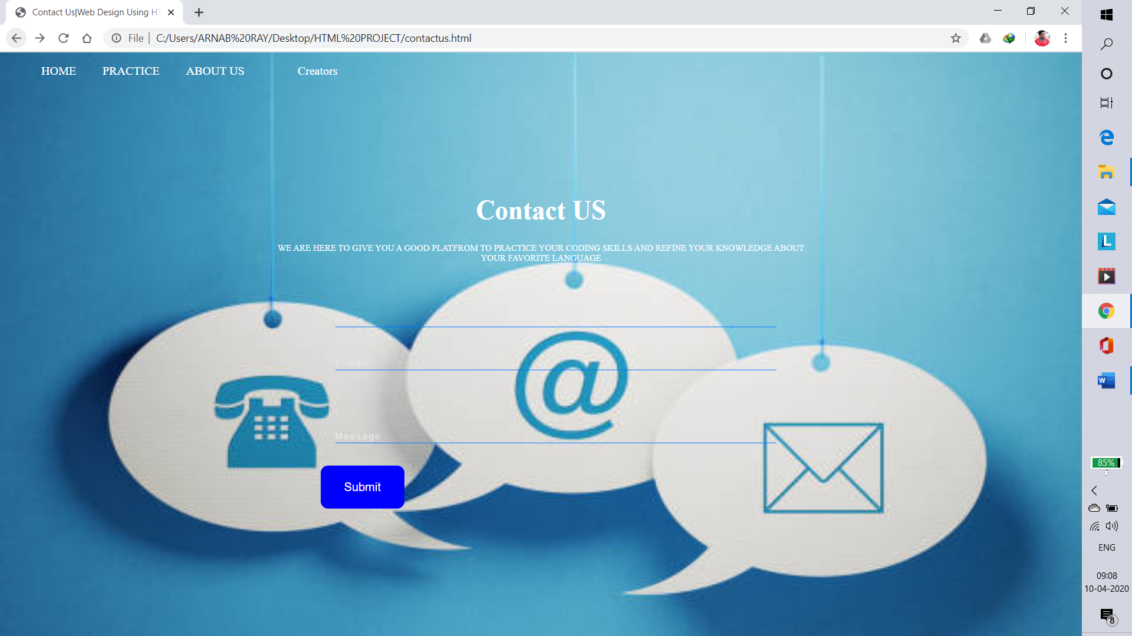

The user can contact with the handler of this page and the creators through this.

* CREATORS

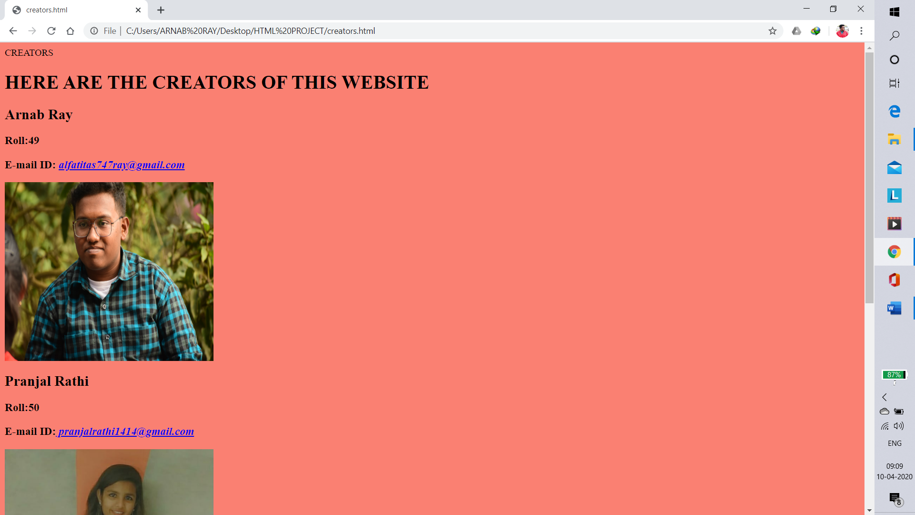

Here the coders can see who has developed this website and can get inspired by that.

**REFERENCE**

The following are the websites which were used as a reference for the making of the project:

http://www.hackersearth.com

**PLAGIRISM**

We have put lot of effort to make our project genuine and authentic. In this process we have tried to keep each facts and information on our website real and eventually we have relied upon content from some of the popular websites for various section such as PRATICE, CONTACT US. The contents which are influenced by the popular websites and name of websites are listed as-:

**About Us**

To give customers more insight into who is involved with coding and can practice in our website to polish their skills.

**RESULT**

The result of the project given to us is a coding website. In which people can go and code and can polish their skills of coding along with that in case of any assistance they can contact us. In the contact Us section. There is also a creator section where the coders can also contact the creators of the website in the email-ID given.

**CONCLUSION**

CODING WEBSITE allows the user to practice coding, for any assiatance he or she can contactUS.This website allows writing message to the creators in the Contact Us section. The system is strong enough to withstand regressive yearly operations under condition where the database is maintained and cleared over a certain time of span.