CAMPUS CLUB & EVENT HUB

Team Feature
Documentation
  - Architecture, ownership, demonstrations, and viva preparation
━━━━━━━━━━━━━━━━━━━━
Faisal Mahbub · Rifat Mahmud · Tarannum Diha
PHP 8 / MySQL / XAMPP / August 2026

Document map
01 | Project and shared architecture
02 | Database model and relationships
03 | Tarannum Diha — management lifecycle
04 | Rifat Mahmud — registration lifecycle
05 | Faisal Mahbub — dashboards and engagement
06 | Integration, status, demo, and viva reference

PRESENTATION RULE Only items labeled Implemented now should be presented as complete working features. Schema-ready items are planned extensions.

1. Project overview
CampusHub is a framework-free PHP and MySQL web application for BRAC University club activities. Students discover clubs, request membership, browse events, and register for events. Approved club executives manage their assigned clubs, members, and events. Administrators have system-wide visibility and management authority.
The application runs on XAMPP:
- Apache serves PHP pages.
- PHP handles sessions, validation, authorization, and business logic.
- MySQL stores normalized relational data.
- JavaScript adds live filtering, view preferences, AJAX actions, and feedback messages.
- Every AJAX operation retains a normal HTML form fallback.

Current working URL
http://localhost/campus-club-hub/

Technology stack
Layer | Technology | Responsibility
Presentation | HTML5 and CSS3 | Editorial responsive interface
Browser behavior | Vanilla JavaScript | Search, filters, AJAX, view state, motion
Server | PHP 8 | Authentication, authorization, validation, CRUD
Database | MySQL / MariaDB | Normalized persistent data and constraints
Local environment | XAMPP | Apache, PHP, MySQL, phpMyAdmin

2. Shared architecture all members should understand

2.1 Request flow
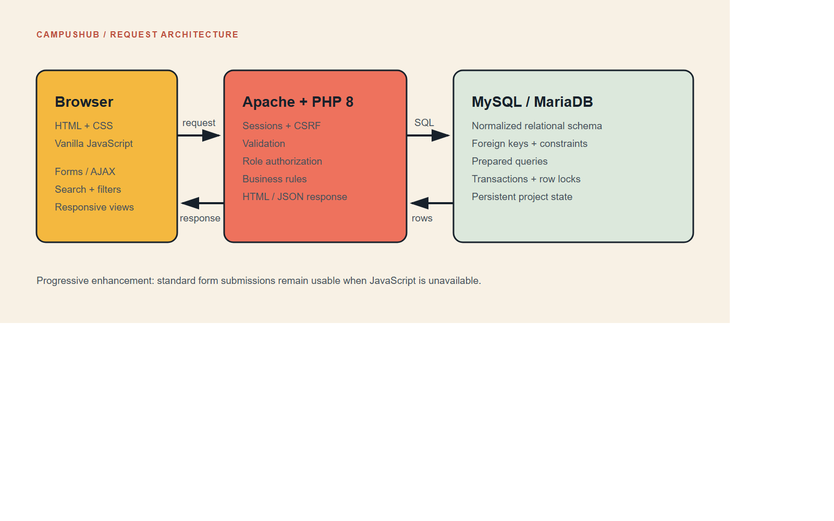
Figure 1. CampusHub request architecture
- The browser requests a PHP page.
- includes/bootstrap.php starts the session and database connection.
- The page reads the current user from the session.
- Prepared SQL statements retrieve only the required records.
- PHP escapes output through e() before generating HTML.
- A form submission includes a CSRF token.
- PHP verifies the token, permissions, and business rules.
- The database is changed only after validation succeeds.
- The user receives either a flash message or a JSON response.
For progressive AJAX forms, assets/app.js sends the same form data to an endpoint under api/. The endpoint responds in this consistent shape:
{
"ok": true,
"message": "Membership updated.",
"data": {
"action": "approve",
"membership_id": 4
}
}
The interface changes only after the server confirms success. If JavaScript is unavailable, the standard PHP form action still works.

2.2 Authentication and security foundation
Authentication is shared infrastructure rather than an individual showcase feature.
- New registration accepts only email addresses ending in @g.bracu.ac.bd.
- Email and student number are unique.
- Passwords are stored with PHP password_hash() and checked with password_verify().
- Successful login regenerates the session identifier.
- Suspended or deactivated accounts cannot log in.
- State-changing forms require a CSRF token.
- SQL uses prepared statements rather than concatenating user input.
- Output is escaped with htmlspecialchars() through the e() helper.
- Authorization is checked on the server; hiding a button is never treated as permission.
Key files: signup.php, login.php, logout.php, includes/bootstrap.php, and includes/functions.php.

2.3 Role model
The application deliberately does not store “Club Executive” as a global user role.
- users.role contains Student or Admin.
- A student becomes an executive for a particular club through club_membership.member_role.
- Executive roles include Executive, President, Vice President, Secretary, and Treasurer.
- The membership must also be Approved and Active.
This allows one student to be President of one club, an ordinary Member of another, and have a Pending request in a third club.
The central authorization function is:
can_manage_club(int $clubId): bool
It returns true for an administrator or for an approved, active executive membership in that exact club.

3. Database relationships

3.1 Core relational chain
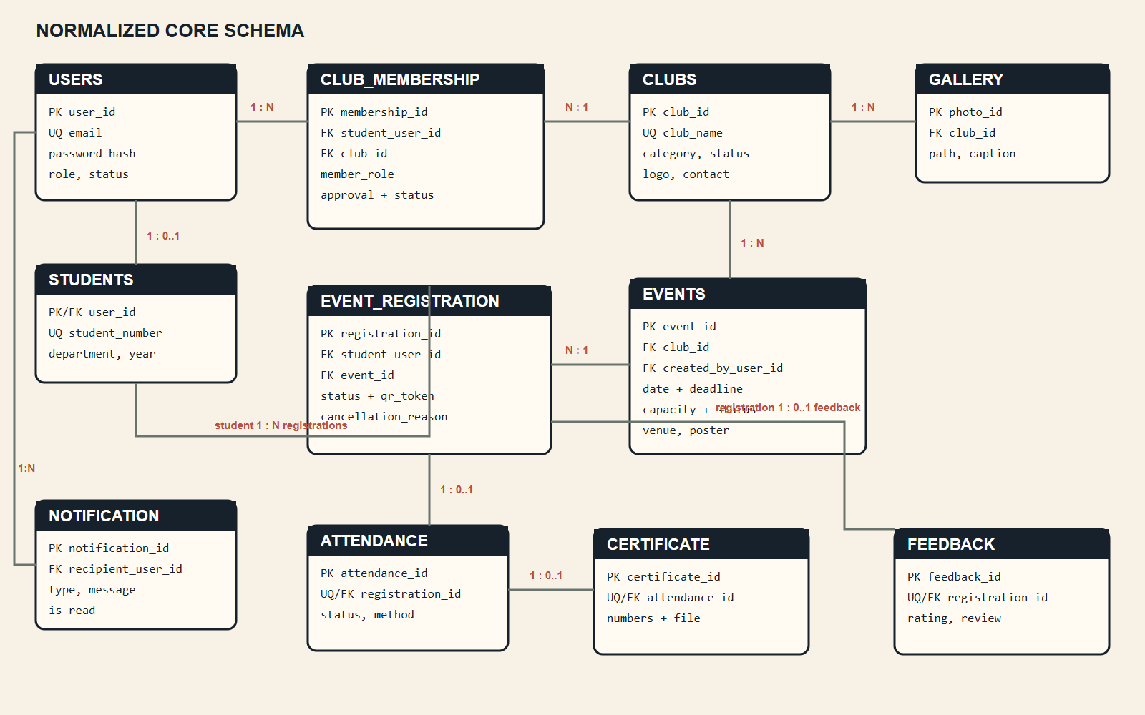
Figure 2. Normalized core relational schema
Additional relations:
- One user receives many notifications.
- One authorized user publishes many announcements.
- An announcement may optionally belong to one club.
- One club has many gallery photos.
- One student has many interests through student_interest.

3.2 Why associative entities are required
club_membership resolves the many-to-many relationship between students and clubs. It also stores facts about that relationship: approval, role, join date, and membership status.
event_registration resolves the many-to-many relationship between students and events. It stores registration status, QR token, cancellation reason, and timestamps.
These values do not belong solely to a student or solely to a club/event; they belong to the relationship between them.

3.3 Important database constraints
Constraint | Business rule protected
users.email UNIQUE | One account per email
students.student_number UNIQUE | One account per student number
club_membership(student_user_id, club_id) UNIQUE | No duplicate membership relationship
event_registration(student_user_id, event_id) UNIQUE | No duplicate event registration relationship
maximum_participants > 0 | Event capacity must be meaningful
deadline <= event_date | Registration cannot close after the event
one unique attendance per registration | Attendance cannot be recorded twice
feedback rating from 1 to 5 | Valid rating scale
unique certificate/verification numbers | Certificates remain identifiable

The complete normalized model is available in docs/campus_club_hub_normalized.drawio, with executable definitions in database/schema.sql.

4. Tarannum Diha - Club, Membership, and Event Management

4.1 Individual feature statement
“My feature area controls the club-management lifecycle: club discovery and profiles, membership requests and approvals, club-specific executive authority, and event CRUD for authorized executives.”
This is an independent feature because it owns the relationship that turns students into club members/executives and uses that relationship to authorize event management.

4.2 Implemented now
- Visual club directory with database-backed counts
- Live club search and category filtering
- Student membership request
- Duplicate request prevention
- Personal membership-status view
- Executive membership queue
- Approve and reject actions
- Remove member action
- Assign and update executive roles
- Club profile create/update for authorized users
- Event create, read, update, cancel, and delete
- Club-scoped authorization for every management operation
- AJAX membership actions with normal form fallback
- Executive dashboard containing assigned clubs, pending requests, and capacity snapshots

4.3 Tables owned or heavily used

clubs
Stores one record per club: name, description, category, contact details, image path, status, and timestamps.

club_membership
Connects a student to a club. This is the authority table for membership and executive access.
Important state combinations:
Approval | Membership | Meaning
Pending | Active | Waiting for executive review
Approved | Active | Current official member
Rejected | Active | Request rejected
Approved | Removed | Previously approved, later removed
Approved | Resigned | Student left voluntarily

An executive is authorized only when approval is Approved, membership is Active, and the member role is an executive role.

events
Every event contains club_id, so every event belongs to exactly one club. created_by_user_id preserves who created it.

4.4 Main PHP and AJAX flow
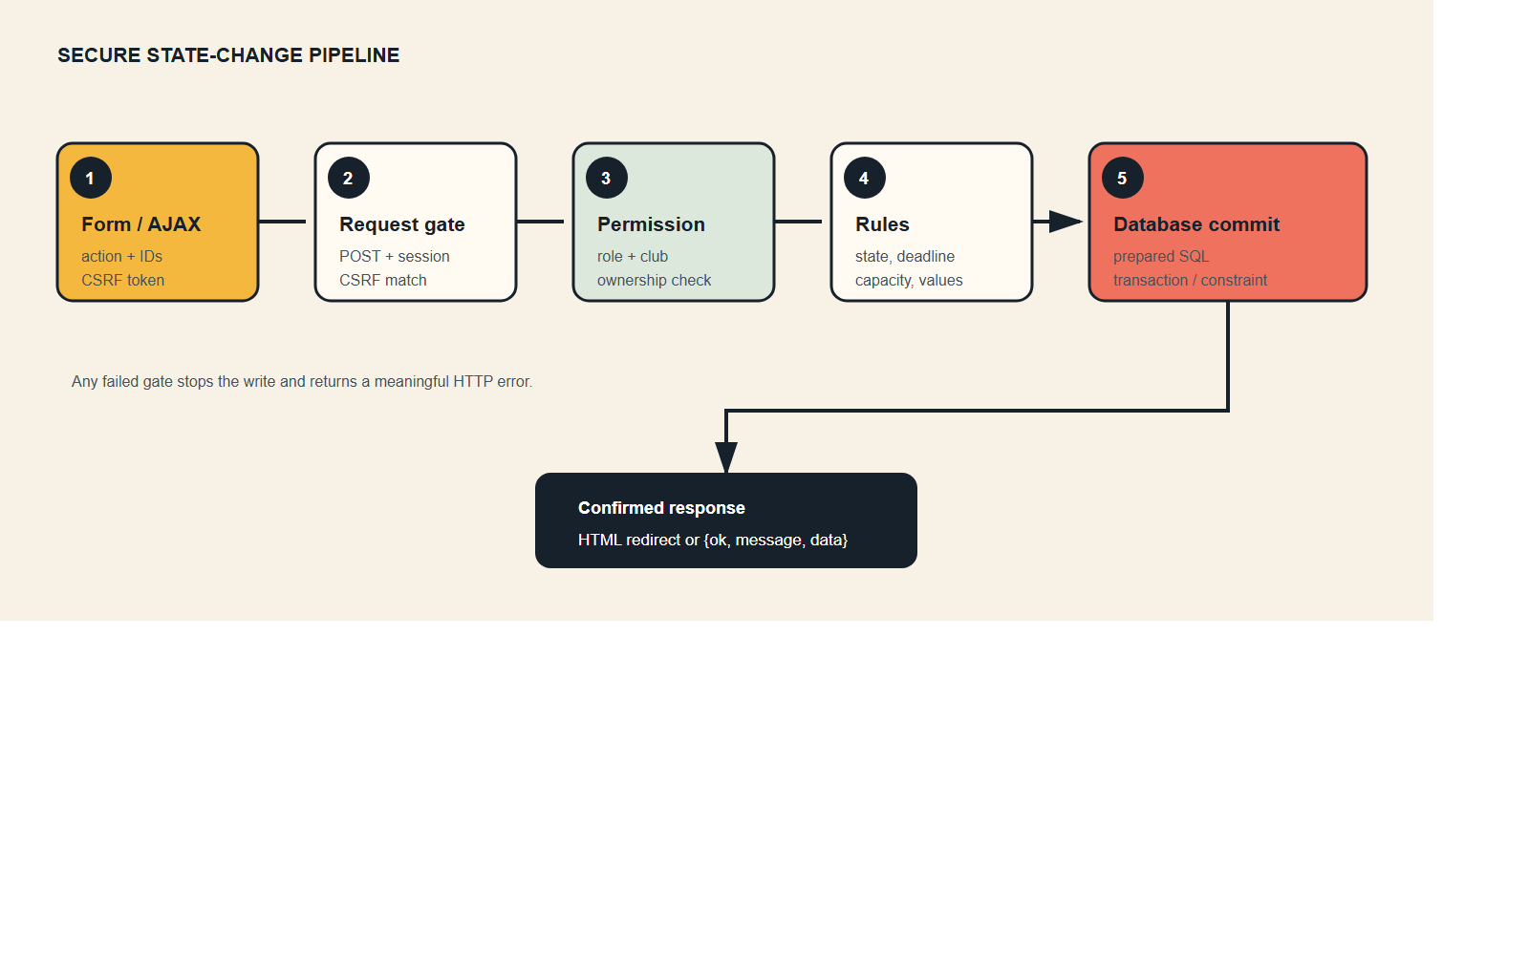
Figure 3. Secure state-change pipeline

Membership request
- Student clicks Request to join on clubs.php.
- JavaScript posts club_id, action, and CSRF token to api/membership.php.
- The endpoint verifies that the session user exists in students.
- It inserts a Pending/Active/Member relationship.
- The unique student-and-club key rejects duplicate requests.
- JSON confirms success and the card changes to Pending.

Executive approval
- Executive opens memberships.php.
- The page lists only clubs returned by the executive membership query.
- Approve posts a membership ID to the API.
- The server obtains the related club ID.
- can_manage_club() checks authority for that club.
- Only then is the membership changed to Approved and Active.

Event management
- The event editor lists only manageable clubs.
- On save, PHP validates title, date, deadline, and positive capacity.
- Creating inserts an event with its club and creator.
- Editing first checks authority against the event’s stored club.
- Cancelling preserves the event record but changes its status.
- Deleting removes the event; related registrations cascade through the foreign key.

4.5 Files to know
- clubs.php - club listing, filtering, join request, club create/update
- memberships.php - personal status and executive management table
- events.php - event discovery and authorized event CRUD
- api/membership.php - AJAX membership operations
- includes/functions.php - executive role list and can_manage_club()
- assets/app.js - live filters and AJAX interface updates

4.6 Recommended live demonstration
- Log in as an executive student.
- Open Clubs and demonstrate instant search/category filtering.
- Open Memberships and show the club-specific member queue.
- Approve a pending member; explain that the row changes only after JSON success.
- Change a member role and explain club-scoped executive authority.
- Open Events and create a new event for the assigned club.
- Attempt to explain why another club is not manageable.
- Edit the event, then cancel it rather than deleting it to demonstrate status preservation.

4.7 Likely viva questions and answers
Why is executive not stored in `users.role`?
Executive authority is club-specific. A global role would incorrectly give the person access to every club. The membership relationship captures a different role for each club.
How do you prevent a student from joining the same club twice?
The application checks the action, while the database enforces a unique composite key on student and club. The database remains the final protection against concurrent duplicate requests.
What prevents one executive from editing another club?
Every write calls can_manage_club() using the target club ID. It verifies an approved and active executive membership for that exact club.
Why cancel an event instead of deleting it?
Cancellation preserves history and lets registrations or notifications reference the event. Deletion is reserved for mistakes or administrative cleanup.

4.8 Schema-ready / next phase
- Event poster upload processing (the path column and display are ready)
- Club logo upload processing
- Full gallery upload CRUD
- Rich registration-list export
- Attendance-management screen for club executives

5. Rifat Mahmud - Event Registration and Participation Lifecycle

5.1 Individual feature statement
“My feature area safely connects students to events. It validates event status, deadlines and capacity, creates a unique QR token, supports cancellation and re-registration, and feeds each confirmed event into the student dashboard.”
The working independent feature is event registration and cancellation. Attendance and certificates are normalized and ready for the next implementation phase.

5.2 Implemented now
- Browse database-backed events
- Search by event, club, venue, or category
- Category filtering
- Grid/list view with remembered browser preference
- Live capacity counts and indicators
- Registration deadline validation
- Maximum-capacity validation
- Cancelled/non-upcoming event validation
- Student-only registration
- Duplicate-safe registration and reactivation after cancellation
- Cryptographically unpredictable 64-character QR token generation
- Registration cancellation with stored reason
- Transactional registration and row locking
- Student dashboard list of confirmed upcoming events
- Progressive AJAX registration/cancellation with normal form fallback

5.3 Tables owned or heavily used

event_registration
This is the central associative entity between students and events.
Column | Purpose
registration_id | Stable primary key
student_user_id | Registered student
event_id | Selected event
registration_status | Registered, Cancelled, Attended, or Absent
qr_token | Unique token used by later attendance workflow
cancellation_reason | Audit detail for cancellation
updated_at | Last state-change timestamp

Downstream participation tables
- attendance has at most one row per registration.
- certificate has at most one row per attendance.
- feedback has at most one row per registration and requires attended participation by business rule.
This creates a traceable chain from person to event to attendance to certificate.

5.4 Transaction and concurrency flow
Registration is deliberately transactional:
- Begin a database transaction.
- Verify the current account is a student.
- Select the event and count active registrations using FOR UPDATE.
- Reject missing or non-Upcoming events.
- Reject an expired registration deadline.
- Reject an event at maximum capacity.
- Generate a SHA-256 token using student ID, event ID, and random bytes.
- Insert the registration, or reactivate the existing cancelled relationship.
- Commit only after every check succeeds.
- Roll back if any validation or database operation fails.
FOR UPDATE matters when two students attempt to take the final available place simultaneously. Locking serializes the capacity decision inside the transaction.

5.5 Cancellation and re-registration design
Cancellation updates the existing row rather than deleting it. This preserves registration history and the cancellation reason. If the student later registers again while the event is eligible, the composite unique key routes the operation to ON DUPLICATE KEY UPDATE, which restores Registered status, creates a new QR token, and clears the cancellation reason.

5.6 Files to know
- events.php - event UI and accessible server-side fallback
- api/event-registration.php - transactional AJAX endpoint
- dashboard.php - student’s confirmed upcoming events
- assets/app.js - registration button/count state changes
- database/schema.sql - registration, attendance, and certificate relationships

5.7 Recommended live demonstration
- Log in as an ordinary student.
- Open Events and switch between grid and list views.
- Search for a venue or filter by category.
- Register for an Upcoming event and show the count increment without page reload.
- Open Dashboard and show that the event appears in Upcoming.
- Return and cancel the registration; show the count decrement.
- Explain the saved Cancelled row and cancellation reason.
- Explain the deadline/full/cancelled validation cases using the event card fields and code flow.

5.8 Likely viva questions and answers
Why use a transaction?
Capacity checking and registration insertion must succeed as one unit. Otherwise two users could both observe the same final place and exceed capacity.
How are duplicate registrations prevented?
The composite unique key on student and event allows only one relationship row. Re-registration updates a cancelled row rather than creating another.
Is the QR token a QR image?
No. It is the secure unique payload that a QR image can encode. Storing the token separately keeps presentation generation independent of database identity.
Why keep cancelled registrations?
It preserves audit history, supports a cancellation reason, and allows controlled reactivation without duplicate records.
What happens without JavaScript?
The normal form submits to events.php, which executes the same core checks and redirects with a flash message.

5.9 Schema-ready / next phase
- Registration detail/history page
- QR image rendering and scanning interface
- Manual and QR attendance screens
- Attendance eligibility enforcement in UI
- Certificate file generation/download
- Reminder creation through notifications

6. Faisal Mahbub - Dashboards, Notifications, Reporting, and Engagement

6.1 Individual feature statement
“My feature area turns relational data into useful role-aware information. The same dashboard recognizes students, club executives, and administrators, then displays the statistics, alerts, queues, and actions appropriate to their authority.”
The implemented independent feature is the role-aware live dashboard and engagement presentation. Notifications are read and displayed from the database. Advanced feedback CRUD, leaderboard formulas, and full reports remain next-phase modules.

6.2 Implemented now
- Role-aware Student, Executive, and Administrator dashboard branches
- Real database statistics rather than hard-coded totals
- Student upcoming-registration agenda
- Student membership total
- Latest user notifications with read/unread state
- Executive assigned-club count
- Executive pending membership queue
- Executive event capacity snapshots
- Administrator user, club, registration, and event totals
- Administrator club moderation queue
- Homepage database statistics, upcoming stories, activity, and calls to action
- Animated statistics, reveal motion, toast feedback, and reduced interface friction
- Seeded announcements and notifications for demonstration

6.3 Dashboard role decision
The dashboard calculates three conditions:
- is_admin() checks the global Admin role.
- An executive query checks for approved, active executive memberships.
- If neither condition is true, the user receives the student dashboard.
Priority is Admin, then Executive, then Student. This ensures an administrator sees system-wide controls even if related data exists elsewhere.

6.4 Data aggregation examples

Student view
- Counts approved and active memberships for the logged-in user.
- Joins registration, event, and club to show the user’s upcoming Registered events.
- Queries notifications by recipient and orders newest first.

Executive view
- Determines all clubs the user can manage.
- Uses those club IDs in parameterized IN queries.
- Finds Pending membership requests for those clubs.
- Left-joins event registrations to display event capacity and registration volume.

Administrator view
- Counts all users.
- Counts Active clubs and Pending clubs.
- Counts active registrations and current events.
- Retrieves non-Active clubs for the moderation queue.
These are derived reports. They are calculated from source tables rather than stored as duplicate totals, avoiding stale data.

6.5 Notifications and announcements model
notification belongs to exactly one recipient user and stores message, type, timestamp, and read state. This supports an in-application inbox without email or SMS.
announcement has one publisher and an optional club:
- club_id = NULL represents a system-wide announcement.
- A club ID represents a club-specific announcement.
- Expiry and status determine whether it should remain active.
The current seed data and dashboard demonstrate reading notifications. Full announcement publishing and notification state-management pages are planned.

6.6 Files to know
- dashboard.php - all three role-aware dashboard branches
- index.php - public statistics and active campus content
- database/seed.sql - demonstration announcements and notifications
- database/schema.sql - notification, announcement, and feedback models
- assets/app.js - number animation, reveal motion, and toast messages
- assets/style.css - role-neutral editorial design system

6.7 Recommended live demonstration
Use separate browser sessions or log out between accounts.
- Log in as a Student and show memberships, upcoming events, and notifications.
- Log in as an Executive and show assigned clubs, pending members, and event capacity.
- Log in as Administrator and show system totals and moderation queue.
- Explain that the page is one controller with role-aware data branches, not three duplicated dashboards.
- Return to Home and explain that statistics are queried from the live database.

6.8 Likely viva questions and answers
Why calculate reports instead of storing them?
Counts and rankings change whenever source records change. Calculating them prevents duplicated, stale values and follows normalization principles.
How does the dashboard know someone is an executive?
It queries membership records for Approved, Active status and an executive role. Authority is derived from the relationship, not only from the user account.
Why is `club_id` optional in announcements?
A system notice applies to everyone and has no single club. A club notice needs a club foreign key.
What is the difference between an announcement and a notification?
An announcement is published content for an audience. A notification is a recipient-specific message stored for one user.
How would the leaderboard work without a table?
An aggregate SQL query groups by club and calculates a score from event count, attendance, and average rating. The ranking is a derived report, not permanent data.

6.9 Schema-ready / next phase
- Notification inbox and mark-as-read actions
- Announcement create/update/expiry management
- Feedback and rating submission/moderation
- Rule-based event recommendations from student interests
- Active-club leaderboard query and view
- Complete administrative reports and export
Suggested leaderboard formula from the specification:
Activity Score = (Number of Events × 5)
+ Total Attendance
+ (Average Rating × 10)

7. Cross-feature integration
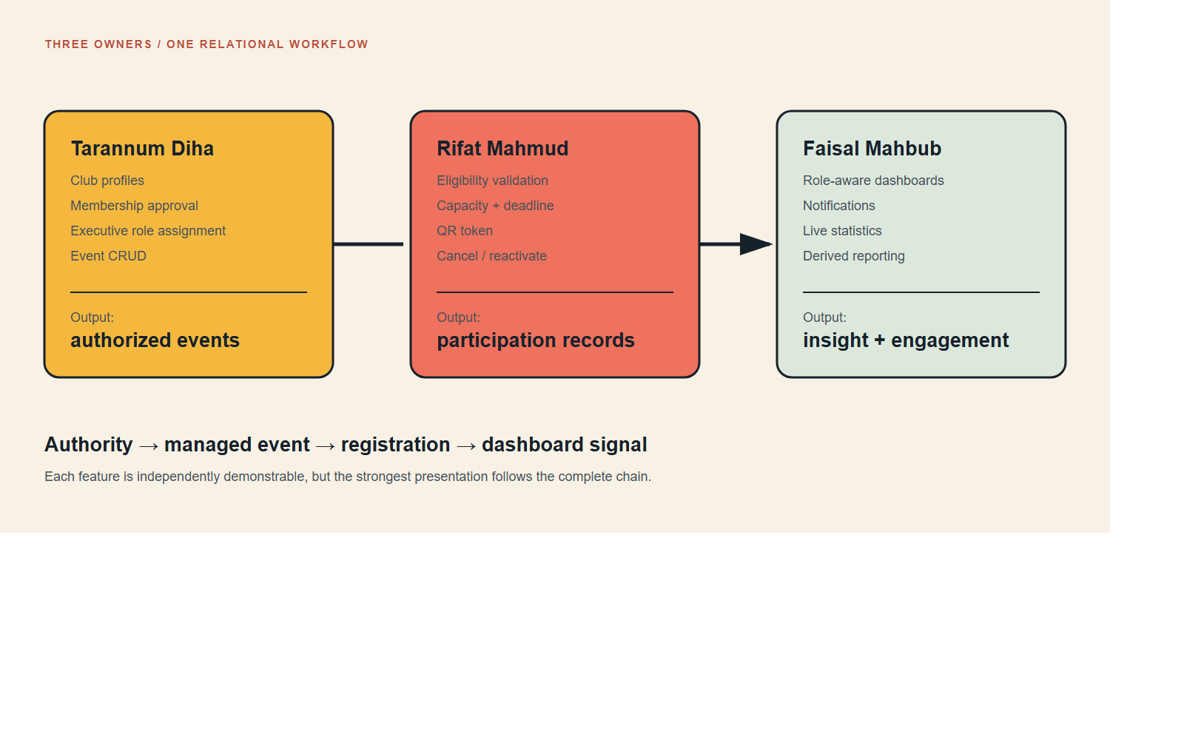
Figure 4. Three feature owners, one integrated workflow
No member’s feature is isolated from the database workflow:
- Diha’s membership system grants a club-specific executive role.
- That authority allows an executive to create an event.
- Rifat’s registration system allows eligible students to register for that event.
- Registration data appears on the student and executive dashboards.
- Future attendance changes the registration to Attended or Absent.
- Present attendance enables certificates and feedback.
- Faisal’s engagement/reporting system summarizes registrations, notifications, ratings, and club activity.
This is the project’s strongest integration story: authorization creates managed events, events create participation records, and participation records become engagement and reports.

8. Current feature-status matrix
Module | Database | Working UI | CRUD/action coverage | Owner
Authentication | Yes | Yes | Signup/login/logout | Shared
Club profiles | Yes | Yes | Create/read/update | Diha
Memberships | Yes | Yes | Request/approve/reject/remove/role | Diha
Events | Yes | Yes | Create/read/update/cancel/delete | Diha
Event registration | Yes | Yes | Register/cancel/reactivate | Rifat
Attendance | Yes | Not yet | Schema-ready | Rifat
Certificates | Yes | Not yet | Schema-ready | Rifat
Notifications | Yes | Dashboard read | Read display | Faisal
Announcements | Yes | Seed/home content | Read display | Faisal
Feedback | Yes | Not yet | Schema-ready | Faisal
Recommendations | Derived | Limited dashboard context | Next phase | Faisal
Leaderboard/reports | Derived | Dashboard summaries | Partial | Faisal

9. Demonstration preparation

9.1 Reset predictable demo data
For a clean demonstration, import database/schema.sql followed by database/seed.sql in phpMyAdmin. This recreates the schema, so do it only when replacing the current demo database is acceptable.

9.2 Seeded accounts
Persona | Email | Password | Useful demonstration
Executive student | amina@student.edu | Password123! | Computing Club President
Student | nafis@student.edu | Password123! | Registration and membership request
Administrator | admin@campus.edu | Admin123! | Admin dashboard and all-club authority

The legacy demo addresses remain usable for login. Newly created student accounts must use @g.bracu.ac.bd.

9.3 Suggested presentation order
- Shared introduction: problem, roles, technology, and normalized model.
- Diha: club membership authority followed by event creation.
- Rifat: register for the newly created event, show capacity and dashboard.
- Faisal: show role-aware dashboards and explain how the actions became statistics/alerts.
- Shared conclusion: security, progressive enhancement, future modules.

9.4 Before presenting
- Start Apache and MySQL in XAMPP.
- Confirm the app URL works.
- Confirm seed accounts can log in.
- Use a wide browser window for the main demo, then briefly resize for responsiveness.
- Avoid changing seed passwords immediately before the presentation.
- Keep phpMyAdmin open on a second tab to show tables and relationships.
- Rehearse both successful operations and one rejected business-rule case.

10. General viva reference

What normal form is the schema?
The relational design is intended to satisfy Third Normal Form. Repeating groups such as interests and gallery images are separated into child tables. Many-to-many relationships use associative tables. Non-key facts describe their table’s key and are not duplicated across unrelated entities.

Why use foreign keys?
Foreign keys prevent orphan records and express ownership. Cascades remove dependent records where the parent no longer exists, while SET NULL preserves attendance if the executive membership that marked it is later removed.

Why use both PHP and database validation?
PHP produces friendly business-rule errors. Database constraints provide the final integrity guarantee, including when simultaneous requests occur or another client bypasses the browser.

What is progressive enhancement?
The base feature works with ordinary HTML forms and server redirects. JavaScript upgrades it to inline updates and toast feedback. Accessibility and reliability do not depend on JavaScript.

What makes the interface dynamic?
The pages use live database counts, instant search and filters, remembered event view preference, asynchronous actions, capacity updates, role-specific dashboards, intersection-based motion, and clear success/error feedback.

What are the main HTTP/API failure statuses?
- 400 - unknown or malformed action
- 401 - user is not signed in
- 403 - signed-in user lacks permission
- 405 - wrong request method
- 409 - business conflict such as duplicate/full/expired registration
- 419 - expired or invalid CSRF token
- 422 - invalid submitted role/value

11. Source map
Path | Purpose
database/schema.sql | Complete normalized database definition
database/seed.sql | Mock users, clubs, memberships, events, and activity
docs/campus_club_hub_normalized.drawio | Visual normalized schema
includes/bootstrap.php | Shared startup/session/database loading
includes/functions.php | Security, role, authorization, and output helpers
signup.php / login.php | Authentication
clubs.php | Club discovery and management
memberships.php | Membership and executive-role management
events.php | Event discovery, registration fallback, and event CRUD
dashboard.php | Student/executive/admin dashboard
api/membership.php | Membership JSON actions
api/event-registration.php | Transactional registration JSON actions
api/_json.php | JSON, authentication, method, and CSRF contract
assets/app.js | Dynamic browser behavior
assets/style.css | Responsive editorial design system
install.bat | XAMPP discovery, deployment, database setup, and launch

12. Ownership summary cards

Tarannum Diha
Showcase: club-specific membership authority and event management.
Best proof: approve a member, assign a role, and create/edit an event.
Core concept: authorization derived through an associative entity.

Rifat Mahmud
Showcase: safe event registration and cancellation.
Best proof: register inline, watch capacity change, verify Dashboard, then cancel.
Core concept: transactional enforcement of uniqueness, deadline, and capacity.

Faisal Mahbub
Showcase: one role-aware dashboard driven by relational aggregates.
Best proof: compare Student, Executive, and Administrator views.
Core concept: live derived information without duplicating report data.

