TECHNICAL REPORT
SHORIR AI
Bangla-First Privacy-Aware Fitness Intelligence

Prepared by Team El Bracino
Mindsparks 26 CodeFront Challenge | AUST Innovation and Design Club
26 June 2026

Executive Summary
SHORIR AI is a Bangla-first fitness companion that combines browser-side pose analysis, a bilingual exercise library, personalized workout planning, Bangladeshi diet guidance, image-based calorie review, progress diagnostics, and a guided demo flow in one coordinated product.
CORE DESIGN DECISION
When pose tracking is uncertain, the system pauses and explains why. It prioritizes missed repetitions over false repetitions.

The system uses a React and Vite frontend, an Express API, shared TypeScript contracts, and ports-and-adapters boundaries for MediaPipe, persistence, and AI services. The refreshed interface uses compact navigation, shadcn-style local primitives, tabbed secondary detail, and a white-blue visual system with dark mode. Raw live pose video remains in the browser. Phone video uses encrypted WebRTC, with the API handling temporary signaling metadata.

1. Problem and Local Context
Generic fitness applications often assume English fluency, prior knowledge of exercise form, stable camera placement, and access to globally common foods. These assumptions reduce usability for beginners in Bangladesh.
- Beginners need direct setup, movement, depth, and safety cues.
- False repetition counts damage trust and can reinforce poor form.
- Workout, food, calorie, and progress tools are commonly fragmented.
- Live camera upload creates avoidable privacy and bandwidth costs.
- Diet guidance should recognize familiar Bangladeshi meals and portions.

2. Product Scope
Module | Implemented capability
Daily dashboard | Profile-aware workout plan using goals, schedule, equipment, safety flags, and recent sessions.
Pose Coach | Strict squat, push-up, and forward-lunge analysis with calibration and diagnostics.
Exercise library | Bilingual guides, filters, demonstrations, safety cues, and live-coach links.
Diet Chart | Bangladeshi meal template scaled to profile-based calorie and macro targets.
Calorie Check | Desktop upload and QR/phone capture with cautious structured meal review.
Progress | Saved sessions, review history, and detection-quality diagnostics.
Demo | First-time judging walkthrough, presenter script, and acceptance checks.
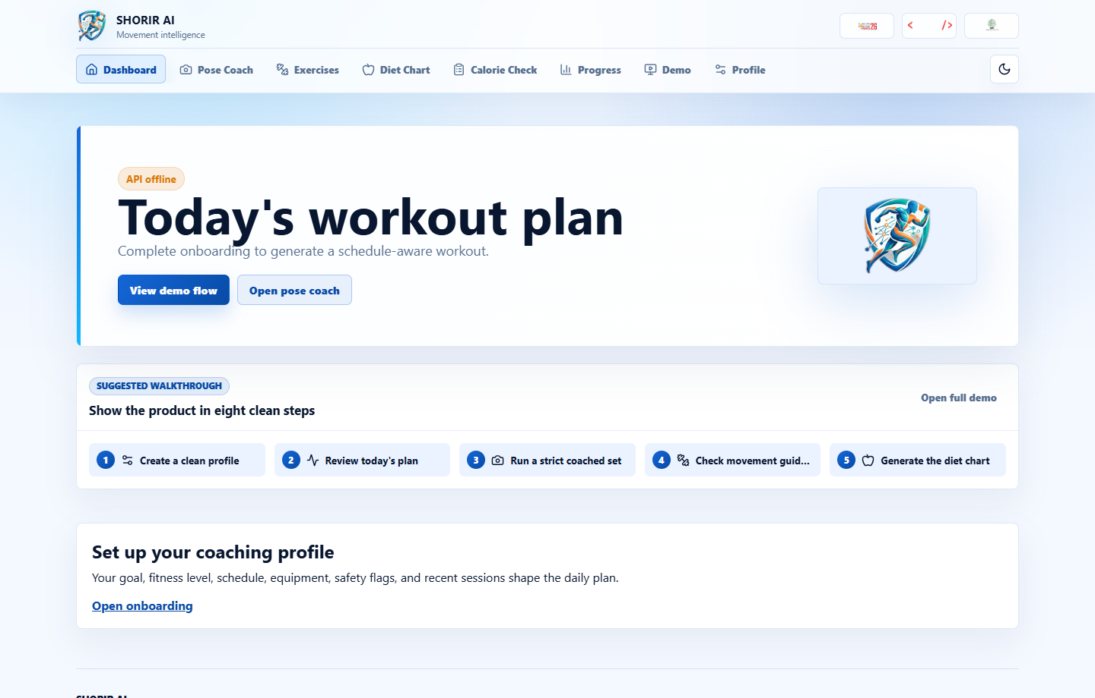
Figure 1. Coordinated dashboard with light theme and competition branding.

3. User Experience and Visual System
The release interface uses a semantic white and blue palette, a fully functional dark mode, compact icon navigation, consistent eight-pixel-or-less radii, thin borders, and responsive layouts. The visual direction adapts the reference design's disciplined grid, whitespace, and restrained controls to an operational fitness product.
- Light and dark themes persist locally and respect the initial system preference.
- Mindsparks 26, CodeFront, and AUST IDC assets appear in the shared product frame.
- Dense workflows use stable grids and independent scrolling where appropriate.
- Mobile navigation prioritizes icons while preserving accessible names and tooltips.
- No route is reduced to a marketing page; the first screen remains a usable product.

3.1 Demo Sequence
The live product now includes a dedicated /demo route. It replaces the earlier placeholder presentation/report tabs with a practical first-time walkthrough, presenter script, and acceptance checklist.
Step | Route | Purpose
1 | /onboarding | Create a clean profile.
2 | / | Review today's plan and shortcuts.
3 | /coach?exercise=squat | Show strict live rep coaching.
4 | /exercise-library | Open movement guidance.
5 | /diet-chart | Generate local diet guidance.
6 | /calorie-check | Review calories from desktop or phone capture.
7 | /progress | Close with saved session diagnostics.
8 | /about-competition | Show submission package.
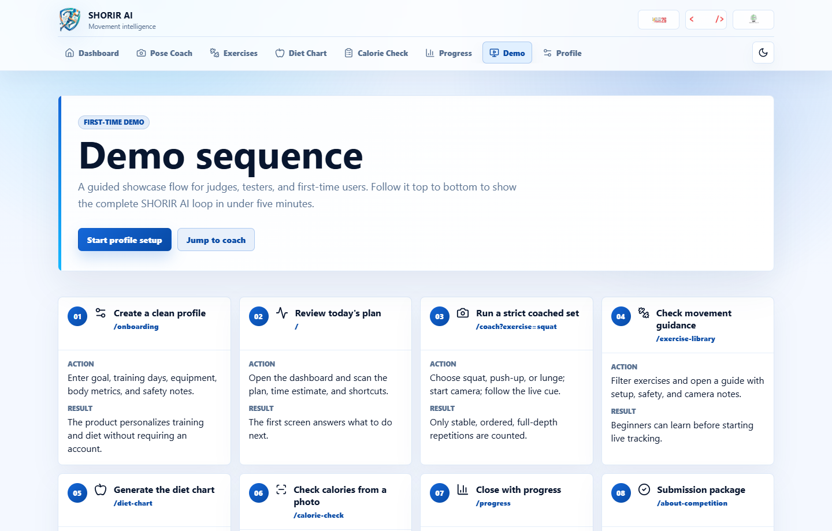
Figure 2. First-time demo sequence with walkthrough, presenter script, and acceptance checks.

4. System Architecture
SHORIR AI is a PNPM TypeScript monorepo. Shared contracts keep browser and API wire shapes aligned, while ports isolate external technology choices.
Layer | Technology | Responsibility
Web | React 19, Vite | Routes, workflows, local session state, camera UI, and rendering.
Pose | MediaPipe Tasks Vision | Browser-side landmark estimation and local analysis.
API | Express | Profiles, sessions, coach reviews, meal reviews, and signaling.
Contracts | TypeScript package | Shared request, response, and domain shapes.
Persistence | Memory / Supabase | Demo storage or persistent production storage.
AI | Stub / Gemini adapter | Deterministic development output or configured AI review.
- The browser creates a persistent anonymous profile identifier.
- Onboarding stores goals, fitness level, equipment, schedule, body metrics, and safety notes.
- Pose landmarks are estimated and analyzed locally; only derived session summaries are saved.
- Meal images are submitted only for an explicit review request.
- Progress aggregates saved sessions and diagnostic metadata for the same profile.

5. Pose Detection and Rep Validation
The original angle-threshold approach was replaced by a conservative temporal state machine. A repetition can advance only while the quality gate remains valid.

5.1 Quality Gate
- Required landmark confidence average of approximately 0.68 or higher.
- Several consecutive valid frames before calibration or repetition logic advances.
- Body-scale stability to reject meaningful camera-distance changes.
- Landmark jitter checks to reject unstable tracking.
- Exercise-specific orientation, side consistency, and activity-region checks.
- Immediate repetition reset when quality fails mid-repetition.

5.2 Temporal State Machine
A valid repetition follows a stable top posture, controlled descent, confirmed bottom or depth, controlled ascent, and stable top lockout. Minimum duration, bottom confirmation, and cooldown rules prevent rapid or duplicated counts.
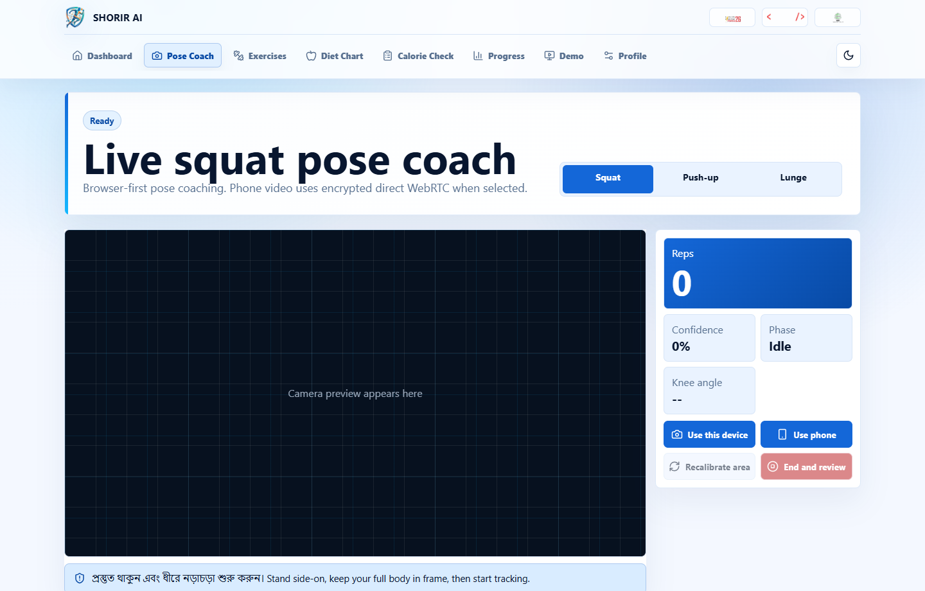
Figure 3. Live squat coach with activity stage, compact readout rail, and hidden detail tabs.

6. Exercise-Specific Rules
Exercise | Primary validity rules
Squat | Shoulder, hip, knee, and ankle visibility; side view; knee-angle depth; standing reset.
Push-up | Shoulder, elbow, wrist, hip, and ankle visibility; plank line; wrist alignment; elbow depth; top lockout.
Forward lunge | Split stance, alternating balance, controlled knee depth, stable return, and side-aware calibration.
DEPTH LIMITATION
This is monocular tracking. Depth means relative MediaPipe z and body-scale estimation, not physical depth-sensor measurement.

7. Nutrition and Meal Review
The diet chart calculates an estimated target from age, gender, height, current weight, and target weight when those values are available. It then scales familiar meal templates across breakfast, lunch, and dinner. Without complete body metrics, the system provides a more general fitness-level estimate.
- Local meal images and portions improve recognizability.
- Calorie and macro values are planning estimates, not clinical prescriptions.
- The calorie-check workflow supports desktop upload and QR-based phone capture.
- The AI response is structured and cautious, with uncertainty and next-step guidance.
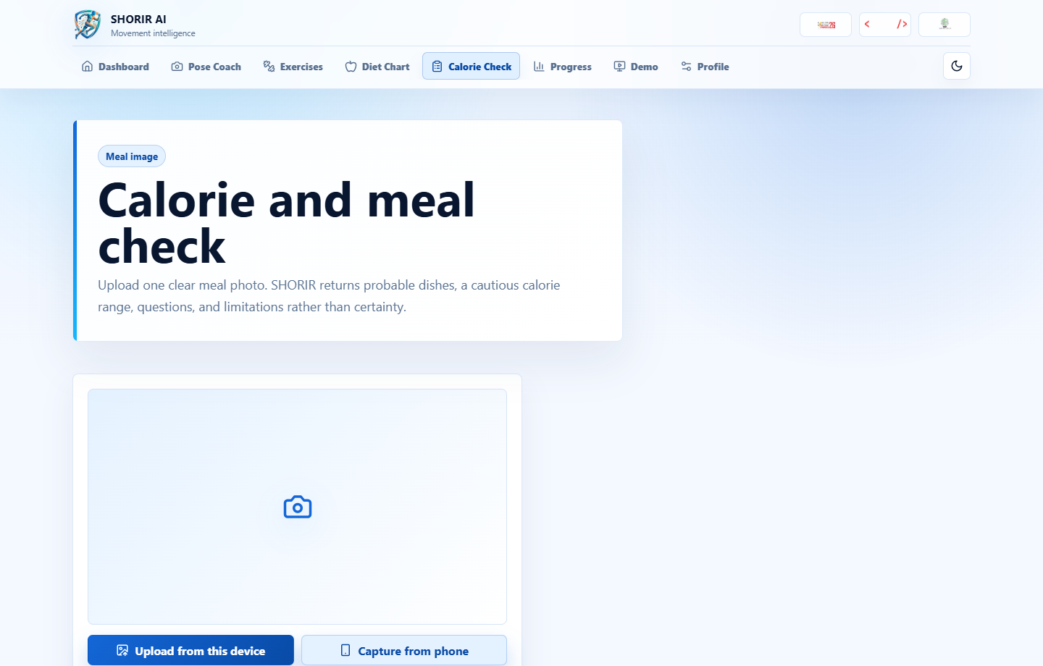
Figure 4. Calorie-check workflow with desktop and phone-capture entry points.

8. Privacy, Safety, and Ethics
- Raw pose frames are not uploaded to the API.
- Phone pose video travels through encrypted peer-to-peer WebRTC when available.
- The API stores temporary signaling metadata, not continuous video.
- Safety flags influence workout guidance and are visible in the interface.
- The product does not diagnose injury or replace medical or nutritional professionals.
- Users are instructed to stop when movement causes pain.

9. Verification
The repository includes unit tests for daily planning, exercise content, camera geometry, coaching language, pose analysis, and progress diagnostics. The release gate runs type checking, linting, unit tests, and production builds across the monorepo.
Acceptance scenario | Expected result
Five valid squats | Exactly five repetitions; no duplicates.
Five valid push-ups | Exactly five repetitions; no extras.
Arm waving or walking | Zero repetitions.
Partial crouches | Zero squat repetitions.
Plank shifting or hip sag | Zero push-up repetitions.
Camera movement | Repetition resets and UI explains the pause.

10. Deployment and Operations
The production configuration builds the full monorepo and starts the Express API. In production, Express serves the compiled Vite application and provides a single-page fallback for deep links. The API health endpoint at /api/health is used for Railway health checks.
- Runtime: Node.js 20 or later and PNPM 9.
- Railway configuration: Railpack builder, root build, root start, health check, and restart policy.
- Default demo adapters: in-memory persistence and deterministic stub AI.
- Production persistence option: Supabase with environment configuration.
- Production AI option: Gemini using API key or application-default credentials.

11. Limitations and Future Work
- Broader real-device calibration is required across body shapes, clothing, lighting, and camera placements.
- Monocular body scale cannot provide true physical depth.
- WebRTC reliability at scale requires TURN and shared signaling storage.
- The memory database resets when the service restarts.
- Meal recognition quality depends on the configured AI adapter and image quality.
- Future safety guidance should be reviewed with qualified fitness and health professionals.

12. Repository and Submission
Deliverable | Location
Live website | https://shorir-ai-production.up.railway.app
Demo sequence | deliverables/SHORIR_AI_Demo_Sequence.md
Demo video | deliverables/SHORIR_AI_Demo_Walkthrough.mp4
Project presentation | deliverables/SHORIR_AI_Project_Presentation.pptx
Technical report | deliverables/SHORIR_AI_Technical_Report.docx
Source code archive | deliverables/SHORIR_AI_Source_Code.zip
Source code is organized under apps/web, apps/api, packages/contracts, packages/content, supabase, docs, and delegated contributor packages. Secrets, dependency folders, generated builds, and local environment files are excluded from the source archive.

