Popov Matvey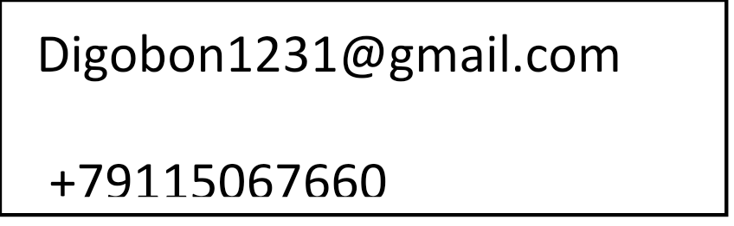

*Junior Python Developer*

**TECHNOLOGIES COURSES LANGUAGES**

Python Python: Basics and applications English B2

OOP Python Generation Russian (Native)

Selenium Udemy – Full Python3 Course

C# course

Linux Course(mail.ru)

**ADDITIONAL COURSES**

PHP - first acquaintance

Bash scripting

**EXPERIENCE**

**Technical laboratory “KGTU” -** Development of a door lock for a laboratory that can only be accessed by a key card. I was developing the design of the door lock and accompanied the team in technical terms

October 2021 – Today

**Hackathon -** <https://github.com/AlfaGustaf/AlfaEco> . The project is dedicated to the global problem associated with the disposal of waste of the first and second hazard class

November 2021

**EDUCATION**

**Kaliningrad State Technical University “KGTU”,** Institute of Digital Technologies, Computer science and engineering.

September 2021 – Today