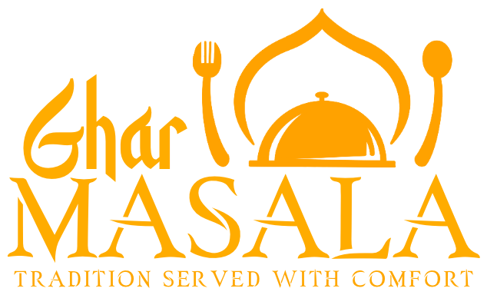 | حلال HALAL  TIVIDALE · OLDBURY · FRESH TO ORDER  NEW CUSTOMERS 25% OFF  your first order online
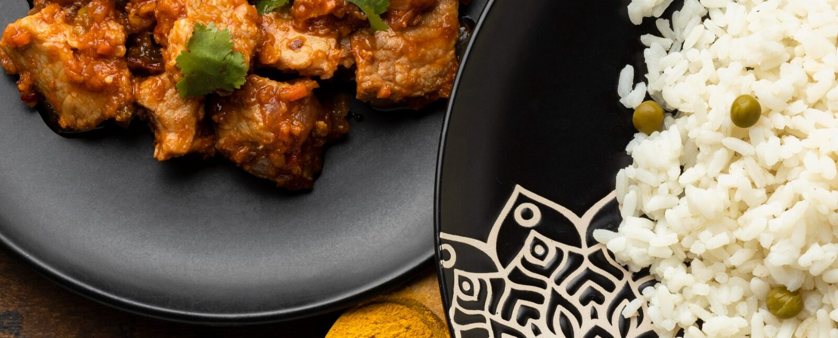
Good food starts in the Kitchen.
Home-cooked Bangladeshi & Indian curries, made the way they are at home — cooked fresh on the day, with no base sauce, and delivered to your door.
15 min  DELIVERY WINDOW | £10  MINIMUM ORDER | Free  DELIVERY WITHIN 2 MILES

How to order  1 Choose your dishes  Browse the menu online and pick your spice level.  2 Book a delivery slot  Pre-order for the evening you want — we cook to booked slots.  3 We cook it fresh & deliver  Everything is cooked on the day and brought to your door within a 15-minute window.  Why pre-order? Because we shop and cook for your order on the day — spices blended here, meat marinated overnight, nothing held over. That is how home cooking tastes. | SCAN TO ORDER    ghar-masala.co.uk  or call / WhatsApp  07497 601572

●●●●●●●●● 50%
Your 10th order is 50% off
Create a free account at ghar-masala.co.uk — every order of £20 or more earns a stamp. Collect nine and your 10th order is half price (or save it for later).

WE DELIVER TO  Tividale · Oldbury · Tipton · Dudley Port · Great Bridge · Rowley Regis · Burnt Tree — free within 2 miles, up to 3 miles from Tividale | Instagram @ghar.masalaa  Facebook: Ghar Masala

Our Menu
HOME-STYLE · COOKED FRESH · HALAL

STARTERS  Served with salad & mint sauce  Vegetable Samosas (V) £3.95  Golden, crisp pastries generously filled with gently spiced vegetables, fried until perfectly flaky and satisfying.  Lamb Samosas £3.95  Crispy pastry parcels filled with seasoned minced lamb, rich in flavour and comforting in every bite.  Chicken Tikka Spring-Rolls ● ★ £4.45  Crisp golden rolls filled with our spiced chicken tikka, fried until flaky and satisfying.  Chicken Tikka £4.95  Tender chicken pieces marinated in our flavourful homemade tikka spices, gently cooked with fried onions for extra depth.  Fish Pakora £4.95  Succulent pieces of fish coated in our in-house spiced batter, fried until crisp and golden.  CURRIES  Spice level adjusted on request  Chicken Curry ● ★ SPICE TO ORDER £8.25  Tender, boneless, chicken breast pieces, slow-cooked in a rich, home style curry sauce, balanced with traditional spices for comforting flavour.  Lamb Curry ● ★ SPICE TO ORDER £9.45  Succulent boneless lamb, gently cooked until tender in a hearty, spiced curry sauce full of warmth and depth.  King Prawn Curry ● ★ SPICE TO ORDER £9.95  Juicy king prawns cooked in a fragrant, lightly spiced curry sauce — comforting, rich and perfectly balanced.  Tarka Dhal ★ (V) £6.95  A lentil curry slow-cooked until soft and creamy, finished with a fragrant tarka of garlic, onions and warming spices.  SPICE TO ORDER  Curries can be made as hot as you like — choose when you order:  ● Slightly hot ●● Hot ●●● Madras +30p ●●●● Vindaloo +30p |  | SUNDRIES  Paratha (V) £1.95  Soft, flaky flatbread, freshly cooked and perfect for scooping up curries.  Boiled Rice (V) £3.75  Steamed plain rice, light and fluffy — the perfect base for any curry.  Fried Rice (V) £4.45  Lightly fried rice seasoned for flavour, simple and satisfying.  Chips (V) £3.25  Classic golden chips, freshly cooked and crisp.  Masala Chips ●● ★ (V) £4.95  Crispy chips tossed in warming masala spices for a bold, flavourful twist.  Biran Bread ● ★ (V) £3.95  Traditional street style bread stir-fry with onions and warming spices, finished with fresh coriander for a comforting, savoury bite.  ENGLISH  Served with chips & a can of drink  Chicken Fillet Burger (meal) £7.95  Crispy chicken fillet served in a soft brioche bun with fresh salad and mayo.  Chicken Nuggets & Chips £7.95  Golden, crunchy chicken nuggets and chips served with fresh salad.  Fish & Chips £7.95  Crispy battered cod served with a side of fresh salad.  DRINKS  Coke (can) £1.45  Coke Zero (can) £1.45  Rubicon Mango (can) £1.45  Rubicon Passion (can) £1.45  J2O (orange & passion) £2.95  Water (bottle) £0.89
(V) Vegetarian ★ Chef’s recommendation ●● Spice level All meat is halal
Allergies: Due to the nature of our operations, we cannot guarantee that our dishes are completely free from traces of allergens. Please see the allergen table at ghar-masala.co.uk/allergens or call 07497 601572 before ordering if you have any allergies.

 | Order online at ghar-masala.co.uk  New customers: 25% off your first order online.  Pre-order for an evening delivery slot · £10 minimum order · Free delivery within 2 miles, then £1 per extra mile (up to 3 miles) | CALL OR WHATSAPP  07497 601572

