Lento — UI Spec & Wireframes (v1)
Lebih tenang. Lebih berirama. | Less rush. More rhythm.
Disusun: 25 Dec 2025
Keputusan: Mobile bottom nav 5 tab (Today/Kebiasaan/Jurnal/Space/More) + Space desktop 2-pane (list+editor).

1. Sitemap & Navigasi

1.1 Top-level destinations
- Today — quest otomatis + quick actions + ringkasan.
- Kebiasaan — daftar habit + check-in + streak.
- Jurnal — mode 3 menit & bebas + histori.
- Space — page list + tags + search + editor markdown.
- More — modul tambahan + Settings.

1.2 Perangkat
- Desktop: Sidebar + Topbar (ada SyncIndicator).
- Mobile: Bottom nav 5 tab; Quick Add via FAB/bottom sheet.

2. Layout & Aturan Responsif
- Mobile-first: layout 1 kolom; bottom nav fixed.
- Desktop (>= lg): grid 2-3 kolom di Today; Space 2-pane.
- Space: list pane ~420px; editor fleksibel.

3. Komponen (Design System mini)
- AppShell (Sidebar/BottomNav + Topbar).
- SyncIndicator (Tersinkron/Menyimpan/Offline sementara).
- QuestCard, QuickAddBar (desktop), QuickAddSheet (mobile).
- TagChips, PageList, MarkdownEditor, JournalComposer.

4. Wireframes (Visual)

4.1 Desktop — Today
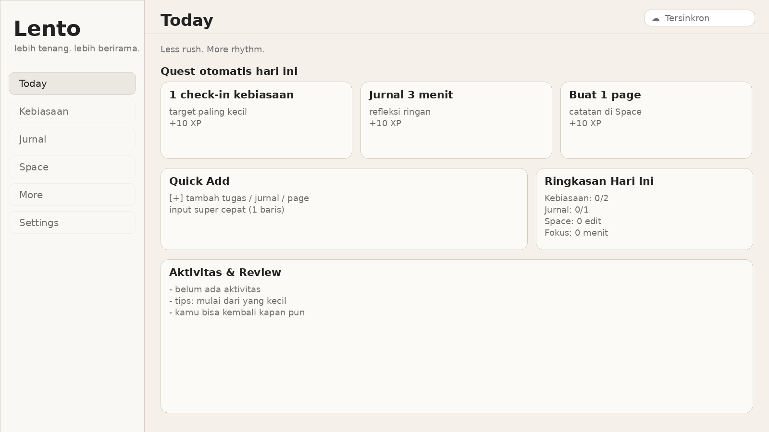

4.2 Desktop — Space (2-pane)
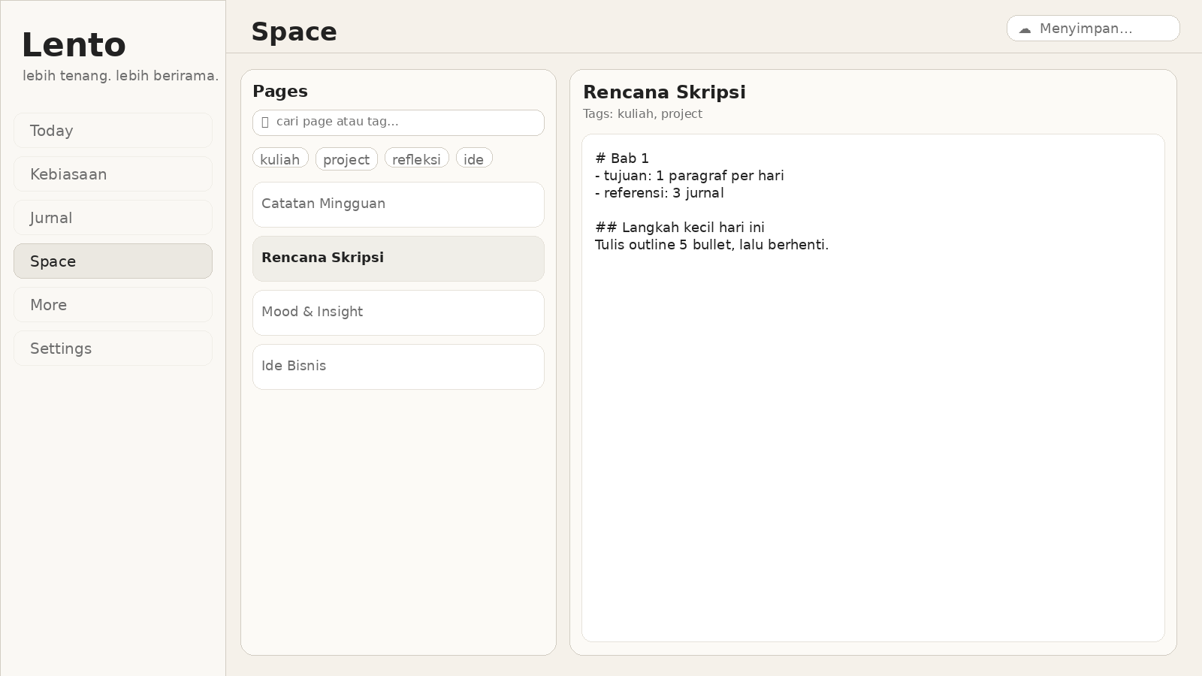

4.3 Mobile — Today
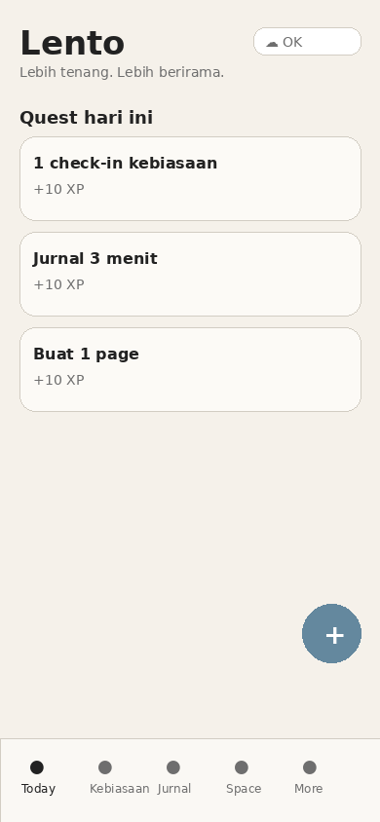

4.4 Mobile — Space
