lab-report1

2025-03-01

## Feb 28

Setting up version control and starting to copy over r functions.

First step: reading in the data file

library(here)

## here() starts at /Users/josephdekel/git_projects/fish-reflectance

here("/Users/josephdekel/Desktop/UCLA/Winter\ 25/SRP\ 199/Week\ 6", "varied_spectra.csv" )

## [1] "/Users/josephdekel/Desktop/UCLA/Winter 25/SRP 199/Week 6/varied_spectra.csv"

df <- read.csv("varied_spectra.csv")

I first created synthetic data that would effectively demonstrate how different patches on fish can be distinguished using hyperspectral measurements. The varied_spectra.csv file was designed to contain five measurements per patch type, simulating natural variation while maintaining distinct spectral signatures and characteristic spectral patterns that mirror biological reality.

Function to calculate the spectral angle:

# Calculating spectral angle between two spectra (x and y)  
calc_spectral_angle <- function(x, y)   
{  
 sum_xy <- sum(x * y)   
 sum_x2 <- sum(x^2)   
 sum_y2 <- sum(y^2)  
 alfa <- acos(sum_xy / sqrt(sum_x2 * sum_y2))  
 return(alfa) # Returning angle in radians  
}

The code implementation centres around the spectral angle calculation function, which implements the formula from the paper: α = cos⁻¹(ΣXY/√(Σ(X)²Σ(Y)²)). This calculation is crucial for identifying the most representative measurement for each patch type by finding the measurement closest to the mean. The function returns angles in radians, providing a standardized measure of similarity between spectra.

First Plot:

# Creating first plot (initialized with first measurement)  
plot(df[,1], df[,2], # Plotting wavelength (col 1) vs first measurement (col 2)   
 type="l", # Line plot  
 ylim=c(0,100), # Y-axis from 0 to 100%  
 xlab="Wavelength (nm)",   
 ylab="Reflectance (%)",  
 main="Patch Measurements and Means")  
  
# Defining colors and patch names for plotting  
colors <- c("black", "blue", "orange", "gray") # Colour for each patch  
patches <- c("black", "blue", "orange", "white") # Names of patches  
  
# Ploting all individual measurements for each patch  
for(patch in patches)   
{  
 patch_cols <- grep(patch, names(df)) # Finding all columns for this patch  
 for(col in patch_cols) # Loop through each column of this patch  
 {  
 lines(df[,1], df[,col], # Adding line for each measurement  
 col=colors[which(patches == patch)]) # Using corresponding colour  
 }  
}  
  
# Calculating & plotting mean spectra  
means <- data.frame(wavelength = df[,1]) # Creating dataframe for means  
for(patch in patches)   
{  
 patch_cols <- grep(patch, names(df)) # Finding columns for this patch  
 means[[patch]] <- rowMeans(df[,patch_cols]) # Calculating mean spectrum  
 lines(df[,1], means[[patch]], # Plotting mean as thicker line  
 col=colors[which(patches == patch)],   
 lwd=3)   
}  
  
# Legend for first plot  
legend("topleft", patches, col=colors, lwd=2)

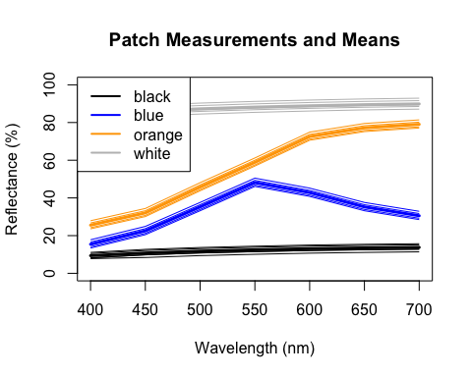 The plot displays all measurements and means, with individual measurements shown as thin lines and means as thicker lines in corresponding colours. This visualization demonstrates the variation within patches while maintaining clear distinction between patch types.