RAILSYNC
Internal Hackathon Frontend Prototype
End-to-End Build Specification — Next.js + Mock Data + Mock Responses
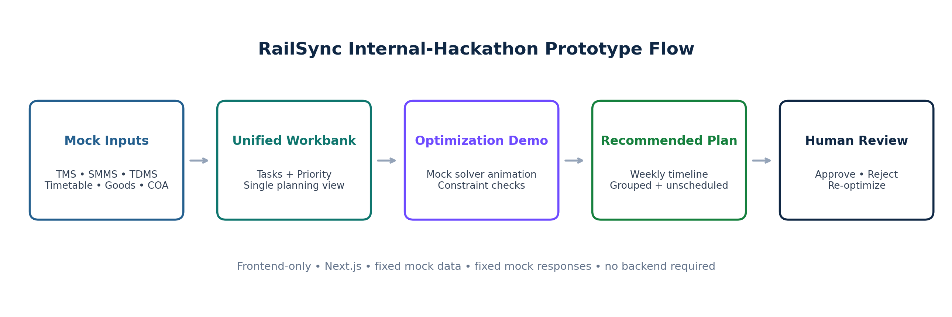
Prototype goal
Build a polished, judge-facing, frontend-only simulation that explains the complete RailSync concept without depending on a backend, database, FastAPI, OR-Tools, or real railway APIs. Every result shown in the prototype must be clearly labelled as synthetic / simulated.

Version 1.0 • SIH 2026 Internal Selection • Prototype specification

Document Map
Use this document as the source of truth for the internal-selection prototype. It intentionally simplifies the production architecture while preserving the exact story and interactions we want to demonstrate.
Section | What it defines
1. Prototype Strategy | What to build, what to skip, and what success looks like
2. Technology Stack | Next.js frontend stack and exact libraries
3. Architecture | Frontend-only architecture and future replacement path
4. UI/UX System | Layout, colors, navigation, badges, status language
5. Screen Specifications | Every page, component, state, and judge-facing message
6. Mock Data Contracts | Tasks, windows, resources, plans, metrics, disruption scenario
7. Interactions & State | Run optimization, COA disruption, re-optimize, approve/reject
8. Implementation Blueprint | Folder structure, TypeScript types, store, mock services
9. Build Order for Codex | Exact phase-by-phase build sequence
10. Testing & Demo | Prototype QA, internal-hackathon demo flow, acceptance checklist

Important honesty rule
The UI may simulate optimizer execution, but we must not tell judges that OR-Tools actually ran. Present it as an interactive prototype demonstrating the intended optimization workflow. The final MVP architecture can still be shown as Next.js → Node → PostgreSQL → FastAPI → OR-Tools.

1. Prototype Strategy

1.1 What we are building
For the internal hackathon, RailSync is a clickable frontend prototype that demonstrates the entire planning experience from fragmented department inputs to a recommended plan and human approval.
- Use fixed TypeScript mock data for TMS, SMMS, TDMS, timetable, goods forecast, COA windows, resources, compatibility rules, and the current/manual baseline.
- Use fixed mock optimization responses to show the recommended weekly plan.
- Simulate processing with a 1.5–2.2 second loading sequence.
- Simulate one operational disruption by changing a COA block window from Available to Unavailable.
- Switch to a second predefined mock plan after re-optimization.
- Simulate planner approval/rejection entirely in frontend state.
- Show before-vs-after metrics as prototype simulation data, not real railway performance.

1.2 What we are not building now
Skip for internal prototype | Reason
Node/Express backend | Does not improve judge understanding for this round
PostgreSQL / Prisma | No persistence is required for the demo
Python / FastAPI | No real optimizer service is required yet
Google OR-Tools | Show intended behavior with deterministic mock responses
Gemini API | Use deterministic explanation text; remove external failure risk
Real CRIS/TMS/SMMS/TDMS/COA APIs | Not available / not required for internal selection
Authentication system | Optional fake planner identity is enough
Excel parsing | Display preloaded source cards; actual file parsing is optional
Mobile app | Desktop operations dashboard is the correct demo surface

1.3 Prototype success criteria
1. Judge sees three maintenance departments as separate source inputs.
2. Judge sees one unified maintenance workbank with transparent priority.
3. Judge understands the current fragmented/manual planning view.
4. Judge presses Run Optimization and sees an understandable constraint-check sequence.
5. Judge sees a recommended plan with at least one compatible grouped block.
6. Judge sees at least one task intentionally left unscheduled with a clear reason.
7. Judge sees a COA availability change make the plan stale.
8. Judge presses Re-optimize and sees a new predefined valid plan.
9. Judge sees human planner Approve / Reject controls.
10. Judge sees a before-vs-after comparison labelled Prototype Simulation.
Core prototype story
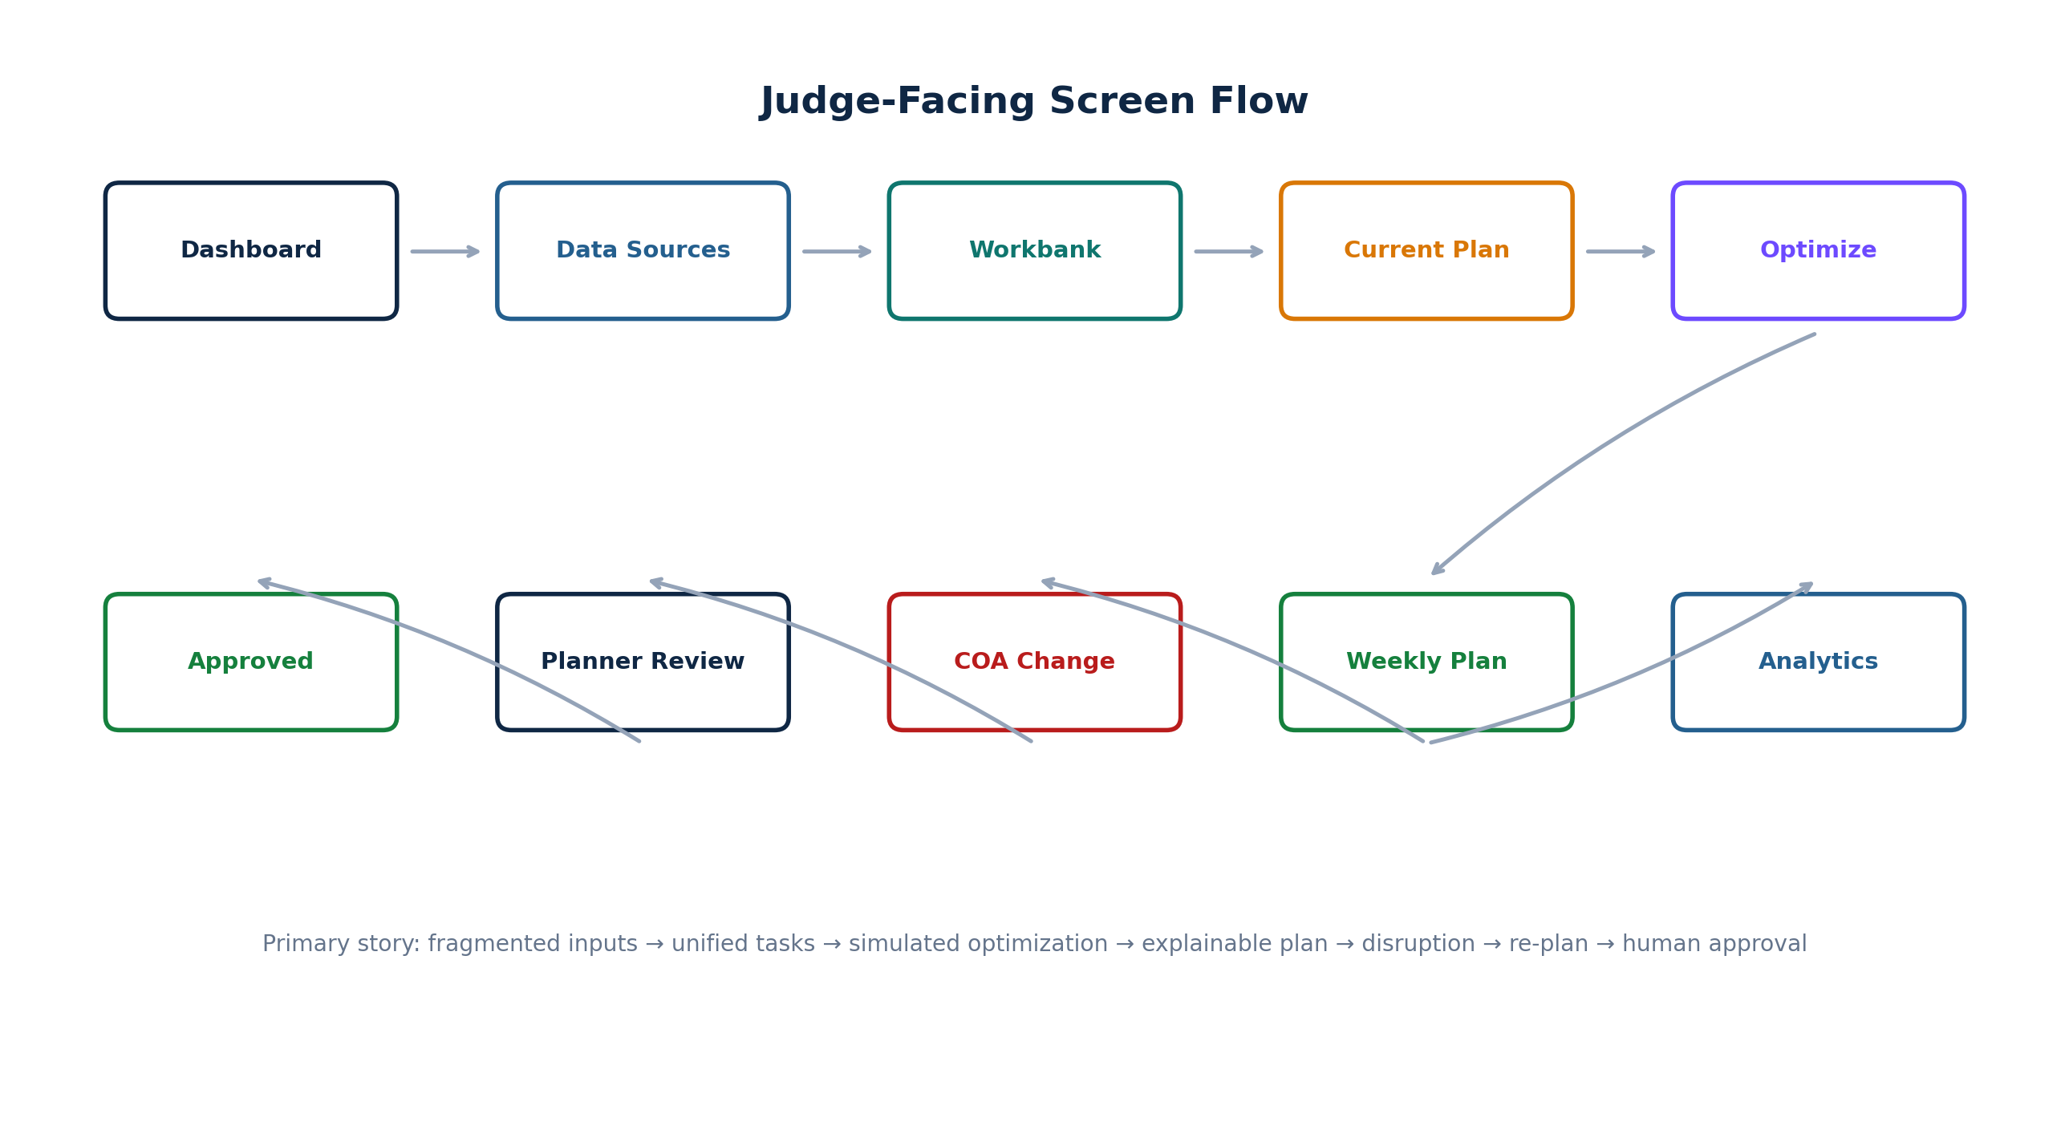

2. Technology Stack and Libraries

2.1 Recommended stack
Need | Library / Tool | Why
Framework | Next.js App Router + TypeScript | Fast routing, reusable layouts, future production path
Styling | Tailwind CSS | Rapid consistent UI
Component system | shadcn/ui | Professional cards, dialogs, drawers, tabs, buttons, tables
Icons | lucide-react | Clean operational icon set
Tables | @tanstack/react-table | Filtering/sorting for maintenance workbank
Charts | recharts | Simple analytics and dashboard charts
State | zustand | Small global prototype state without backend
Dates | date-fns | Formatting planning dates/times
Toasts | sonner | Run/approval/status feedback
Animation | framer-motion | Small transitions only; avoid flashy UI
Fonts | Geist / Next.js default | Clean technical/enterprise look

2.2 Installation
npx create-next-app@latest railsync-prototype --typescript --tailwind --eslint --app
cd railsync-prototype
npx shadcn@latest init
npx shadcn@latest add button card badge table tabs dialog sheet dropdown-menu \
tooltip progress separator alert skeleton select input
npm install @tanstack/react-table recharts lucide-react zustand date-fns sonner framer-motion

Optional only
Install `xlsx` only if you decide to demonstrate real client-side Excel parsing. For internal selection, preloaded mock source cards are cleaner and lower risk.

2.3 Do not add
- Express, Prisma, PostgreSQL, FastAPI, OR-Tools, Redis, WebSockets, RAG/vector DB, Kafka, authentication libraries, file storage, Docker orchestration.

3. Frontend-Only Architecture
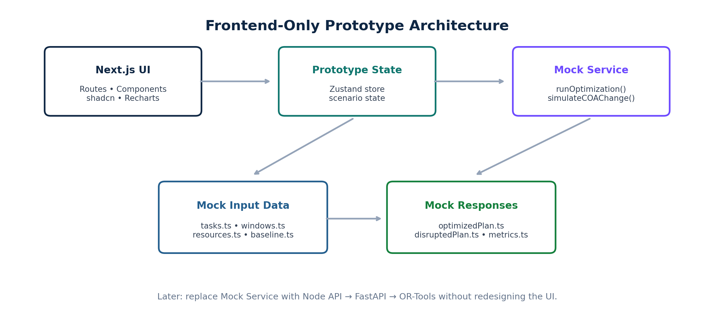

3.1 Architecture principle
Build the prototype so the UI can later switch from mock services to real APIs without redesigning screens. Pages should consume typed service functions, not import giant mock objects everywhere.
// Today
const result = await runMockOptimization(input);
// Later
const result = await api.post('/optimization-runs', input);

3.2 Frontend layers
Layer | Responsibility
Routes / Pages | Judge-facing pages and layouts
Components | Reusable cards, tables, timelines, badges, drawers
Prototype Store | Current scenario, plan state, disruption state, approval state
Mock Services | Fake async operations such as optimize/re-optimize/approve
Mock Data | Static input and fixed response objects
Domain Types | TypeScript contracts shared across pages

3.3 Scenario state machine
BASELINE
↓ Run Optimization
OPTIMIZING
↓ mock response
RECOMMENDED
↓ Simulate COA Change
STALE
↓ Re-optimize
REOPTIMIZING
↓ disrupted mock response
RECOMMENDED_V2
↓ Planner Approve
APPROVED

Do not reload the page during demo
Keep state in Zustand with `persist` so accidental route navigation does not destroy the prototype state. Add a visible “Reset Demo” action for the presenter.

4. UI/UX Design System

4.1 Visual direction
RailSync should look like an enterprise railway operations console: calm, dense enough to feel serious, but not overloaded. Avoid neon, gaming aesthetics, giant gradients, and chat-first layouts.
Token | Recommended value | Use
Background | #F6F8FB | App canvas
Sidebar | #0F2744 | Primary navigation
Primary blue | #245F8E | Links / active states / info
Teal | #0F766E | Unified/system actions
Green | #15803D | Available / approved / feasible
Amber | #D97706 | High priority / warning / current plan
Red | #B91C1C | Critical / unavailable / stale
Purple | #6D4AFF | Optimization engine / traction accent
Text | #0F172A | Main text
Muted | #64748B | Secondary text

4.2 Department visual language
Department | Badge | Icon suggestion
Engineering | Blue label | Wrench / construction
Signal & Telecom | Amber label | Radio / traffic signal
Traction Distribution | Purple label | Zap / utility pole

Never rely only on color. Always show department text or icon so screenshots remain understandable and accessible.

4.3 Layout
- Fixed left sidebar: ~240 px on desktop.
- Top bar: page title, planning horizon, “Synthetic Demo Data” badge, Reset Demo action.
- Content area: max width around 1440 px, 24 px desktop spacing.
- Cards: 12–16 px radius, 1 px slate border, very subtle shadow.
- Use 2–4 KPI cards per row; avoid 12 tiny cards.
- Tables use sticky header where practical.
- Primary CTA appears once per screen, not everywhere.

4.4 Global badges and labels
Label | Meaning
SYNTHETIC DEMO DATA | Current input is simulated
PROTOTYPE SIMULATION | Metrics are illustrative outputs of the mock scenario
CRITICAL / HIGH / MEDIUM / LOW | Priority band
AVAILABLE / RESTRICTED / UNAVAILABLE | COA window state
RECOMMENDED | System recommendation; not final
STALE | Underlying operational input changed
APPROVED | Human planner approved
UNSCHEDULED | No valid placement in current scenario

5. Routes and Screen Specifications

5.1 Route map
app/
├── page.tsx → redirect /dashboard
├── dashboard/page.tsx
├── data-sources/page.tsx
├── tasks/page.tsx
├── current-plan/page.tsx
├── optimize/page.tsx
├── plan/page.tsx
└── analytics/page.tsx

Route | Judge question answered
/dashboard | What is the planning situation?
/data-sources | Where does the planning data come from?
/tasks | How do three departments become one workbank?
/current-plan | What is wrong with the current fragmented approach?
/optimize | What does RailSync consider before planning?
/plan | What plan is recommended, why, and what cannot be scheduled?
/analytics | What changes in the simulated scenario?

5.2 Screen 1 — Command Center / Dashboard
Purpose: establish the problem in under 15 seconds.
Area | Contents
Top KPIs | 35 maintenance tasks • 6 critical • 8 overdue • 21 available windows
Department split | Engineering 15 • Signal 10 • Traction 10
Priority chart | Critical / High / Medium / Low distribution
Corridor workload | C001–C005 task counts
Data readiness | TMS, SMMS, TDMS, timetable, goods, COA all loaded
Primary CTA | Review Maintenance Workbank

Judge-facing line
“Today these maintenance requirements originate from separate departmental systems. RailSync first creates a unified planning workbank.”

5.3 Screen 2 — Data Sources
Purpose: prove that the solution understands the multiple source systems mentioned by the problem statement.
Source card | Mock contents
TMS | Engineering • 15 tasks • Loaded
SMMS | Signal & Telecom • 10 tasks • Loaded
TDMS | Traction • 10 tasks • Loaded
Train Timetable | 140 movements • Loaded
Goods Forecast | 105 windows • Loaded
COA Availability | 21 demo candidate windows • Loaded
Compatibility Rules | 12 rules • Prototype assumptions
Resources | Crew availability • Loaded

Each card should have source name, what it contributes, record count, synthetic/public label, and “View Sample” drawer. Do not waste time on a real upload flow.

5.4 Screen 3 — Unified Maintenance Workbank
Purpose: show a single view of all department maintenance requirements and transparent priority.
Column | Example
Task ID | ENG-001
Source | TMS
Department | Engineering
Corridor | C001 Ahmedabad → Nadiad
Work | Track Repair
Duration | 120 min
Priority | 92 / Critical
Due | Today
Required state | Track Possession

Filters: department, corridor, priority, due state. Sorting default: priority descending.
Row click opens a right-side Sheet with score breakdown, source, requirements, notes, and “Why this priority?” explanation.
Priority explanation
Criticality 10/10 • Urgency 10/10 • Safety impact 10/10 • Availability impact 9/10 → Prototype priority score 92.

5.5 Screen 4 — Current / Fragmented Plan
Purpose: create a visual “before” state.
- Three horizontal lanes: Engineering, Signal, Traction.
- Show separate block cards that do not coordinate across departments.
- Show a small “coordination opportunity” marker where compatible work exists on the same corridor.
- Keep baseline metrics at top: 18 blocks, 1,620 block-minutes, 5/6 critical tasks covered. Label all as prototype simulation.
C001 — Current department-wise planning
ENGINEERING 01:00 ───────────── 03:00 ENG-001 Track Repair
SIGNAL 03:00 ────── 04:00 SIG-001 Signal Inspection
TRACTION 04:00 ───────── 05:30 TRD-001 OHE Maintenance

5.6 Screen 5 — Optimization Setup
Purpose: make the system intelligence understandable without claiming a real solver is running.
Input summary | Demo value
Maintenance tasks | 35
Candidate windows | 21
Compatibility rules | 12
Resources | 15
Planning horizon | 7 days
Corridors | 5

Center of the screen should show the pipeline: Priority → Timetable/Goods/COA → Constraints → Optimization → Recommendation.
Primary CTA: Run Optimization
On click, show a modal or full-card progress sequence:
1. Analyzing maintenance priorities…
2. Checking corridor and available block windows…
3. Checking task compatibility…
4. Checking crew/resource availability…
5. Evaluating traffic impact…
6. Generating recommended weekly plan…
Presenter wording
“For the internal prototype this response is simulated. In the final MVP this step is handled by the OR-Tools optimization service.”

5.7 Screen 6 — Recommended Weekly Plan
Purpose: this is the strongest screen. Show the answer, the reason, and the exceptions.
- Page status: RECOMMENDED — Human approval required.
- Timeline grouped by corridor, not by department.
- Each block displays time, corridor, task chips, departments, traffic impact, and lock state.
- Side panel lists unscheduled tasks with exact reason.
- Block click opens “Why this block?” details.
C001 Ahmedabad → Nadiad
01:00 ───────────────────────── 03:00
BLOCK-001
ENG-001 Track Repair Engineering
SIG-001 Point Machine Inspection Signal
Why grouped?
✓ Same corridor
✓ Compatible prototype rule R-001
✓ Both fit the 120-minute block
✓ Required crews available
✓ Low simulated traffic impact

5.8 Unscheduled-work card
UNSCHEDULED — ENG-002 Track Tamping
Priority: Medium (58)
Required duration: 180 min
Largest valid candidate window: 120 min
Reason: NO_FEASIBLE_WINDOW
Planner action required

Why this matters
Do not make the prototype “perfect.” Showing one task the system refuses to schedule makes the concept look safer and more credible.

5.9 Interaction — Simulate COA Change
On the recommended plan page add a button: Simulate COA Change.
BW-001 • C001 • 01:00–03:00
AVAILABLE → UNAVAILABLE

Immediately change plan state to STALE and show:
⚠ PLAN STALE
The operational availability for BW-001 changed.
Affected: 1 block • 2 maintenance tasks
[ Re-optimize ]

5.10 Interaction — Re-optimize
Re-optimize uses a second predefined mock response. Show the same progress animation for ~1.5 seconds and then replace the plan.
Before disruption:
01:00–03:00 ENG-001 + SIG-001
03:30–05:00 TRD-001
After disruption:
03:00–05:00 ENG-001 + SIG-001
22:00–23:30 TRD-001

Show a small banner: “Plan re-generated after COA availability change.”

5.11 Planner Review and Approval
Sticky action bar at bottom/right: Reject • Modify (optional mock) • Approve Plan.
Approve click:
Status: APPROVED
Reviewed by: Demo Railway Planner
Approved at: <current demo time>
RailSync recommends the plan.
Final operational authority remains with the railway planner.

Reject click opens a dialog with reason choices and returns the plan to a rejected state. For internal selection, Modify can open a simple “prototype only” drawer or be omitted if time is tight.

5.12 Screen 7 — Analytics / Comparison
Metric | Current / Baseline | RailSync mock plan
Blocks | 18 | 12
Total block minutes | 1,620 | 1,080
Critical tasks covered | 5 / 6 | 6 / 6
Coordinated multi-dept blocks | 0 | 4
Unscheduled critical tasks | 1 | 0
Hard violations | Not modelled | 0 in mock response

Mandatory label
“Illustrative prototype simulation using synthetic data. These values are not measured Indian Railways performance results.”

Use one grouped bar chart for blocks/block minutes and one donut or small bar for coverage. Do not overload the page with vanity charts.

6. Mock Data and Response Contracts

6.1 Core TypeScript domain types
export type Department = 'Engineering' | 'Signal' | 'Traction';
export type PriorityBand = 'Critical' | 'High' | 'Medium' | 'Low';
export type PlanStatus =
| 'BASELINE'
| 'OPTIMIZING'
| 'RECOMMENDED'
| 'STALE'
| 'REOPTIMIZING'
| 'APPROVED'
| 'REJECTED';
export interface MaintenanceTask {
id: string;
source: 'TMS' | 'SMMS' | 'TDMS';
department: Department;
corridorId: string;
corridorName: string;
title: string;
durationMin: number;
priorityScore: number;
priorityBand: PriorityBand;
dueDate: string;
criticality: number;
urgency: number;
safetyImpact: number;
availabilityImpact: number;
requiredState: string;
requiredResource: string;
}

6.2 Block and plan types
export interface PlanBlock {
id: string;
windowId: string;
corridorId: string;
corridorName: string;
start: string;
end: string;
durationMin: number;
taskIds: string[];
departments: Department[];
trafficImpact: 'Low' | 'Medium' | 'High';
reasons: string[];
}
export interface UnscheduledTask {
taskId: string;
reasonCode: string;
reason: string;
requiredDurationMin?: number;
largestValidWindowMin?: number;
}
export interface MockPlanResponse {
scenario: 'NORMAL' | 'COA_DISRUPTION';
solverLabel: 'SIMULATED';
status: 'FEASIBLE';
runtimeLabel: string;
blocks: PlanBlock[];
unscheduled: UnscheduledTask[];
metrics: PrototypeMetrics;
}

6.3 Representative mock tasks
ID | Dept | Task | Corridor | Duration | Priority
ENG-001 | Engineering | Track Repair | C001 | 120m | 92 Critical
SIG-001 | Signal | Point Machine Inspection | C001 | 60m | 78 High
TRD-001 | Traction | OHE Maintenance | C001 | 90m | 75 High
ENG-002 | Engineering | Track Tamping | C001 | 180m | 58 Medium
SIG-002 | Signal | Track Circuit Testing | C003 | 90m | 76 High
TRD-002 | Traction | Section Insulator Inspection | C003 | 75m | 71 High

The full UI can still report 35 tasks. Only 6–10 representative rows need to be visible without scrolling during the demo.

6.4 Mock normal plan
export const normalPlan: MockPlanResponse = {
scenario: 'NORMAL',
solverLabel: 'SIMULATED',
status: 'FEASIBLE',
runtimeLabel: '1.84 sec (simulated)',
blocks: [
{
id: 'BLOCK-001',
windowId: 'BW-001',
corridorId: 'C001',
corridorName: 'Ahmedabad → Nadiad',
start: '01:00',
end: '03:00',
durationMin: 120,
taskIds: ['ENG-001', 'SIG-001'],
departments: ['Engineering', 'Signal'],
trafficImpact: 'Low',
reasons: [
'Same corridor',
'Compatible prototype rule R-001',
'Durations fit the available block',
'Required crews available',
'Low simulated traffic impact'
]
}
],
unscheduled: [
{
taskId: 'ENG-002',
reasonCode: 'NO_FEASIBLE_WINDOW',
reason: 'No valid candidate window can fit 180 minutes',
requiredDurationMin: 180,
largestValidWindowMin: 120
}
],
metrics: {/* prototype simulation metrics */}
};

6.5 Mock disrupted plan
Copy the same contract but move the C001 block away from BW-001 and set `scenario: COA_DISRUPTION`. Keep the response deterministic so the demo never surprises the presenter.

6.6 Mock input source counts
Source | Count shown | Label
TMS Engineering | 15 tasks | Synthetic
SMMS Signal | 10 tasks | Synthetic
TDMS Traction | 10 tasks | Synthetic
Passenger timetable | 140 movements | Synthetic demo
Goods forecast | 105 forecast windows | Synthetic demo
COA candidate windows | 21 | Synthetic demo
Compatibility | 12 rules | Prototype assumptions
Resources | 15 | Synthetic demo

7. Prototype State, Services, and Interactions

7.1 Zustand store
interface PrototypeState {
planStatus: PlanStatus;
scenario: 'NORMAL' | 'COA_DISRUPTION';
plan: MockPlanResponse | null;
coaChanged: boolean;
runOptimization: () => Promise<void>;
simulateCoaChange: () => void;
reoptimize: () => Promise<void>;
approvePlan: () => void;
rejectPlan: () => void;
resetDemo: () => void;
}

7.2 Mock service
const sleep = (ms: number) => new Promise(r => setTimeout(r, ms));
export async function runMockOptimization() {
await sleep(2000);
return normalPlan;
}
export async function runMockReoptimization() {
await sleep(1500);
return disruptedPlan;
}

7.3 Progress animation
Do not fake a complex console. Use one progress card whose active step changes every ~300 ms. This keeps the experience believable and readable.
const steps = [
'Analyzing maintenance priorities',
'Checking corridor availability',
'Checking task compatibility',
'Checking resource availability',
'Evaluating traffic impact',
'Generating recommended plan'
];

7.4 Persist and reset
- Use Zustand `persist` with localStorage so navigation keeps the current scenario.
- Add `Reset Demo` in the top bar.
- On reset: state → BASELINE, scenario → NORMAL, plan → null, COA change → false.
- The presenter should be able to reset in one click before judges arrive.

7.5 Guardrails
Situation | UI behavior
User opens /plan before optimization | Show empty state + Go to Optimize
Optimization running | Disable navigation CTA that would duplicate action
Plan stale | Disable Approve until re-optimization
Plan approved | Disable disruption/modify actions or require Reset Demo
Re-optimize clicked twice | Disable button while running
No mock data | Show explicit empty state, never a broken table

8. Repository and Component Blueprint

8.1 Recommended structure
railsync-prototype/
├── app/
│ ├── layout.tsx
│ ├── page.tsx
│ ├── dashboard/page.tsx
│ ├── data-sources/page.tsx
│ ├── tasks/page.tsx
│ ├── current-plan/page.tsx
│ ├── optimize/page.tsx
│ ├── plan/page.tsx
│ └── analytics/page.tsx
├── components/
│ ├── app-shell/
│ │ ├── sidebar.tsx
│ │ └── topbar.tsx
│ ├── dashboard/
│ ├── tasks/
│ ├── planning/
│ │ ├── timeline.tsx
│ │ ├── plan-block-card.tsx
│ │ ├── block-detail-sheet.tsx
│ │ └── unscheduled-card.tsx
│ ├── optimize/
│ │ └── optimization-progress.tsx
│ └── shared/
│ ├── stat-card.tsx
│ ├── priority-badge.tsx
│ ├── department-badge.tsx
│ ├── synthetic-data-badge.tsx
│ └── page-header.tsx
├── data/
│ ├── dashboard.ts
│ ├── tasks.ts
│ ├── sources.ts
│ ├── windows.ts
│ ├── current-plan.ts
│ ├── optimized-plan.ts
│ └── disrupted-plan.ts
├── lib/
│ ├── mock-service.ts
│ ├── format.ts
│ └── demo-metrics.ts
├── store/
│ └── prototype-store.ts
└── types/
└── domain.ts

8.2 Core reusable components
Component | Used on
AppSidebar | All screens
PageHeader | All screens
SyntheticDataBadge | All screens
StatCard | Dashboard / analytics
DepartmentBadge | Tasks / plan
PriorityBadge | Tasks / plan
TaskTable | Workbank
Timeline | Current plan / recommended plan
PlanBlockCard | Plan
BlockDetailSheet | Plan
UnscheduledTaskCard | Plan
OptimizationProgress | Optimize / re-optimize
PlanStatusBanner | Plan
ComparisonChart | Analytics
ConfirmApprovalDialog | Plan

8.3 Timeline implementation
Do not add a heavy scheduling library for this prototype. Use CSS Grid: first column for lane/corridor label, then time columns. Each block is absolutely or grid-positioned using predefined start/end slots. This gives complete visual control and zero licensing risk.
Simplify the timeline
The prototype only needs a 6–8 hour overnight planning view per corridor, not a full 24-hour railway dispatching tool.

9. Exact Build Order for Codex
Do not ask Codex to “build the full prototype” in one prompt. Use these phases in order.
Phase | Build | Done when
1 | App shell + sidebar + top bar + theme | All routes render inside consistent layout
2 | Domain types + mock data files | No page owns ad-hoc data shapes
3 | Dashboard | KPIs, department split, readiness cards work
4 | Data Sources | All source cards and sample drawers work
5 | Maintenance Workbank | Table, filters, detail Sheet work
6 | Current Plan | Fragmented 3-lane timeline visible
7 | Prototype Store + Mock Service | State survives route navigation
8 | Optimization screen | Progress sequence + redirect/update works
9 | Recommended Plan | Timeline + reasons + unscheduled card work
10 | COA disruption + Re-optimize | STALE → new plan interaction works
11 | Planner approval/rejection | Final state + dialog/toast work
12 | Analytics | Comparison chart/table and disclaimer work
13 | Polish | Responsive behavior, loading states, reset, demo QA

9.1 First Codex prompt
Build Phase 1 of the RailSync internal-hackathon frontend prototype.
Stack:
- Next.js App Router + TypeScript
- Tailwind
- shadcn/ui
- lucide-react
Read this specification before coding.
Implement only:
1. global app layout
2. fixed dark navy sidebar
3. topbar with page title, 15–21 Sep 2026 horizon, Synthetic Demo Data badge, Reset Demo button
4. routes: /dashboard, /data-sources, /tasks, /current-plan, /optimize, /plan, /analytics
5. active navigation styling
6. empty placeholder shell on every route
Do not add backend/API/database/authentication.
Do not invent new routes or libraries.
Return files changed and commands run.

9.2 Prompt rule for every next phase
- Tell Codex exactly which section of this specification to follow.
- Say “frontend-only; no backend/API/database”.
- List acceptance criteria.
- Ask it not to change existing domain types unless the spec requires it.
- Ask it to preserve the Synthetic Demo Data label.
- Ask it to report assumptions instead of silently adding features.

10. Prototype Testing and Internal-Hackathon Demo

10.1 Functional test checklist
Test | Expected
Reset Demo | Returns to baseline state everywhere
Run Optimization | Shows six progress steps and loads normalPlan
Open block | Shows reasons and task details
Unscheduled card | Shows ENG-002 and NO_FEASIBLE_WINDOW
Simulate COA Change | Plan becomes STALE and Approve is disabled
Re-optimize | Loads disruptedPlan and clears stale state
Approve | Status becomes APPROVED and success toast/dialog appears
Reject | Status becomes REJECTED and reason is captured in frontend state
Analytics | Shows prototype label and consistent mock numbers
Navigation | State persists between screens

10.2 Visual QA checklist
- No page should need horizontal scrolling at a 1366×768 presentation resolution.
- Critical status is visually obvious but not overwhelming.
- The “Synthetic Demo Data” badge is visible on every screen.
- Primary CTA is obvious within 2 seconds.
- Timeline text does not overlap block boundaries.
- No more than 2 charts on one page.
- Use skeleton/loading state during optimization instead of blank screen.
- Use consistent terminology: Recommended, Stale, Unscheduled, Approved.

10.3 Six-minute demo script
Time | Action | What to say
0:00–0:35 | Dashboard | “Three departments plan maintenance separately; RailSync creates one planning layer.”
0:35–1:05 | Data Sources | “TMS, SMMS, TDMS plus timetable, goods and COA availability feed the planner.”
1:05–1:45 | Workbank | “We unify tasks and calculate transparent maintenance priority.”
1:45–2:15 | Current Plan | “Here the same corridor is being planned separately by departments.”
2:15–3:05 | Run Optimization | “The final MVP checks compatibility, duration, resources and traffic before recommending blocks.”
3:05–4:05 | Recommended Plan | Open grouped block; show why it is feasible and show unscheduled task.
4:05–4:50 | COA Change + Re-optimize | “Operational availability changed, so the recommendation becomes stale and must be regenerated.”
4:50–5:20 | Approve | “The system recommends; the railway planner remains the final authority.”
5:20–6:00 | Analytics | “These are prototype simulation metrics, demonstrating how we will measure improvement.”

10.4 Questions judges may ask
Question | Short answer
Is the optimizer working now? | “This internal-round build is an interactive prototype with deterministic simulated responses. Our MVP architecture uses OR-Tools for real constraint optimization.”
Where is your railway data from? | “We use synthetic operational data for restricted systems. The production adapter layer is designed to accept authorized real TMS/SMMS/TDMS/COA data later.”
Why AI? | “The core scheduling problem is constraint optimization. GenAI is optional for explanation, not for deciding safety/feasibility.”
What if no slot exists? | “The system explicitly returns Unscheduled with a reason; it never invents a block.”
Does the system automatically close tracks? | “No. RailSync is decision support. A railway planner reviews and approves the recommendation.”
What makes it different from a dashboard? | “It coordinates cross-department maintenance against operations, constraints and resource availability, then explains the recommendation and supports re-planning.”

11. Final Prototype Acceptance Checklist
- All seven routes are polished and connected.
- No backend/database/FastAPI/OR-Tools dependency exists.
- Mock input data is centralized and typed.
- Mock optimization response is centralized and typed.
- Normal and COA-disruption scenarios are deterministic.
- Run Optimization works every time.
- At least one compatible grouped block is shown.
- At least one unscheduled task is shown with a reason.
- COA disruption changes status to STALE.
- Re-optimize switches to the second plan.
- Approve is disabled while stale.
- Planner approval works after re-optimization.
- Analytics numbers are consistent with the selected mock response.
- Every metrics screen says Prototype Simulation / Synthetic Data.
- No claim is made that mock OR-Tools actually executed.
- Prototype runs smoothly at presentation resolution.
- Reset Demo restores the start state in one click.
What “done” means
If a judge can understand the problem, see the fragmented baseline, press one button, understand the recommended plan, see the system refuse an invalid case, watch it react to a COA change, and see a human approve the new plan, the internal prototype has done its job.

11.1 What comes after internal selection
Prototype now | MVP later
TypeScript mock inputs | Excel/API adapters → normalized backend
Mock optimization service | Node → FastAPI → OR-Tools
Fixed recommended plan | Real solver output
Fixed explanation facts | Solver facts + optional Gemini explanation
Zustand/localStorage | PostgreSQL plan/run persistence
Fake planner identity | Real authentication/RBAC
Prototype analytics | Metrics calculated from actual solver run

11.2 Final one-line architecture
INTERNAL PROTOTYPE
Next.js → Mock Data → Mock Optimization Response → Planner UI
FINAL MVP
Next.js → Node/Express → PostgreSQL → FastAPI → OR-Tools → Planner UI

Appendix A — Recommended Demo Copy
UI location | Copy
Global badge | Synthetic Demo Data
Optimize status | Simulated planning run
Plan banner | Recommended Plan — Human approval required
Stale banner | Plan stale — operational availability changed
Unscheduled card | No feasible window — planner action required
Approval footer | RailSync recommends. Railway planner approves.
Analytics footer | Illustrative prototype simulation using synthetic data

Appendix B — Recommended Mock Scenario Summary
Use this same scenario in the UI, PPT, and verbal explanation so the story stays consistent.
Item | Scenario value
Planning horizon | 15–21 Sep 2026
Corridors | 5 demo corridors; C001 used for live story
Maintenance tasks | 35 total
Hero tasks | ENG-001, SIG-001, TRD-001, ENG-002
Normal grouping | ENG-001 + SIG-001 on C001
Separated work | TRD-001 separate due to prototype compatibility/state rule
Unscheduled case | ENG-002 requires 180m; largest valid window 120m
Disruption | BW-001 changes Available → Unavailable
Reoptimized result | ENG-001 + SIG-001 move; TRD-001 moves to late slot
Final authority | Demo Railway Planner

