Proposal for Health Advice Group

Contents

# Organisation Overview

Health Advice Group are a charity which gives information and support for environmental health issues.

They give advice on how to deal with extreme temperatures, information on environmental health conditions, seasonal allergies and risk assessments for your home.

They are looking for a digital solution, a website, that’s gives information on things like the weather, air quality and advice around health effected by the environment.

# Problem Overview

Based on the limited information giving it is likely that either they don’t have a digital system, or that the current system is very bad and they need it updating. This has the impact that the health advice has limited reach which reduces the effectiveness of the advice and reducing the quality of public health. The limited reach provided by the current system, or lack of current system, also has the impact that the charity will get less funding as less people know about them.

The lack of an effective digital system can also give off the impression that the charity isn’t modern and behind the times which can also reduce the reputation of their advice as if it is conveyed in outdated methods, like a newspaper, the advice itself could be perceived as outdated as well.

The advice can also not be personalised without a digital system limiting the effectiveness of the advice. This also presents missed opportunities for giving advice as if you can give a more personalised experience you may be able to give alerts to the users such as if pollen levels spike in their area.

# User Groups

General Public – the public might use the new digital solution to look at the information it provides such as data about the weather and the air quality around them. This can influence what routes they may go to avoid low quality air.

Vulnerable Individuals – those with specific health conditions might make use of the new solution in order to get advice specific to their condition in order to make better informed decisions on how to manage their condition on that specific day.

Caregivers – caregivers will make use of the system in a similar way to vulnerable people as they can use the solution to get advice around specific conditions that their patients may have to tailor their care more closely to the needs of the patients.

Staff at Health Advice Group – staff at HAG could have their own tailored view to the solution to make use of the data it produces to influence what advice they focus their efforts on and new areas for advice they could give

# Empathy Maps

|  |  |
| --- | --- |
| Says  I’m struggling to maintain my health during the current heatwave  The pollen levels in my area have been really volatile at the moment  I wish I could make better informed decisions on how to take care of my patients during the cold | Thinks  I wish there was a place where I could get reliable advice on how to manage my health during the heatwave  It would be better if there was an app/website which could notify me if the pollen levels are about to rise  I need a place to find information around how to give care during specific weather conditions |
| Does  Follows other advice which could be misinformed  Tries their best to monitor the pollen levels, but they rise before they can check again  Tries their best to find information and hopes they found good information | Feels  Even more ill than they did before due to taking poor advice  Unwell as they have an allergic reaction to the pollen  Unsure of the care they have given |

# User Stories

|  |  |  |  |
| --- | --- | --- | --- |
| As a… | I want… | So that… | Acceptance Criteria |
| Member of the public | An easy to use source of information whether that be an app or website that gives good environmental health advice | I can make decisions around my lifestyle to ensure that I remain healthy during irregular environmental conditions | The source needs to have an intuitive UI with concise and to the point text with the opportunity for the user to read further on the same page |

# Laws Guidance and Legislation

Based on the brief I am assuming that the company is UK based and that the service will only be used by UK users.

Data –

GDPR

NHS Digital Guidelines

National Institute for health care and excellence

BSI

Accessibility –

equality act 2010

WCAG

Health and safety –

Health and Safety at Work Act 1974

Clinical Safety Standards (DCB0129 and DCB0160)

UK Medical Device Regulations 2002

Cybersecurity –

ISO 27001

Copywrite –

IPA laws around data sources and APIs

Ethics –

# Alternative Systems

Weather Forcating apps –

Met Office API – gives very accurate weather forecasts to specific regions

OpenWeatherMap – gives global weather forecasts with real time data and long term weather trends

Air quality monitoring systems –

AirVisual – gives air quality data with pollution forecasts and personal health recommendations

Defra UK-AIR – real time updates of air quality and environmental conditions

Personalised health advice systems –

AdaHealth App – uses ai to give symptom based health advice

MyFitnessPal – tracks personal health with sensors and wearables like watches

Need print screens, compare to what you need and what you will do differently, what needs do they meet what do they not

# Risks

System failure/downtime

Integration issues

Data security

Scalability limits

Dependency on third party services

Legal issues

Lack of return on investment

Falls short of user expectations

Talk about how to limit them

# Decomposition

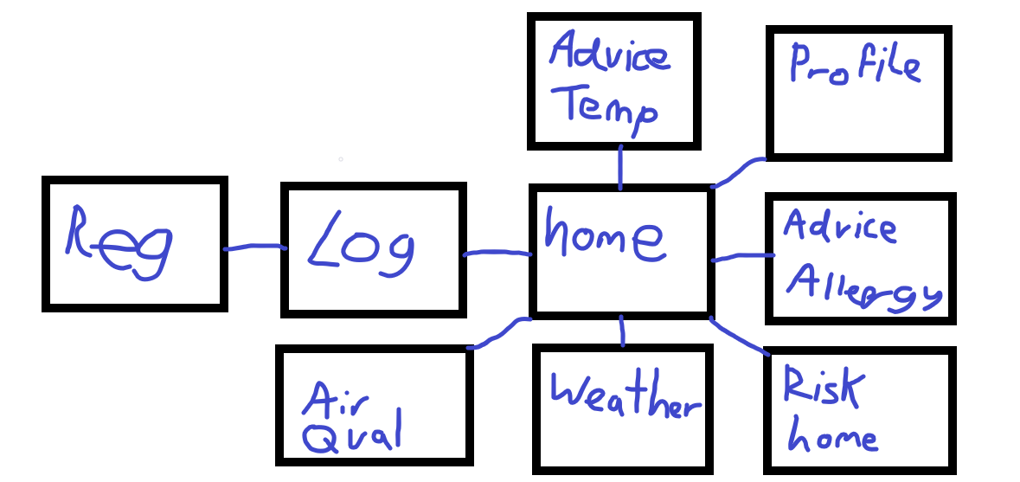

How it fixes the problem, talk about a database, api to get the weather

# User Acceptance criteria

Accessible

Friendly and easy UI

Login and Register

Reliable with little downtime

Weather Forecasting

Health advice

Personal health tracking

Custom alerts

Multi user management

Home risk assessment

Custom dashboards

Split into user groups, a little bit of commentary

# Functional Requirements

Stuff it should do

# Non-Functional requirements

How it should do things

# KPI

Ratings/reviews

Traffic to the site

Where people are coming from

Number of new/returning users per time

Donations coming from the site or increase in donations after the solution launch

# Description of Proposed solution

What you are going to do very generally like it will store data securely, secure, scalable maintainable, css