**Table Design**

## Table: users

| **No** | **Field Name** | **Datatype (Size)** | **Key Constraints** | **Description** |
| --- | --- | --- | --- | --- |
| 1 | id | int (11) | PRIMARY KEY | Auto-incremented user ID |
| 2 | name | varchar (100) | NOT NULL | Full name of user |
| 3 | email | varchar (100) | NOT NULL, UNIQUE | Email address of user |
| 4 | password | varchar (255) | NOT NULL | Hashed password |
| 5 | role | enum('admin','provider','customer') | NOT NULL | Role of the user |
| 6 | phone | varchar (20) | NOT NULL | Phone number |
| 7 | address | text | NOT NULL | Full address |
| 8 | city | varchar (100) | NOT NULL | City of user |
| 9 | state | varchar (100) | NOT NULL | State of user |
| 10 | pincode | varchar (20) | NOT NULL | Postal code |
| 11 | profile_image | varchar (255) | NULL | Optional profile photo |
| 12 | is_active | boolean | DEFAULT TRUE | User active status |
| 13 | created_at | timestamp | DEFAULT CURRENT_TIMESTAMP | Record creation time |
| 14 | updated_at | timestamp | AUTO ON UPDATE | Last update time |

## Table: service_categories

| **No** | **Field Name** | **Datatype (Size)** | **Key Constraints** | **Description of the Field** |
| --- | --- | --- | --- | --- |
| 1 | id | int (11) | PRIMARY KEY | Auto-incremented ID |
| 2 | name | varchar (50) | NOT NULL, UNIQUE | Name of service category |
| 3 | description | text | NULL | Brief description |
| 4 | icon | varchar (50) | NULL | Icon identifier |

## Table: services

| **No** | **Field Name** | **Datatype (Size)** | **Key Constraints** | **Description of the Field** |
| --- | --- | --- | --- | --- |
| 1 | id | int (11) | PRIMARY KEY | Auto-incremented ID |
| 2 | name | varchar (100) | NOT NULL | Name of service |
| 3 | category_id | int (11) | FOREIGN KEY | References service_categories(id) |
| 4 | description | text | NOT NULL | Details about the service |
| 5 | base_price | decimal(10,2) | NOT NULL | Base price of the service |
| 6 | duration_minutes | int | NOT NULL | Estimated duration |
| 7 | image | varchar (255) | NULL | Optional image |
| 8 | created_at | timestamp | DEFAULT CURRENT_TIMESTAMP | Record created time |

## Table: service_images

| **No** | **Field Name** | **Datatype (Size)** | **Key Constraints** | **Description of the Field** |
| --- | --- | --- | --- | --- |
| 1 | id | int (11) | PRIMARY KEY | Auto-incremented ID |
| 2 | service_id | int (11) | FOREIGN KEY | References services(id) |
| 3 | image_url | varchar (255) | NOT NULL | Image path |
| 4 | created_at | timestamp | DEFAULT CURRENT_TIMESTAMP | Created time |
| 5 | updated_at | timestamp | DEFAULT CURRENT_TIMESTAMP ON UPDATE | Updated time |

## Table: providers

| **No** | **Field Name** | **Datatype (Size)** | **Key Constraints** | **Description of the Field** |
| --- | --- | --- | --- | --- |
| 1 | Id | int (11) | PRIMARY KEY | Auto-incremented provider ID |
| 2 | user_id | int (11) | UNIQUE, FOREIGN KEY | References users(id) |
| 3 | experience | varchar (50) | NOT NULL | Years or type of experience |
| 4 | location | varchar (255) | NULL | Working location |
| 5 | bio | text | NULL | Provider bio |
| 6 | id_proof | varchar (255) | NULL | Proof of ID image |
| 7 | is_verified | boolean | DEFAULT FALSE | Verification flag |
| 8 | verification_status | enum('pending',  'approved',  'rejected') | DEFAULT 'pending' | Verification status |
| 9 | availability | enum('available',  'unavailable') | DEFAULT 'available' | Current status |
| 10 | avg_rating | decimal(3,2) | DEFAULT 0.00 | Average rating |

## Table: provider_services

| **No** | **Field Name** | **Datatype (Size)** | **Key Constraints** | **Description of the Field** |
| --- | --- | --- | --- | --- |
| 1 | Id | int (11) | PRIMARY KEY | Auto-incremented ID |
| 2 | provider_id | int (11) | FOREIGN KEY | References users(id) |
| 3 | service_id | int (11) | FOREIGN KEY | References services(id) |
| 4 | price | decimal(10,2) | NOT NULL | Provider-specific price |
| 5 | is_available | boolean | DEFAULT TRUE | Service availability |

## Table: bookings

| **No** | **Field Name** | **Datatype (Size)** | **Key Constraints** | **Description of the Field** |
| --- | --- | --- | --- | --- |
| 1 | id | int (11) | PRIMARY KEY | Auto-incremented ID |
| 2 | user_id | int (11) | FOREIGN KEY | References users(id) |
| 3 | provider_id | int (11) | FOREIGN KEY | References users(id) |
| 4 | service_id | int (11) | FOREIGN KEY | References services(id) |
| 5 | booking_date | datetime | NOT NULL | Date and time of booking |
| 6 | address | text | NOT NULL | Booking address |
| 7 | amount | decimal(10,2) | NOT NULL | Total amount |
| 8 | status | enum('pending',  'confirmed',  'completed',  'cancelled',  'rejected') | DEFAULT 'pending' | Booking status |
| 9 | cancellation_reason | text | NULL | Reason if cancelled |
| 10 | payment_type | enum('cash',  'later') | DEFAULT 'cash' | Mode of payment |
| 11 | payment_status | enum('pending','paid','unpaid') | DEFAULT 'pending' | Payment status |
| 12 | admin_notes | text | NULL | Admin remarks |
| 13 | customer_notes | text | NULL | Customer message |
| 14 | provider_notes | text | NULL | Provider note |
| 15 | created_at | timestamp | DEFAULT CURRENT_TIMESTAMP | Created time |

## Table: reviews

| **No** | **Field Name** | **Datatype (Size)** | **Key Constraints** | **Description of the Field** |
| --- | --- | --- | --- | --- |
| 1 | id | int (11) | PRIMARY KEY | Auto-incremented ID |
| 2 | booking_id | int (11) | UNIQUE, FOREIGN KEY | References bookings(id) |
| 3 | user_id | int (11) | FOREIGN KEY | References users(id) |
| 4 | provider_id | int (11) | FOREIGN KEY | References users(id) |
| 5 | service_id | int (11) | FOREIGN KEY | References services(id) |
| 6 | rating | tinyint | NOT NULL | Rating between 1 to 5 |
| 7 | comment | text | NULL | User feedback |
| 8 | created_at | timestamp | DEFAULT CURRENT_TIMESTAMP | Review time |

**Use Case Diagram**

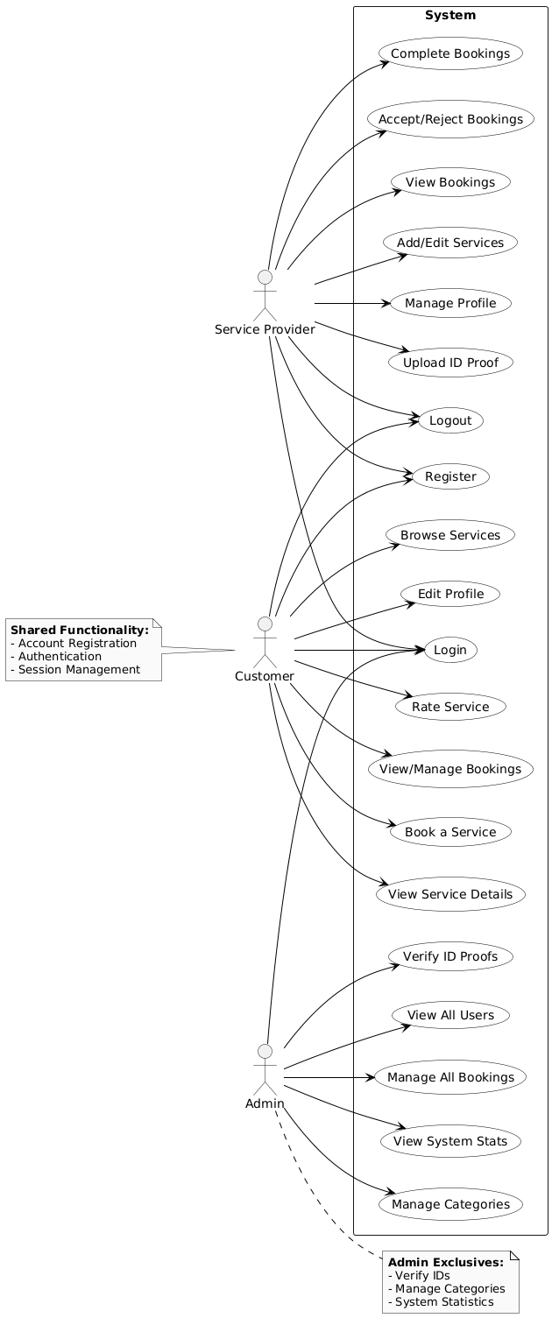

**Sequence Diagram**

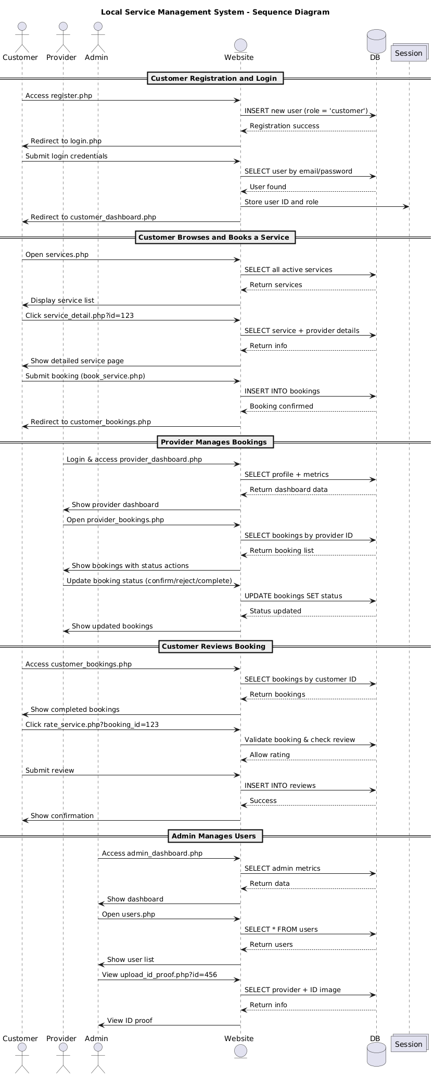

**Class Diagram**

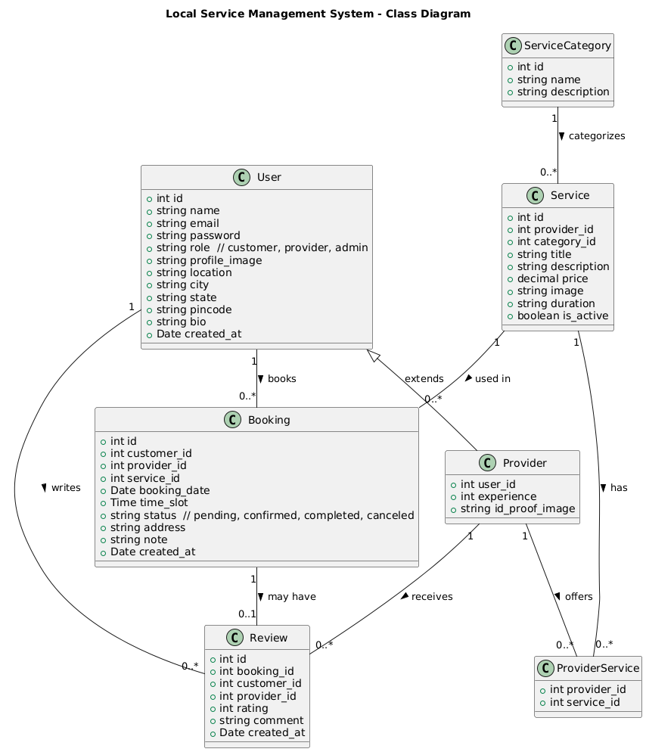

**Activity Diagram**

