

Motion Detection From a Live Video Feed

30.07.2018
─Alfin S. Thomas

Introduction
The aim of this project is to create a method to capture a live video feed , process it , detect the motion from the objects observed , and show regions of motion in the video .

Requirements:

-basic software to compile and run C++ program

-External Library used : OpenCV (C++)

Brief Summary:

The Directory Tree is supposed to look like this :

-src
|
| - B/
| |-Cany
| |-cropped
| |-Fil
| |-Filter
|
| - C/ {initially empty}
| - LiveFG.cpp
| - Subtractor.cpp
| - Contours.cpp
| - Playimg2vid.cpp
| - {compiled files of the 4 programs}

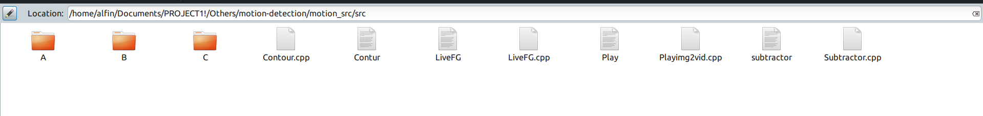
There are 4 programs namely LiveFG.cpp , Subtractor.cpp , Contours.cpp & Playimg2vid.cpp , compiling and running them in the same order will give us the final output.

As the programs are now, it will take 100 frames from the source and save it to a folder called C, the processed results are stored in a folder called B. On running the last program we get the video output with marked regions of motion .

In Detail:

For Compiling Programs in Linux:
g++ filename.cpp -o name `pkg-config --cflags --libs opencv`
Example : g++ Subtractor.cpp -o subtractor `pkg-config --cflags --libs opencv`

- Programs Explained

-LiveFG.cpp
Run using: ./name
Example : ./LiveFG
Description:
For capturing the video feed, a program called LiveFG.cpp was written. It’s inside the program that the source of the video feed is entered . The entire program is to be recompiled every time the source is changed. All the stored frames are numbered and stored as (0- 99).jpg . The rate in which frames are stored is based on the resolution of the video feed, greater the resolution more the time. Should the source be inaccessible appropriate errors are send.

Once the program is run, the C folder is supposed to look like this
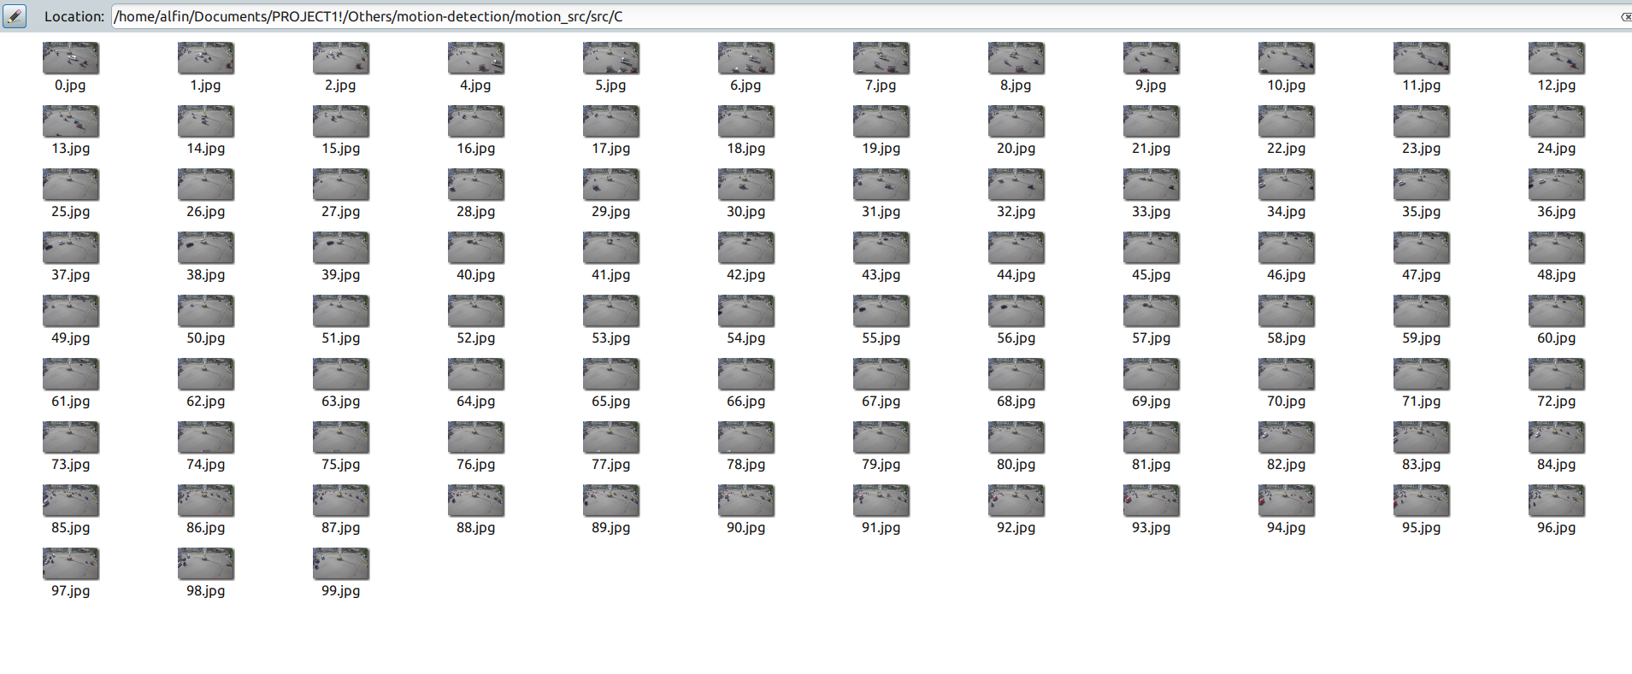

Subtractor.cpp

Run using : ./name -img path_to_first_frame

Example: ./subtractor -img C/0.jpg

Description :

The purpose of this program is to subtract a frame from the next one

Example:

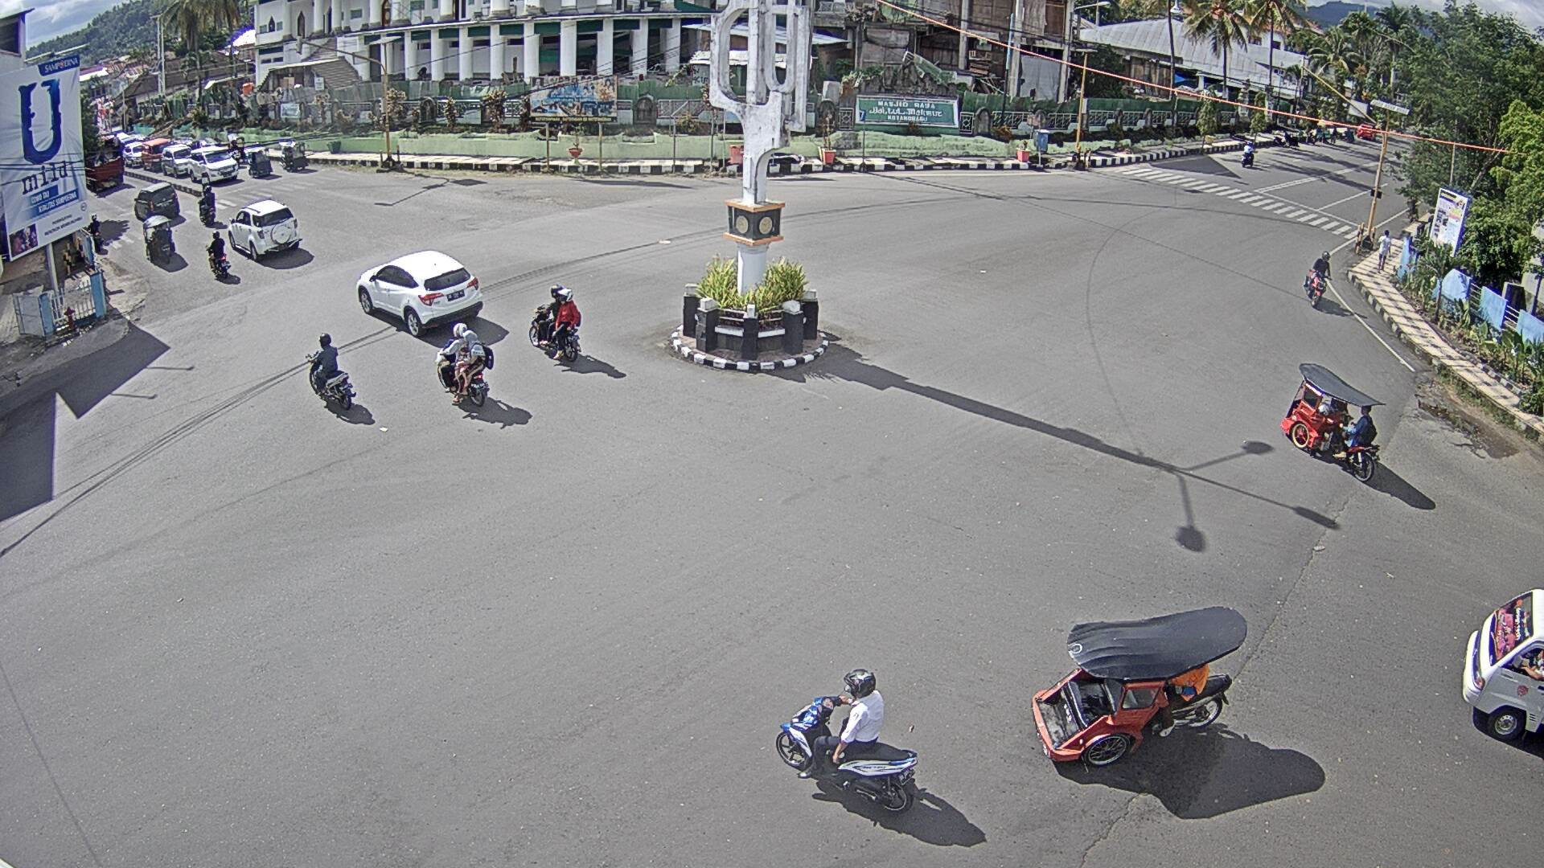

Original

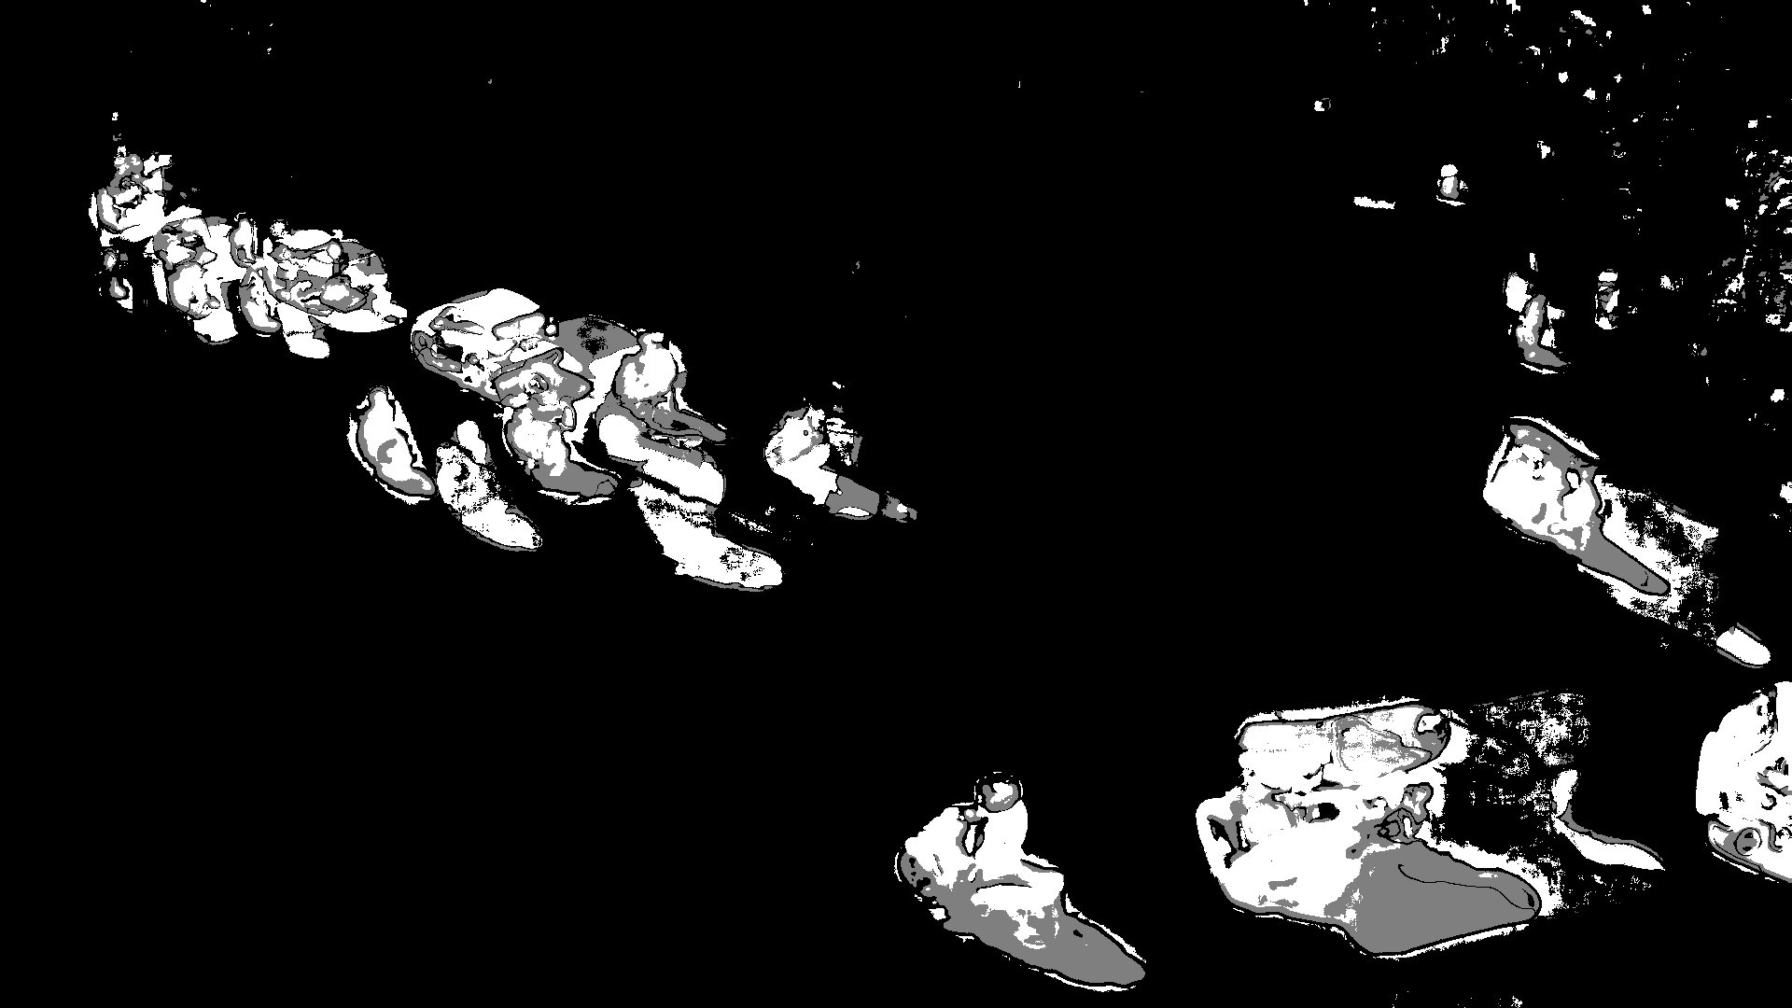

Subtracted

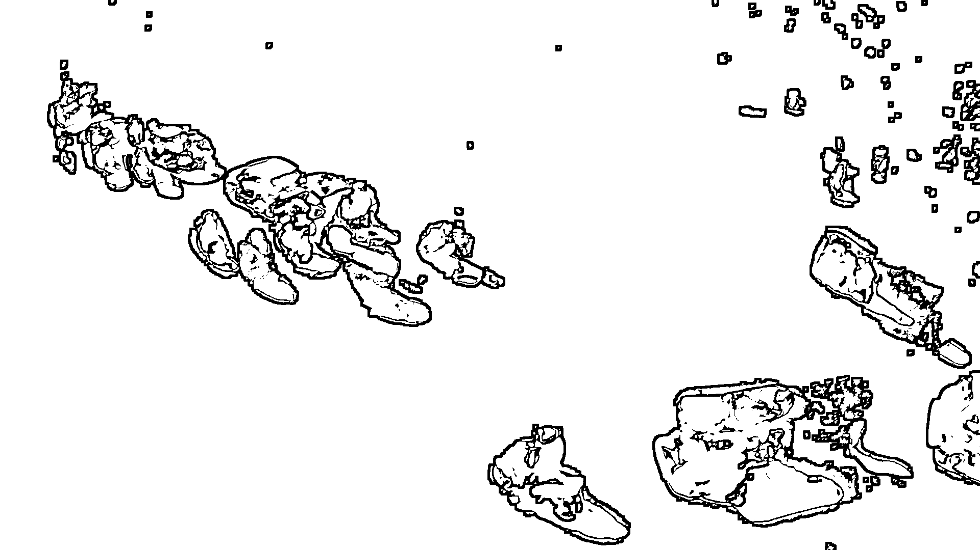

Filtered

This is done using OpenCV functions for Background subtraction {MOG2 method is implemented}. The image is first blurred and filtered before going through this process. For the purpose removing the subtracted frames with too many disparities{mainly due to light and sometimes shadow} those frames whose size is more than a specific amount (set as 650 kB) is subtracted again and again till the size is lesser than the set amount. The amount can be changed in the program depending of the source.

The subtracted frames are stored in B/.

The filtered frames are stored in B/Filter/.

Contours.cpp

Run using: ./name path_to_Filtered_First_Frame

Example: ./Contours B/Filter/0.jpg

Description:
Original

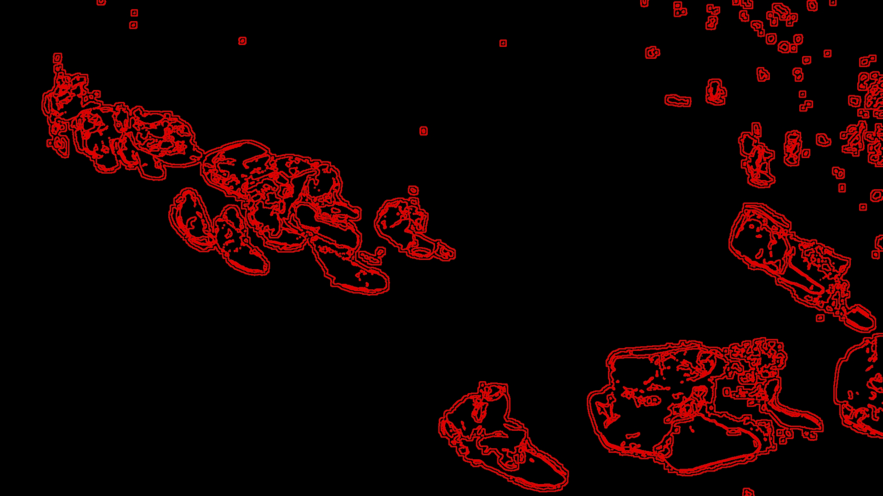
Contours
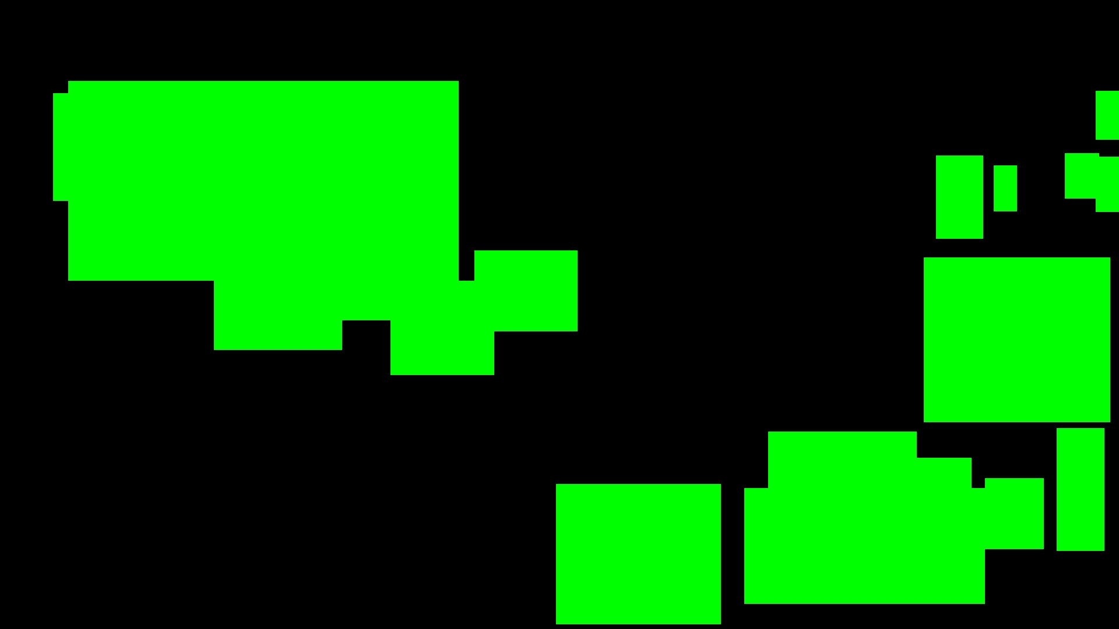
FILLED Bounded Rectangles
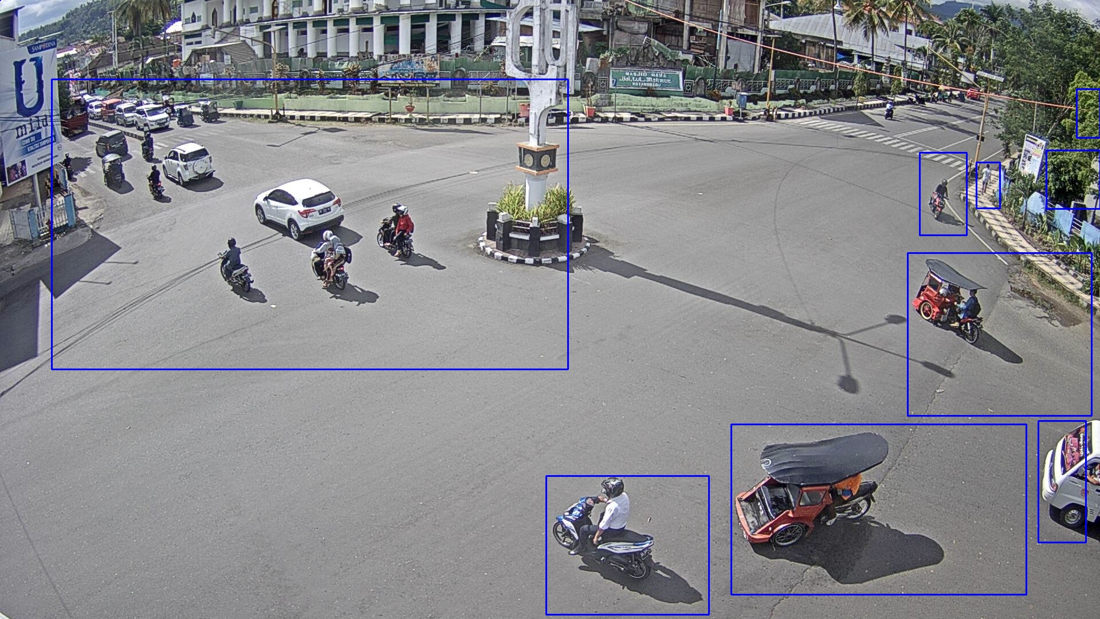

This Program does the job of getting the contours of the inputted source , and also producing the final image. To get the rectangles around the area of motion, the contours of the original is used . With those contours on a blank frame, bounded FILLED rectangles are created. The contours of those newly created FILLED rectangles are traced on the Original Image to produce the Final Image.
The minimum size of the detection should be changed within the code and recompiled.
Contours of original are shown in B/Canny/.
The Filled Rectangles are shown in B/cropped/.
The Final Image is Stored in B/Fil/.

Playimg-2-vid.cpp:

Run using: ./name

Example: ./Play

Description:
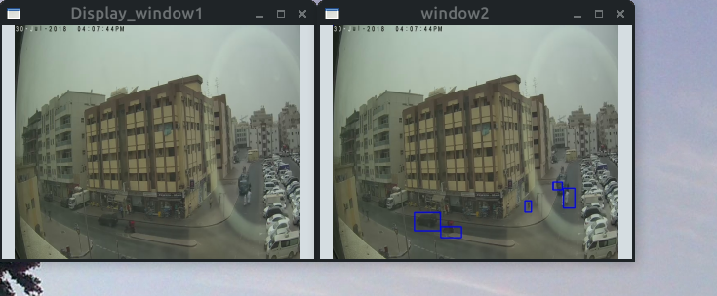

This is a simple program used to play the Original and Final Image side by side in a video like manner. Both read the next image after a certain preset time interval .

Milestones
- Algorithm created is fairly easy
- Motion can be detected fairly accurately

Drawbacks:
- It’s not real-time ready and everything is fully manual
- Detection cannot be done at night time accurately
- Lights and shadows changes still create inaccuracy
- Areas of interest cannot be selected.
- It doesn’t detect motion when the camera is a moving type.
- If there are too many objects(above approx 50), processing is heavy.

Things To Do From Here :

As of now all the programs needed for motion detection can be said to have been completed.
The next steps are:-
1.MultiThread the project so it can be real-time ready.
As of now the project only takes in 100 frames and the processing is all manual. Its only once it’s real-time ready , the true optimization can be done.
2.User friendliness.
It’s very clear this project isn’t exactly the best in terms of user friendliness
3. Memory Efficiency
The frames stored in B/ aren’t exactly needed and storing them with the original and final image is not memory efficient. To cyclically
4.Next Stage
For taking this project to the next level , Deep Learning is meant to be applied to teach object detection and maybe even object identification .

