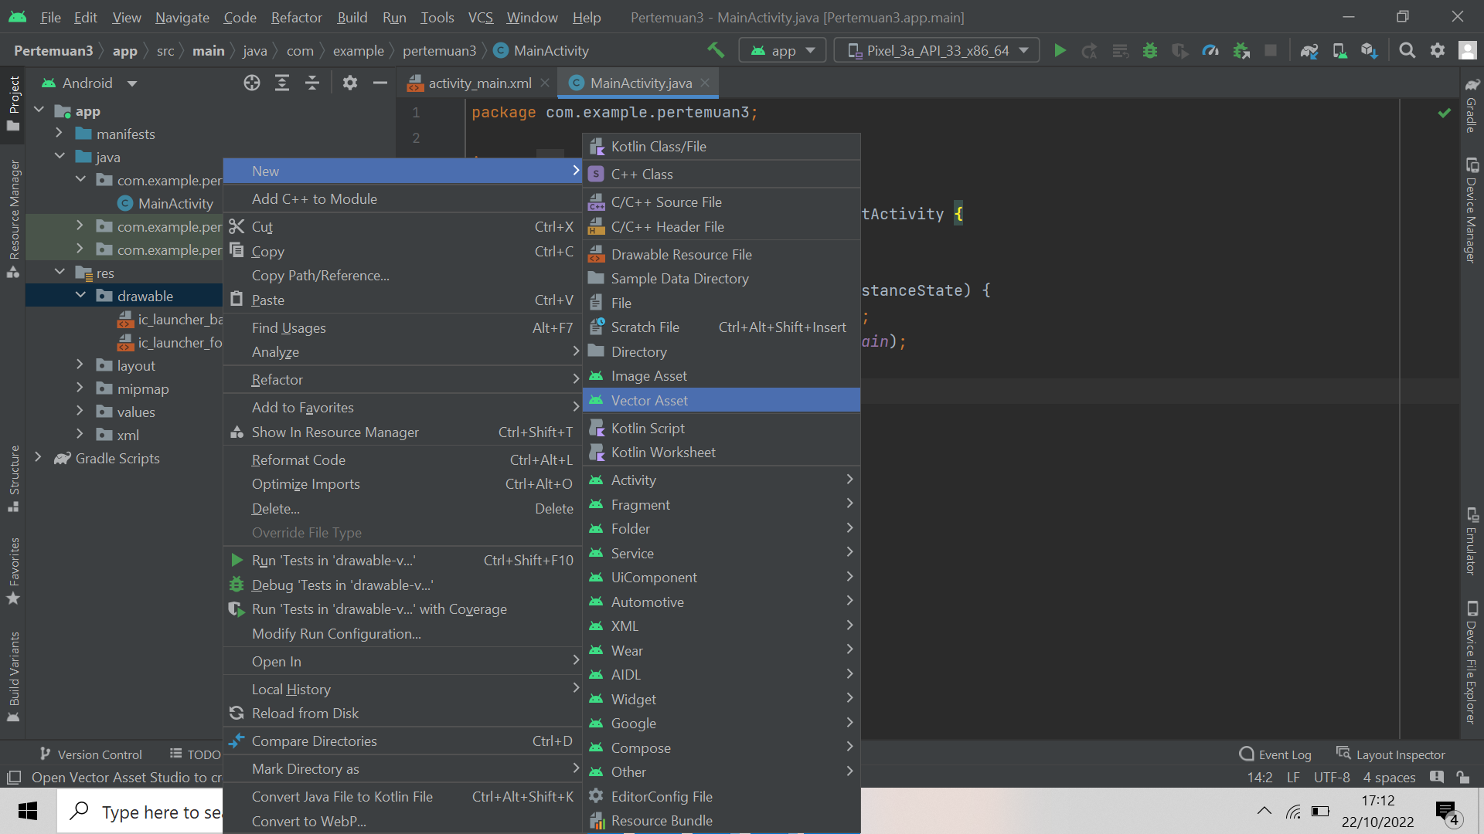

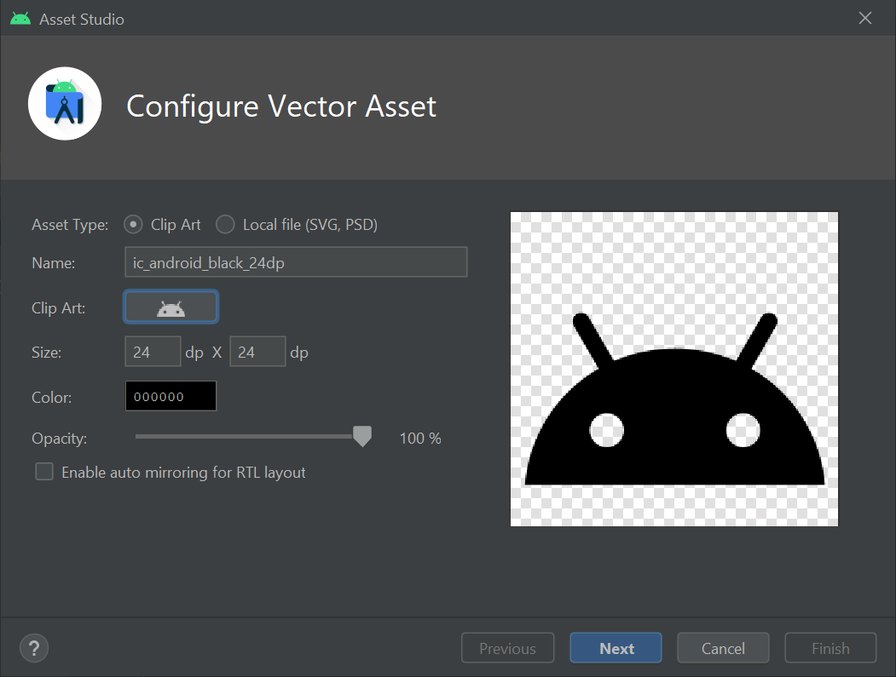

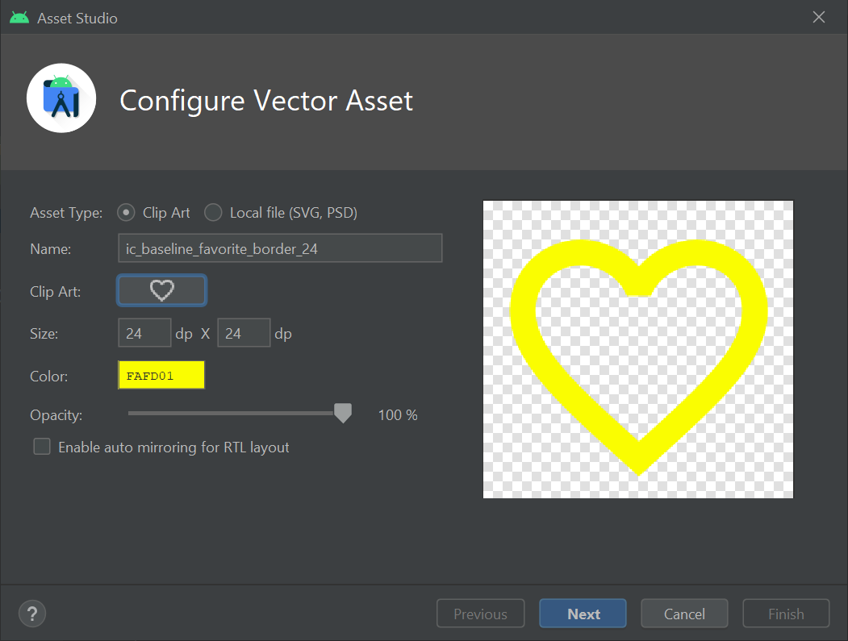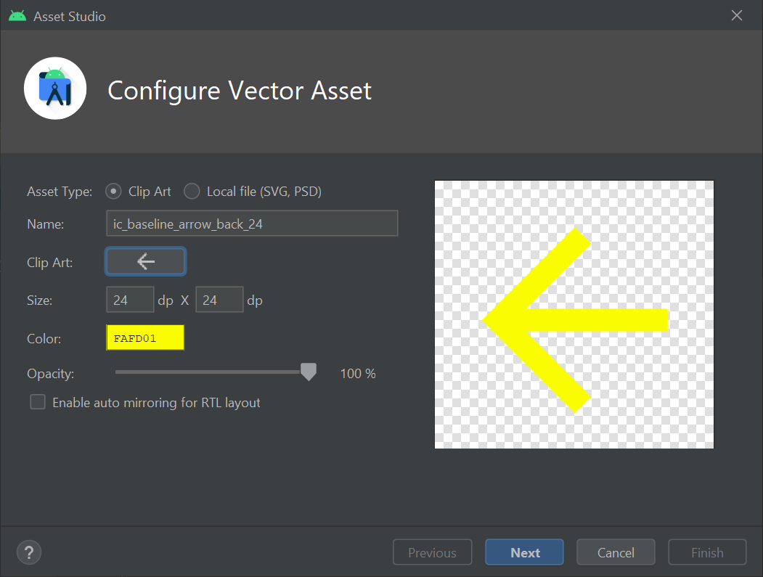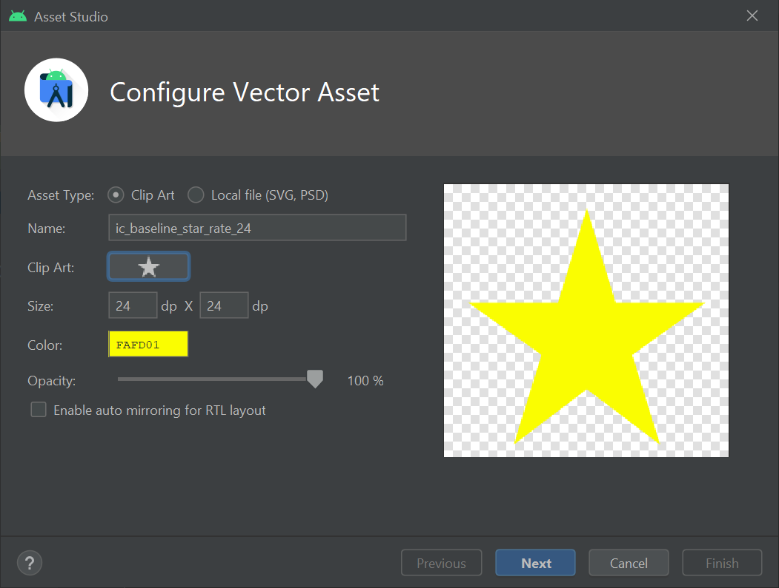

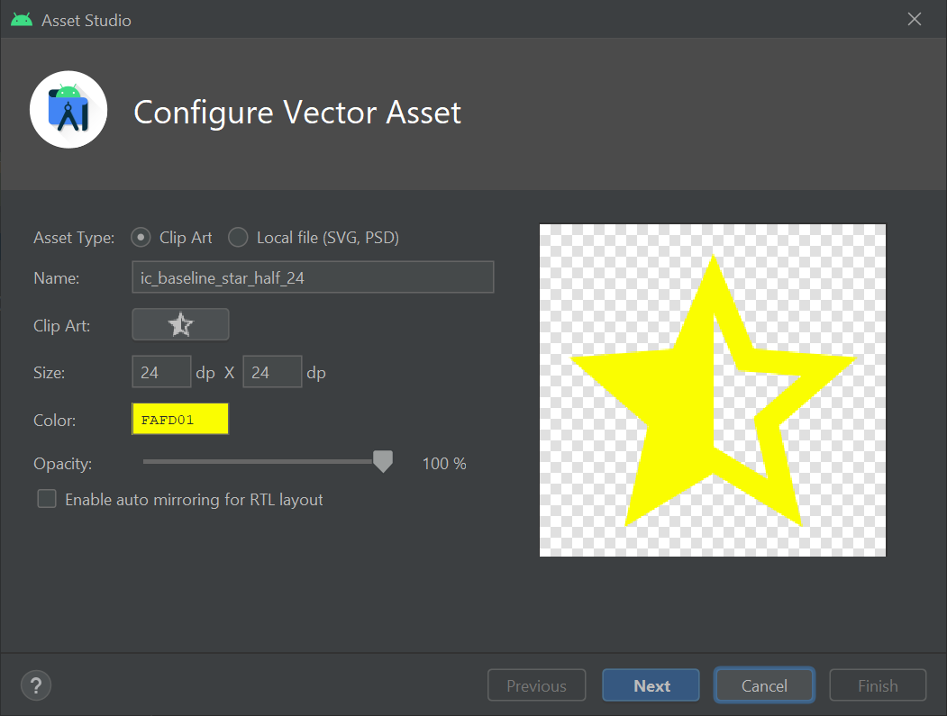

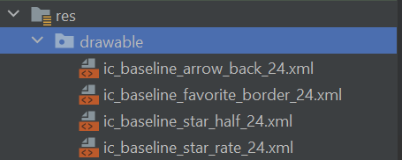

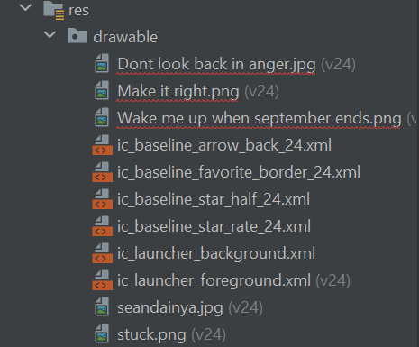



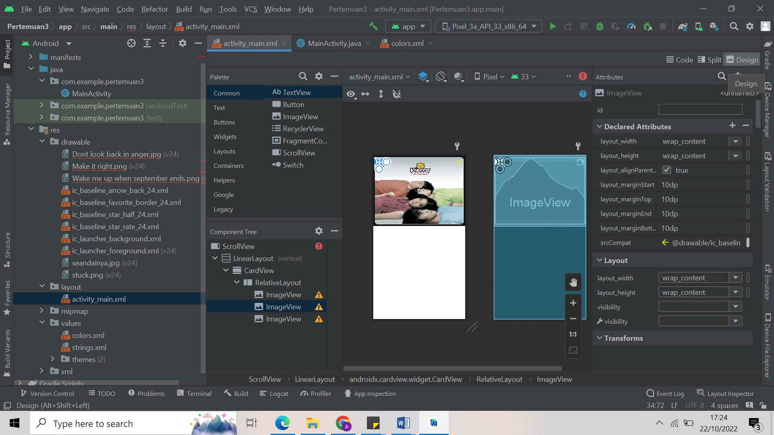

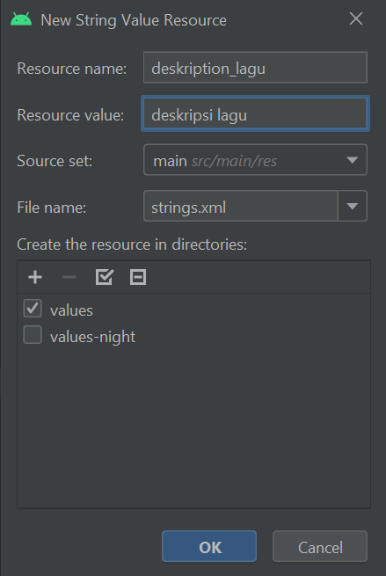

|  |
| --- |
| <?xml version="1.0" encoding="utf-8"?> <ScrollView  xmlns:android="http://schemas.android.com/apk/res/android"  xmlns:app="http://schemas.android.com/apk/res-auto"  xmlns:tools="http://schemas.android.com/tools"  android:layout_width="match_parent"  android:layout_height="match_parent"  tools:context=".MainActivity">   <LinearLayout  android:layout_width="match_parent"  android:layout_height="wrap_content"  android:background="@color/grey_dark"  android:orientation="vertical">   <androidx.cardview.widget.CardView  android:layout_width="match_parent"  android:layout_height="wrap_content"  app:cardCornerRadius="15dp"  app:cardUseCompatPadding="true">   <RelativeLayout  android:layout_width="match_parent"  android:layout_height="wrap_content">   <ImageView  android:layout_width="match_parent"  android:layout_height="300dp"  android:scaleType="fitXY"  app:srcCompat="@drawable/seandainya" />   <ImageView  android:layout_width="wrap_content"  android:layout_height="wrap_content"  android:layout_alignParentStart="true"  android:layout_margin="10dp"  android:layout_marginTop="10dp"   app:srcCompat="@drawable/ic_baseline_arrow_back_24" />   <ImageView  android:layout_width="wrap_content"  android:layout_height="wrap_content"   android:layout_alignParentEnd="true"  android:layout_gravity="end"  android:layout_marginTop="10dp"  android:layout_marginEnd="10dp"  app:srcCompat="@drawable/ic_baseline_favorite_border_24" />  </RelativeLayout>  </androidx.cardview.widget.CardView>   <androidx.cardview.widget.CardView  android:layout_width="match_parent"  android:layout_height="match_parent"  app:cardBackgroundColor="@color/grey_card"  app:cardCornerRadius="10dp"  app:cardUseCompatPadding="true">   <LinearLayout  android:layout_width="match_parent"  android:layout_height="wrap_content"  android:layout_marginStart="10dp"  android:orientation="vertical">   <TextView  android:id="@+id/textView"  android:layout_width="wrap_content"  android:layout_height="wrap_content"  android:layout_marginBottom="10dp"  android:paddingStart="10dp"  android:text="Seandainya"  android:textColor="@color/white"  android:textSize="24sp" />   <LinearLayout  android:layout_width="match_parent"  android:layout_height="wrap_content"  android:orientation="horizontal">   <ImageView  android:layout_width="wrap_content"  android:layout_height="wrap_content"   app:srcCompat="@drawable/ic_baseline_star_rate_24" />   <ImageView  android:layout_width="wrap_content"  android:layout_height="wrap_content"   app:srcCompat="@drawable/ic_baseline_star_rate_24" />   <ImageView  android:layout_width="wrap_content"  android:layout_height="wrap_content"   app:srcCompat="@drawable/ic_baseline_star_rate_24" />   <ImageView  android:layout_width="wrap_content"  android:layout_height="wrap_content"   app:srcCompat="@drawable/ic_baseline_star_rate_24" />   <ImageView  android:layout_width="wrap_content"  android:layout_height="wrap_content"   app:srcCompat="@drawable/ic_baseline_star_half_24" />   <TextView  android:id="@+id/textView2"  android:layout_width="wrap_content"  android:layout_height="wrap_content"  android:layout_marginStart="2dp"  android:layout_marginTop="3dp"  android:layout_weight="1"  android:text="4.8"  android:textColor="@color/white" />  </LinearLayout>   <TextView  android:id="@+id/textView3"  android:layout_width="match_parent"  android:layout_height="wrap_content"  android:layout_marginStart="10dp"  android:layout_marginTop="15dp"  android:layout_marginEnd="15dp"  android:layout_marginBottom="15dp"  android:text="@string/deskription_lagu"  android:textColor="@color/white" />   <TextView  android:id="@+id/textView4"  android:layout_width="match_parent"  android:layout_height="wrap_content"  android:layout_marginStart="10dp"  android:text="@string/album"  android:textColor="@color/white" />   <TextView  android:id="@+id/textView5"  android:layout_width="match_parent"  android:layout_height="wrap_content"  android:layout_marginStart="10dp"  android:text="@string/genre"  android:textColor="@color/white_blur" />   <LinearLayout  android:layout_width="match_parent"  android:layout_height="wrap_content"  android:layout_marginBottom="15dp"  android:orientation="horizontal">   <LinearLayout  android:layout_width="match_parent"  android:layout_height="wrap_content"  android:layout_marginTop="15dp"  android:layout_weight="0.5"  android:orientation="vertical">   <TextView  android:id="@+id/textView6"  android:layout_width="44dp"  android:layout_height="wrap_content"  android:layout_marginStart="10dp"  android:layout_weight="1"  android:text="@string/tahun_rilis"  android:textColor="@color/white" />   <TextView  android:id="@+id/textView7"  android:layout_width="wrap_content"  android:layout_height="wrap_content"  android:layout_marginStart="10dp"  android:layout_weight="1"  android:text="@string/artis"  android:textColor="@color/white"  android:textSize="24sp" />  </LinearLayout>   <Button  android:id="@+id/button"  android:layout_width="300dp"  android:layout_height="wrap_content"  android:layout_gravity="center_vertical"  android:layout_marginEnd="15dp"  android:layout_weight="0.5"  android:text="Dengarkan Sekarang"  android:textAllCaps="false" />  </LinearLayout>  </LinearLayout>  </androidx.cardview.widget.CardView>   <androidx.cardview.widget.CardView  android:layout_width="match_parent"  android:layout_height="match_parent"  app:cardBackgroundColor="@color/grey_card"  app:cardCornerRadius="10dp"  app:cardUseCompatPadding="true">   <LinearLayout  android:layout_width="match_parent"  android:layout_height="match_parent"  android:orientation="vertical">   <TextView  android:id="@+id/textView8"  android:layout_width="match_parent"  android:layout_height="wrap_content"  android:layout_marginStart="15dp"  android:layout_marginTop="15dp"  android:text="Saran Lagu"  android:textColor="@color/white"  android:textSize="24sp" />   <TableLayout  android:layout_width="match_parent"  android:layout_height="match_parent"  android:layout_marginStart="15dp"  android:layout_marginEnd="15dp"  android:layout_marginBottom="15dp">   <TableRow  android:layout_width="match_parent"  android:layout_height="match_parent">   <LinearLayout  android:layout_width="match_parent"  android:layout_height="match_parent"  android:orientation="horizontal">   <androidx.cardview.widget.CardView  android:layout_width="wrap_content"  android:layout_height="wrap_content"  app:cardCornerRadius="5dp"  app:cardUseCompatPadding="true">   <ImageView  android:id="@+id/imageView1"  android:layout_width="150dp"  android:layout_height="100dp"  app:srcCompat="@drawable/stuck" />  </androidx.cardview.widget.CardView>   <LinearLayout  android:layout_width="match_parent"  android:layout_height="wrap_content"  android:layout_gravity="center_vertical"  android:orientation="vertical">   <TextView  android:layout_width="match_parent"  android:layout_height="wrap_content"  android:text="Stuck"  android:textColor="@color/white"  android:textSize="20dp" />   <LinearLayout  android:layout_width="match_parent"  android:layout_height="match_parent"  android:orientation="horizontal">   <ImageView  android:layout_width="30dp"   android:layout_height="wrap_content"  android:foregroundGravity="left"  app:srcCompat="@drawable/ic_baseline_star_rate_24" />   <TextView   android:layout_width="wrap_content"  android:layout_height="wrap_content"  android:layout_gravity="center_vertical"  android:text="4.8"   android:textColor="@color/white" />  </LinearLayout>   <TextView  android:layout_width="match_parent"  android:layout_height="wrap_content"  android:text="Justin ft Ariana"  android:textColor="@color/white"  android:textSize="20dp" />  </LinearLayout>  </LinearLayout>  </TableRow>   <TableRow  android:layout_width="match_parent"  android:layout_height="match_parent">   <LinearLayout  android:layout_width="match_parent"  android:layout_height="match_parent"  android:orientation="horizontal">   <androidx.cardview.widget.CardView  android:layout_width="wrap_content"  android:layout_height="wrap_content"  app:cardCornerRadius="5dp"  app:cardUseCompatPadding="true">   <ImageView  android:id="@+id/imageView2"  android:layout_width="150dp"  android:layout_height="100dp"  app:srcCompat="@drawable/sdont" />  </androidx.cardview.widget.CardView>   <LinearLayout  android:layout_width="match_parent"  android:layout_height="wrap_content"  android:layout_gravity="center_vertical"  android:orientation="vertical">   <TextView  android:layout_width="match_parent"  android:layout_height="wrap_content"  android:text="Dont Look Back in Anger"  android:textColor="@color/white"  android:textSize="20dp" />   <LinearLayout  android:layout_width="match_parent"  android:layout_height="match_parent"  android:orientation="horizontal">   <ImageView  android:layout_width="30dp"  android:layout_height="wrap_content"   android:foregroundGravity="left"   app:srcCompat="@drawable/ic_baseline_star_rate_24" />   <TextView   android:layout_width="wrap_content"   android:layout_height="wrap_content"  android:layout_gravity="center_vertical"  android:text="4.8"  android:textColor="@color/white" />  </LinearLayout>   <TextView  android:layout_width="match_parent"  android:layout_height="wrap_content"  android:text="Oasis"  android:textColor="@color/white"  android:textSize="20dp" />  </LinearLayout>  </LinearLayout>  </TableRow>   <TableRow  android:layout_width="match_parent"  android:layout_height="match_parent">   <LinearLayout  android:layout_width="match_parent"  android:layout_height="match_parent"  android:orientation="horizontal">   <androidx.cardview.widget.CardView  android:layout_width="wrap_content"  android:layout_height="wrap_content"  app:cardCornerRadius="5dp"  app:cardUseCompatPadding="true">   <ImageView  android:id="@+id/imageView"  android:layout_width="150dp"  android:layout_height="100dp"   app:srcCompat="@drawable/seight" />  </androidx.cardview.widget.CardView>   <LinearLayout  android:layout_width="match_parent"  android:layout_height="wrap_content"  android:layout_gravity="center_vertical"  android:orientation="vertical">   <TextView  android:layout_width="match_parent"  android:layout_height="wrap_content"  android:text="Eight"  android:textColor="@color/white"  android:textSize="20dp" />   <LinearLayout  android:layout_width="match_parent"  android:layout_height="match_parent"  android:orientation="horizontal">   <ImageView  android:layout_width="30dp"   android:layout_height="wrap_content"  android:foregroundGravity="left"  app:srcCompat="@drawable/ic_baseline_star_rate_24" />   <TextView   android:layout_width="wrap_content"  android:layout_height="wrap_content"  android:layout_gravity="center_vertical"  android:text="4.8"   android:textColor="@color/white" />  </LinearLayout>   <TextView  android:layout_width="match_parent"  android:layout_height="wrap_content"  android:text="IU"  android:textColor="@color/white"  android:textSize="20dp" />  </LinearLayout>  </LinearLayout>  </TableRow>   <TableRow  android:layout_width="match_parent"  android:layout_height="match_parent" />  </TableLayout>  </LinearLayout>  </androidx.cardview.widget.CardView>  </LinearLayout> </ScrollView> |

|  |
| --- |
| <resources>  <color name="purple_200">#FFBB86FC</color>  <color name="purple_500">#FF6200EE</color>  <color name="purple_700">#FF3700B3</color>  <color name="teal_200">#FF03DAC5</color>  <color name="teal_700">#FF018786</color>  <color name="black">#FF000000</color>  <color name="white">#FFFFFFFF</color>  <color name="grey_dark">#131313</color>  <color name="grey_card">#201F1F</color>  <color name="yellow">#FDFD1F</color>  <color name="white_blur">#BDBDBD</color> </resources> |

|  |
| --- |
| <resources>  <string name="app_name">Pertemuan3</string>  <string name="deskription_lagu">Lagu yang dibawakan oleh grup band Vierra</string>  <string name="album">My First Love</string>  <string name="genre">Childrens Music, Pop, J-Pop, Indonesian Pop</string>  <string name="tahun_rilis">2009</string>  <string name="artis">Vierratale</string> </resources> |