|  |  |
| --- | --- |
| Student Name | Alfiya Javed Sayyed |
| SRN No | 202202232 |
| Roll No | 51 |
| Program | Computer Engg. |
| Year | Third Year |
| Division | F |
| Subject | Project Management |
| C2P2 | 1 |

Project Management C2P2 1

Stakeholder Management Plan for Smart City Construction

**1.Title Page**

**Project Title:** Stakeholder Management Plan for Smart City Construction

**Author Name:** Alfiya Javed Sayyed

**Organization/Institution:** Vishwakarma University

**Date of Submission:**

**2.Executive Summary/Abstract:**

The Stakeholder Management Plan for the smart city construction project aims to systematically engage and address the diverse interests of stakeholders, including government entities, residents, businesses, and NGOs. The primary objectives are to ensure effective communication, gather stakeholder feedback, and align project goals with community needs, ultimately fostering a collaborative environment for sustainable urban development.

This project is expected to result in a more engaged stakeholder community, ensuring that their needs and feedback are incorporated into the development of the smart city, leading to sustainable urban development and higher citizen satisfaction.

**3.Introduction:**

**3.1 Background Information**

Urbanization is rapidly transforming cities around the globe, leading to a myriad of challenges that threaten the quality of life for residents. Traffic congestion results in wasted time and increased emissions, while pollution poses serious health risks. Additionally, resource management, particularly regarding water and energy, is becoming increasingly complex due to growing populations and environmental concerns.

The smart city initiative emerges as a strategic response to these challenges. By integrating advanced technologies—such as the Internet of Things (IoT), big data analytics, and renewable energy solutions—smart cities aim to enhance urban infrastructure and improve public services. This initiative is not only about deploying technology but also about fostering innovation and community engagement. It encourages residents to actively participate in shaping their urban environment, ensuring that development aligns with their needs and aspirations.

Ultimately, this project serves a dual purpose: it addresses immediate urban issues while laying the groundwork for a sustainable future. By creating smart cities, we can enhance urban resilience, optimize resource use, and improve the overall quality of life for current and future generations.

**3.2 Objectives of the Project**

The project is designed to achieve several key objectives:

1. **Identify and Categorize Stakeholders:**
   * Conduct a comprehensive stakeholder analysis to identify all relevant parties, including government agencies, local businesses, community organizations, and residents.
   * Assess their influence and interests to prioritize engagement strategies.
2. **Develop Tailored Communication Strategies:**
   * Create customized communication plans that address the specific needs and concerns of different stakeholder groups.
   * Implement various communication channels (e.g., social media, public forums, newsletters) to ensure inclusive engagement and information dissemination.
3. **Foster Collaboration Among Stakeholders:**
   * Organize collaborative workshops and meetings to facilitate dialogue and gather feedback on project objectives.
   * Establish a stakeholder advisory board to ensure ongoing participation and input throughout the project lifecycle.
   * Encourage partnerships between public and private sectors to leverage resources and expertise.

By achieving these objectives, the project aims to build a robust framework for stakeholder engagement, ensuring that the smart city vision aligns with community expectations and maximizes the benefits for all involved.

**3.3 Scope of the Project**

The scope of the stakeholder management plan encompasses several key activities:

* **Engagement Methods:**
  + Utilize surveys, focus groups, and workshops to gather insights from stakeholders about their needs and expectations.
  + Conduct interviews with key stakeholders to obtain in-depth perspectives on specific concerns and ideas.
* **Development of Communication Plan:**
  + Design a comprehensive communication strategy that outlines key messages, target audiences, and communication methods.
  + Create a timeline for communication activities to ensure timely and relevant information sharing.
* **Monitoring and Feedback Mechanisms:**
  + Implement mechanisms for ongoing feedback from stakeholders to continually refine engagement strategies.
  + Establish metrics to assess the effectiveness of communication efforts and stakeholder satisfaction.

**Example:**

Examples of smart city technologies include intelligent traffic management systems that reduce congestion, smart lighting that adjusts based on human activity, and IoT-based waste management systems for efficient resource allocation.

**Exclusions:**

* The project will not cover technical design or engineering details related to the physical construction of the smart city.
* Specific implementation plans for technologies and infrastructure developments will also fall outside the stakeholder management scope, as the focus remains on engagement and communication.

By clearly defining the scope, the project aims to maintain focus on stakeholder management while enabling the successful execution of the smart city initiative.

**4.Theoretical Framework:**

4.1 **Stakeholder Theory**

* **Overview:** Stakeholder theory posits that organizations should consider the interests of all stakeholders—not just shareholders—when making decisions. This approach emphasizes the importance of stakeholder engagement in creating value for both the organization and its community.
* **Application:** In the context of the smart city project, stakeholder theory guides the identification and prioritization of stakeholders, ensuring their needs and concerns are integral to project planning and execution.

4.2 **Public Engagement Models**

* **Overview:** Public engagement models focus on the processes and strategies used to involve the community in decision-making. These models highlight the importance of transparency, inclusivity, and communication in fostering trust and collaboration between stakeholders and project managers.
* **Application:** By implementing public engagement models, the smart city project can create opportunities for meaningful dialogue with residents, businesses, and government entities, ensuring that diverse perspectives are considered in the planning process.

4.3 **Project Management Frameworks**

* **Overview:** Project management frameworks provide structured methodologies for planning, executing, and closing projects. These frameworks encompass best practices in resource allocation, risk management, and stakeholder communication.
* **Application:** Utilizing project management frameworks ensures that the smart city project is executed efficiently, with clear roles, responsibilities, and timelines. It also facilitates the integration of stakeholder feedback into the project lifecycle, enhancing overall project success.

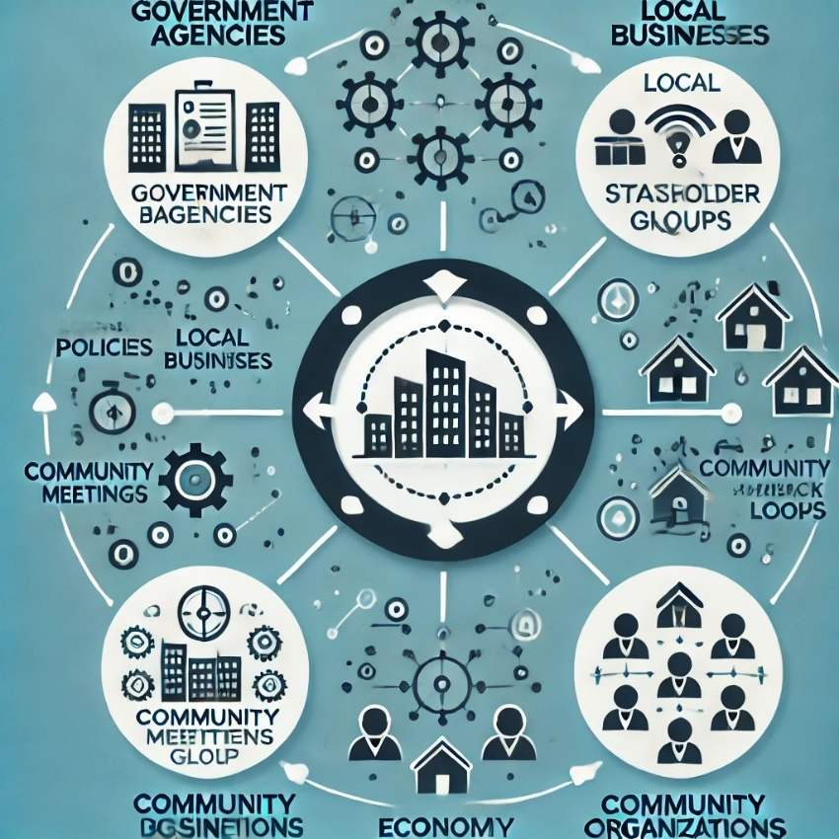

**5.Methodology:**

**5.1. Project Approach**

**Description of the Approach Taken to Complete the Project:** The project adopts a **participatory approach**, which emphasizes active involvement from all stakeholders throughout the project lifecycle. This method ensures that the perspectives, needs, and expectations of various stakeholders are adequately considered and integrated into the smart city development process.

**Key Components of the Approach:**

* **Workshops:**
  + **Purpose:** To facilitate collaborative discussions among stakeholders, allowing them to share their views, ideas, and concerns about the smart city project.
  + **Structure:** Workshops will be organized in different phases, focusing on specific themes (e.g., transportation, healthcare, technology integration). Each workshop will include presentations, group activities, and feedback sessions to foster interactive dialogue.
* **Surveys:**
  + **Purpose:** To gather quantitative and qualitative data from a broader audience, ensuring that stakeholder input is representative of the entire community.
  + **Implementation:** Surveys will be distributed through online platforms and community events, covering key areas such as desired features of the smart city, concerns about technology use, and expectations regarding urban services.
* **Focus Groups:**
  + **Purpose:** To conduct in-depth discussions with selected stakeholder groups (e.g., residents, business owners, city officials) to explore specific issues or topics in detail.
  + **Format:** Focus groups will be moderated sessions that encourage open dialogue, allowing participants to express their thoughts and build on each other’s ideas. This qualitative approach will help uncover deeper insights and prioritize stakeholder needs.

This participatory approach not only enhances stakeholder engagement but also fosters a sense of ownership and accountability among all parties involved, ultimately contributing to the project’s success.

**5.2. Tools and Techniques**

**Software, Tools, or Methodologies Used:**

* **Project Management Software:**
  + **Examples:** MS Project, Trello
  + **Purpose:** These tools will facilitate effective project planning, scheduling, and tracking of tasks and milestones.
  + **Features:**
    - Task assignments and deadlines to ensure accountability.
    - Gantt charts for visualizing project timelines.
    - Collaboration features for real-time updates and communication among team members.
* **Survey Tools:**
  + **Examples:** Google Forms, SurveyMonkey
  + **Purpose:** To design and distribute surveys that collect feedback from a wide range of stakeholders efficiently.
  + **Features:**
    - User-friendly templates for creating diverse question types (multiple choice, open-ended, Likert scales).
    - Real-time data collection and analysis capabilities.
    - Options for anonymizing responses to encourage honest feedback.
* **Data Analysis Software:**
  + **Examples:** Excel, Tableau
  + **Purpose:** To analyze and visualize the data collected from surveys and feedback sessions.
  + **Features:**
    - Excel will be used for statistical analysis, including descriptive statistics and trend analysis.
    - Tableau will facilitate the creation of interactive dashboards and visualizations to present key findings to stakeholders in an easily digestible format.

By employing this methodology, the project will effectively capture and incorporate stakeholder input, ensuring that the smart city development is aligned with community needs and expectations.

**6.Management Plans:**

**9. Risk Management Plan:**

* **Identification of Risks:** Analyze potential risks in the stakeholder management process (e.g., miscommunication, conflict of interest, disengagement).
* **Risk Mitigation Strategies:** Propose actions to address these risks, such as transparent communication protocols or conflict resolution mechanisms.

**10. Change Management Plan:**

* **Change Control Process:** Explain how stakeholder feedback will be incorporated into the project in a controlled manner.
* **Change Communication Strategy:** Develop a plan to communicate project changes to stakeholders.

**11. Sustainability Considerations:**

* **Environmental Impact:** Address how stakeholder engagement can contribute to sustainable city development, including green technologies and resource management.
* **Social Sustainability:** Ensure that the smart city project meets social sustainability goals by considering marginalized communities.

**12. Legal and Ethical Considerations:**

* **Data Privacy:** Since smart cities collect vast amounts of data, address how stakeholder concerns regarding privacy and data security will be managed.
* **Ethical Engagement:** Explore how ethical guidelines will shape stakeholder interactions to ensure fairness and transparency.

**13. Budget Allocation:**

* **Cost of Engagement:** Outline the budget for stakeholder engagement activities, such as workshops, surveys, and communication platforms.
* **Cost-Benefit Analysis:** Include a simple cost-benefit analysis to show how engagement can enhance project success and reduce long-term costs.

**14. Lessons Learned and Future Recommendations:**

* **Lessons from Engagement:** Reflect on lessons learned from engaging stakeholders in the smart city project.
* **Recommendations:** Provide recommendations for future stakeholder engagement initiatives, especially for other smart city projects.

Incorporating these additional elements will give your project a more comprehensive structure and show that you're considering various dimensions of stakeholder management.

**1. Risk Management Plan**

* Add this as a **new section** after "Methodology" or "Results/Findings."
* Title it **"Risk Management Plan"** and discuss potential risks related to stakeholder engagement and how to mitigate them.

**2. Change Management Plan**

* Include this in your existing **Methodology** section as a subsection under **"Tools and Techniques."**
* It will complement the tools and methodologies you've listed by explaining how stakeholder feedback will be incorporated through a formal change process.

**3. Sustainability Considerations**

* Integrate this into the **Introduction** or **Theoretical Framework.**
* You can add a small subsection, **"Sustainability and Stakeholder Engagement,"** which emphasizes how your project supports environmental and social sustainability goals.

**4. Legal and Ethical Considerations**

* Add this as a **new subsection** under your **Theoretical Framework.**
* Title it **"Legal and Ethical Considerations in Stakeholder Engagement,"** where you discuss how data privacy and ethical concerns will be managed.

**5. Budget Allocation**

* This can be included in a new section called **"Financial Plan"** or **"Budget for Stakeholder Engagement"** after **"Methodology"** or as part of **"Results/Findings."**
* Outline the cost of engagement tools and activities and add a cost-benefit analysis.

**6. Lessons Learned and Future Recommendation**

* Add this as a **final section** titled **"Lessons Learned and Future Recommendations."**
* Include reflections on the engagement process, what worked well, and provide suggestions for future projects.

**7.Cost Analysis:**

Cost Breakdown in INR:

1. Stakeholder Identification and Analysis

- Estimated Cost: ₹415,000 - ₹830,000

2. Communication Plan Development

- Estimated Cost: ₹581,000 - ₹1,245,000

3. Workshops and Public Meetings

- Estimated Cost: ₹1,660,000 - ₹2,905,000

4. Surveys and Feedback Collection

- Estimated Cost: ₹415,000 - ₹830,000

5. Data Analysis and Reporting

- Estimated Cost: ₹664,000 - ₹1,245,000

6. Ongoing Stakeholder Engagement

- Estimated Cost: ₹1,245,000 - ₹2,490,000

### Additional Costs:

1. Technology and Tools

- Estimated Cost: ₹166,000 - ₹415,000

2. Miscellaneous Expenses

- Estimated Cost: ₹415,000 - ₹664,000

Total Estimated Cost in INR:

Depending on the scale and scope of the project, the total cost can range from ₹5,510,000 to ₹10,640,000.

Cost Summary Table in INR:

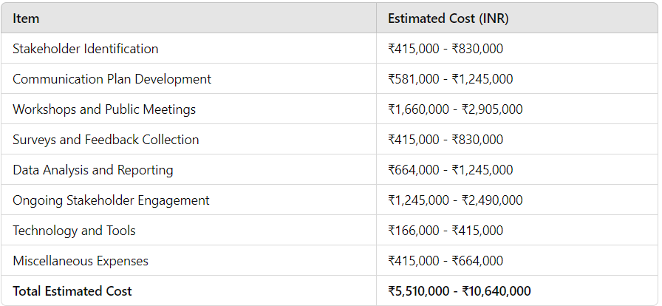

These figures provide a useful guide for budgeting your Stakeholder Management Plan in Indian Rupees. Adjustments may be necessary based on specific project needs and resources.

**8.Results/Findings:**

1. Stakeholder Identification:
   * A thorough stakeholder analysis was conducted, resulting in a comprehensive list of stakeholders involved in the smart city project. This list includes:
     + Government Agencies: Local municipalities, urban planning departments, environmental regulatory bodies, and transportation authorities.
     + Local Businesses: Small enterprises, large corporations, and service providers that will be affected by or can contribute to smart city initiatives.
     + Community Organizations: Non-profit organizations, advocacy groups, and resident associations that represent various community interests.
     + Residents: Diverse demographic groups, including homeowners, renters, and marginalized communities, ensuring a holistic understanding of community needs.
   * This identification process utilized surveys, interviews, and workshops to capture a wide array of voices and perspectives.
2. Communication Strategies:
   * Tailored communication strategies were developed for each stakeholder group to facilitate effective information flow and engagement. These strategies include:
     + Government Agencies: Regular briefings, reports, and formal meetings to ensure alignment on regulatory requirements and policy objectives.
     + Local Businesses: Informational sessions and networking events to foster collaboration and address concerns related to economic impacts and opportunities.
     + Community Organizations: Community forums and focus groups to gather input and facilitate discussions on project benefits and concerns.
     + Residents: Multi-channel communication approaches, including newsletters, social media updates, and public town hall meetings to ensure inclusive participation.
   * Each strategy was designed to cater to the unique preferences and information needs of the stakeholder group, enhancing overall engagement and transparency.
3. Success Metrics:
   * To evaluate stakeholder satisfaction and the effectiveness of the engagement strategies, a set of success metrics was defined, including:
     + Feedback Scores: Utilizing surveys to assess stakeholder satisfaction with the engagement process and the perceived responsiveness of the project team to their concerns. A target feedback score of 80% satisfaction was set.
     + Participation Rates: Tracking attendance and participation in workshops, meetings, and events. The goal is to achieve at least 60% participation from identified stakeholders, indicating strong interest and engagement.
     + Project Alignment with Stakeholder Needs: Analyzing alignment through periodic assessments of project objectives against stakeholder feedback. This includes regular reviews and adjustments based on community input to ensure that project outcomes reflect stakeholder aspirations.

These outcomes demonstrate a proactive approach to stakeholder engagement, ensuring that diverse voices are heard and integrated into the smart city development process. The strategies and metrics set the stage for ongoing collaboration, ultimately enhancing the project's potential for success and community impact.

**9.Data Representation:**

* **Communication Flow Diagram:**

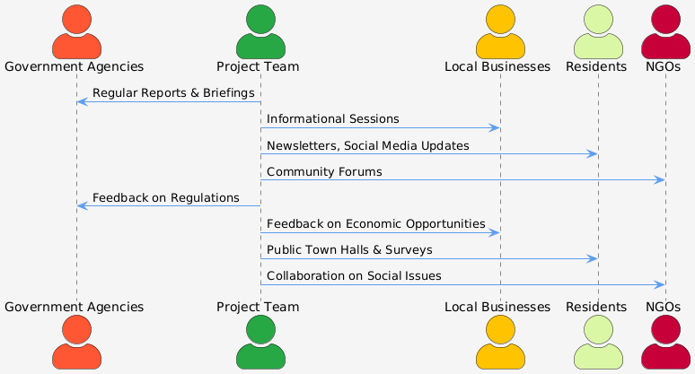

* **Flowchart:**

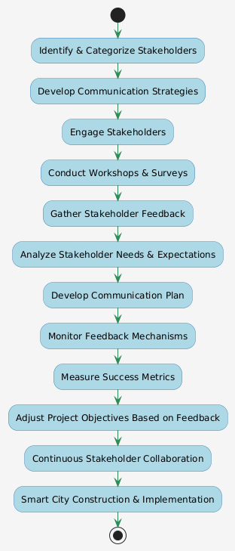

* **Table:**
  + **Summary of Stakeholder Needs and Expectations:**

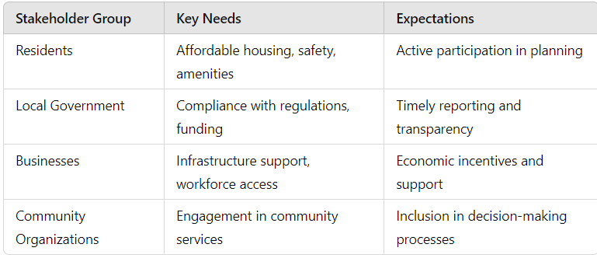

**10.Result/Output:**

• **Stakeholder Identification**:

* A comprehensive stakeholder analysis was successfully completed, resulting in a well-defined list of stakeholders crucial for the smart city project. This list includes:
  + **Government Agencies**: Local municipalities, urban planning departments, environmental regulatory bodies, and transportation authorities.
  + **Local Businesses**: Small enterprises, large corporations, and service providers that will be impacted by or can contribute to smart city initiatives.
  + **Community Organizations**: Non-profit organizations, advocacy groups, and resident associations representing various community interests.
  + **Residents**: A diverse demographic spectrum, including homeowners, renters, and marginalized communities, ensuring a holistic understanding of community needs.
* Various methods, including surveys, interviews, and workshops, were employed to capture a wide array of voices and perspectives.

• **Communication Strategies**:

* Tailored communication strategies were developed for each stakeholder group to facilitate effective information flow and engagement. These strategies include:
  + **Government Agencies**: Regular briefings, reports, and formal meetings to ensure alignment on regulatory requirements and policy objectives.
  + **Local Businesses**: Informational sessions and networking events aimed at fostering collaboration and addressing economic concerns and opportunities.
  + **Community Organizations**: Community forums and focus groups to gather input and facilitate discussions on project benefits and concerns.
  + **Residents**: A multi-channel communication approach, utilizing newsletters, social media updates, and public town hall meetings to ensure inclusive participation.
* Each strategy was designed to cater to the unique preferences and information needs of the stakeholder group, enhancing overall engagement and transparency.

• **Success Metrics**:

* A set of success metrics was defined to evaluate stakeholder satisfaction and the effectiveness of engagement strategies:
  + **Feedback Scores**: Surveys indicated a target feedback score of 80% satisfaction regarding the engagement process and responsiveness of the project team to stakeholder concerns.
  + **Participation Rates**: Attendance tracking showed a goal of at least 60% participation from identified stakeholders, reflecting strong interest and engagement.
  + **Project Alignment with Stakeholder Needs**: Periodic assessments of project objectives against stakeholder feedback were conducted, with regular reviews and adjustments made based on community input to ensure that project outcomes reflect stakeholder aspirations.

• **Data Representation**:

* **Communication Flow Diagram**: This visual representation outlines the channels and processes for communication among stakeholders and project managers, ensuring clarity in information dissemination.
* **Stakeholder Interest vs. Influence Chart**: A graph illustrating the relationship between stakeholders' interest levels and their influence on project outcomes, helping prioritize engagement efforts.
* **Summary of Stakeholder Needs and Expectations**: A table summarizing key stakeholder concerns, needs, and expectations to guide project decision-making.

**11.Conclusion:**

In conclusion, the Stakeholder Management Plan for the smart city construction project has established a robust framework for stakeholder engagement, highlighting the importance of diverse participation in the project's success. Through comprehensive analysis, tailored communication strategies, and defined success metrics, the project ensures that stakeholder voices are heard and integrated into decision-making processes. This proactive approach addresses urban challenges while promoting sustainable development, ultimately leading to a smart city that enhances the quality of life for its residents.

By continuously monitoring engagement and feedback, the plan sets the stage for ongoing collaboration and adaptability throughout the project's lifecycle, aligning the smart city vision with the aspirations of the community.