
Your Business Solution Partner

CONSULTANCY AGREEMENT
FOR
OFFSHORE IT SUPPORT SERVICES

Your Business Solution Partner

CONFIDENTIAL STATEMENT

This document contains proprietary information about Iqra Technology and is supplied to you purely to enable you to evaluate details concerning our proposed solution. This document, including any part thereof, is not to be disclosed or transferred outside your organization without the prior written consent of a duly authorized representative of Iqra Technology and may not be copied or reproduced in any form or by any means except internally within your organization to enable such evaluation. None of the information contained in this document shall be contractually binding until signed by both parties.

All trademarks are the property of their respective companies.
©All rights reserved.

Your Business Solution Partner

GENERAL
IQRA TECHNOLOGY
Iqra Technology is a software development, enterprise solution, and consulting firm. We provide flexible and tailored IT outsourcing models as per the client's requirements and offer the best solutions for business-related problems.

Iqra Technology also provides services in:
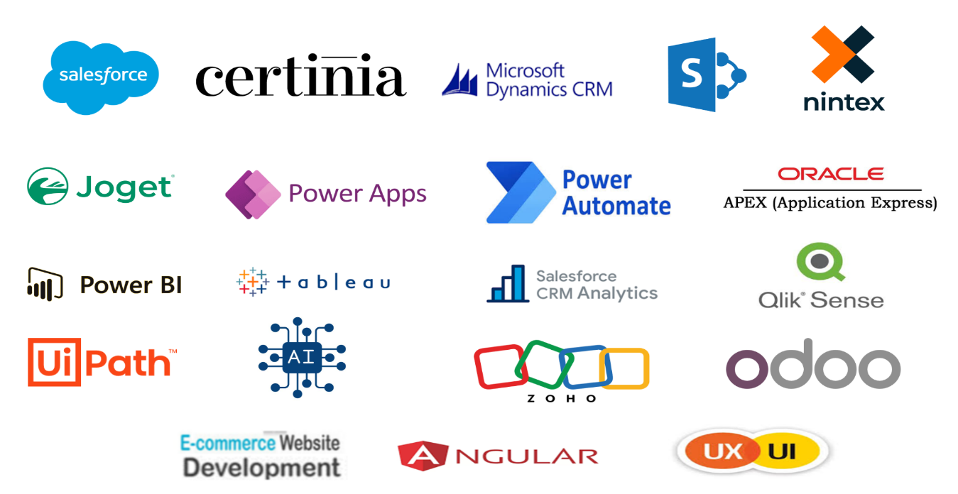
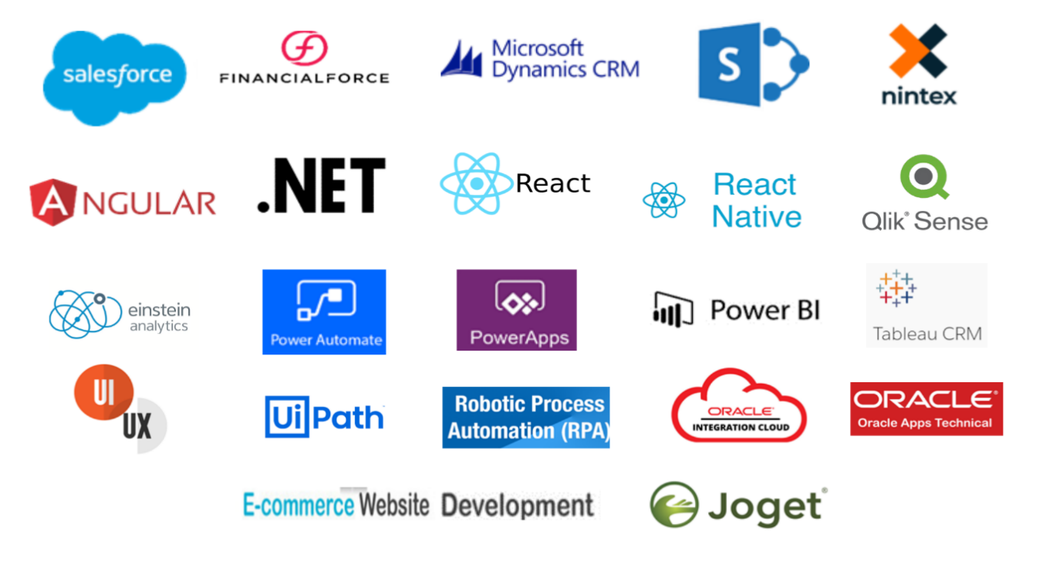

OUR TECHNOLOGY PARTNER

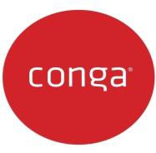






Your Business Solution Partner

Client Name

Your Business Solution Partner

DEFINITIONS

"Account" means all aspects of the Service provided to you under this Agreement. "Agreement" means these terms and conditions of Service.
“Claim" means any action, claim, demand, cost, loss, damage, (whether special, indirect, consequential, general, or any other damage), expense, or other liability (including for death and injury, and the costs of defending or settling any Claim) whether arising in contract, negligence or any other tortuous action.

"Person" includes an individual, a body corporate, an office, commission, authority, committee, tribunal, board, institute, organization, or other body however described.

"Direct Customer" means any person who pays you directly for your service (the service we are providing support for). Direct Customers include your resellers, but not the clients of your resellers.

"Service" means the provision to you, by us, of labor-based and IT-enabled services, and all associated systems and software.

"You” and “your” means the entity/client that agrees to use the Service "Confidential Information" means information or material:
- Containing or being passwords.
- Concerning either party's internal business practices and/or actual or
- Potential customers.
- which derives independent economic value, actual or potential, from not being generally known to, and not being readily ascertainable by proper means by, other persons who can obtain economic value from its disclosure or use; or
- Identified in writing by the disclosing party as confidential.

But does not include any information or material:
- Which is or subsequently becomes available to the general public other than through a breach by the receiving party.
- Which is already known to the receiving party before disclosure by the disclosing party.
- Which is independently developed by the receiving party without the use of or reference to the Confidential Information of the other; or
- Which the receiving party rightfully receives from third parties without restriction as to us to use or disclosure.
Your Business Solution Partner

SCOPE

Your Business Solution Partner

WORKING HOURS

The assigned resource will work as per the below schedule.

Client office | Position | Proposed Region  Work Time | Proposed Indian Standard Time (IST) | Workdays
 |  |  |  | Monday to Friday

Note: Resource will work 9 hours a day with 30 mins lunch/ dinner break and 2 no’s 15 mins break per day for 5 days a week.

SERVICE LEVEL
Your Business Solution Partner

The following service levels will be followed during the Services and Iqra Technology shall be bound by the same.

Severity Level & Description | Response time | Progress Update | Resolution Time
S1-Emergency  Major system or component failure.  Malfunctions with a critical impact on the client’s ability to operate entire business processes on production. No workaround or manual process is available. The problem must be resolved immediately. | Immediate | Every 1 Hour | 4 Hours
S2-High  Minor system or component failure  Malfunction causes an impact on the client’s ability to operate significant business processes or production. No workaround or manual process is available. | 2 Hours | Every 3 Hours | 1 Business  Day
S3 – Medium  Component failure or malfunction does not cause an impact on the client’s ability to operate significant business processes on production. Workaround or manual processes are available. | 8 Hours | Every 1  Business  Day | 3 Business Days
S4- Low  Any enhancement to the existing implementation including new report development, minor customization, new alert and workflow development. | 1 Business Day | Every 3  Business  Day | 2-7 Business Day (Based on the complexity of development)

Note: During non-business hours only the SLAs for Severity 1 are applicable. The issues with other severity will be addressed the next business day. The client will contact the support personal directly on the contact number specified for an immediate response.
The above time excludes the
- Time involved in consulting and obtaining resolution from software vendor
- Delay involved due to non-availability of infrastructure or connectivity
- Time involved in obtaining clarification from the users and time involved in obtaining user acceptance of the solution provided that the Consultant has timely notified to client Representative in writing of any likely delay arising from said reasons.

In case multiple issues in the same functional or technical area are reported at the same time, Client Representative will prioritize the issues and communicate the same to the Consultant’s support team in writing. If there are multiple issues of the same priority, Client Representative will review with business and lower the priority of the remaining open issues.
Your Business Solution Partner

The severity level is applicable only for support task for all new projects, development, customization , changes etc timeline will be defined as per effort estimation.

CONSULTANCY SUPPORT COST
Your Business Solution Partner

Below is the cost of the monthly resources.

Item | Duration | Price Per Month in USD | Total Price in USD
Total Cost

Note:
- There are no taxes envisaged but if applicable at the time of billing the client will be liable to pay all applicable taxes if any.

PAYMENT SCHEDULE

The invoice will be raised at the beginning of the month and payment terms will be Net 30 days from the invoice date and the invoice payable at the end of the month. If your payment is overdue, we will discontinue the Service until payment of all applicable fees is made
Your Business Solution Partner

GENERAL TERMS

1. Work Monitoring

The client will need to monitor the work undertaken by the assigned resource(s). We recommend that you give your resource(s) details of your project/support timetable and the deliverables you require from them. We also recommend that you regularly check the development process so that both you and your resources can be sure that the project is staying on track. You will be responsible for the allocation and prioritizing of the support task. Please note that you will need to interact directly with your hired resource(s) about your projects. We do not provide project management and only provide basic supervision to your resource(s) (i.e., monitoring of attendance, ensuring they work hard while at work, shift scheduling, and so on). Essentially, your dedicated resource provides the same service as you would get from an in-house resource but is located offshore at our development center in India.

2. Reporting

The assigned resources will report to the client representative and maintain a task list/timesheet on a daily basis on the client Time sheet logging system.

3. Escalation Process

In the event of any dissatisfaction from our consultant's support service, as a first step, the matter could be escalated to the team manager to remedy, if still not resolved to solve it the second step would be to escalate it to the account manager and as a final step could be escalated to the Director to solve.

4. Documentation

No documentation will be maintained by Iqra Technology. All conversations will be maintained by email. If any documentation is required, then the same can be produced as per customers’ requirements.

5. On-Site Services

In case consultants need to travel to the client location will arrange for air tickets, visas, and accommodation for the consultants. An additional per diem of $100 per day will be paid to cover food and other expenses.

6. Prices
Prices are subject to change with prior intimation/notice. Any change in monthly fees will apply to your next service agreement period but will not be payable for your current service period. A 10% - 15% hike is usually appreciated on contract/agreement renewal. The annual appraisal is applicable if the resource(s) are doing well. Or seek a replacement.

7. Contract Termination
Your Business Solution Partner

The contract can be terminated at any time by providing us with written authorization to cease the Service, the below-mentioned notice period will apply to the termination of the contract. Our client acknowledges that our regular fees will continue to apply until you explicitly and unambiguously cancel service and advise us of the date of cancellation which should include the below notice period.
- 3 months cancellation notice in annual contracts.
- 2 months’ cancellations notice for contracts less than 1 year (greater than 3 months).
- 1-month cancellation notice in less than and equal to 3 -month contracts.

8. Dissatisfaction of Our Services
Due to any reason if you are not satisfied with our service(s) then you (client) are entitled to email the sales executive explicitly the reason for dissatisfaction and pause/hold the contract. No refund will be payable for the days/weeks/months used already.
Hours/days/weeks used by undertaking our services will be payable by the client.
If you find the primary resource unsatisfactory, we offer the option of substituting it. Within a week, the primary resource will impart their knowledge to the secondary resource, ensuring a seamless transition. During this knowledge transfer phase, both resources will be active, and you will be billed for only one resource.
If the client is dissatisfied with the secondary resource, then both parties can cancel the contract with 15-day notice period. The client will have to pay all the amount due to Iqra Technology.

9. Notice Period for Resource Changes

Both Iqra Technology and Client mutually suggest instituting a 30-day notice period for any changes to resources. During this period, we commit to supplying one replacement resource at no additional cost. The designated replacement will be well-versed in the project requirements, ensuring a smooth transition. Additionally, you have the flexibility to schedule an interview with the end client for the proposed resource.

10: Holiday Policy:

Below is the list of paid holidays for our services, all other holidays will be in accordance with the Client holiday calendar. In case of urgent work, support will be provided.

Sr.No | Date | Holiday Name
1 | 1-Jan-25 | New Year
2 | 26-Jan-25 | Republic Day
3 | 14-Mar-25 | Holi
4 | 30-Mar-25 | Eid-al Fitr
5 | 31-Mar-25 | Eid-al Fitr
6 | 6-Jun-24 | Eid al- Adha
7 | 7-Jun-24 | Eid al- Adha
8 | 15-Aug-24 | Independence Day
9 | 20-Oct-25 | Diwali
10 | 21-Oct-25 | Diwali

Besides the above holidays employees are also entitled to 15 days holiday per annum. Iqra Technology will provide alternate resources when the assigned resource is on leave.
Your Business Solution Partner

11. Intellectual Property Rights

The client will completely own the intellectual property rights of all the work done by the resource(s) assigned to the client.

12. Confidential Information

Each party will maintain all Confidential Information of the other party in strict confidence and will not at any time or for any reason disclose any Confidential Information of the other to any third party without the disclosing party's prior written consent. Neither party will use any Confidential Information of the other for any purpose whatsoever except in performing its duties and exercising its rights under this Agreement. Neither party will disclose any Confidential Information of the other to any of its agents or employees who do not participate directly in the performance of its duties or exercise of its rights under this Agreement, and each party will advise its employees who are permitted access to any Confidential Information of the other party, of the restrictions on disclosure and use set forth in this Agreement. Notwithstanding the foregoing, either party may disclose the Confidential Information of the other if it believes in good faith that any applicable law, rule, or regulation requires the disclosure, provided that it makes a reasonable effort to give the disclosing party as much advanced notice as may be practicable. On termination or expiration of this Agreement, each party will return or destroy all Confidential Information obtained from the other party and copies thereof.

13. Non-Solicitation of Employees or Contractors

Except for the Service itself, you will not directly or indirectly, during this Agreement and for a period of two years after its expiry or termination solicit, engage, employ, contract or otherwise work in any manner with any person who is or was employed or engaged by us (including our subsidiaries). This obligation applies not only to you but also to each of your directors and principals (where existent). In the event that You or one or more of Your Directors or principals reaches this section, then You agree to pay us a fee of USD 35,000 for each breach (that is, once for each employee) plus any legal costs incurred by us in recovering such fees from you. You acknowledge that the two-year period mentioned above is no greater than is reasonably required to protect goodwill in the business.

14. Other Terms and Conditions
  - These agreement terms are applicable for all future purchases of our service(s) in lifetime. Hence, no further agreement(s) need to be signed until unless there are any changes in clause(s) which will be mutually discussed & accepted in written by both the parties.
  - Any change of signatory authority in the client’s company doesn’t impact this or any future engagement norms until mutually notified and with the agreed consent written by both the parties.
  - We would like to receive details of who the resource should report to and where he should mail his reports.

Your Business Solution Partner

15. Force Majeure Clause

Iqra Technology will not be responsible for the non-performance of any or all other obligations under this contract if such non-performance is due to reasons beyond the control of Iqra Technology. “Force Majeure” situations are also included in the expression “beyond the reasonable control of Iqra Technology”.

16. Jurisdiction

This agreement shall be interpreted under the laws of (India), and both parties agree that any legal action or proceedings relating to this agreement shall be settled in the courts and/or tribunals in the (India).

17. Limitation of Liability

We will not be liable to you or any other person for any claim arising out of or relating to this agreement or any product or service furnished or to be furnished under this agreement or the use thereof (including but not limited to damage, loss, or corruption of data, service interruptions or errors, inaccurate advice provided to your clients, or loss of profit, business, revenue, goodwill or anticipated savings), even if you have been advised of the possibility of such loss or damage. The aggregate liability of us for any claims howsoever arising out of or relating to this agreement or any products or services furnished or to be furnished by us under this agreement will, in any event, be absolutely limited to the amount paid by you to us under this agreement for the applicable products and/or services. You acknowledge that we have set our prices and entered into this agreement in reliance upon the limitation of liability set forth in this agreement and that the same forms an essential basis of the bargain between the parties. The parties agree that the limitation of liability specified in this agreement will survive and apply even if any limitation of remedies is found to have failed of its essential purpose. Notwithstanding the foregoing, nothing contained herein will limit your liability for its own willful or wanton conduct.



You’re Business Solution Partner

You’re Business Solution Partner

