
Your Business Solution Partner

IT OFFSHORE PROJECT


CONFIDENTIAL STATEMENT

This document contains proprietary information about Iqra Technology and is supplied to you purely to enable you to evaluate details concerning our proposed solution. This document, including any part thereof, is not to be disclosed or transferred outside your organization without the prior written consent of a duly authorized representative of Iqra Technology and may not be copied or reproduced in any form or by any means except internally within your organization to enable such evaluation. None of the information contained in this document shall be contractually binding until signed by both parties.

All trademarks are the property of their respective companies.
©All rights reserved.

GENERAL
IQRA TECHNOLOGY
Iqra Technology is a software development, enterprise solution, and consulting firm. We provide flexible and tailored IT outsourcing models as per the client's requirements and offer the best solutions for business-related problems.

Iqra Technology also provides services in:
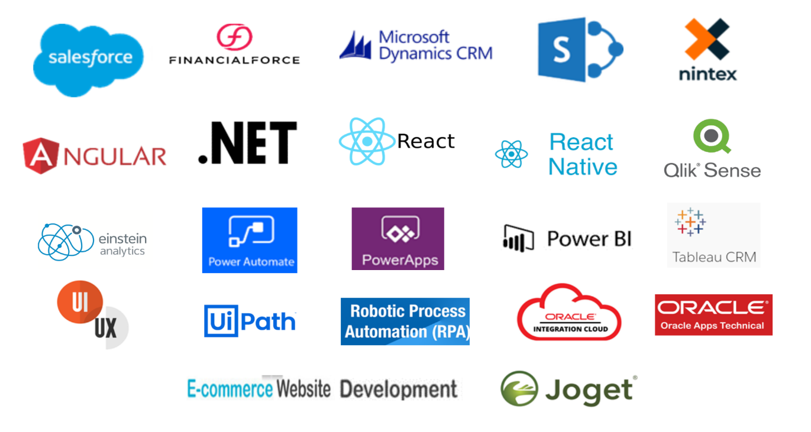

TECHNOLOGY PARTNER




SCOPE

COST

IMPLEMENTATION PRICE: -
Iqra Technology will implement the project on an offshore basis as per the scope defined in the scope section above.

Sr. No. | Description | Duration | Total Cost (USD)

PAYMENT TERMS & SCHEDULE

Payment Terms- Project Implementation:
1. 50% Advance
2. 30% UAT
3. 20% Go-Live

Invoice once raised will have payment terms 1 week from the invoice date. If your payment is overdue, we will discontinue the Service until payment of all applicable fees is made.

GENERAL TERMS

Documentation

No documentation will be maintained by Iqra Technology. All conversations will be maintained by email. If any documentation is required, then the same can be produced as per customers’ requirements.

2. On-Site Services

In case of consultants need to travel to Client Location will arrange for air tickets, visas, and accommodation for the consultants. An additional per diem of $100 per day will be paid to cover food and other expense.
3. Contract Termination

The contract can be terminated at any time by the client by providing us with written authorization to cease the Service. In case of termination any time before completion of the design and development stage 50% of the contract value needs to be paid and in case of termination of the contract any time after the completion of the design stage and before going live then 90% of contract values should be paid.

4. Confidential Information

Each party will maintain all Confidential Information of the other party in strict confidence and will not at any time or for any reason disclose any Confidential Information of the other to any third party without the disclosing party's prior written consent. Neither party will use any Confidential Information of the other for any purpose whatsoever except in performing its duties and exercising its rights under this Agreement. Neither party will disclose any Confidential Information of the other to any of its agents or employees who do not participate directly in the performance of its duties or exercise of its rights under this Agreement, and each party will advise its employees who are permitted access to any Confidential Information of the other party, of the restrictions on disclosure and use set forth in this Agreement. Notwithstanding the foregoing, either party may disclose the Confidential Information of the other if it believes in good faith that any applicable law, rule, or regulation requires the disclosure, provided that it makes a reasonable effort to give the disclosing party as much advanced notice as may be practicable. On termination or expiration of this Agreement, each party will return or destroy all Confidential Information obtained from the other party and copies thereof.

5. Other Terms and Conditions

Any change of signatory authority in the client’s company doesn’t impact this or any future engagement norms until mutually notified and with the agreed consent written by both the parties.

6. Non-Solicitation of Employees or Contractors

Except for the Service itself, you will not directly or indirectly, during this Agreement and for a period of two years after its expiry or termination solicit, engage, employ, contract or otherwise work in any manner with any person who is or was employed or engaged by us (including our subsidiaries). This obligation applies not only to you but also to each of your directors and principals (where existent). In the event that You or one or more of Your Directors or principals reaches this section, then You agree to pay us a fee of USD 35,000 for each breach (that is, once for each employee) plus any legal costs incurred by us in recovering such fees from you. You acknowledge that the two-year period mentioned above is no greater than is reasonably required to protect goodwill in the business.

7. Force Majeure Clause

Iqra Technology will not be responsible for the non-performance of any or all other obligations under this contract if such non-performance is due to reasons beyond the control of Iqra Technology. “Force Majeure” situations are also included in the expression “beyond the reasonable control of Iqra Technology”.

8. Jurisdiction

This agreement shall be interpreted under the laws of (India), and both parties agree that any legal action or proceedings relating to this agreement shall be settled in the courts and/or tribunals in the (India).

9. Limitation of Liability

We will not be liable to you or any other person for any claim arising out of or relating to this agreement or any product or service furnished or to be furnished under this agreement or the use thereof (including but not limited to damage, loss, or corruption of data, service interruptions or errors, inaccurate advice provided to your clients, or loss of profit, business, revenue, goodwill or anticipated savings), even if you have been advised of the possibility of such loss or damage. The aggregate liability of us for any claims howsoever arising out of or relating to this agreement or any products or services furnished or to be furnished by us under this agreement will, in any event, be absolutely limited to the amount paid by you to us under this agreement for the applicable products and/or services. You acknowledge that we have set our prices and entered into this agreement in reliance upon the limitation of liability set forth in this agreement and that the same forms an essential basis of the bargain between the parties. The parties agree that the limitation of liability specified in this agreement will survive and apply even if any limitation of remedies is found to have failed of its essential purpose. Notwithstanding the foregoing, nothing contained herein will limit your liability for its own wilful or wanton conduct.



You’re Business Solution Partner
You’re Business Solution Partner

