Intro. To Compiler Design Proj2 Report

0416324 An – Fong Hwu

1.Part of Lex I have modified to make it interact with Yacc parser?

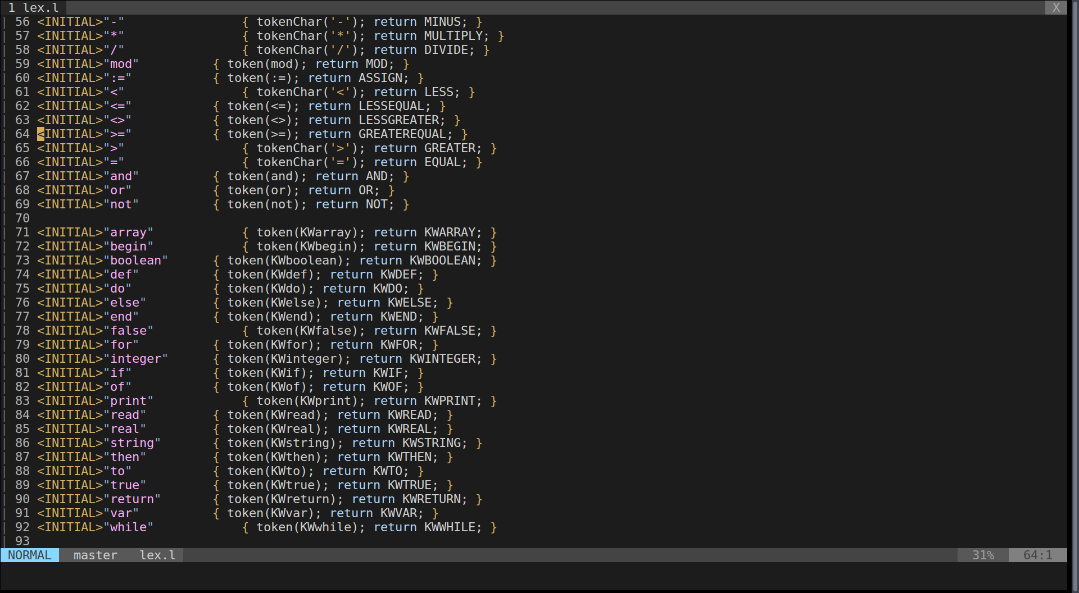I have modified it to make lex scanner return what keyword and some other things required to be parsed.

2.What platfotm to run my parser

I use the Linux4 workstation to run my program, just SSH in it and run.

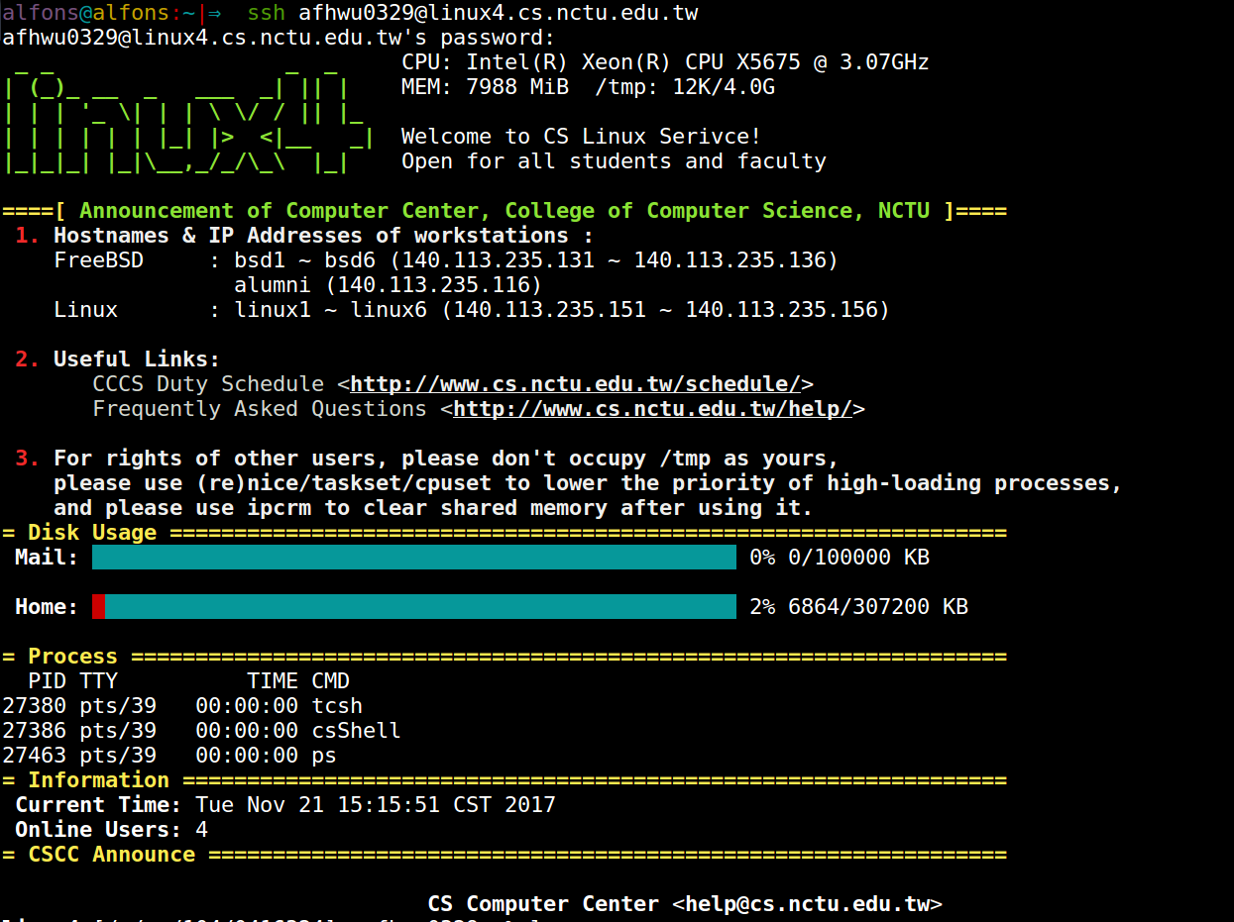And it successfully runs.

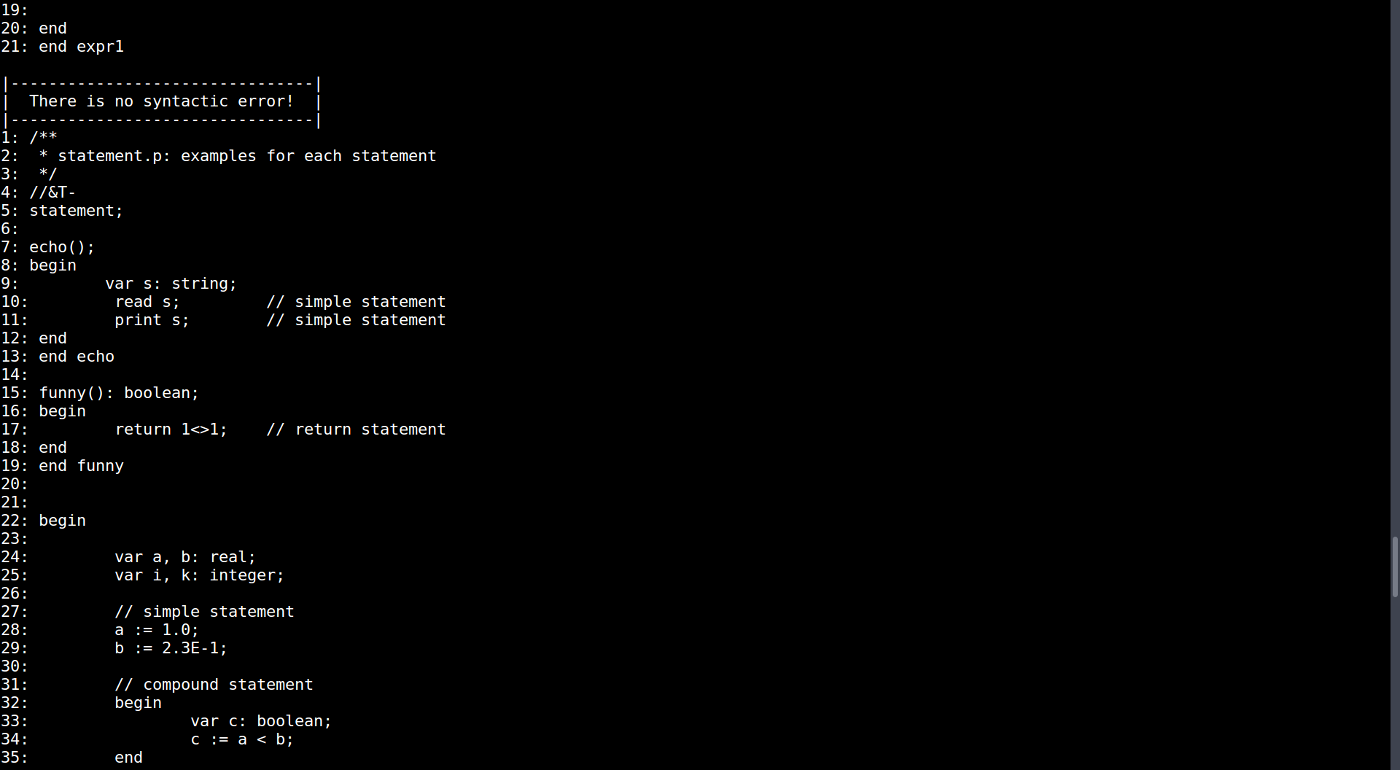

3.How to run my parser

Makefile as the picture, description are written in the comments

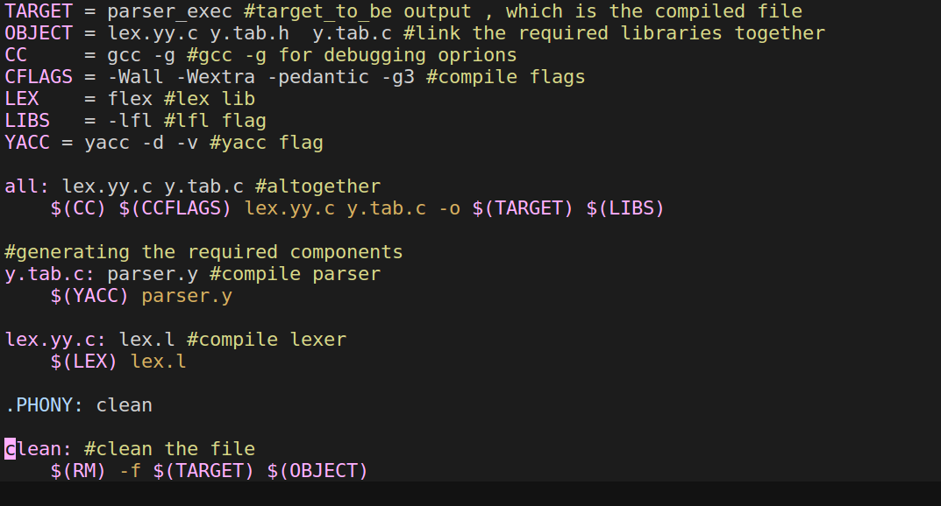

4.Ability of my parser

Able to parse all the all testcases by TA and run through my own testcases

My own testcases--> <https://pastebin.com/MZEvqiHW>