Database HW2 Report Group1_0416324 胡安鳳

1.SELECT COUNT(*) as allPlayersRecorded

FROM Master;

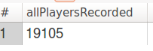

2.SELECT COUNT(DISTINCT birthCountry)

FROM Master;

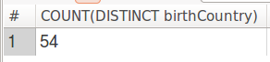

3.SELECT yearID,playerID

FROM Batting b

WHERE (b.HR>=50 AND b.HR<=60);

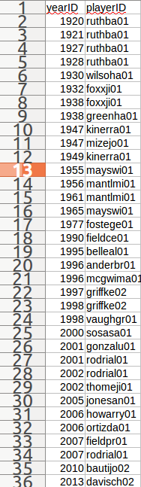

4.select count(distinct `park.name`) as ParkName_withStadium_cnt

from Parks p

where p.`park.name` like '%Stadium%';



5.select avg(datediff(finalGame,debut))/365 as year_diff

from Master;



6. select distinct name_full as School_fullName

from Schools s,Master m,CollegePlaying c

where m.debut like '%2000-05%'

and (m.playerID=c.playerID)

and (c.schoolID=s.schoolID);

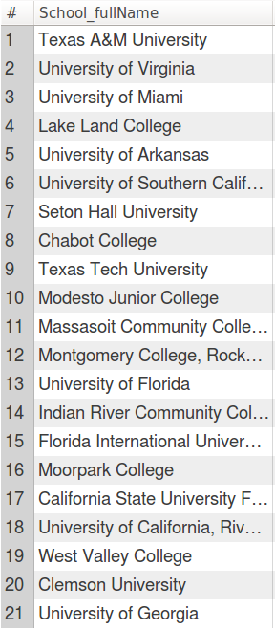

7.select avg(salary) as avgSalary ,max(salary) as maxSalary ,yearID as years

from Salaries s

group by s.yearID;

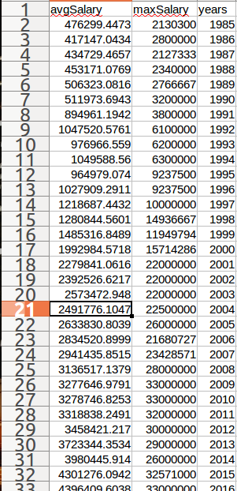

8.select s.yearID,s.playerID

from (select max(s2.salary) as s2maxsalary , s2.yearID from Salaries s2 group by s2.yearID)as s3, Salaries s

where s.yearID = s3.yearID

and s.salary = s3.s2maxsalary;

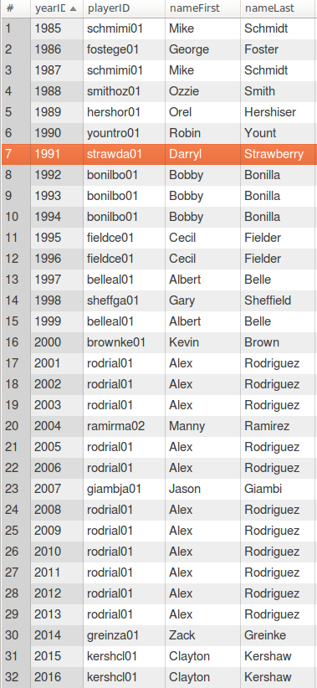

9.select distinct p.playerID

from Salaries s,Teams t,Pitching p,(select max(s2.salary),s2.playerID from Salaries s2 group by s2.yearID) as s2maxsalary_g_year

where

p.teamID=t.teamID

and t.WSWin='Y'

and t.yearID >=1920 and t.yearID<=2004

and p.playerID=s2maxsalary_g_year.playerID

union

select distinct b.playerID

from Salaries s,Teams t,Batting b,(select max(s3.salary),s3.playerID from Salaries s3 group by s3.yearID) as s3maxsalary_g_year

where

b.teamID=t.teamID

and t.WSWin='Y'

and t.yearID >=1920 and t.yearID<=2004

and b.playerID=s3maxsalary_g_year.playerID;

10.

首先先求出鈴木一郎他的playerID 得知為 suzukic01

select playerID

from Master m

where m.nameFirst = 'Ichiro' and m.nameLast = 'Suzuki';

為何鈴木一郎是個好球員，由於鈴木一郎是一位打者，我們發現他的個人打擊數（包含一二三壘安打都比整個batting的平均打擊數還要多，對於全壘打亦然）　而且就薪資方面而言它也高出整個salary的平均值許多，可以見得他是身具實力又被球隊賞是的超強球員。

select avg(allbat.H),avg(ichirobat.H),avg(allbat.2B),avg(ichirobat.2B),avg(allbat.3B),avg(ichirobat.3B), avg(allbat.HR),avg(ichirobat.HR)

from Batting allbat,Batting ichirobat

where ichirobat.playerID = 'suzukic01';



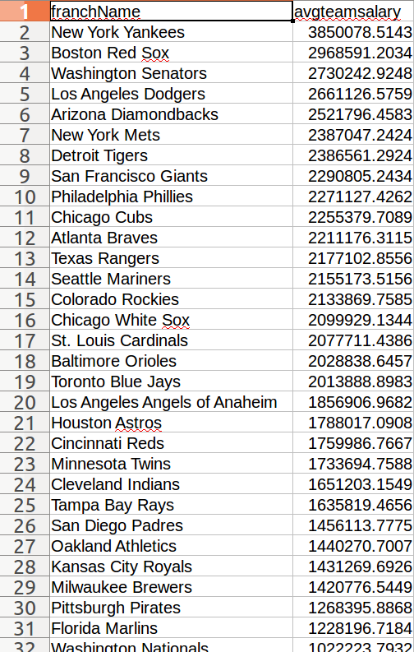

11.在此統計了球隊-薪資的關係降冪排序找出最有錢球隊，得知為紐約洋基隊