Introduction to Computer Network Proj3 Report

0416324 胡安鳳

Exp1 UDP packets

1.

Select the UDP packet. How many fields are there in UDP header? Name these fields.

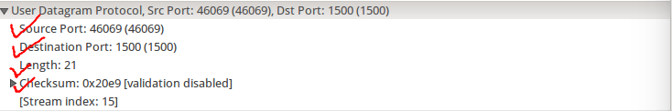Ans:

This picture is captured from wireshark, as we can see, there are total of four fields in header, including Source Port, Destination Port, Length of the total UDP data(including the header, unit in byte) and the checksum for error detection.

Validating from wikipedia, it is also 4 fields.

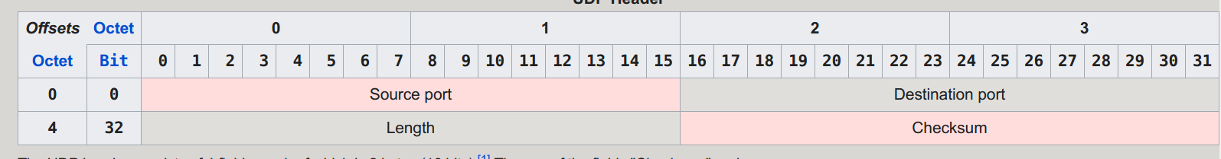

2.

Following the first operation, click on the header and observe the display at the bottom of Wireshark window. Determine the length(in bytes) of each field

Ans:

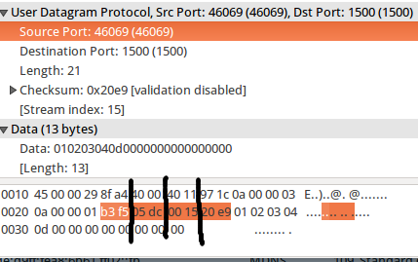

As the picture taken form wireshark, each field is equally divided into 16bits, namely 2 bytes.

3.

Focus on Length field. According to the format:total Length = header + payload, fill in the numbers and explain how you calculate. Ans as follows:

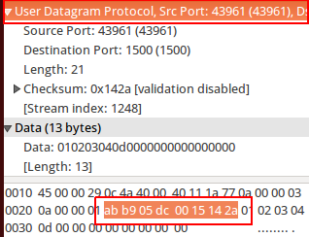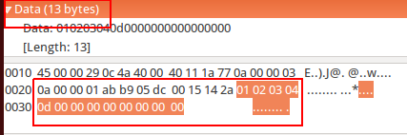

The UDP header is fixed into 8 bytes(see pic1) and in this experiment, I found that the data part, namely the payload part is 13 bytes(see pic2).

4.

What is the maximum number of bytes that can be included in a UDP payload? (Referred to class notes)

Ans:

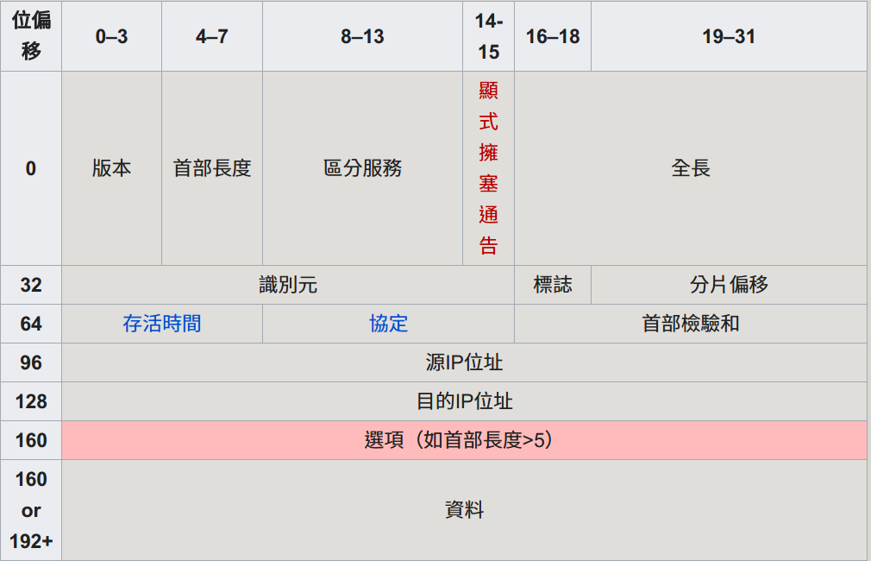

In IPv4, the maximum length of packet size is 65536. So, for UDP datagram we have maximum data length as:

65535 bytes - 20 bytes(Size of IP header) = 65515 bytes (including 8 bytes UDP header)

**And finally the payload should be 65515 – 8 = 65507 bytes**